**ABOUT:**

Students have the option of either staying on-campus or off-campus in apartments located close to the university. Most of the new students arriving here from India stay in apartments off the school campus.

**OFF CAMPUS HOUSING:**

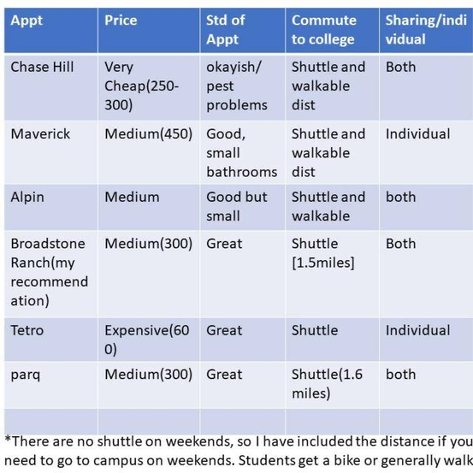

There are some apartments located close to the university, we have listed a few of them above. You can also check our websites like www.apartmentratings.com for a more refined search based on your requirements. Please note we do not have complete and up-to-date information such as the rent for some of the apartments so if you are interested in any particular apartment then the best way to find out more information would be to call them up.  
  
Please note that in all cases you will also need about $200 for other initial expenses. This is because the apartments are unfurnished, and you will have to buy some basic stuff for the apartment. The apartments comes with a gas-range, dish-washer, refrigerator, air conditioner/heater, hot water; some apartments have a washer-dryer.