**ABOUT:**

Once you have finalized on UTSA and have gotten your VISA, the first thing that you will need to do is buy/collect stuff that you will have to carry with you. Following is a list of suggestions regarding things that you might want to get with you. This list is primarily for students coming to UTSA. You may decide what to bring from India and what to buy in the US according to your considerations. You can buy almost everything in the US after you get here, but we strongly recommend you to get all the books that you need from India.  
  
Please make sure that you get only as much as you can carry, and can unpack/re-pack it fast. Also note that the list of items is constructed according to the personal experiences of students who have come here, so it is possible that there are some important items that are missing or are unnecessarily specified here. Please use your personal discretion and in case you feel there is something missing then you can always send us an email (isa.utsa@gmail.com) and we will try to update it in the list as soon as possible.

**CLOTHING:**

The dress code on campus is informal and a T-shirt worn with jeans is almost a universal dress for everybody here. So, bring plenty of them. Formal clothes may come in use occasionally like during presentations, career fairs, interviews etc. You may, of course, want to bring along some Indian clothes (saris, salwar-kameez, kurtas, etc.) with you for those traditional events like Independence Day, etc.  
  
**Formals:** One suit (Optional), ties (1 or 2), shirts and trousers (2 or 3), traditional saris/kurta.  
**Casuals:** Jeans (3 or 4), T-shirts & sweats (6+), cotton shirts (2+), shorts (for outdoor, indoor, sports use) (2 or 3).  
San Antonio has hot summers (35-48 C) and cold winters (-3 to 15 C), so you will need both summer wear as well as winter clothes. Get a good sweater/jacket, a muffler, a scarf and a woolen cap, but you might get a better coat/jacket in the US. It gets cold here in winter so do not forget the warm clothes. An umbrella might be a good idea, since the rain here, though not a lot tends to come without a warning.  
**Footwear:** Sneakers, formal shoes (highly recommended as they are pretty costly here), leather chappals/sandals, bathroom slippers, shoe polish, polishing brush.  
**Winter wear:** Sweaters (medium quality, at most 2), muffler/ scarf, woolen cap.  
No matter where you stay, you'll have access to washing and drying facilities. These machines have large capacities, so that it is possible to do 2-3 week's laundry at a time. So plan your wardrobe accordingly.  
**Undergarments & socks:** About 12 sets of undergarments and socks, preferably cotton.  
**Miscellaneous:** Towel (2+), napkins (1/2), leather belts (2+), handkerchiefs (6+).  
**Linen:** Bed sheets (double bed size, 2), pillow covers (big, 2), shawl/light blanket (for spring/summer use).  
**Things you better buy in the US:** Winter jacket, winter gloves, caps, wind-cheaters, track-suits, good sweaters (they're cheap), and comforter.  
  
**NOTE:** Indian clothes (particularly cottons) have a tendency to shrink a lot when washed on the hot and/or warm cycle in a washing machine here or by drying them in the dryer, so please be careful with sizes.

**KITCHEN:**

Food is not a problem for either vegetarians or non-vegetarians, although if you are a non-vegetarian you have more choices. There are lots of eating joints in the vicinity, providing Indian/American/Mexican/Oriental foods. But it would certainly be cheaper and healthier to develop some culinary skills. Come well-armed with your pots and pans & some recipes. Be sure to bring along flat bottomed vessels because you would be using electric stoves here (preferably the ones with copper bottom).  
  
**Cooking Utensils:** Spoons, forks, GOOD knives, cups, glasses (2 each), a melamine (microwaveable) set (Optional) consisting of plates, soup-bowls and regular bowls (2 each), (these are pretty cheap here and are optional) and a good cooking book  
Although, you can buy almost all kinds of Indian foodstuff here, get a reasonable quantity of the following, enough to last you for your setup period and save you some money initially.  
  
**Condiments and spices:** It is better not to bring spices as some people have faced problems bringing them in the recent past. You will find almost all the spices here in San Antonio, so you don't need to bring them along. You can buy them here.  
**NOTE:**DO NOT get any fresh fruits or meat and spices like Jeera.  
  
**Remember:** the easiest way to make new friends, is to feed the existing Indian food-starved populace with desi delicacies and sweets, so if there are any specialties of your place, do get them along.

**MONEY:**

The initial expenses are high. Below is an estimate of how much money you might need. This will vary depending on your course and the apartment.  
  
**Tuition Fees:** The total fees for one semester (Computer Science) looks as below:

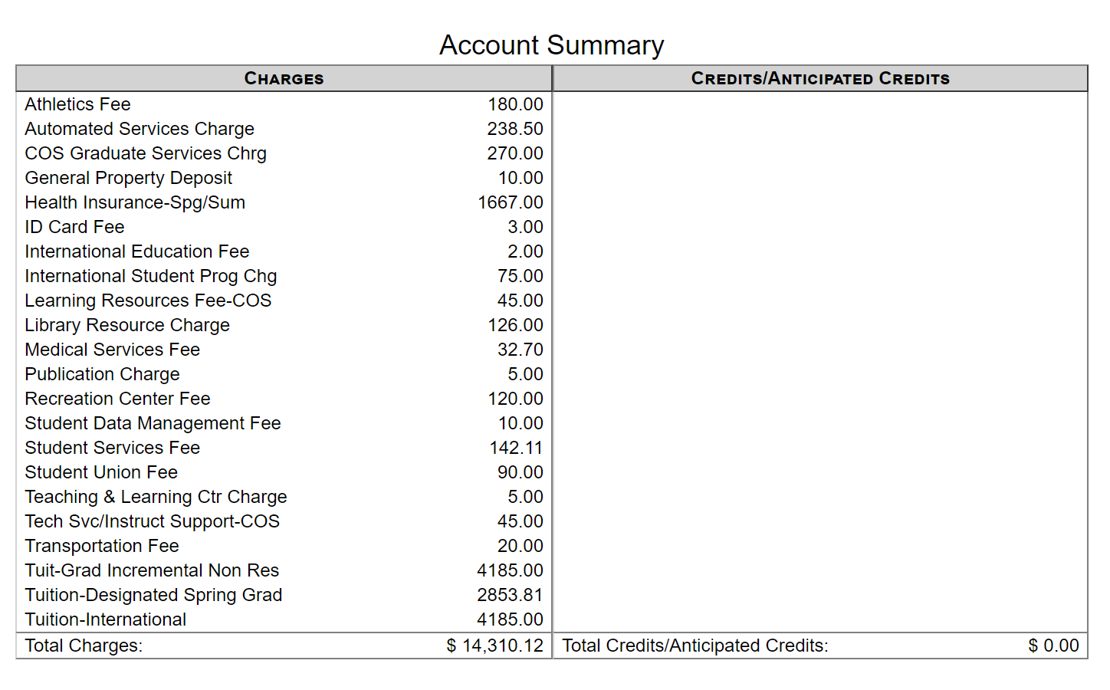

Once you get appointed as a TA or an RA you are eligible for in-state fees. TA's and RA's pay about $1100 a semester. This includes the in-state tuition fees and all expenses mentioned above. RAs may get paid slightly more than this amount. The school also lets you pay the fees in three installments over the entire semester or take a short-term loan (5% interest) over three months and pay the entire amount at the end of the 3 months. But we would STRONGLY advise you to bring the entire amount with you at least for the first semester.  
  
**Living Expenses:** Living expenses are generally $800 - $850 per month. This includes room rent, groceries, electricity and telephone bills and other miscellaneous expenses (assuming that you are sharing your apartment with fellow students). If you plan on staying individually expenses will be a lot higher than the amount listed above.  
  
You can get a check/DD payable to "University of Texas at San Antonio" for the exact amount (if you know it), for a slightly smaller amount, and pay the remainder in cash/travelers checks or get a check for a larger amount and the university will refund you with the remaining by writing you a personal check. If you plan on not getting a DD, then you could carry the whole amount in traveler’s checks. Once you reach UTSA you can open your own bank account and deposit the travelers checks and cash. To pay your tuition you could then write the university a personal check. Also remember to keep your money/checks/demand drafts in your cabin luggage which you will be carrying with you always.

**NOTE:** We would advise you to carry your money in the form of Traveler’s Checks so that you may encash them immediately. DDs take about a fortnight to be credited to your account. Also make sure you have some 1 dollar bills, 25 cent and 10 cent coins with you (essential in case you need to call us from the airport as miss a connecting flight and arrive late is quite common).  
  
*These are just estimates. Although we try to update this page regularly, these may not be most current ones, so PLEASE check with the admissions office for the exact fees at tuition Fees Schedule. The information listed here is current as of Spring 2019.  
  
**PRE-REQUISITE COURSES:** If you have any pre-requisites and you feel that you do not need to complete them, then please get all the relevant documents (for each pre-requisite you wish to get waived, get separate official (attested by your department head or college principal) and sealed copy of syllabus and transcript, copy of experience letter and any other documents you feel appropriate) you can to get that pre-requisite waived. Generally, during the middle of the semester students can apply for pre-requisite waiver. You will find information about the procedure to apply for a waiver in the post arrival section.

**MISC:**

**Medicines:** You will have to buy medical insurance here, but medication is very expensive here, so, get some medicines that you have used for minor ailments and any special ones that you need. Medicines with prescriptions for standard minor ailments like fever, cold, cough, stomach-ache etc. Also, personal medication (if any) and medical history papers.  
  
Antiseptic cream, etc. Spare eyeglasses/ contact lenses. (Get the eye prescription too!) Get a complete medical checkup done before getting here, including a chest X-ray.  
  
Vicks, balm, moov, iodex /relispray, dettol, some band aids (waterproof), iodine, burnol antiseptic, painkillers like ibuprofen/brufen, antibiotics, B-complex tablets, Vaseline and cold cream (remember that getting medicines in America is a bit of a hassle and generally antibiotics and some medicines are not sold without a proper prescription so it’s better you get the stuff you might need).  
  
**Books and Stationary:** Books are very expensive here, so, find out the books that you will need for your course from us and try to get them from India. A single book might cost you more than a month's grocery bill!! You will find a list of the text books that you may need listed department wise on the ISA website books section.  
  
Your calculator (but you'll soon want to buy some fancy stuff here), micro tip pencils + refills (2), good pens (2), eraser, stapler & staples, Indian calendar, backpack. (Most of the stationary is optional. You can also buy it here), cello tape, Glue.  
  
**Documents:** You may want to bring along photocopies of your documents (2-3) as each photocopy costs 6cts, and furthermore it may help if you want to take transfer to another university. Copies of passport, I20, VISA , admission letter, transcripts and recommendation letters (if you have any intentions for a transfer), GRE/TOEFL score sheets, vaccination certificate (MMR, TB test), medical prescription of all medicines you are carrying with you, college leaving certificate (optional), receipts of your travelers checks.  
  
**Drivers license:** It is preferable that you learn driving and come, as eventually sooner or later you will be driving here in the US. If you have a driving license in India or will be getting one before coming here, be sure to get an IDP (International Driving Permit). It is generally valid for 1 year and you can rent a car and drive in the US with it. Once you reach UTSA, you can apply for a Texas Driver’s license.  
  
**Toilette:** (For first few days) Toothbrush, toothpaste, tongue-cleaners (if using), soap, a complete shaving kit (for guys) (all in a toiletry bag), (though you'll soon want to try the 'phirangi' stuff, your home kit is good to carry around in travel), trimming scissors. You can buy shampoo, talcum powder etc. later (no need to bring them from India).  
  
**Others:** Needles & thread, buttons, sports equipment if you play tennis, squash, soccer.

**DOs/DON’Ts:**

**TO DO:**  
  
**Driving:** Learn driving and get an International Driving Permit (if possible).  
  
**Cooking:** You will be staying in an apartment either on-campus or off-campus and would have your own kitchen. If you have never stayed away from home and cooked on your own, then you better start brushing up on your culinary skills as soon as possible. Knowing how to cook is indispensable. Eating out is expensive here and you have a limited choice in the menu if you are vegetarian. Cooking is a very important aspect of your life here and if neglected it can create problems with your roommates so make sure you get a few cooking lessons from your mom before you leave home.  
  
**Medical checkups:** Get your eyes, teeth and body checked up thoroughly and have any issues taken care of before coming here. Medical tests cost a fortune here and even with health insurance you must pay a lot of money for the most minor doctor visits. Bring along an extra pair of spectacles or contact lenses along with a small medical kit of medicines you generally use in case of a common cold or fever. Also bring your medical history in case of specific ailments. If possible, also take your MMR, FLU and Hepatitis shots (optional), shot in India and do not forget to bring along those certificates. Plan even the date of taking the shots well in advance as multiple doses are usually administered with a specific time gap.  
  
**Apply for an Apartment:** Since the housing options and the procedure to apply for an apartment is a pretty big one we have decided to provide a separate section for it.   
  
**DO NOT**  
**Electrical appliances:** The voltage and frequency used here are different (110V/60Hz). And in any case, appliances like iron, toasters etc. are very inexpensive and you can purchase them once you are settled in. Some other things that you might be better of buying here are blank notebooks, file folders, hangars, washing soap, knives, large rice cookers (they occupy a lot of space in the luggage and you get really good ones here for around $30). You also need not bring stuff like rice, salt, sugar, electrical iron, audio players etc.