Final Project Report

Predicting Recessions Using Economic indicators

Using several economic/job indicators such as GDP, Employment rates, Wage increases, etc.

Jesus Burgoa

Jose Sarmiento Ruiz

Utkarsh Singh

Nikko Bolanos

Introduction Section)

Data Science is essentially analyzing data and making it into a concrete visual representation of what we ought to particularly do with that data. Foremost, this summer session course instructed us about analyzing a big set of data and setting it into specific and feasible to read data through visual representations such as graphs. We took matters into hands as a group to analyze the fields of economics and job industries to compare the employment/unemployment rates between 1980 – 2015 in the United States. Additionally, we then compare the data and make an educational guess to determine the path the overall economy and what kind of future it may reach, all dependent on the data we output from the big data files we will be using.

Overall working with ourselves from different background, we managed to over come difficult and dreadful obstacles to present you our results to the best of our knowledge. Additionally, as you go down this report you will encounter the following: a detailed result based on our data and hypothesis from comparing the data charts, obstacles that we encountered along the way throughout the journey, a rundown of our program overall, visual data with brief summary on it, things that we learned throughout the journey, what we learned throughout, and the contribution every group member.

On the next page, you will find a timeline in which we used to plan our project’s progress throughout the weeks:

Timeline for the tasks)

1. Plan Outline
2. Economic Research
3. Data Research
4. Pre-Processing Program
5. Visualization & Data
6. Conclusion

Plan Outline)

This particular step was dreadful and challenging because it was the start of our project and we found ourselves shying from finding a particular data set(s) to analyze, or what approach we would take for this class. In any case, thanks to our professor’s recommendation of websites, along with the practice we have had with the homework in analyzing files. Eventually, we started by having everyone equally search for data sets to work on then decided to initiate our plan course of action in which ended in us analyzing a total of six data sets, going as follow: Employment, Unemployment, Business Confidence Index (BCI), Composite Leading Indicator (CLI), GDP spending, and National income. Truthfully, it was challenging working with these many data sets, but we did so in order to get an accurate result based on our intentions of comparing the economy and job characteristics.

Economic Research)

This step required us to research how the economy essentially worked and we had everyone look up a fair amount so that we would each pick ourselves in fields the other didn’t have time to look into. In fact, we did not struggle with this step because everyone was able to contribute in the end. In essence, we learned that the economy keeps rising, no sign of a current recession occurring at the current moment. Unemployment is at an incredible low, and employment keeps on rising.

Data Research)

All of our data sets come from OECD Data sets: <https://data.oecd.org/>. From here on we downloaded all .csv files mentioned in the outline. Once we decided the data sets that we would be analyzing, we filtered the data from years 1980 to 2018. Creating Visualization of how economic factors are looking within those years. One interesting thing we found, once we could finish the graphs, was that based on unemployment and employment, the economy for the moment is nowhere near a recession. As a matter of fact, the economy keeps on rising. No sign of a recession to come any time soon. We utilized pandas, matplotlib, numpy and some pure python to process all of our data. Searching for the specific given years to look at how the current economy is doing.

Pre-Processing Program)

Once we had our data the work was distributed among all members of the team, we had Utkarsh and Jose do initial codes, gathering the data from BCI, CLI, unemployment and employment among others. Once all data was gathered, we created the charts, visualizing our results of the economy from 1980 to 2018. Afterwards, Nikko setup the data into visual graphs to represent particular data from 1980s to 2018. As well as helping with final report. Jesus helped with the creation of the graphs and writing the report, among keeping up with progress report and initial conduction of the team. Maintaining that all team members were putting on their weight, doing what was required of them. We ended up creating a git repository to maintain all code organized. Jesus then took the initiative to work on the reports and communicated with everyone to gather data. He also picked up with Jose in analyzing data that needed to be divided from the big set.

Visualization & Data)

The data range is from June 1974 - June 2019. Data will be cut off resulting in: January 1980-December 2018. We will use data by year.

**Business Confidence Index (BCI):**

Definition of Business confidence index (BCI) This business confidence indicator provides information on future developments, based upon opinion surveys on developments in production, orders and stocks of finished goods in the industry sector. It can be used to monitor output growth and to anticipate turning points in economic activity. Numbers above 100 suggest an increased confidence in near future business performance, and numbers below 100 indicate pessimism towards future performance.

**Composite Leading Indicator (CLI):**

Definition of Composite leading indicator (CLI) The composite leading indicator (CLI) is designed to provide early signals of turning points in business cycles showing fluctuation of the economic activity around its long term potential level. CLIs show short-term economic movements in qualitative rather than quantitative terms.

Based on data collected from CLI, the years 2005 to 2010 show extreme cycles of fluctuation, outliers. Based on current years 2015 on, there are no signs of any fluctuations. It’s actually the opposite, it’s been steadily rising.

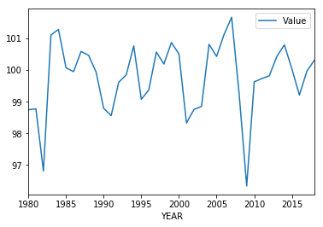

**Government Debt:**

Definition of General government debt General government debt-to-GDP ratio measures the gross debt of the general government as a percentage of GDP. It is a key indicator for the sustainability of government finance. Debt is calculated as the sum of the following liability categories (as applicable): currency and deposits; debt securities, loans; insurance, pensions and standardized guarantee schemes, and other accounts payable. Changes in government debt over time primarily reflect the impact of past government deficits.

Based on the data gathered from government debt we can conclude that it is increasing tremendously and continuously over the most recent years. Do to military spending, contribution among other countries and borrowing. As well as student loans and debt increasing.

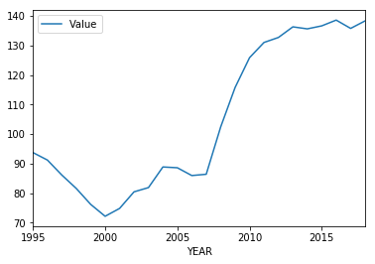

**GDP:**

Definition of Gross domestic product (GDP) is the standard measure of the value added created through the production of goods and services in a country during a certain period. As such, it also measures the income earned from that production, or the total amount spent on final goods and services (less imports). While GDP is the single most important indicator to capture economic activity, it falls short of providing a suitable measure of people's material well-being for which alternative indicators may be more appropriate. This indicator is based on nominal GDP (also called GDP at current prices or GDP in value) and is available in different measures: US dollars and US dollars per capita (current PPPs). All OECD countries compile their data according to the 2008 System of National Accounts (SNA). This indicator is less suited for comparisons over time, as developments are not only caused by real growth, but also by changes in prices and PPPs.

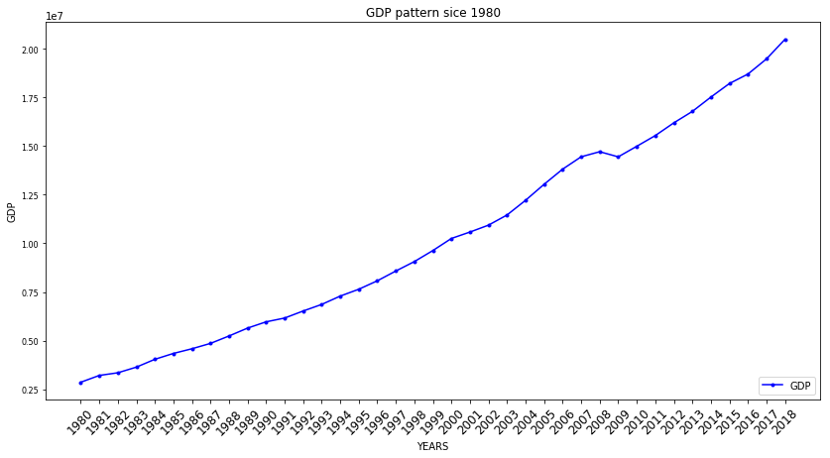

**National Income:**  
National income can be defined as: value added reflects the value generated by producing goods and services, and is measured as the value of output minus the value of intermediate consumption. Value added also represents the income available for the contributions of labour and capital to the production process. Value added by activity shows the value added created by the various industries (such as agriculture, industry, utilities, and other service activities). The indicator presents value added for an activity, as a percentage of total value added. All OECD countries compile their data according to the 2008 System of National Accounts (SNA).

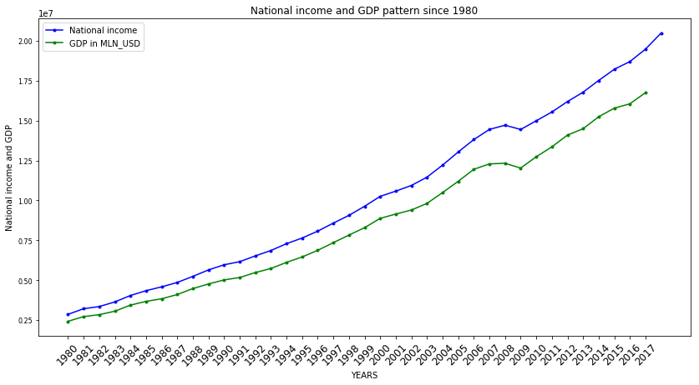

**Employment & Unemployment:**

From the years 2012 to 2018 unemployment rates keep on decreasing with no indicator showing otherwise.

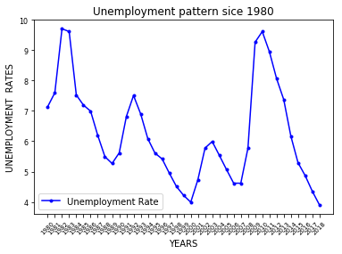

Employment since the 1980s rising steadily.

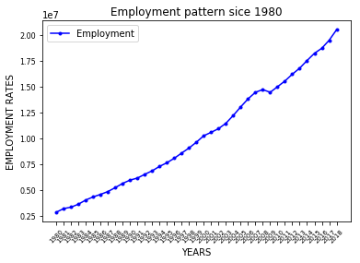

Conclusion)

Based on all data sets there is no sign of a recession occurring at the moment. To the contrary, all information shows that the economy on current years has risen, with very high employment rates, and very little unemployment among USA.