[2751. Robot Collisions](https://leetcode.com/problems/robot-collisions/)

Attempted

Hard

Topics

Companies

Hint

There are n **1-indexed** robots, each having a position on a line, health, and movement direction.

You are given **0-indexed** integer arrays positions, healths, and a string directions (directions[i] is either **'L'** for **left** or **'R'** for **right**). All integers in positions are **unique**.

All robots start moving on the line**simultaneously** at the **same speed**in their given directions. If two robots ever share the same position while moving, they will **collide**.

If two robots collide, the robot with **lower health** is **removed** from the line, and the health of the other robot **decreases** **by one**. The surviving robot continues in the **same** direction it was going. If both robots have the **same** health, they are bothremoved from the line.

Your task is to determine the **health** of the robots that survive the collisions, in the same **order**that the robots were given,i.e. final heath of robot 1 (if survived), final health of robot 2 (if survived), and so on. If there are no survivors, return an empty array.

Return an array containing the health of the remaining robots (in the order they were given in the input), after no further collisions can occur.

**Note:** The positions may be unsorted.

**Example 1:**

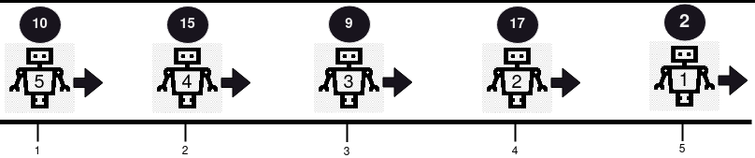

**Input:** positions = [5,4,3,2,1], healths = [2,17,9,15,10], directions = "RRRRR"

**Output:** [2,17,9,15,10]

**Explanation:** No collision occurs in this example, since all robots are moving in the same direction. So, the health of the robots in order from the first robot is returned, [2, 17, 9, 15, 10].

**Example 2:**

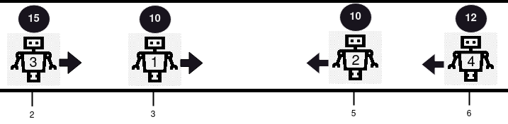

**Input:** positions = [3,5,2,6], healths = [10,10,15,12], directions = "RLRL"

**Output:** [14]

**Explanation:** There are 2 collisions in this example. Firstly, robot 1 and robot 2 will collide, and since both have the same health, they will be removed from the line. Next, robot 3 and robot 4 will collide and since robot 4's health is smaller, it gets removed, and robot 3's health becomes 15 - 1 = 14. Only robot 3 remains, so we return [14].

**Example 3:**

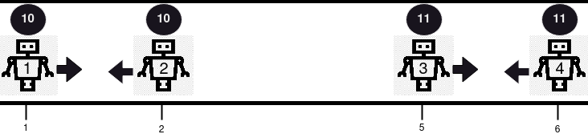

**Input:** positions = [1,2,5,6], healths = [10,10,11,11], directions = "RLRL"

**Output:** []

**Explanation:** Robot 1 and robot 2 will collide and since both have the same health, they are both removed. Robot 3 and 4 will collide and since both have the same health, they are both removed. So, we return an empty array, [].

**Constraints:**

* 1 <= positions.length == healths.length == directions.length == n <= 105
* 1 <= positions[i], healths[i] <= 109
* directions[i] == 'L' or directions[i] == 'R'
* All values in positions are distinct