# Understanding metadata with an online shopping experience

**BaseCamp material collaboration:** [**https://3.basecamp.com/4931550/projects/31844882**](https://3.basecamp.com/4931550/projects/31844882)

**Initial Annotation for consultancy:** [**https://hackmd.io/SAGJ_joRSU6GOOznlE-jeg**](https://hackmd.io/SAGJ_joRSU6GOOznlE-jeg)

## 

## Contributors

Flora D`Anna

Paula Oset Garcia

Bruna Piereck

**Understanding metadata with an online shopping experience 1**

Contributors 1

Description and objectives 1

Previous knowledge 2

Learning outcomes 2

Material for instructors 3

Part A: Step-by-step exercise 3

Part B: Post exercise discussions by group 6

Material for students (TO DO) 7

## Description and objectives

The goal of this activity is to introduce the concept of (machine-actionable) metadata, its use and importance in a more generalized and relatable way to people from any field. To do so, we will use the analogy of online shopping. We will ask participants to look for a piece of furniture in a specialized shop (e.g. IKEA), and to look for a similar piece in a generic online shop (e.g. Amazon, Bol). During their search, participants will get a set of guiding questions to pay attention to specific issues that we want to teach about metadata: difference between generic or domain metadata and how they impact findability, the importance of rich, high-quality metadata, which metadata elements are essential to find a specific item and how this relates to their own data.

For this activity, we aim to prepare an exercise involving one to three examples to help students to experience, discuss and, compare:

1 - One good example against one insufficient (IKEA vs Amazon)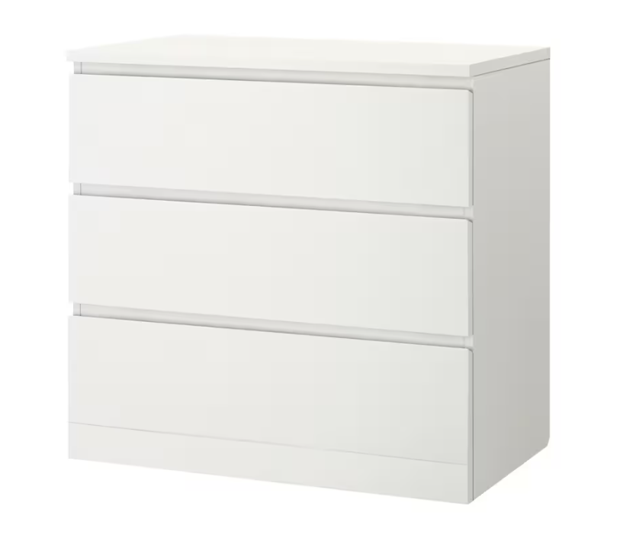

Chest of drawers [IKEA (MALM drawer)](https://www.ikea.com/be/nl/p/malm-ladekast-3-lades-wit-20403562/) and [Amazon (ADGO Malwa M3)](https://www.amazon.com.be/-/en/Drawers-Clothes-Wardrobe-Furniture-Freestanding/dp/B09DSVN5L6/ref=pd_day0fbt_img_sccl_2/259-0196772-1266108?pd_rd_w=bawch&content-id=amzn1.sym.56904fe6-0c03-4b4b-9b17-3b2cf54d9286&pf_rd_p=56904fe6-0c03-4b4b-9b17-3b2cf54d9286&pf_rd_r=YEWHGQX0ZTCK8JNQVRTF&pd_rd_wg=Wb8u2&pd_rd_r=ac4ba5ed-a563-4418-8c7d-73df267b6f73&pd_rd_i=B09DSVN5L6&th=1)

**White** chest of drawer, with **3 drawers**, **depth** between 40-50 cm, **width** between 70-80 cm**, height** between 75-80 cm.

* Printscreen of the pages in the button of the document. It might be needed due the possibly fast changes in amazon website and to more easy finding in case of a broken link.

2 - One good example vs one inconsistent/poor quality metadata (IKEA vs BOL)

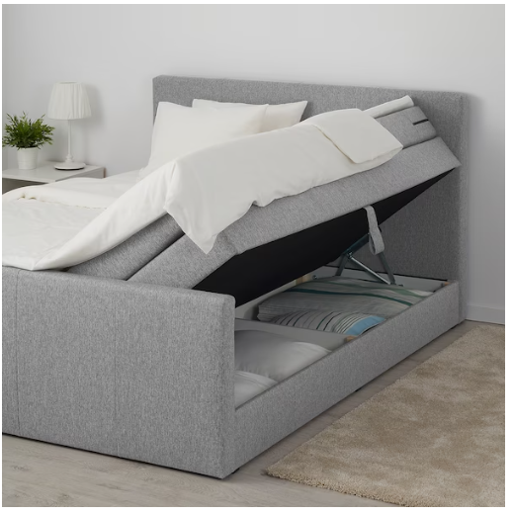

Chest of drawers [IKEA (Mogreina Boxspring)](https://www.ikea.com/be/nl/p/mogreina-boxspring-met-opberger-met-hoofdeinde-grijs-20486010/) and [BOL (Boxspring Shurgard)](https://www.bol.com/be/nl/p/dreamhouse-shurgard-boxspring-met-opbergruimte-bed-180-x-200-cm-antraciet/9300000010275335/?bltgh=gpv0--GGUxsr1V0QgZxHyg.2_41.46.ProductTitle)

**Boxspring (grey/black)** with storage and raised headboard, **width** between 180-190cm**, length** between 200-210cm.

* Printscreen of the pages in the button of the document. It might be needed due the possibly fast changes in amazon website and to more easy finding in case of a broken link.

## Previous knowledge

* Basic knowledge about and acquaintance with data repositories

## Learning outcomes

* Can define metadata and basic related concepts (e.g. structured data, machine readability).
* Can relate metadata to findability (FAIR).
* Can appraise the usefulness of metadata standards to describe a resource.
* Can indicate the main differences between generic and domain specific metadata standards.
* Can deposit metadata in a repository. -> if the session is finalized with an exercise with e.g. Zenodo Sandbox, remove if it has been done in previous session

## Material for instructors

### 

### Part A: Step-by-step exercise

You have moved to a new house. The place is great but you still need some new furniture. In particular, you are looking for a piece to store some clothes for a corner of your attic bedroom . Taking into account the space you have, the ideal **size** would be:

* Width: < 80 cm
* Height: <80 cm
* Depth: < 50 cm

You want to use it to store smaller items, so you are looking for a chest of **three drawers**, and you would like it in **white**. You do not want to spend much more than **100 euro**.

|  | Instructions | Guiding questions | Instructor’s guidance |
| --- | --- | --- | --- |
| 1 | Navigate to <https://www.ikea.com/be/en/> and type “chest of drawers” in the search bar. |  | You should end up with a page with results |
| 2 | Use the filters to try to find a chest of drawers that meet your criteria: size, color, number of drawers and price. | 1. How many features can you use to filter the products? 2. How are these features helping? 3. Are there any filters that you miss and you think would be useful? | 1. Width, Length, Depth, Number of drawers, color, price, material and category. 2. The more accurate features, the easier to narrow search and find what you need. 3. Slide bars for size would help: it would make it easier to look for the exact dimensions. |
| 3 | Have a look at the final options that pass the filters. | 1. Which piece of furniture is closer to your needs? 2. Was it easy to decide? | 1. Three possible options, but the MALM chest of drawers is closer to our budget. The NORDLI options are not only more expensive, but they are also shorter and less deep, so you could make better use of the space.     <https://www.ikea.com/be/en/p/malm-chest-of-3-drawers-white-20403562/>  Article number: 204.035.62   1. Yes, thanks to the appropriate filtering options, the final selection was limited and was easy to decide at glance based on budget and size. |
| 4 | Click on your preferred option. | 1. What is the actual size of this chest of drawers? 2. Where can you find this information? | 1. Width: 80 cm, Depth: 48 cm, Height: 78 cm, Width of drawer (inside): 72 cm, Depth of drawer (inside): 43 cm 2. IKEA's website has a designated section in all product pages for measurements. |
| 5 | The IKEA option has the perfect size to maximize the space you have, but it is a little bit above your desired budget, so you are going to try to look for something similar on Amazon.  Navigate to <https://www.amazon.com.be/> and type “Chest of drawers” in the search bar. |  |  |
| 6 | Use the filters on the left side to try to find a chest of drawers that meet your criteria: size, color, number of drawers and price. | 1. How many features can you use to filter the products? 2. How are these features helping? 3. Are there any filters that you miss and you think would be useful? | 1. Customer reviews, brands, price, material, color, number of drawers, finish type, room type, seller, availability. 2. Color, number of drawers and price are important to the use case. Others could be helpful as well but not as critical. 3. Size/dimensions are not available to filter upon. Size is probably one of the most important features that anyone would look for when deciding on furniture. |
| 7 | Have a look at the final options that pass the filters. | 1. Can you find something similar? Which piece of furniture is closer to your needs? 2. Was it easy to decide? Which criteria did you use to decide? 3. How could you know the size of the product? How can you know which dimensions (length, width, depth) do they refer to? 4. Would it be easier if the size information was provided in a standardized and machine-actionable way (i.e. to be able to filter based on size)? | 1. Out of the different options, they might get something that looks aesthetically similar to the MALM chest of drawers.      1. Picture of the product probably played a more important role. 2. The furniture dimensions are sometimes mentioned in the items or products name, sometimes not. Besides, the order of the dimensions is not always specified (HxWxD, WxHxD?) and does not always follow the same order. 3. Yes |

Part A wrap-up:

Instructor discusses results out loud with the classroom.

### Part B: Post exercise discussions by group

1. What features do you think you need to register for your kind of data? Write down as many features as you can, that you believe are useful for filtering and annotating your data. (3-5 min)

**Possible answer**: Answers will be individual and distinct for each field.

1. What should be the minimum number of features or elements that you should annotate?

**Possible answer**: There is no right or wrong answer, different fields must discuss what is the minimum, what is desired and what would be ideal.

1. How would you relate this activity to metadata in data repositories? Discuss this with your group.
2. Is there any repository you are familiar with? Which metadata standard is used by the repository? What are the minimum or mandatory elements that this standard requires? Take 5 minutes to explore the repository, take some notes if necessary, and discuss it with your group.

Part B wrap up:

Instructor discusses results out loud with the classroom.

## Material for students (TO DO)

(TO DO)

Idea to have the same template as for instructors, but without the last column (“instructor’s guidance”)

**Metadata Activity:**

**Guiding questions:**

Use these questions to guide your reflections during your search, in a way to compare both examples and how the metadata they have are influencing your search.

1. How many features can you use?

**Possible answer:** It will vary according to website and examples.

1. Are there any filters that you miss and you think would be useful? In which website?

**Possible answer:**

1. How are these features helping?

**Possible answer:** The more accurate features, the easier to narrow search and find what you need.

1. Is there any case of inconsistency? If there is, what is the consequence?

**Possible answer:** Inconsistent features, might led to an impression of narrowing the search, when bringing unrelated or non specific results, causing confusion and difficulty in the search for a specific target.

1. Do you think there is a minimum number of feature for describing?

**Possible answer:**

1. Do you believe that adding a description is enough?

**Possible answer:**

1. Do you know what MACHINE-ACTIONABLE metadata is?

**Possible answer:**

**Post exercise discussions:**

1. What features do you think you need to register for your kind of data? Write down as many features as you can, that you believe are useful for filtering and annotating your data. (3-5 min)

**Possible answer:** Answers will be individual and distinct for each field.

1. What should be the minimum number of features that you should annotate?

**Possible answer:** There is no right or wrong answer, different fields must discuss what is the minimum, what is desired and what would be ideal.

How many features can you use?

**Possible answer:** It will vary according to website and examples.

Are there any filters that you miss and you think would be useful? In which website?

**Possible answer:**

How are these features helping?

**Possible answer:** The more accurate features, the easier to narrow search and find what you need.

Is there any case of inconsistency? If there is, what is the consequence?

**Possible answer:** Inconsistent features, might led to an impression of narrowing the search, when bringing unrelated or non specific results, causing confusion and difficulty in the search for a specific target.

Do you think there is a minimum number of feature for describing?

**Possible answer:**

Do you believe that adding a description is enough?

**Possible answer:**

Do you know what MACHINE-ACTIONABLE metadata is?

**Possible answer:**

**Complementary images for reference:**

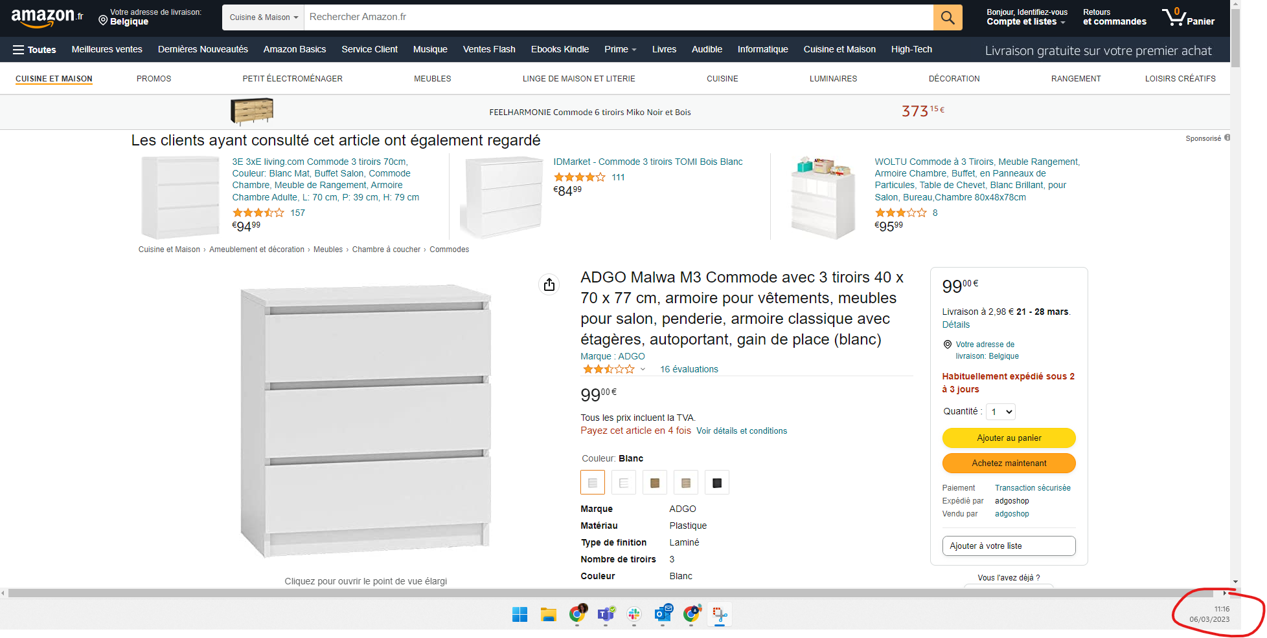

**Image 1 of reference for 1st example with 3 drawer’s cast. Look into the date of the image. The referred link could possibly be replaced in the future, so use it as reference or inspiration for exercise if needed. Image form 06/March/2023.**

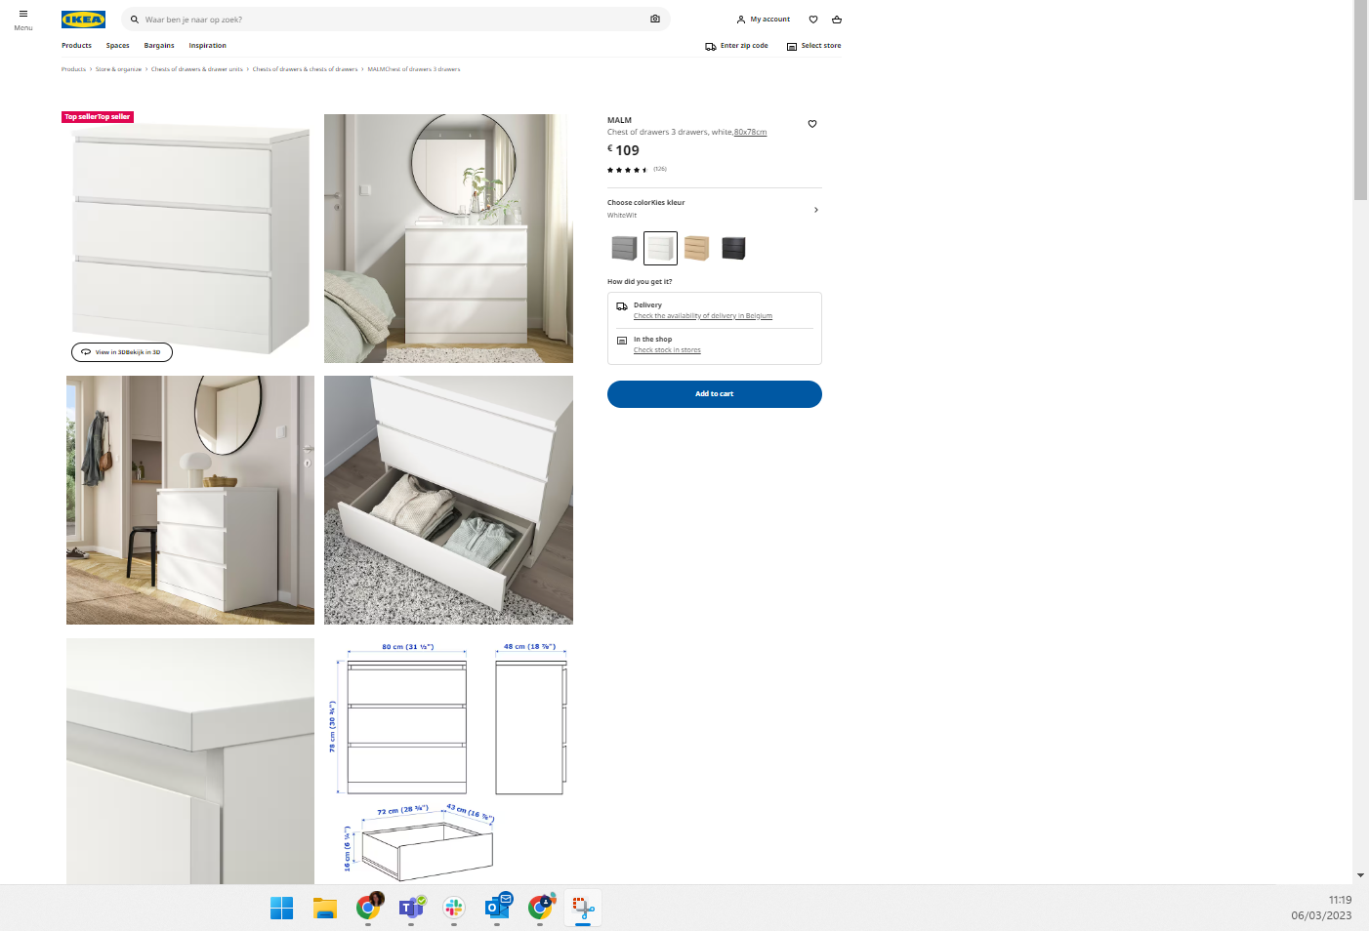

**Image 2 of reference for 1st example with 3 drawer’s cast. Look into the date of the image. The referred link could possibly be replaced in the future, so use it as reference or inspiration for exercise if needed. Image form 06/March/2023.**

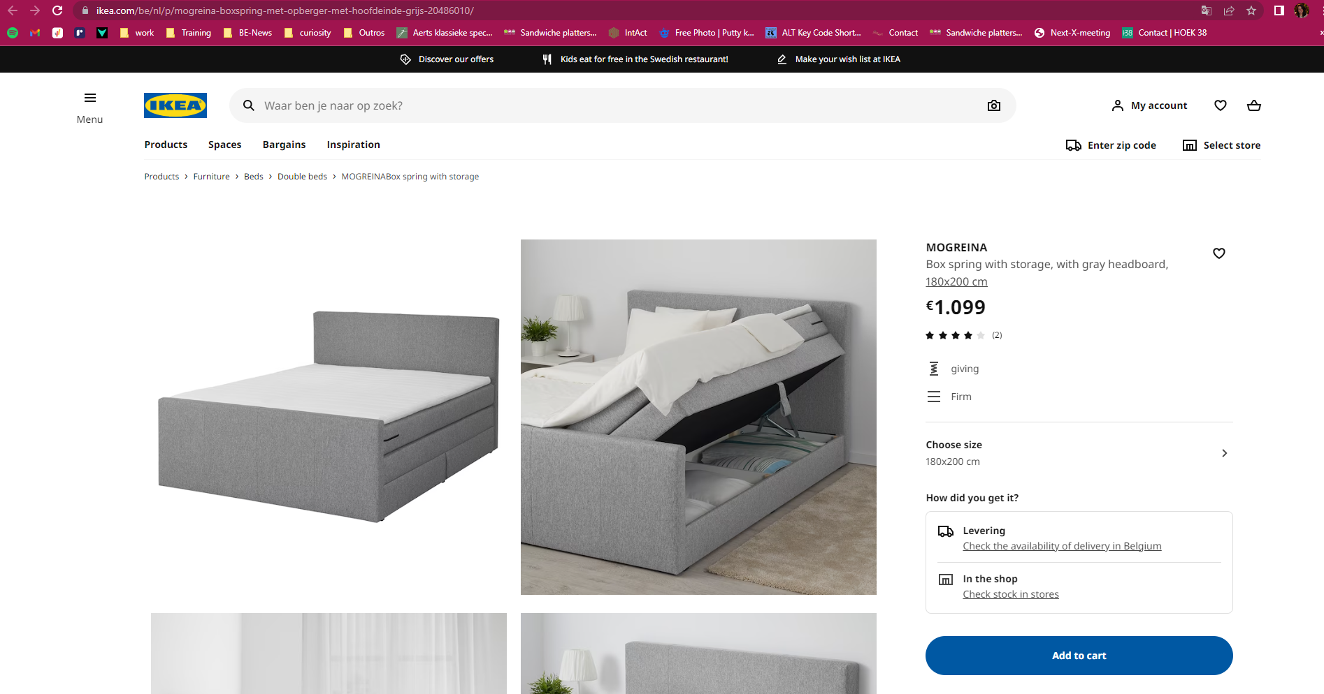

**Image 3 of reference for 2nd example with spring bed with storage. Look into the date of the image. The referred link could possibly be replaced in the future, so use it as reference or inspiration for exercise if needed. Image from 04/April/2023.**

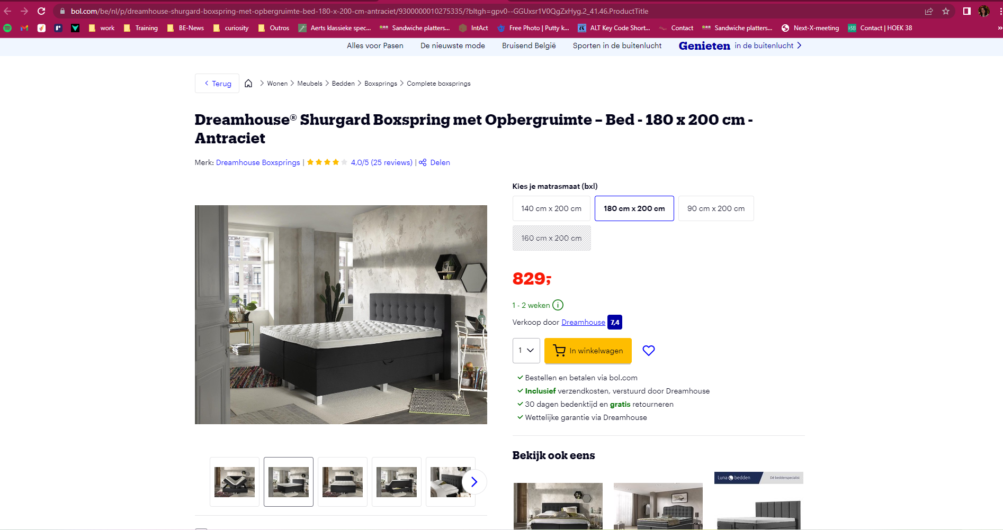

**Image 4 of reference for 2nd example with spring bed with storage. Look into the date of the image. The referred link could possibly be replaced in the future, so use it as reference or inspiration for exercise if needed. Image from 04/April/2023.**