# Abstract

The area of an individual’s daily activity space may be limited by the difficulty of traveling long distances or by the density of destinations, which limits the need for traveling far from home. In this study, we analyze data from a travel diary survey for 327 individuals in Granada, Spain for both a weekday and a weekend to determine the relationship between activity space areas and destination accessibility by car and non-car modes. We find that lower accessibility is associated with smaller activity spaces on weekdays, while weekend activity space areas are better predicted by the availability of household resources.

# Questions (200 words)

Activity spaces represent the area within which someone completes routine activities (Cagney et al. 2020). The size of one’s activity space might relate to well-being, but its interpretation as positive or negative depends on its causes. A constraints-based narrative might suggest that activity spaces are constrained by the difficulty of travel and that larger activity spaces are therefore better. In contrast, a freedom-based narrative would suggest that better access to destinations allows people to participate in desired activities without extensive travel, and that smaller activity spaces are therefore better.

This study evaluates the relationship between the destination accessibility of individuals’ home and the areas of their activity spaces. If small activity spaces and/or household resource constraints are associated with lower accessibility, this would be consistent with a constraint-based narrative. If smaller activity spaces are associated with higher accessibility, this would be consistent with a freedom-based narrative.

# Methods

This study draws on data that was collected ….. (describe survey methodology).

For purposes of this study, an individual’s activity space was defined as (describe method for calculating activity space).

One individual’s weekday activity space and three individuals weekend activity spaces were more than eight standard deviations from the mean. These were removed from the sample.

To calculate destination accessibility, we drew on parcel-level land-use data for the province of Granada (describe dataset). We classified parcel land uses into six categories categories: leisure (retail, restaurants, and indoor culture and recreation), other services (including ….), outdoor recreation (including ….), residential, agricultural, and industrial.

The size of the land use at each location was defined as the as the total land area for outdoor recreation and agricultural land uses, the population for residential uses (estimated as shown in Equation 1), and as the gross floor area for all other uses.

(1)

where *Pparcel* = The estimated population of the parcel,

*Ptract* = The population of the census tract, from ,

*GFAparcel* = The total gross floor area of all residential buildings on the parcel, and

*GFAtract* = The total gross floor area of all residential buildings in the tract.

We used the r5r package (Pereira et al. 2021) to calculate twelve different accessibility metrics for the home location of each survey respondent: Accessibility by car and without a car (by walking and transit) for each of the six destination types. Accessibility was calculated as the sum of the sizes of all parcels in the province of Granada. weighted by travel time from each respondent’s home using a logistic decay function, as shown in Equation 2.

$A=\sum_{d}{\frac{S_{d}}{1+e^{\left({tt}_{d}-30\right)/5}}}$ (2)

where *A* = the accessibility to a particular destination type,

*Sd* = the size of destination *d*, and

*ttd* = the travel time from the respondent’s home to destination *d*.

All accessibility metrics were centered and scaled to have a mean of zero and a standard deviation of one. The correlations among the measures for access by car to land uses other than industrial and agricultural were greater than 0.94, as were the correlations among car-free access to those destination types. These highly correlated measures were averaged to produce combined measures of general access with and without a car. Figure 1 shows the spatial distribution of the homes of survey respondents and their associated accessibility measures.

|  |  |  |
| --- | --- | --- |
|  | Access by Car | Access without a car |
| All land uses except industrial and agriculture |  |  |
| Agricultural land uses |  |  |
| Industrial land uses |  | Ten points located outside the map area are not shown. |

Figure 1. Spatial distribution of survey respondents' residents and associate accessibility measures (Base map © Stadia Maps © Stamen Design © OpenMapTiles © OpenStreetMap contributors)

We estimated a regression model predicting the log-transformed area of the activity space for a weekday and a weekend day. Table 1 lists the variables included in the two models with descriptive statistics and the number of observations that were removed from the sample due to outliers or missingness. The final sample included 327 individuals.

Table 1. Variables included in regression analyses.

|  |  |  |  |  |
| --- | --- | --- | --- | --- |
| **Variable name** | **Description** | **Mean or proportion** | **Standard deviation** | **Effect on sample (number of observations removed due to missingness or outliers)** |
| Outcome variables |  |  |  |  |
| Weekday activity space | Area (km2) of convex hull around home and destination buffers (log transformed in models) | 8.4 | 26.6 | 1 |
| Weekend activity space | 17.3 | 51.1 | 3 |
| Predictor variables |  |  |  |  |
| No vehicles | In zero-vehicle household | 28% | - | 12 |
| General access by car | Standard deviations from the mean for access by car from home | 0.00 | 0.99 |  |
| Industrial access by car | 0.00 | 1.00 |  |
| Agricultural access by car | 0.00 | 1.00 |  |
| General car-free access | Standard deviations from mean for transit/walk access from home | 0.00 | 0.99 |  |
| Industrial car-free access | 0.00 | 1.00 |  |
| Agricultural car-free access | 0.00 | 1.00 |  |
| *Work status* |  |  |  | 2 |
| Not in labor force | Not in a category below | 27% | - |  |
| Student | Attends school | 13% | - |  |
| Unemployed | Seeking work | 11% | - |  |
| Part-time | Employed part time | 11% | - |  |
| Full-time | Full time or self-employed | 37% | - |  |
| Age | Age in years | 48.4 | 19.0 |  |
| Female | Identifies as female | 53% | - |  |
| Lives with children | Lives with children | 31% | - |  |
| Lives with spouse/partner | Lives with spouse/partner | 46% | - |  |
| Lives with parent(s) | Lives with own parent(s) | 13% | - |  |
| *Household Income (Euros per month)* | |  |  | 35 |
| Low income | Less than 1,100 | 24% | - |  |
| Low middle | Between 1,100 and 1,800 | 26% | - |  |
| Middle income | Between 1,801 and 2,700 | 28% | - |  |
| High middle income | Between 2,701 and 3,900 | 14% | - |  |
| High income | Greater than 3,900 | 8% | - |  |

# Findings (~300 words)

Table 2 shows the results of the regression models predicting weekday and weekend activity spaces. The weekday model predicts about 24 percent of the variation in activity space areas, and the weekend model predicts about 17 percent.

Table 2. Results of regression models

|  |  |  |  |  |  |  |  |  |
| --- | --- | --- | --- | --- | --- | --- | --- | --- |
|  | **Weekday activity-space area (log-transformed)** | | | | | **Weekend activity space area (log-transformed)** | | |
| R2 = 0.24 | | | | | R2 = 0.17 | | |
| Estimate | | Standard Error | | p-value | Estimate | Standard Error | p-value |
| Intercept | **0.96** | | **0.20** | | **< 0.001** | **3.03** | **0.64** | **< 0.001** |
| No vehicles | -0.31 | | 0.17 | | 0.063 | **-0.53** | **0.23** | **0.023** |
| Industrial access by car | 0.19 | | 0.15 | | 0.204 | 0.08 | 0.21 | 0.714 |
| Car-free industrial access | 0.16 | | 0.08 | | 0.051 | 0.18 | 0.11 | 0.101 |
| Agricultural access by car | -0.02 | | 0.12 | | 0.847 | -0.32 | 0.17 | 0.060 |
| Car-free agricultural access | 0.07 | | 0.10 | | 0.483 | 0.06 | 0.14 | 0.662 |
| General access by car | -0.19 | | 0.10 | | 0.072 | 0.07 | 0.14 | 0.621 |
| General car-free access | **-0.29** | | **0.10** | | **0.005** | -0.14 | 0.14 | 0.303 |
| Access by car : no vehicles | -0.11 | | 0.30 | | 0.717 | 0.31 | 0.42 | 0.463 |
| Car-free access : no vehicles | 0.19 | | 0.17 | | 0.266 | 0.17 | 0.24 | 0.467 |
| *Work status (relative to not in labor force)* | | | | | | | | |
| Student | -0.53 | | 0.37 | | 0.151 | -0.90 | 0.51 | 0.082 |
| Unemployed | 0.09 | | 0.29 | | 0.759 | -0.14 | 0.40 | 0.738 |
| Part-time | -0.31 | | 0.31 | | 0.314 | 0.10 | 0.43 | 0.820 |
| Full-time | 0.04 | | 0.23 | | 0.875 | 0.24 | 0.32 | 0.467 |
| Age | **-0.02** | | **0.01** | | **0.015** | **-0.02** | **0.01** | **0.008** |
| Female | -0.17 | | 0.13 | | 0.173 | 0.24 | 0.18 | 0.161 |
| Lives with children | 0.08 | | 0.16 | | 0.597 | **-0.70** | **0.22** | **0.002** |
| Lives with spouse/partner | 0.09 | | 0.16 | | 0.579 | -0.04 | 0.22 | 0.839 |
| Lives with parent(s) | **-0.51** | | **0.23** | | **0.028** | -0.55 | 0.32 | 0.088 |
| *Household income (relative to middle income)* | | | | | | | | |
| Low income | -0.35 | 0.20 | | 0.080 | | **-0.78** | **0.28** | **0.006** |
| Low middle income | -0.19 | 0.17 | | 0.281 | | **-0.54** | **0.24** | **0.024** |
| High middle income | 0.03 | 0.21 | | 0.884 | | **-0.64** | **0.29** | **0.025** |
| High income | 0.16 | 0.25 | | 0.521 | | **-0.86** | **0.35** | **0.014** |
| Note: **Bold text** indicates 95% confidence, gray text indicates less than 90% confidence. | | | | | | | | |

On weekdays, older people and those who live with their parents tend to have smaller activity spaces. Controlling for these and other predictors, greater accessibility by transit and walking is associated with smaller activity spaces, which is consistent with the freedom-based narrative. To illustrate the effect of accessibility spaces, Figure 2 shows the predicted sizes of weekday activity spaces for hypothetical individuals with general car-free accessibility levels one standard deviation above and below the mean, with all other predictors held constant at their average or baseline (middle-income, male, with a household vehicle, not in the labor force, and not living with children, parents, or a spouse/partner) values.

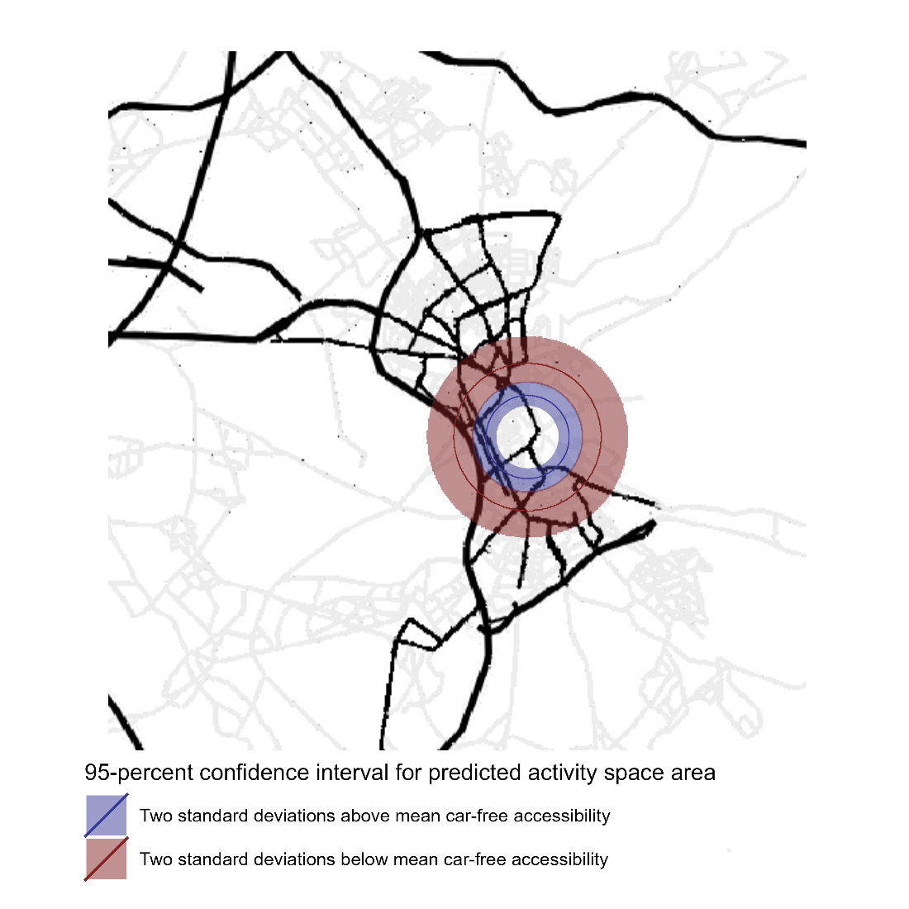

Figure 2. Illustration of the difference in activity spaces for (Base map © Stadia Maps © Stamen Design © OpenMapTiles © OpenStreetMap contributors)

Accessibility is not a significant predictor (at 95-percent confidence) of weekend activity spaces, which are better explained by household resources. This is consistent with a constraints-based narrative. Individuals in households without a vehicle have smaller weekend activity spaces, as do those living in households with children. Relative to those in the middle-income category, individuals in the low- and low-middle-income categories have smaller weekend activity spaces. Interestingly however, individuals in the high-middle- and high-income categories also have smaller activity spaces than those in the middle-income category.

In general, these findings, based on a relatively small sample of 327 individuals in Granada, Spain, support a freedom-based narrative for explaining weekday activity spaces and a constraints-based narrative for weekend activity spaces.