Appendix C
  - Roof types and height variables in the OZFS data standard
The roof_type variable in the OZFS *.bldg file can take any of the following values:
- "flat": A flat roof with the same height across the entire structure.
- "skillion": A roof without a ridge that is higher on one side than the other.
- "mansard": A roof with two slopes on each of four sides.
- "hip": A roof with one slope on each of four sides.
- "gable": A roof with one slope on each of two opposite sides.
- "gambrel": A roof with two slopes on each of two opposite sides.
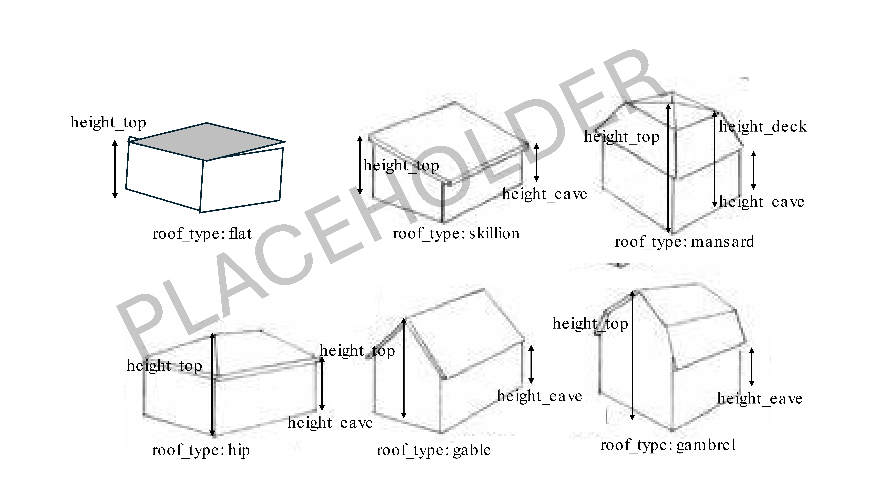

The table below indicate which roof height variables must be defined for each of the above roof types.
Roof type | height_plate | height_eave | height_deck
flat | x
skillion | x | x
mansard | x | x | x
hip | x | x
gable | x | x
gambrel | x | x

