ZoneR and zonepy
  - R and Python packages for checking zoning data for building fit
Abstract
Abstract text here

Introduction
We have developed two equivalent software packages, one in R and one in Python, to analyze OZFS data on building characteristics, zoning regulations, and parcel geometry to classify all parcels in a municipality in which a proposed building:
- Is prohibited under existing zoning regulations,
- Is allowed under existing zoning regulations,
- May be allowed under existing zoning regulations, depending on building, parcel, or zoning characteristics that are not fully represented in the input data sets.

Analysis workflow
Both the R and Python versions of the package analyze data stored according to the Open Zoning Feed Specification (OZFS) data standard, which is described at length by Voulgaris et al. (2025). The OZFS data standard includes methods for storing:
- zoning regulations for a single municipality in a *.zoning file,
- parcel geometry and orientation with respect to the street network for a set of parcels (for instance, all parcels or all vacant parcels within a municipality) in a *.parcel file, and
- relevant building characteristics for a single building in a *.bldg file.
Both packages follow the same analysis workflow, which is illustrated in Figure 1. This workflow is called through a function called zr_run_zoning_checks() in the R version of the package and zp_run_zoning_checks() in the Python version. Either of these functions takes three files paths as arguments: the locations of
- A directory containing zoning regulations for one or more municipalities, stored as *.zoning files using the OZFS data standard;
- A directory containing parcel geometry for one or more municipalities, stored as a *.parcel files using the OZFS data standard; and
- A *.bldg file defining the relevant features of a proposed building.
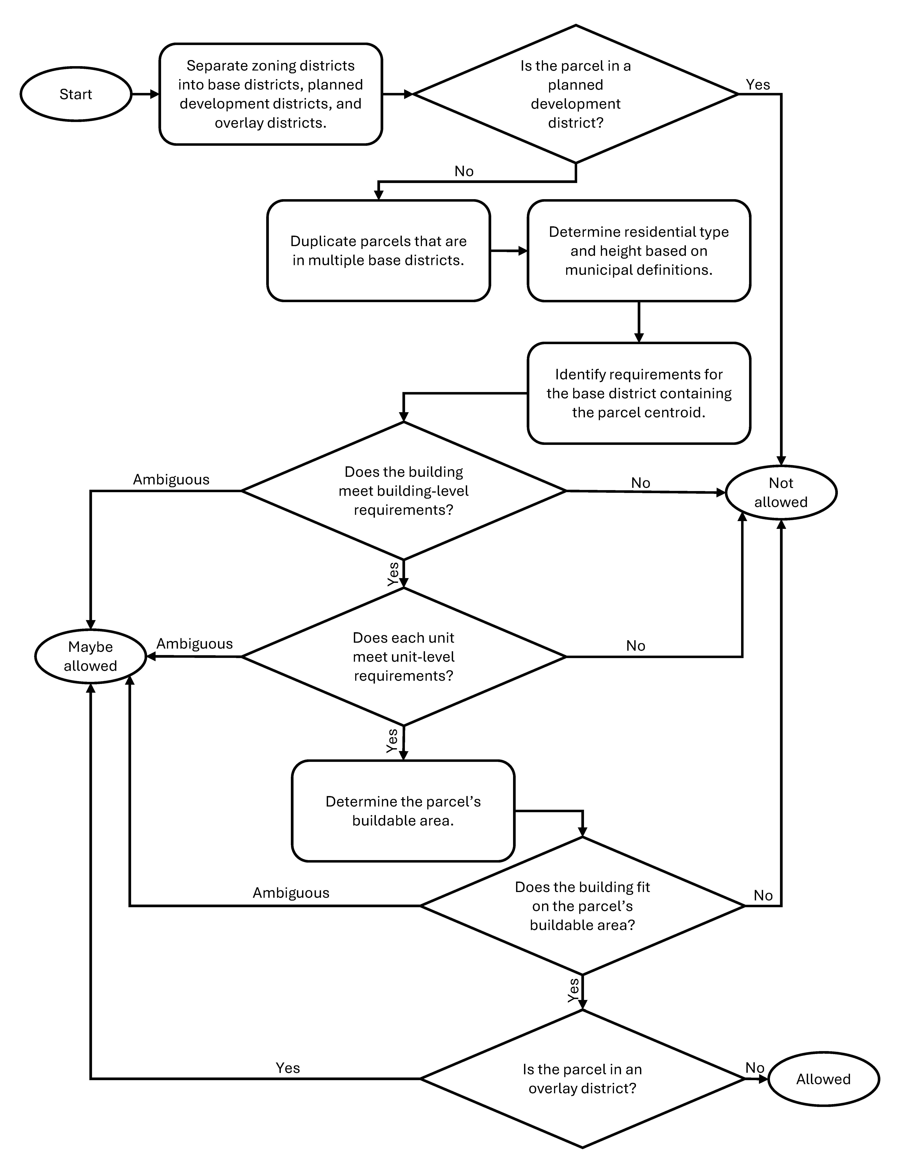
Figure 1: Analysis workflow for z*_run_zoning_checks() function

Illustrative example
To illustrate the use of these two packages, we can run an analysis to identify vacant parcels across eleven municipalities in Texas (including Dallas and ten adjacent cities) on which the respective zoning codes would allow a specific four-unit residential building.
The building in question is 40 feet tall (with a wall-plate height of 39 feet) with four levels, one of which is below-grade. There is one two-bedroom, 1178-square-foot unit on each level, each of which is accessed from inside the building. The building has a flat roof and a 32 by 60-foot rectangular footprint.
The analysis described below uses the R version of the package (zoneR).
Figure 2 shows the boundaries of the municipalities included in this analysis
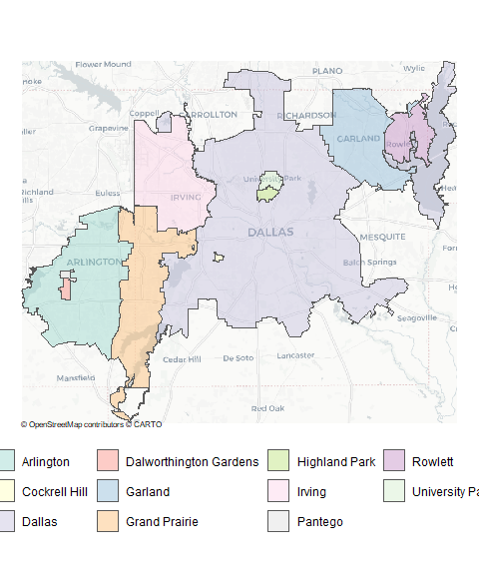
Figure 2: Boundaries of municipalites included in illustrative example
For each of these cities, vacant parcels were identified as those without buildings on them, based on building footprint data from Overture Maps OpenStreetMap contributors (2025). Figure 3 shows the distribution of vacant parcels across the study area.
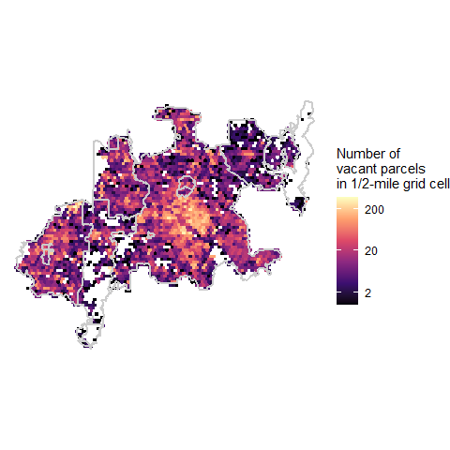
Figure 3: Distribution of vacant parcels within study area
If our project folder includes a buildings directory with the building information in a file called 4_unit_tall.bldg and parcels and zoning directories that respectively contain the *.parcel and and *.zoning files for all the cities in our study area, we can use the zr_run_zoning_checks() function to identify all the parcels in our study area where the proposed building is (or might be) allowed. Checking this set of 69,500 parcels takes about three hours on a laptop computer with 16GB installed RAM and a 2.6GHz processor.
The function returns of simple features dataset of parcel centroid points, and it can optionally write the result to a geojson file.
Table X shows the first few rows of the result.
parcel_id | muni_name | dist_abbr | allowed | reason | is_duplicate | geometry
Dallas_County_combined_parcel_611370 | Irving | S-P-2 | FALSE | res_type | FALSE | POINT (-96.99765 32.9105)
Dallas_County_combined_parcel_137653 | Dallas | R-7.5(A) | FALSE | res_type, height | FALSE | POINT (-96.81503 32.69729)
Dallas_County_combined_parcel_286363 | Dallas | PD | FALSE | PD_dist | FALSE | POINT (-96.83554 32.85727)
Dallas_County_combined_parcel_563565 | Dallas | PD | FALSE | PD_dist | FALSE | POINT (-96.71805 32.73292)
Dallas_County_combined_parcel_366551 | Grand Prairie | HI | FALSE | res_type | FALSE | POINT (-96.94152 32.77184)
Dallas_County_combined_parcel_575937 | Dallas | LI | FALSE | res_type | FALSE | POINT (-96.67324 32.78808)
Dallas_County_combined_parcel_357365 | Dallas | CR | FALSE | res_type | FALSE | POINT (-96.7616 32.79297)
Dallas_County_combined_parcel_589943 | Dallas | CR | FALSE | res_type | FALSE | POINT (-96.80486 32.71979)
Dallas_County_combined_parcel_146232 | Dallas | R-7.5(A) | FALSE | res_type, height | FALSE | POINT (-96.81814 32.66565)
Tarrant_County_combined_parcel_211009 | Arlington | PD | FALSE | PD_dist | FALSE | POINT (-97.09637 32.79008)
Once the analysis has completed, we can use zr_summary_by_muni() to see the number of parcels in each municipality where our building would be allowed, the number of parcels where it would not be allowed, and the number where it might be allowed, depending on the resolution of one or more ambiguous requirement.
muni_name | num_allowed | num_maybe | num_prohib
Dallas | 3 | 748 | 42127
Arlington | 51 | 48 | 10931
Irving | 0 | 0 | 7015
Grand Prairie | 17 | 23 | 3957
Garland | 211 | 21 | 1610
Rowlett | 0 | 0 | 460
University Park | 0 | 0 | 392
Pantego | 0 | 0 | 180
Dalworthington Gardens | 9 | 0 | 175
Highland Park | 0 | 5 | 150
Cockrell Hill | 0 | 0 | 100
Total | 291 | 845 | 67097
Of the 68,233 vacant parcels in our study area, our proposed building would be allowed on 291, and there are an additional 845 parcels (mostly in Dallas) where the building might be allowed, depending on how we resolve ambiguity in our input datasets.
We can map the locations of the parcels where the building is (or might be allowed).
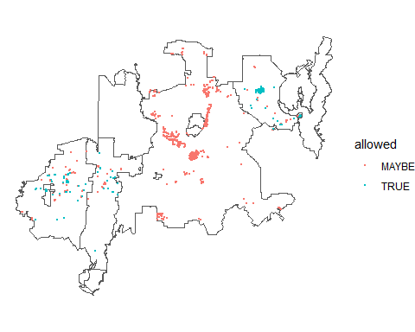
The zr_summary_maybe() function returns the frequency with which each reason is given for
Reason for ambiguity | Number of parcels
Ambiguous requirement for building height | 417
Building is in an overlay district | 368
Sides are not labeled in the parcel file | 301
Ambiguous requirement for setbacks | 101

Conclusion
This data standard represents an important step towards the development of scaleable, automated methods that can facilitate strategic increases in the supply of housing in the United States through their direct use by developers and policy-makers. They also offer researchers new opportunities to uncover the ways in which zoning regulations vary across the United States.

References
OpenStreetMap contributors. 2025. “OpenStreetMap Data.” https://www.openstreetmap.org.
Overture Maps Foundation. 2025. “Overture Maps Buildings (Building Footprint) Dataset, Release 2025‑07‑23.0.” https://overturemaps.org.
Voulgaris, Carole Turley, Kamryn Mansfield, Houpu Li, Paul Salama, and Elizabeth Christoforetti. 2025. “Open Zoning Feed Specification (OZFS): Data Standards for Describing Zoning Regulations, Parcel Geometry, and Building Characteristics.” https://vibe‐lab‐gsd.github.io/ozfs‐standard/.

