March 18, 2018

Vibhavi Peiris

Student #: 1000597687

CSC412

Assignment 2

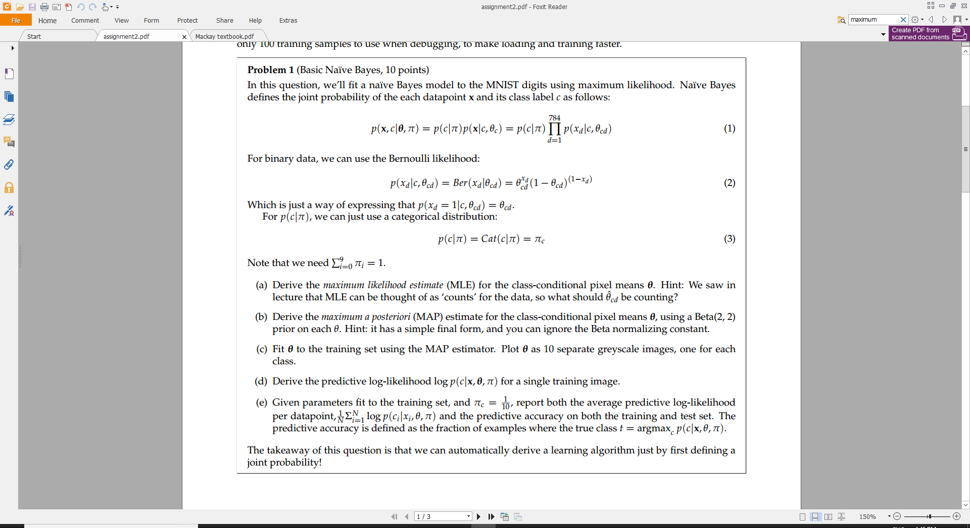

1. Problem 1: Basic Naïve Bayes
   1. *Derive MLE*



* 1. *Derive MAP*



* 1. *Code for q1c & image output*

#Q1C code

def find_theta_MAP(train_images, train_labels):

theta_map = np.zeros((10,784))

#find theta for each digit

for i in range(0,theta_map.shape[0]):

img_digit_locs = train_labels[:,i] #get all images locations that have a digit i

current_data = np.transpose(train_images)

Nd = np.dot(current_data,img_digit_locs) #multiply data with current digit locs to get data only for current digit (true digit)

N = np.sum(img_digit_locs) #get total points for current digit

current_theta = np.divide((Nd+1),(N+2))

theta_map[i,:] = current_theta #save the theta for this digit

return theta_map

#run Q1C code and save image

theta_map = find_theta_MAP(train_images, train_labels)

save_images(theta_map,'Q1C')

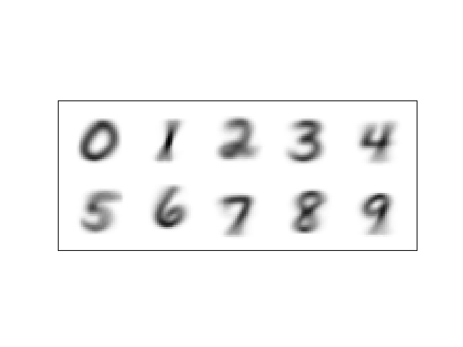

* 1. *Derive predicted log-likelihood*





* 1. *Get average and accuracy*

Average train log likelihood -172.353823347

Average test log likelihood -173.043603091

Train Accuracy 0.8398

Test Accuracy 0.8372

Code for q1e on next page

#Q1e code

def find_log_likelihood(images, theta_map, pi_c):

#find using formula generated in q1d

likelihoods = np.zeros((images.shape[0],10))

#find the likelihood for each digit/datapoint

for digit in range(0,10): #loop through each digit

for i in range(0,images.shape[0]):

current_data = images[i,:] #get current data point

current_theta = theta_map[digit] #get theta for current digit

likelihoods[i,digit] = np.dot(current_data,np.log(current_theta))+np.dot((1-current_data),np.log(1-current_theta)) #q1d

return likelihoods + np.log(pi_c)

def avg_likelihood(images,label, log_likelihood):

sum_likelihood = 0

#go through each datapoint find all likelihoods for current_label

for i in range(0,images.shape[0]):

sum_likelihood = sum_likelihood + np.sum(log_likelihood[i,:]*label[i,:]) # sum of likelihoods for each image wrt. its label

avg_likelihood = sum_likelihood/images.shape[0] #divide by number of images to get average

return avg_likelihood

def predict(images, theta_map, log_likelihood):

predictions = np.zeros((images.shape[0],log_likelihood.shape[1])) #N by 10

#find best class true class for each image

for i in range(0,images.shape[0]):

current_likelihood = log_likelihood[i,:] #get likelihoods for current datapoint

best_class = np.argmax(current_likelihood) #choose the class with highest likelihood

predictions[i,best_class] = 1 #set index = digit to 1 as it is the best prediction for current image

return predictions

def Q1E_report(train_images,train_labels,test_images,test_labels,theta_map):

#average for train

log_likelihood_train = find_log_likelihood(train_images, theta_map, 1/10)

avg_likelihood_train = avg_likelihood(train_images,train_labels,log_likelihood_train)

print("Avg train log likelihood ",avg_likelihood_train)

#average for test

log_likelihood_test = find_log_likelihood(test_images, theta_map, 1/10)

avg_likelihood_test = avg_likelihood(test_images,test_labels,log_likelihood_test)

print("Avg test log likelihood ",avg_likelihood_test)

#predictions for train

predict_train = predict(train_images, theta_map, log_likelihood_train)

total_correct_train = np.sum(np.nonzero(predict_train)[1] == np.nonzero(train_labels)[1]) #get total number of correct predictions

accuracy_train = total_correct_train/float(train_labels.shape[0]) #get accuracy

print('Train Accuracy ',accuracy_train)

#predictions for test

predict_test = predict(test_images, theta_map, log_likelihood_test)

total_correct_test = np.sum(np.nonzero(predict_test)[1] == np.nonzero(test_labels)[1]) #get total number of correct predictions

accuracy_test = total_correct_test/float(test_labels.shape[0]) #get accuracy

print('Test Accuracy ',accuracy_test)

#run Q1e code

Q1E_report(train_images,train_labels,test_images,test_labels,theta_map)

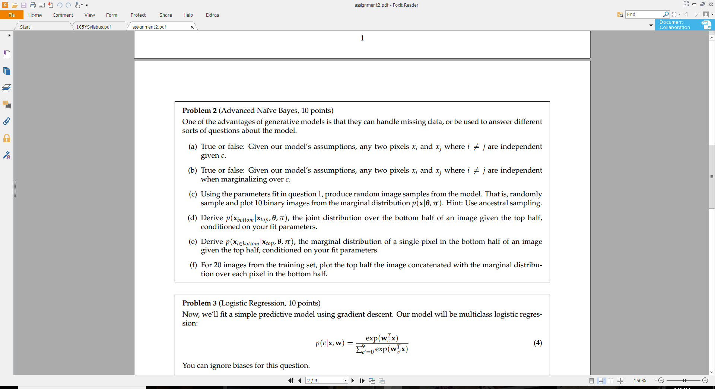

1. Problem 2: Advanced Naïve Bayes
   1. *Independent given c?*

**True**, since we are using Naive Bayes, which treats each data point as independent

* 1. *Independent when marginalizing over c?*

**False**, because when we marginalize over c, that means we are summing out c. Which results in the x’s being dependent on each other.

* 1. *Code and images*

#Q2c code

def create_samples(num_of_samples,theta_map):

sample_data = np.random.rand(num_of_samples,784)

rand_cs = np.random.randint(num_of_samples, size=(1, 10))[0] #generate random numbers(digit class)

for i in range(0,num_of_samples):

#using p(x_d | c, Î¸_cd ) i.e. ancestral sampling

c = rand_cs[i] #get the rand c

current_theta = theta_map[c,:] # get the thetha for the specific digit

xd = sample_data[i,:] #get current rand sample

#pick current random data point based on c value. Also binarize

xd[xd < current_theta] = 0

xd[xd >= current_theta] = 1

#save the updated xd

sample_data[i,:] = xd

return sample_data

#run Q2C code

sample_data = create_samples(10,theta_map)

save_images(sample_data,'Q2C')

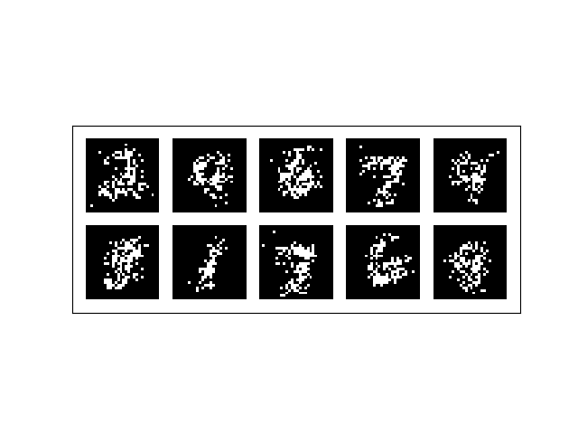

* 1. *Derive join distribution over bottom half*



* 1. *Derive join distribution over single pixel in bottom half*



* 1. *Code and images*

#Code for Q2F

def mult_bern_likelihood(x, theta_c,c,stop):

#compute multiple p(x_d|c,0_cd) = ber(x_d|0_cd)

likelihood = np.ones(stop)

for d in range(0,stop):

theta_cd = theta_c[d]

x_d = x[d]

likelihood[d] = likelihood[d]*((theta_cd**x_d)*(1-theta_cd)**(1-x_d))

return likelihood

def advanced_bayes(images, theta_map):

half_size = int(images.shape[1]/2) # where the top half of the image ends, should be 392

#find for each image

for img_num in range(0, images.shape[0]):

#numerator (P(x_inbottom and x_top))

sum_overc_nume = np.zeros((half_size))

for c in range (0,10):

#p(x_inbottom|0)

theta_c = theta_map[c,:]

#p(x_top|0) from 0 to 392

likelihood_num = mult_bern_likelihood(images[img_num,:half_size],theta_c[:half_size],c,half_size)

#sum over c for p(x_inbottom|0)*p(x_top|0)

sum_overc_nume = sum_overc_nume + likelihood_num*theta_c[half_size:]

#Denominator (P(x_top))

sum_overc_dem = np.zeros((half_size))

for c in range (0,10):

#p(x_inbottom|0)

theta_c = theta_map[c,:]

#p(x_top|0) from 0 ot 392

likelihood_dem = mult_bern_likelihood(images[img_num,:half_size],theta_c[:half_size],c, half_size)

#sum over c for p(x_top|0)

sum_overc_dem = sum_overc_dem + likelihood_dem

#divide num by dem to get final result (x in bottom) for current image

images[img_num,half_size:] = np.divide(sum_overc_nume,sum_overc_dem)

return images

#run 2F code

results = advanced_bayes(train_images[0:20,:],theta_map)

save_images(results,'Q2F')

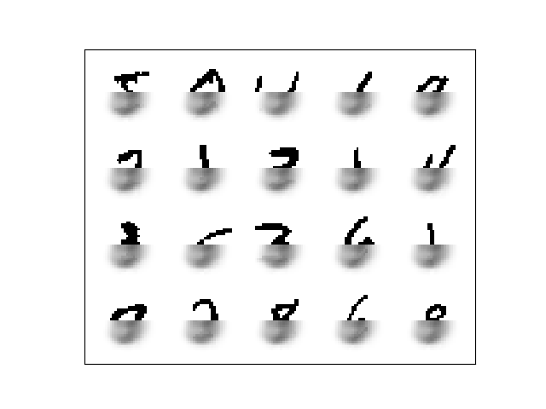

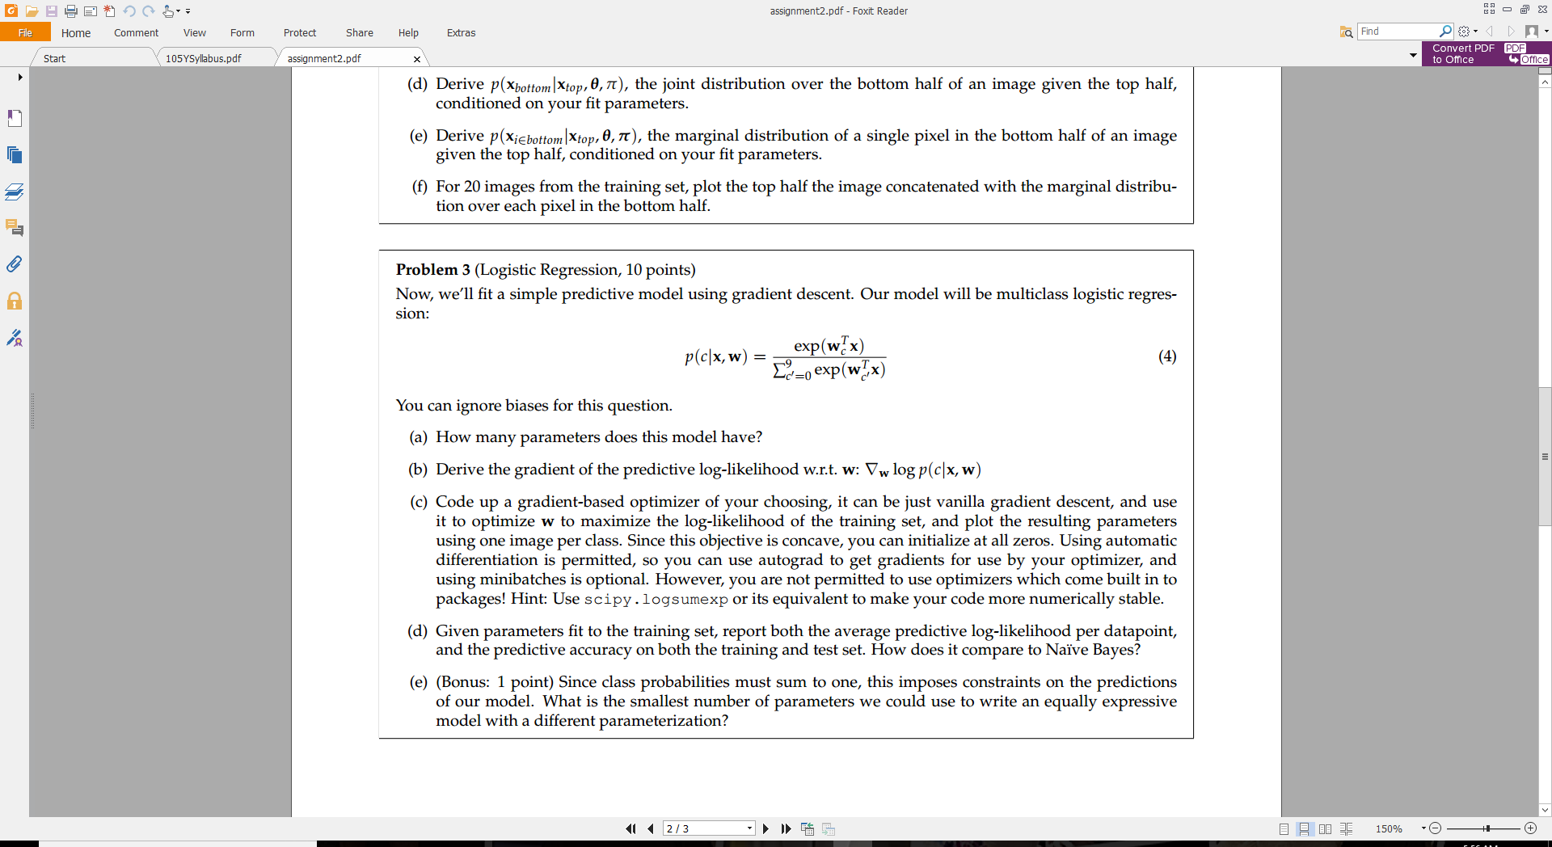

1. Problem 3: Logistic Regression
   1. *How many parameters?*

The number of digits (classes) times number of data points for each digit(image)

10 x 784 = 7840 parameters

* 1. *Derive predictive log-likelihood?*



* 1. Gradient Optimizer code and images

#Q3C code

def one_per_class(images, labels):

out_images = np.zeros((10,images.shape[1]))

out_labels = np.zeros((10,10))

classes = np.where(labels == 1)[1] # get the class digit for each image by getting column idx of ones in labels

#get first image in training set with each class label

for i in range(0,10):

img_num = np.where(classes == i)[0][0]

out_images[i,:] = images[img_num,:]

out_labels[i,:] = labels[img_num,:]

return out_images,out_labels

def cost_function(w):

sum_final = 0 #temporary create sum_final var

dem = logsumexp(np.dot(np.transpose(w),grad_images))

#mutliclass likelihood function is sum from 0 to k of label*predictive_log_likelihood

for k in range(0,10):

log_pc_x = np.dot(np.transpose(w[:,k]),grad_images) - dem

if k == 0:

sum_final = np.dot(grad_labels[k],log_pc_x)

else:

sum_final = sum_final + np.dot(grad_labels[k],log_pc_x)

return sum_final

def logistic_gradient_desc(iterations,lr):

#set globals so that cost function can access these values after usign autograd w.r.t. w

global current_c

global grad_images

global grad_labels

w = np.zeros((784,10)) #create the weights

for i in range(0,iterations):

for img_num in range(0,10):

#get gradient of cost function/likelihood

grad_images = new_images[img_num,:] #get current image

grad_labels = new_labels[img_num,:] #get labels for current image

current_c = img_num #sinces we sampled 1 image for each class in order c = img_num

cost_grad = elementwise_grad(cost_function)

#update weights

w = w + lr*cost_grad(w)

print(i)

return w

#run Q3C code

new_images,new_labels = one_per_class(train_images,train_labels)

grad_images=grad_labels = new_images #temporary just to create a gobal var for use with autograd

current_c = 0 #temporary just to create a gobal var for use with autograd

weights = logistic_gradient_desc(5000, 0.01) #5000 iterations with a common learning rate of 0.01

save_images(np.transpose(weights),'Q3c')

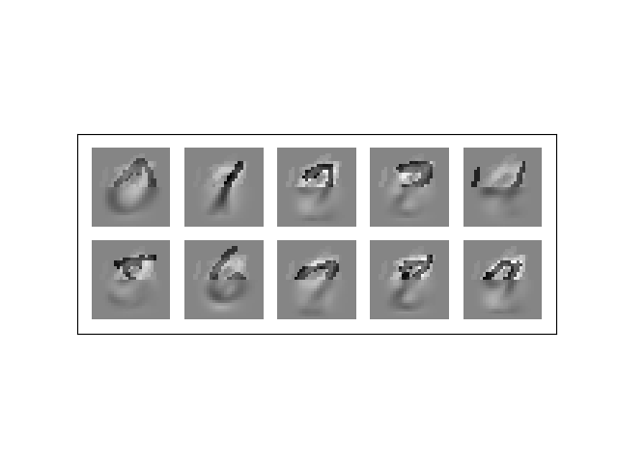

* 1. *Report average and accuracy*

Avg train log likelihood -29.4875731391

Avg test log likelihood -29.3802306385

Train Accuracy 0.511

Test Accuracy 0.4958

There is something wrong with my gradient descent, I spent a really long time trying to figure out where I went wrong, but sadly no luck.

The accuracy for logistic regression should have been better than Naïve Bayes. Due to the fact that logistic regression looks at the whole image (all pixels together) where as Naïve Bayes looks at each individual pixel separately

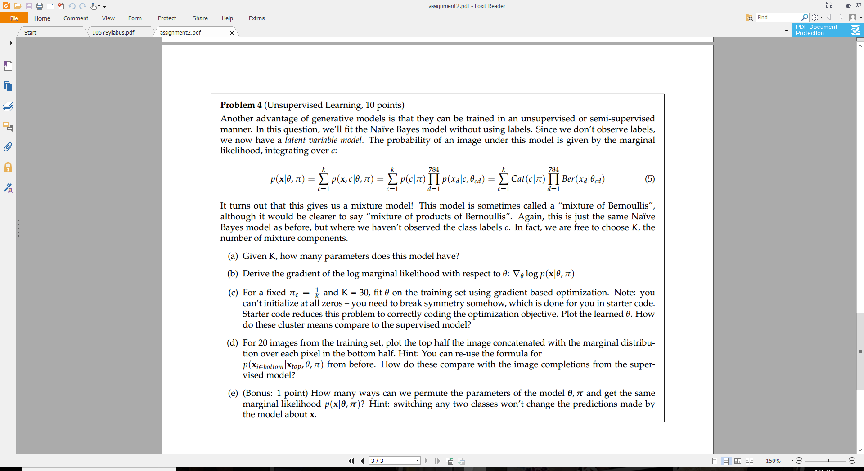

1. Problem 4: Unsupervised learning
   1. *How many parameters?*

10*784+K

* 1. *Derive gradient of log marginal likelihood*



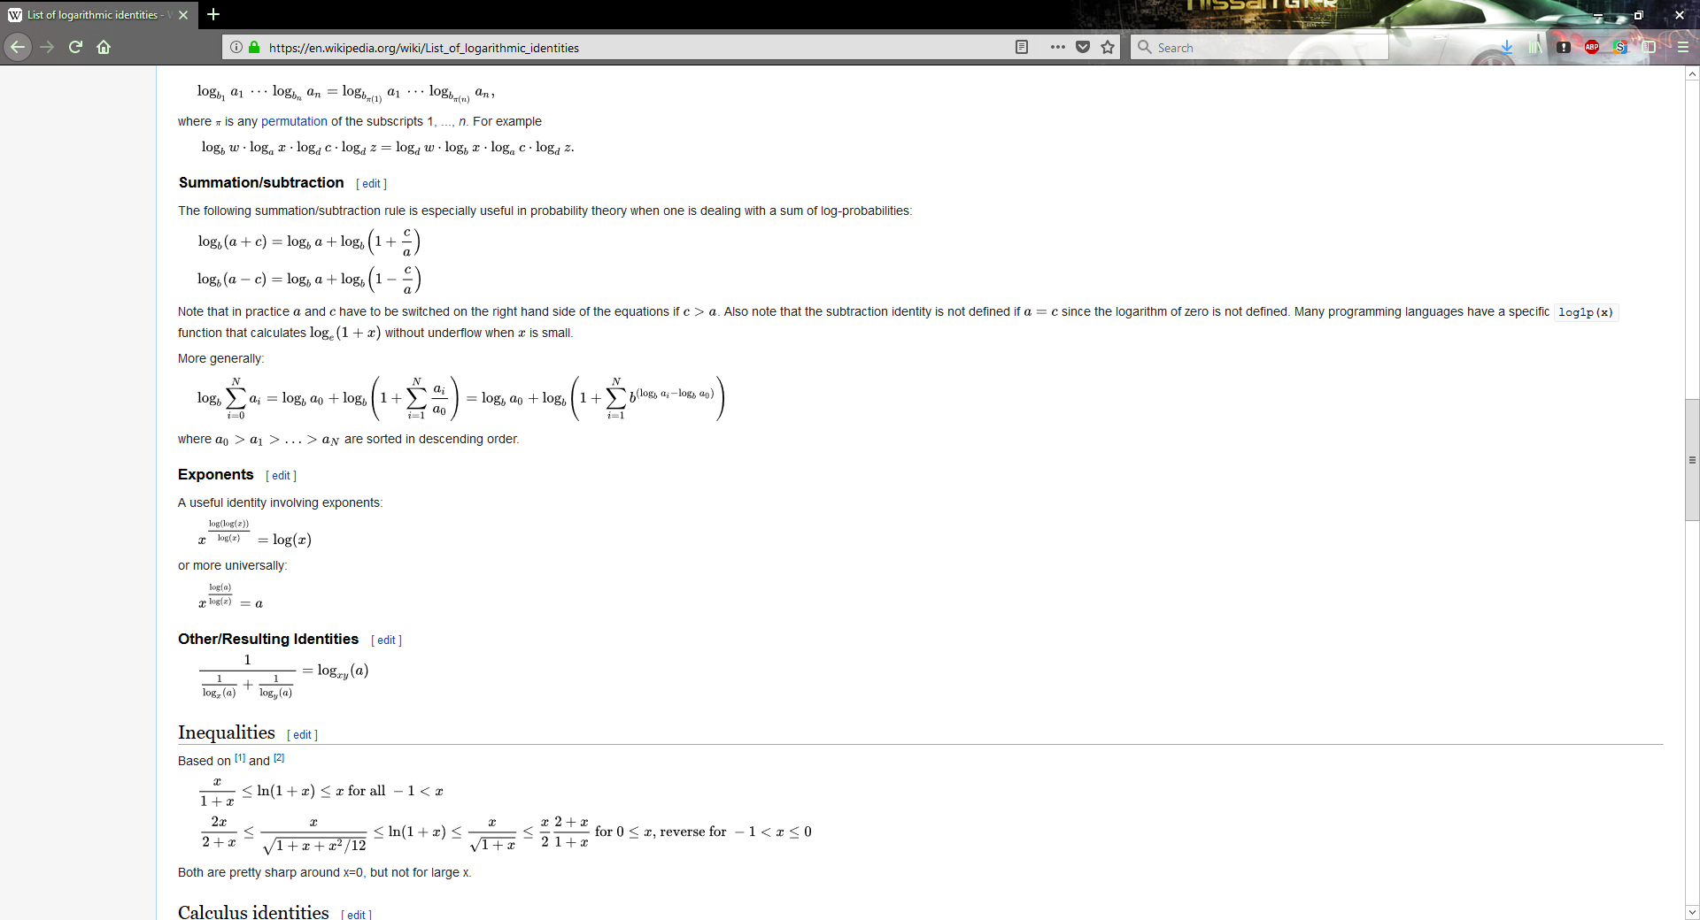



* 1. Code for neglogprob on next page and image

I could not get the neglobprob working properly is produces a weird optimized parameters

def neglogprob(params, data):

# Implement this as the solution for 4c!

##METHOD 1

#pi_c = 1/K

##sum from 0 to 784 of second part in 4b

#log_prob = []

#for i in range(0,data.shape[0]):

#k_sum = np.zeros((1,10))

#for c in range(1,K):

#mult = np.ones((1,10))

##mult = ((params[c,:]**data[i,:])*((1-params[c,:])**(1-data[i,:]))) #vectorized version of the loop, i hope

#for d in range(0,data.shape[1]):

#mult = mult* ((params[c,d]**data[i,d])*((1-params[c,d])**(1-data[i,d])))

#mult = mult *bernoulli_log_density(data[i,d], params[c,d])

#k_sum = k_sum + pi_c*mult

#log_prob.append(np.sum(np.array(-1*np.log(k_sum)[0]))/10)

#return log_prob

#METHOD 2 --------------------------------------------------------

#derived formula from 4b

pi_c = 1/K

results = []

for i in range (0,data.shape[0]):

x = data[i,:]

theta = params[i,:]

#first term from 4b eq

log_pi_c = np.log(pi_c)

#second term from 4b eq

second_term = 0

for d in range(0,data.shape[1]):

second_term = second_term + bernoulli_log_density(x[d], theta[0])

#third term from 4b eq

third_term = 0

for c in range(2,K):

first_power = log_pi_c

for d in range(0,data.shape[1]):

first_power = first_power + bernoulli_log_density(x[d], theta[c])

power = first_power-(log_pi_c+second_term)

third_term = third_term + 10**power

log_prob = log_pi_c + second_term + third_term

print(log_prob)

results.append(log_prob)

return -1*np.array(results)

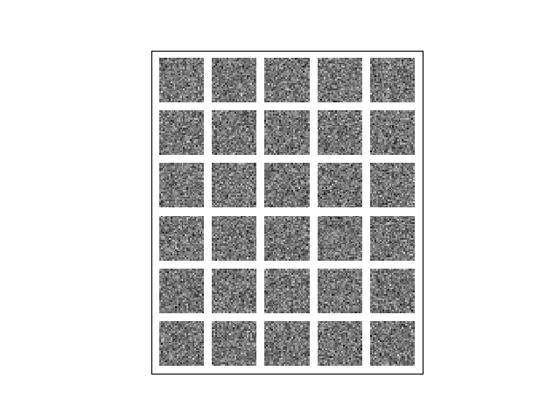

* 1. Code and images

#Q4D code: just need to run 2fs code given optimized_params

results = advanced_bayes(train_images[0:20,:],optimized_params)

save_images(results,'Q4D')

