April 6, 2018

Vibhavi Peiris

Student #: 1000597687

CSC412

Assignment 3

1. Problem 1: L2-Regularized Logistic Regression
   1. *Use code from A2 with 300 training points*

#A3 Q1A From my-A2 Q3C code

def one_per_class(images, labels):

out_images = np.zeros((10,images.shape[1]))

out_labels = np.zeros((10,10))

classes = np.where(labels == 1)[1] # get the class digit for each image by getting column idx of ones in labels

#get first image in training set with each class label

for i in range(0,10):

img_num = np.where(classes == i)[0][0]

out_images[i,:] = images[img_num,:]

out_labels[i,:] = labels[img_num,:]

return out_images,out_labels

def cost_function(w):

sum_final = 0 #temporary create sum_final var

dem = logsumexp(np.dot(np.transpose(w),grad_images))

#mutliclass likelihood function is sum from 0 to k of label*predictive_log_likelihood

for k in range(0,10):

log_pc_x = np.dot(np.transpose(w[:,k]),grad_images) - dem

if k == 0:

sum_final = np.dot(grad_labels[k],log_pc_x)

else:

sum_final = sum_final + np.dot(grad_labels[k],log_pc_x)

return sum_final

def logistic_gradient_desc(iterations,lr):

#set globals so that cost function can access these values after usign autograd w.r.t. w

global current_c

global grad_images

global grad_labels

w = np.zeros((784,10)) #create the weights

for i in range(0,iterations):

for img_num in range(0,new_images.shape[0]):

#get gradient of cost function/likelihood

grad_images = new_images[img_num,:] #get current image

grad_labels = new_labels[img_num,:] #get labels for current image

current_c = img_num #sinces we sampled 1 image for each class in order c = img_num

cost_grad = elementwise_grad(cost_function)

#update weights

w = w + lr*cost_grad(w)

print(i)

return w

#run A2 Q3C code

new_images = train_images

new_labels = train_labels

grad_images=grad_labels = new_images #temporary just to create a gobal var for use with autograd

current_c = 0 #temporary just to create a gobal var for use with autograd

weights = logistic_gradient_desc(1000, 0.01) #5000 iterations with a common learning rate of 0.01

save_images(np.transpose(weights),'Q1a')

#A2 Q3d code

def avg_pred_log(w,images):

log_pc_x = 0

for i in range(0,images.shape[0]):

current_log_pc_x = np.dot(np.transpose(w),images[i,:]) - logsumexp(np.dot(np.transpose(w),images[i,:]))

log_pc_x = log_pc_x + current_log_pc_x

return np.sum(log_pc_x)/float(images.shape[0])

def predict_regression(images, w):

predictions = np.zeros((images.shape[0],w.shape[1])) #N by 10

#find best class true class for each image

for i in range(0,images.shape[0]):

best_class = np.argmax(np.dot(np.transpose(w),images[i,:])) #choose the class with highest

predictions[i,best_class] = 1 #set index = digit to 1 as it is the best prediction for current image

return predictions

def Q3D_report(train_images,train_labels,test_images,test_labels,w):

#average for train

avg_likelihood_train = avg_pred_log(w,train_images)

print("Avg train log likelihood ",avg_likelihood_train)

#average for test

avg_likelihood_test = avg_pred_log(w,test_images)

print("Avg test log likelihood ",avg_likelihood_test)

#predictions for train

predict_train = predict_regression(train_images, w)

total_correct_train = np.sum(np.nonzero(predict_train)[1] == np.nonzero(train_labels)[1]) #get total number of correct predictions

accuracy_train = total_correct_train/float(train_labels.shape[0]) #get accuracy

print('Train Accuracy ',accuracy_train)

#predictions for test

predict_test = predict_regression(test_images, w)

total_correct_test = np.sum(np.nonzero(predict_test)[1] == np.nonzero(test_labels)[1]) #get total number of correct predictions

accuracy_test = total_correct_test/float(test_labels.shape[0]) #get accuracy

print('Test Accuracy ',accuracy_test)

#run A2 Q3D code

#Q3D_report(train_images,train_labels,test_images,test_labels,weights)

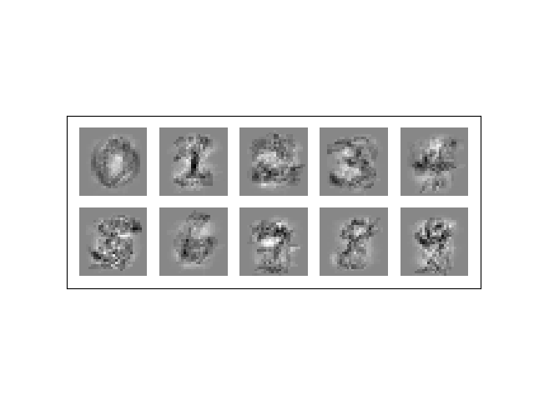

#A2 Q3d code

def avg_pred_log(w,images):

log_pc_x = 0

for i in range(0,images.shape[0]):

current_log_pc_x = np.dot(np.transpose(w),images[i,:]) - logsumexp(np.dot(np.transpose(w),images[i,:]))

log_pc_x = log_pc_x + current_log_pc_x

return np.sum(log_pc_x)/float(images.shape[0])

def predict_regression(images, w):

predictions = np.zeros((images.shape[0],w.shape[1])) #N by 10

#find best class true class for each image

for i in range(0,images.shape[0]):

best_class = np.argmax(np.dot(np.transpose(w),images[i,:])) #choose the class with highest

predictions[i,best_class] = 1 #set index = digit to 1 as it is the best prediction for current image

return predictions

def Q3D_report(train_images,train_labels,test_images,test_labels,w):

#average for train

avg_likelihood_train = avg_pred_log(w,train_images)

print("Avg train log likelihood ",avg_likelihood_train)

#average for test

avg_likelihood_test = avg_pred_log(w,test_images)

print("Avg test log likelihood ",avg_likelihood_test)

#predictions for train

predict_train = predict_regression(train_images, w)

total_correct_train = np.sum(np.nonzero(predict_train)[1] == np.nonzero(train_labels)[1]) #get total number of correct predictions

accuracy_train = total_correct_train/float(train_labels.shape[0]) #get accuracy

print('Train Accuracy ',accuracy_train)

#predictions for test

predict_test = predict_regression(test_images, w)

total_correct_test = np.sum(np.nonzero(predict_test)[1] == np.nonzero(test_labels)[1]) #get total number of correct predictions

accuracy_test = total_correct_test/float(test_labels.shape[0]) #get accuracy

print('Test Accuracy ',accuracy_test)

#run A2 Q3D code

Q3D_report(train_images,train_labels,test_images,test_labels,weights) #REPORT FOR A3 Q1a

*Average train log likelihood -117.989022988*

*Average test log likelihood -97.3003729208*

*Train Accuracy 1.0*

*Test Accuracy 0.7727*

* 1. *MAP Estimator*







* 1. *Fit map*

#A3 Q1C

#logitsic regression with gradient descent using map

def grad_desc(iterations,lr,sigma):

#set globals so that cost function can access these values after usign autograd w.r.t. w

global grad_images

global grad_labels

w = np.zeros((784,10)) #create the weights

for i in range(0,iterations):

for img_num in range(0,new_images.shape[0]):

#get gradient of cost function/likelihood

grad_images = new_images[img_num,:] #get current image

grad_labels = new_labels[img_num,:] #get labels for current image

cost_grad = elementwise_grad(cost_function)

#update weights

w = w + lr*cost_grad(w)

#NEW ADDITION FOR A3

w = w - w/sigma**2

print(i)

return w

#run cod for A3 q1c

print("Map logitsic regression")

##Testing for best sigma value was 36

#for i in range(1,10):

#sigma = i**2 # from 5 to 100

#print(sigma)

#map_weights = grad_desc(100, 0.01,sigma) #5000 iterations with a common learning rate of 0.01

#save_images(np.transpose(map_weights),'Q1c')

#Q3D_report(train_images,train_labels,test_images,test_labels,map_weights)

#sigma = 1/i**2 #from 1 to 1/100

#print(sigma)

#map_weights = grad_desc(100, 0.01,sigma) #5000 iterations with a common learning rate of 0.01

#save_images(np.transpose(map_weights),'Q1c')

#Q3D_report(train_images,train_labels,test_images,test_labels,map_weights)

sigma = 36

map_weights = grad_desc(1000, 0.01,sigma) #5000 iterations with a common learning rate of 0.01

save_images(np.transpose(map_weights),'Q1c')

Q3D_report(train_images,train_labels,test_images,test_labels,map_weights)

*Average train log likelihood -93.0039030291*

*Average test log likelihood -77.2325259507*

*Train Accuracy 1.0*

*Test Accuracy 0.7711*

*Best sigma value was 36. With 4,9,16,25 close behind.*

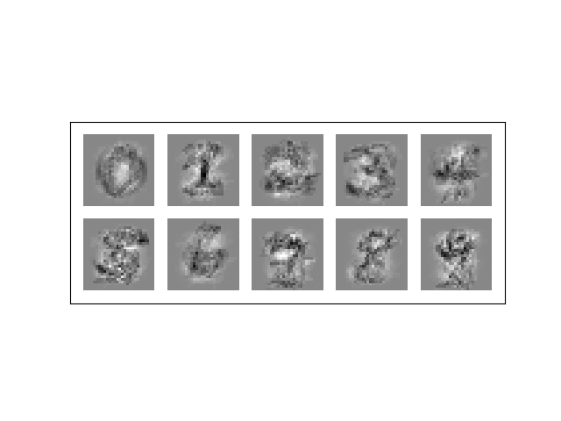

1. Problem 2: Bayesian Logistic Regression using Stochastic Variational Inference
   1. *Number of parameters?*

For w it is 784 * 10 = 7840 parameters.

For ф its (mean + standard deviation) =7840+7840 = 14960 parameters.

* 1. *Code SVI.*

def elbo_estimate(var_params, logprob, num_samples, rs):

"""Provides a stochastic estimate of the variational lower bound.

var_params is (mean, log_std) of a Gaussian."""

mean, log_std = var_params

samples = sample_diag_gaussian(mean,log_std,num_samples,rs)

log_ps = logprob(samples)

log_qs = diag_gaussian_log_density(samples,mean,log_std)

E_q = np.sum(log_ps-log_qs)/num_samples # E_q(z|x)[log p(x,z) - log q(z|x)]

return E_q

def logprob_given_data(params):

data_logprob = logistic_logprob(params,train_images,train_labels)

prior_logprob = np.sum(np.sum(-np.log(np.sqrt(2*np.pi*prior_std))-(params**2)/(2*prior_std),axis=2),axis=1)

return data_logprob + prior_logprob

* 1. Compute accuracy for test

predict_test = predict_regression(test_images, np.transpose(optimized_params[0])) #A3 q1/A2 code

total_correct_test = np.sum(np.nonzero(predict_test)[1] == np.nonzero(test_labels)[1]) #get total number of correct predictions

accuracy_test = total_correct_test/float(test_labels.shape[0]) #get accuracy

print('\nTest Accuracy ',accuracy_test)

##testing a bunch of std values, std = 1 is best with 77.68% and std =9 is second best 77.09%

#for i in range(1,10):

#prior_std = i**2 # from 5 to 100

#print(prior_std)

#optimized_params = adam(objective_grad, init_params, step_size=0.05, num_iters=100, callback=print_perf)

#predict_test = predict_regression(test_images, np.transpose(optimized_params[0])) #A3 q1/A2 code

#total_correct_test = np.sum(np.nonzero(predict_test)[1] == np.nonzero(test_labels)[1]) #get total number of correct predictions

#accuracy_test = total_correct_test/float(test_labels.shape[0]) #get accuracy

#print('\nTest Accuracy ',accuracy_test)

#prior_std = 1/i**2 #from 1 to 1/100

#print(prior_std)

#optimized_params = adam(objective_grad, init_params, step_size=0.05, num_iters=100, callback=print_perf)

#predict_test = predict_regression(test_images, np.transpose(optimized_params[0])) #A3 q1/A2 code

#total_correct_test = np.sum(np.nonzero(predict_test)[1] == np.nonzero(test_labels)[1]) #get total number of correct predictions

#accuracy_test = total_correct_test/float(test_labels.shape[0]) #get accuracy

#print('\nTest Accuracy ',accuracy_test)

Standard deviation = 1 is the best with 77.68% and Standard deviation = 9 is second best 77.09%. These number are only slightly higher than MAP inferences accuracy.

* 1. *Plot 10 images*
     1. *Mean*

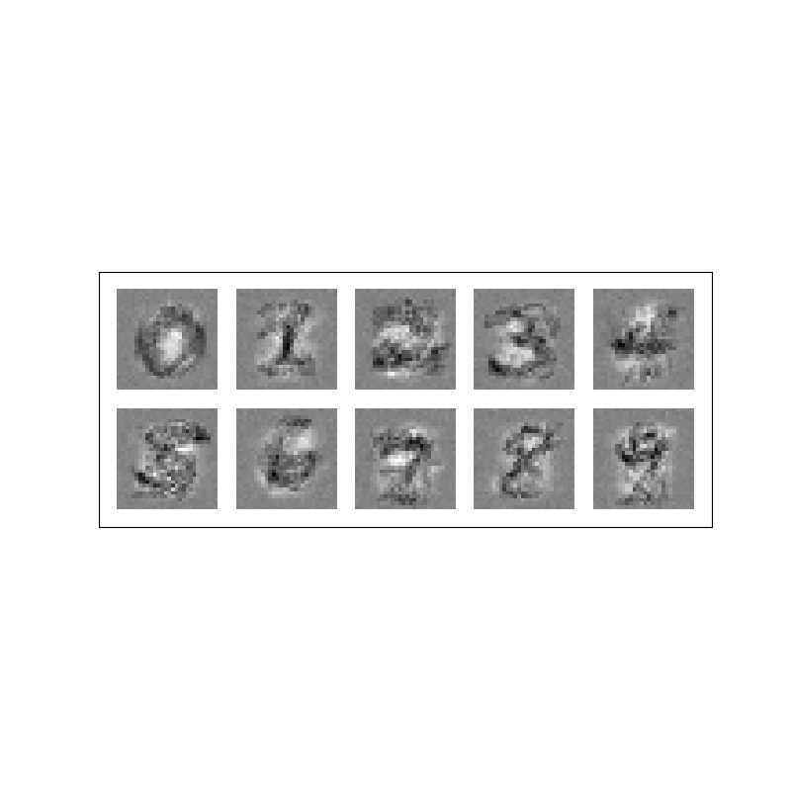

The mean is as I expected because the darkest regions would be the most common pixels of a digit (middle for 1).

* + 1. *Variation*

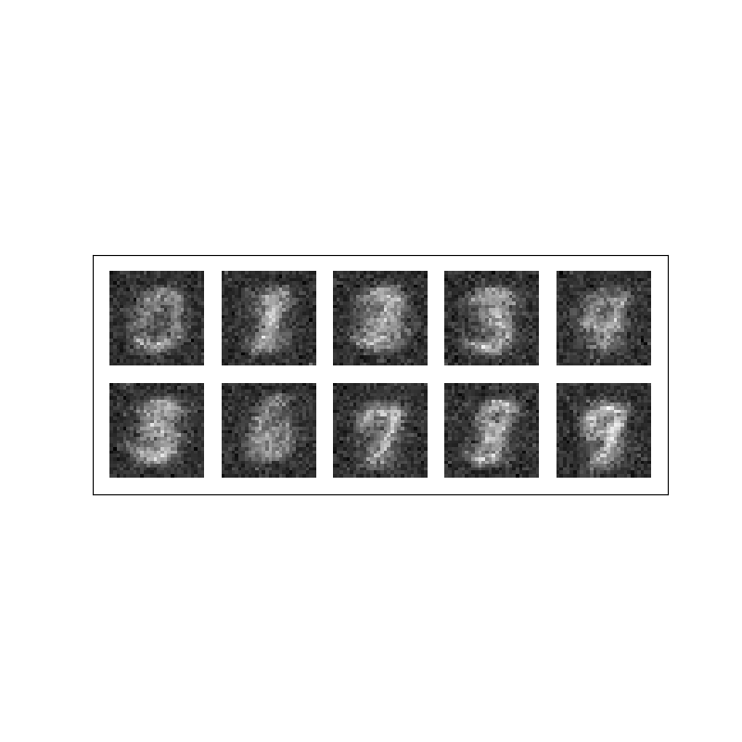

The variation would have the opposite effect of mean because the further away (up to a certain distance) from the digits mean locations the more variation on pixel values. I.E. for digit 1 the close pixels around the one would have high variation (due to all possible ways one is drawn)

* + 1. *Samples*

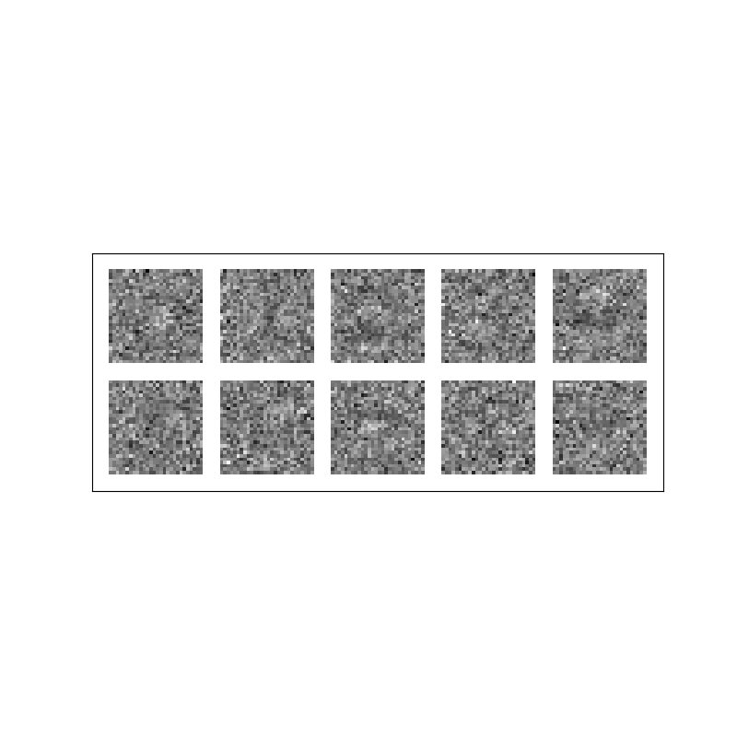

The sample is not what I expected, there is more noise. I expected it to be a combination of mean and variance.

* 1. *Single sample q*

When xdєB that means that xd = 0. So wcdTxd will be 0. Which means it does not affect the optimal because p(t|w,x) is 0 (substitute wcdTxd=0 into the p(t|w,x equation).

* 1. *Posterior questions*
     1. *Does training affect posterior and variational?*

No, true posterior seems to stay the same through the training. Yes, Variational posterior changes.

* + 1. *How does standard deviation affect posterior?*

Increasing standard deviation makes the true posterior wider across the horizontal.

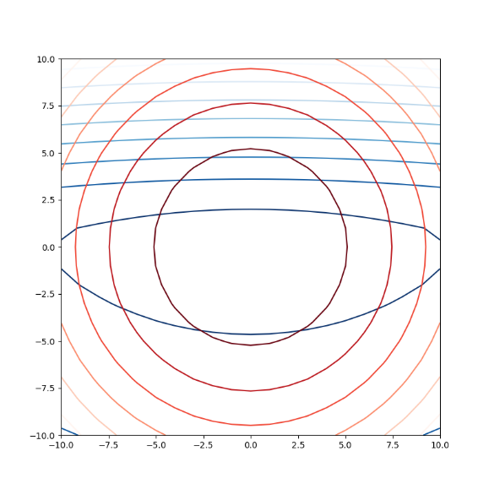Standard deviation = 1

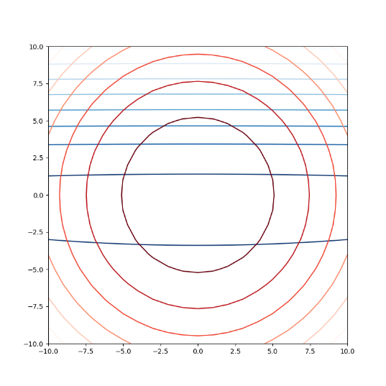standard deviation = 10

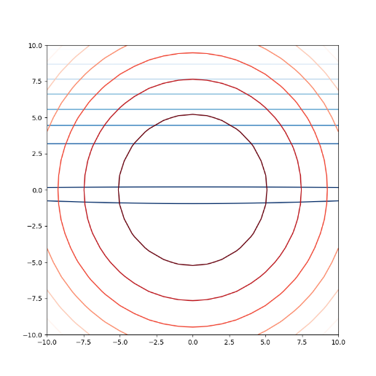standard deviation = 100

* + 1. *Px2’s affect?*

It makes the true posterior oval shaped & different from variational posterior.

* + 1. *Changing px2’s affect?*

It makes true posterior more circular similar to variational.

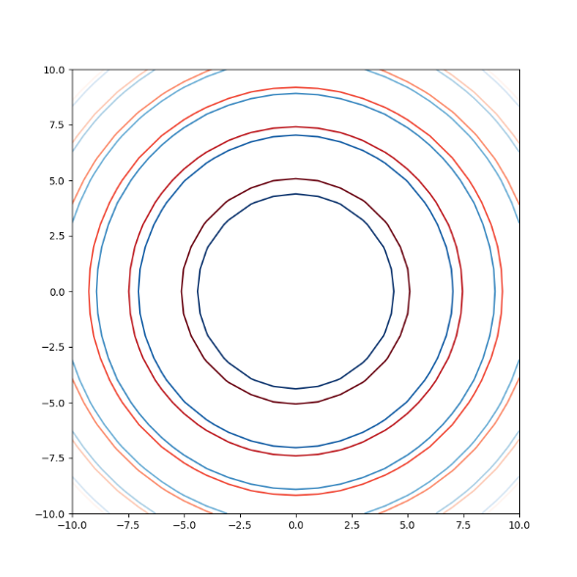

* + 1. *Using improper flat model?*

No