TeleScope Agent Questions and Responses
S.No | Questions | Category
1 | Provide detailed TeleScope analytics insights with key metrics, trends, and supporting figures. | Executive & Dashboard Insights
2 | Summarize TeleScope executive insights with concise, high-impact facts. | Executive & Dashboard Insights
3 | What are the total active time and idle time for case 5-0000014213670? | Case-Level Analysis
4 | Identify the top cases with the highest total active time. | Case Performance Comparison
5 | Identify the top cases with the highest total idle time. | Case Performance Comparison
6 | What are the start time and end time for case 5-0000014209300? | Case-Level Analysis
7 | What is the percentage breakdown of active vs idle time for user prmummir? | User Productivity & Time Analysis
8 | Provide the total idle time for each user. | User Productivity & Time Analysis
9 | What is the total active time recorded for user v-isravi? | User Productivity & Time Analysis
10 | List all users who have recorded activity in TeleScope. | User Activity & Case Mapping
11 | Which case numbers were handled by user prmummir between May 19, 2026 and May 20, 2026? | User Activity & Case Mapping
12 | What are the total active and idle times for user prmummir between May 10, 2026 and May 20, 2026? | User Productivity & Time Analysis
13 | Which tools were used by user prmummir for case 5-0000014209300? | Tool Usage & Interaction Analytics
14 | What is the average session duration for user prmummir? | User Productivity & Time Analysis
15 | Which user(s) used the Magnum tool for case 5-0000014209300? | Tool Usage & Interaction Analytics
16 | What is the overall distribution of active time versus idle time across TeleScope? | Executive & Dashboard Insights
17 | Which reports should be referenced to analyze TeleScope dashboard insights effectively? | Executive & Dashboard Insights
18 | Provide the PO, EA, and AGN details for case 5-0000014210016. | Case-Level Analysis
19 | Show the complete tool usage flow for case 5-0000014209300. | Case-Level Analysis
20 | Provide a breakdown of time spent on each tool for case 5-0000014209300. | Case-Level Analysis
21 | For Case ID 5-0000014209300, provide a complete profile covering the assigned user's name, their total, active and idle time on this case, their average active time per session compared to other users (show in a bar chart), Compare the % of idle time for all these users. Give all other cases they have handled, the case-level active and idle time, tools used and their sequence, and the associated PO, EN, AGN, and other classification codes. Use visualizations and graphs wherever possible. | Insights
22 | Provide a comprehensive insights summary for TeleScope Analytics with supporting facts and figures, covering the following: total time, active time, and idle time distribution shown in a pie chart; monthly breakdown of active and idle time across all months; user-level active time shown in a bar chart; user-level idle time shown in a bar chart; and average active time per session by user a bar chart.. Show one by one with details in text and visualizations as well. | Insights

Provide a comprehensive insights summary for TeleScope Analytics with supporting facts and figures, covering the following: total time, active time, and idle time distribution shown in a pie chart; monthly breakdown of active and idle time across all months; user-level active time shown in a bar chart; user-level idle time shown in a bar chart; and average active time per session by user a bar chart.. Show one by one with details in text and visualizations as well 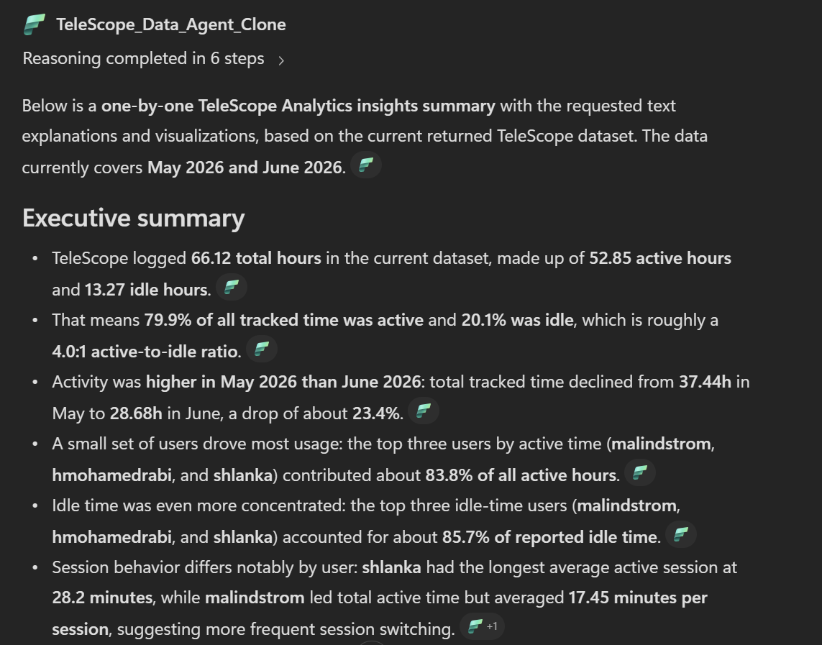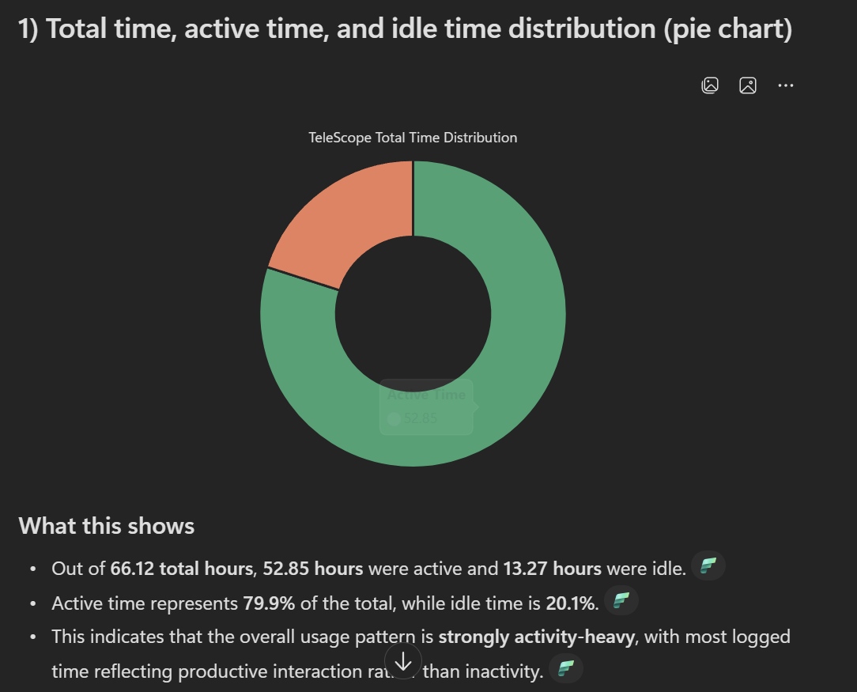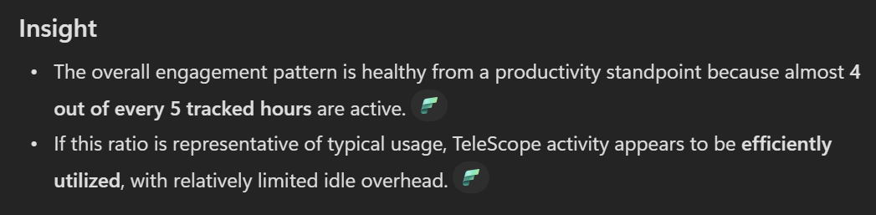

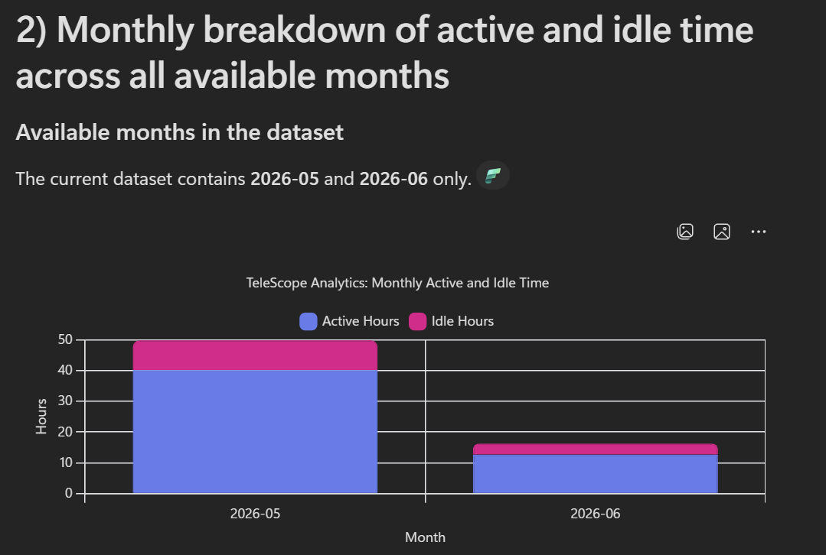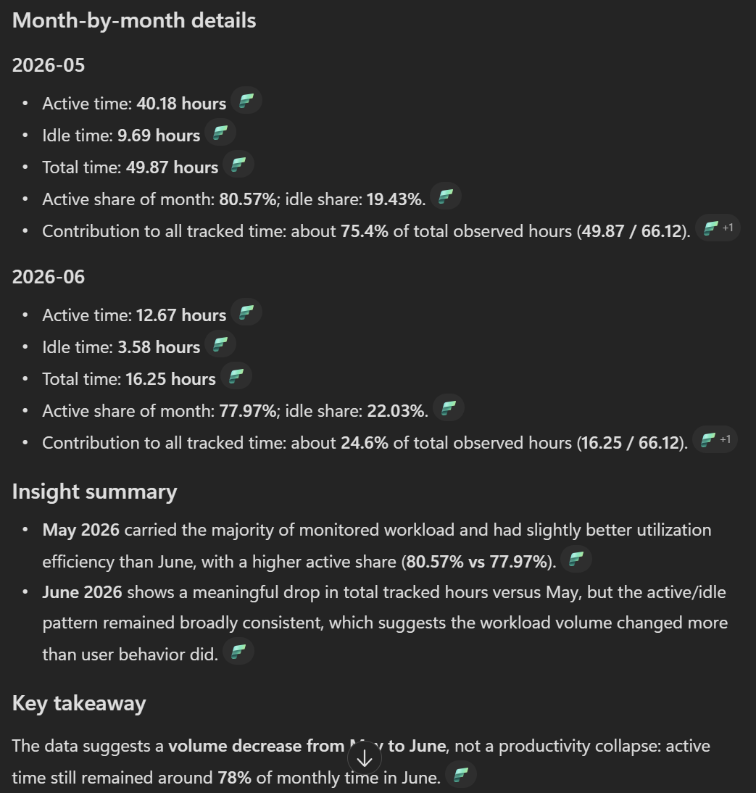

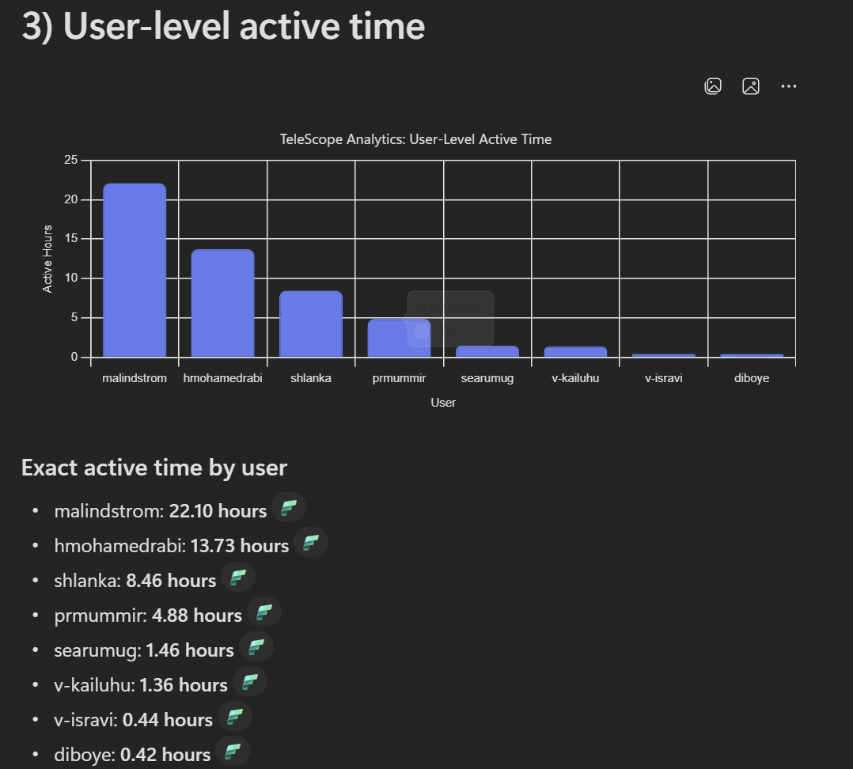
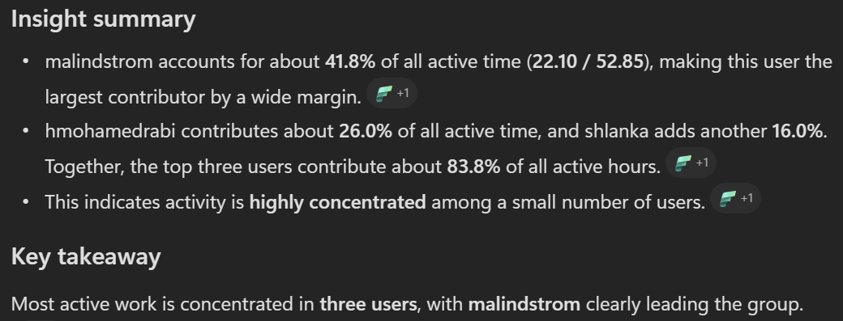

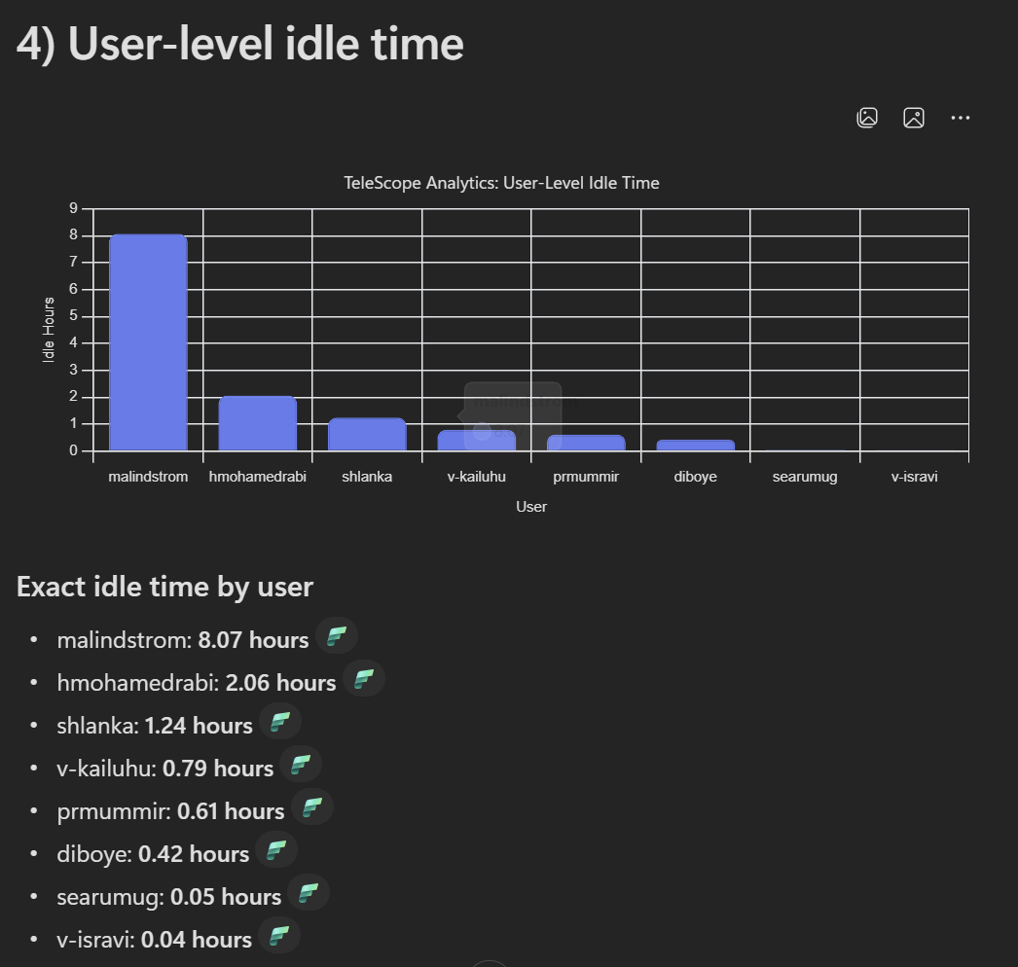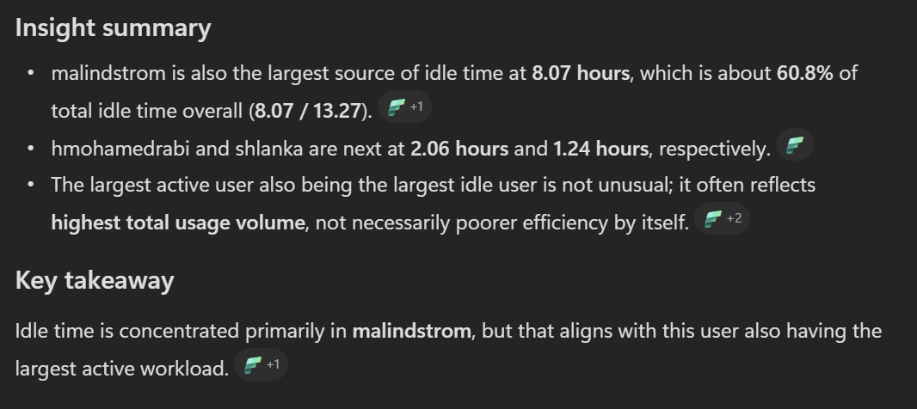
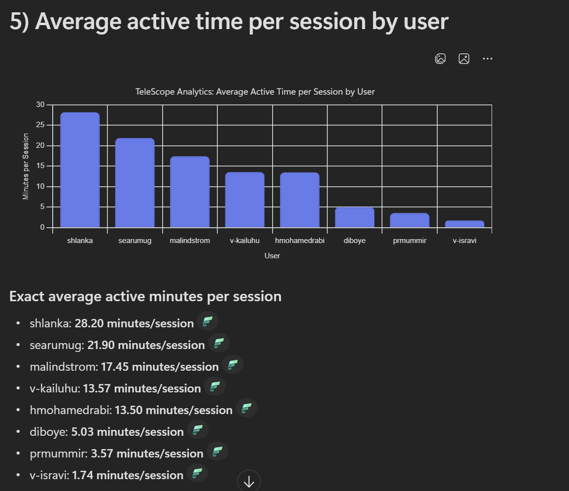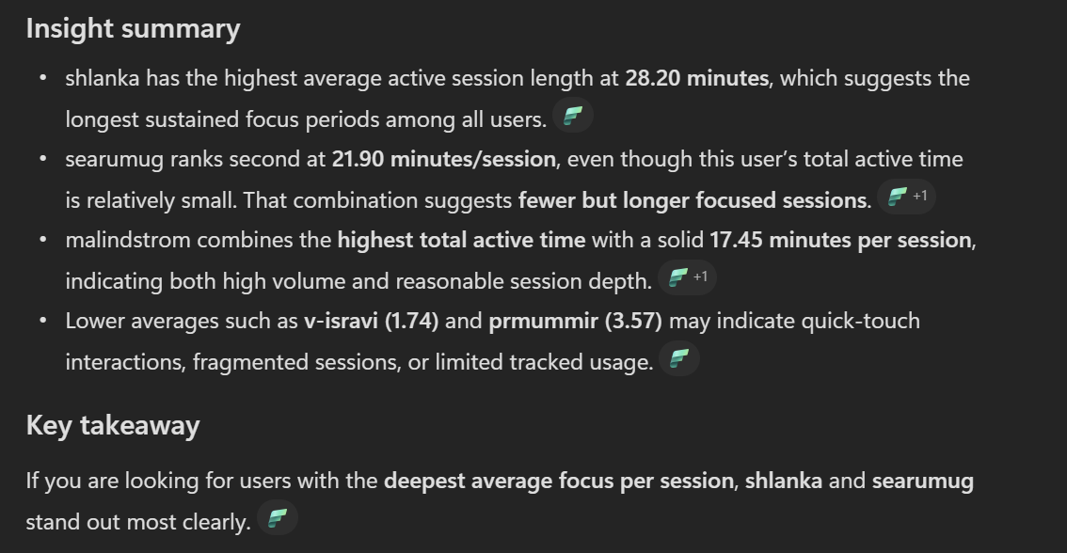

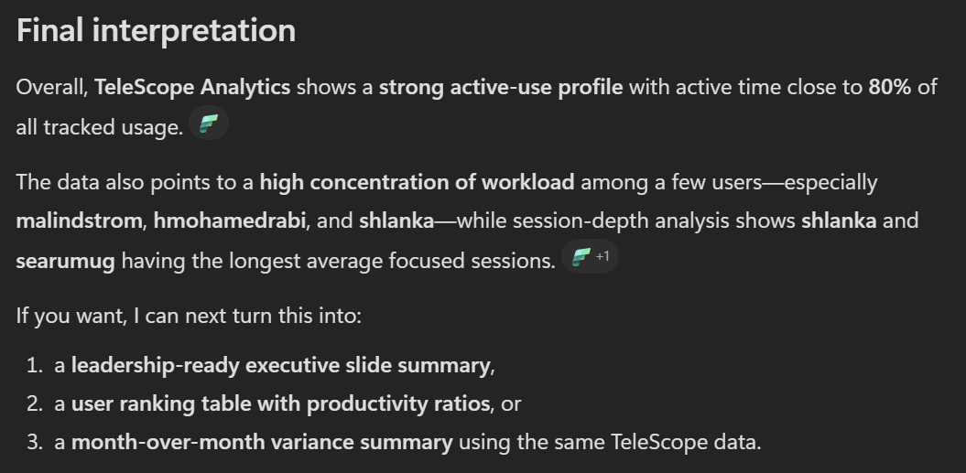

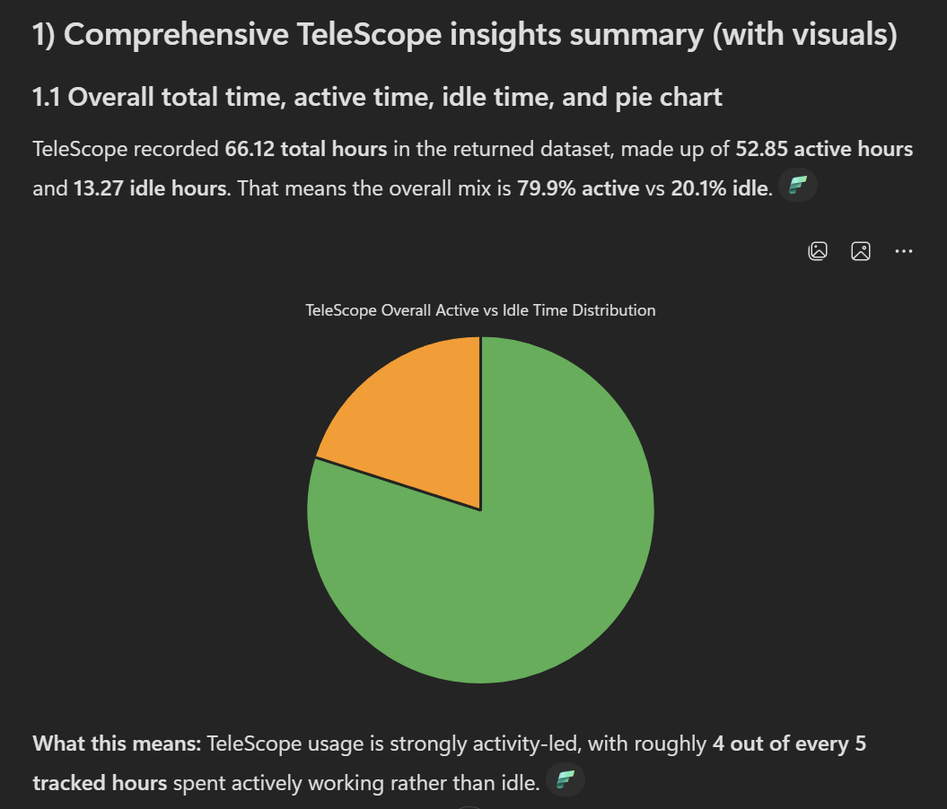

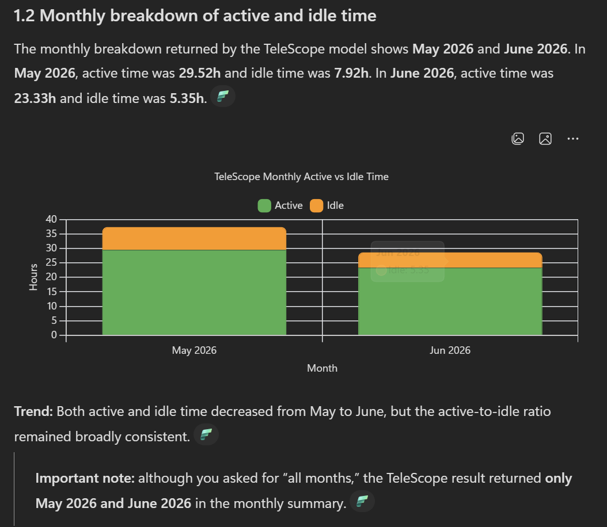

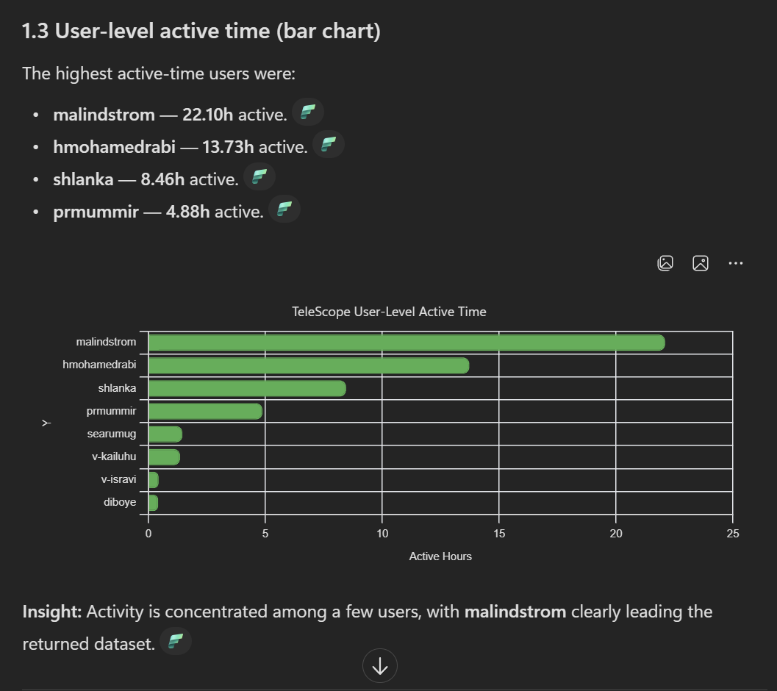

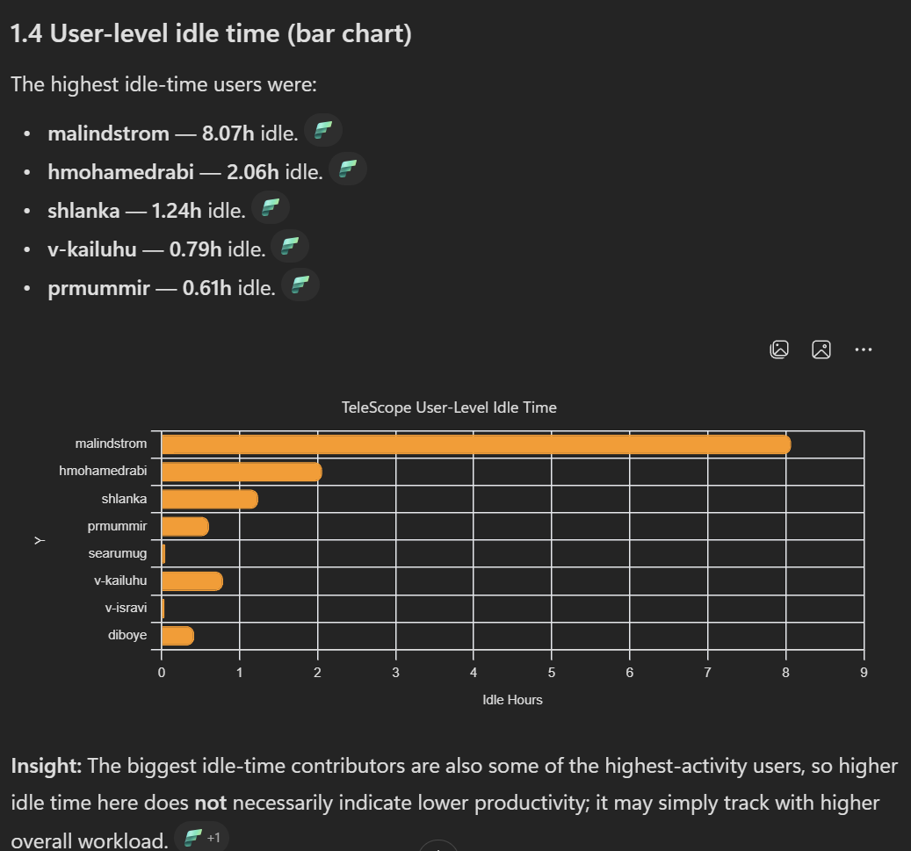

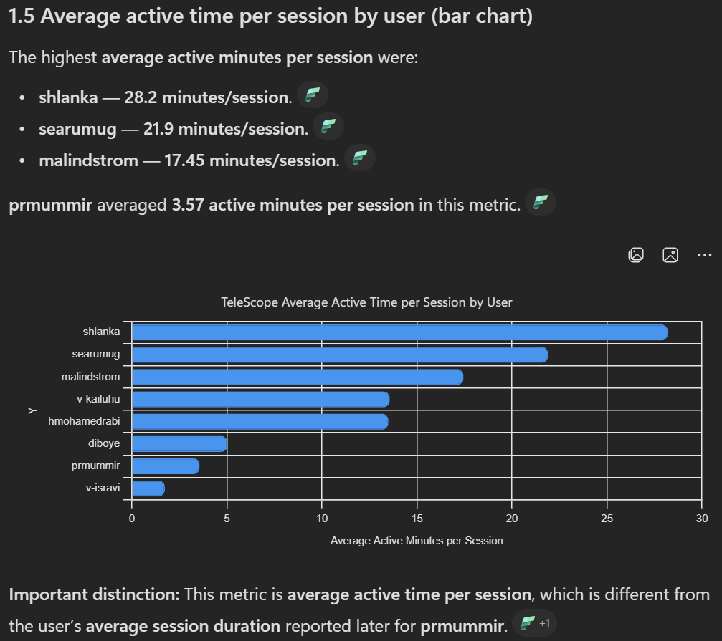

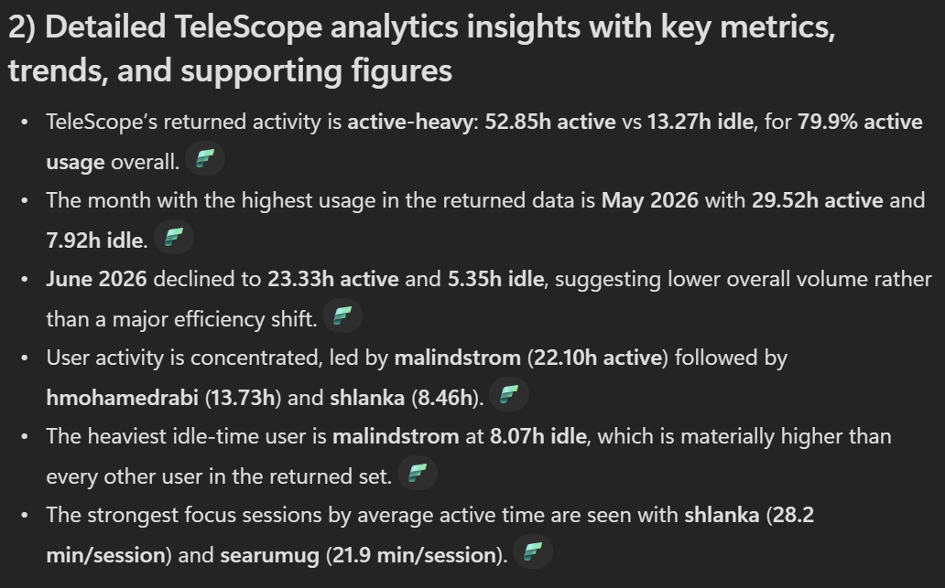

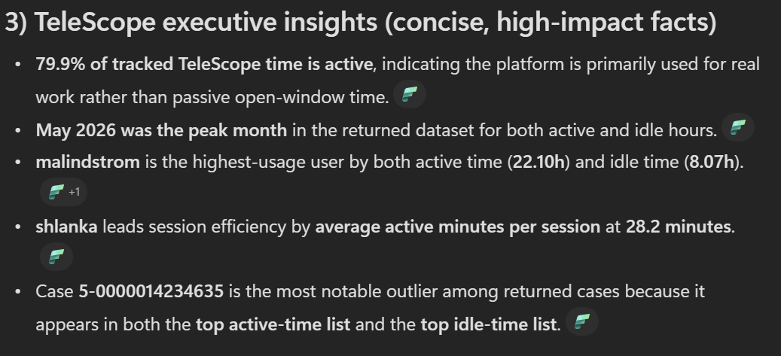

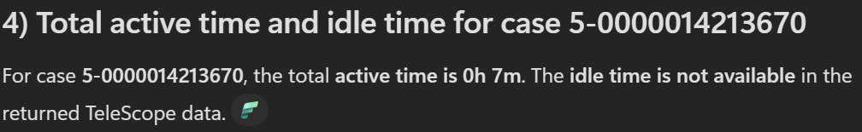

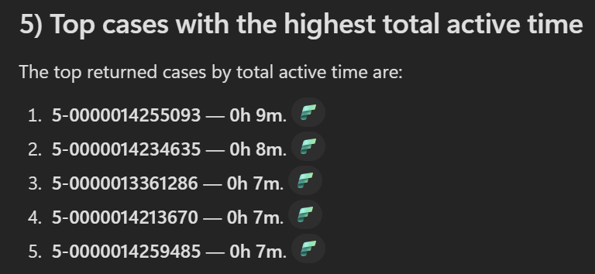

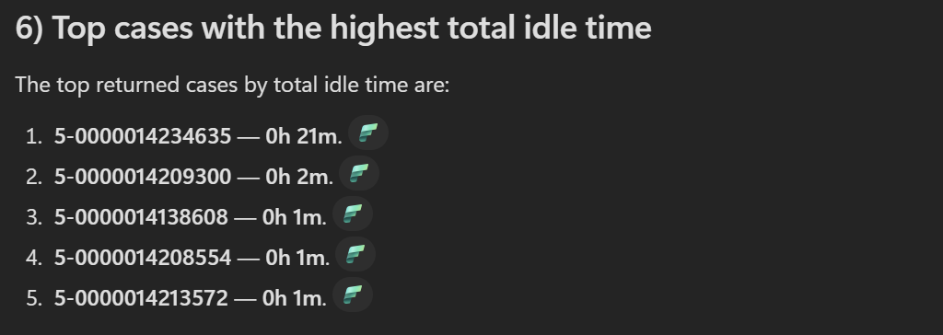



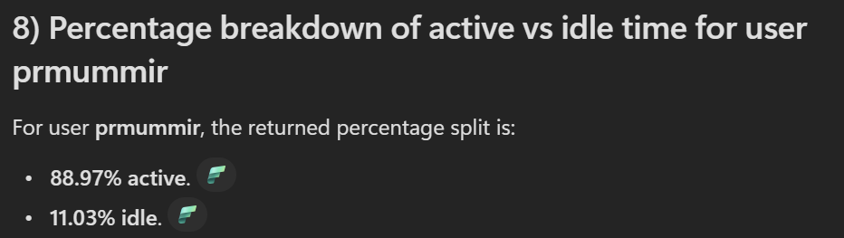

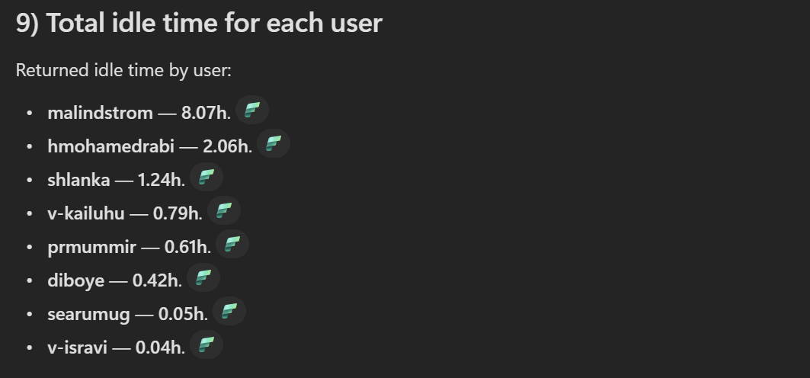



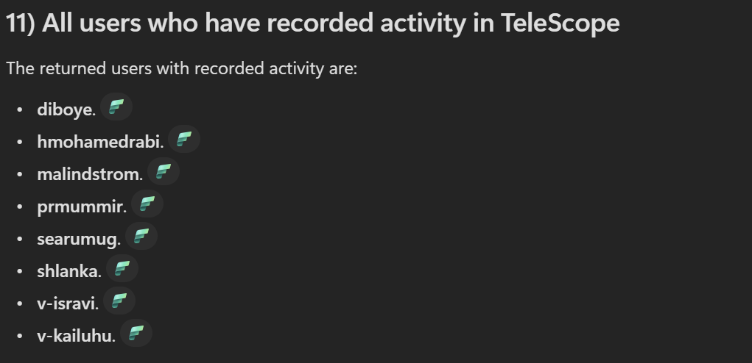

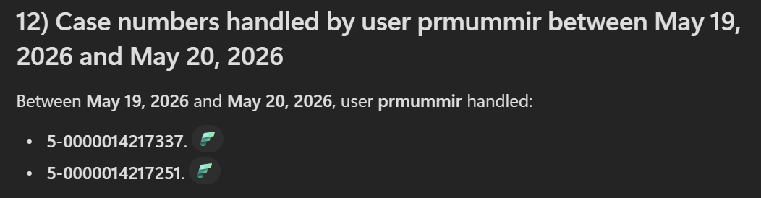

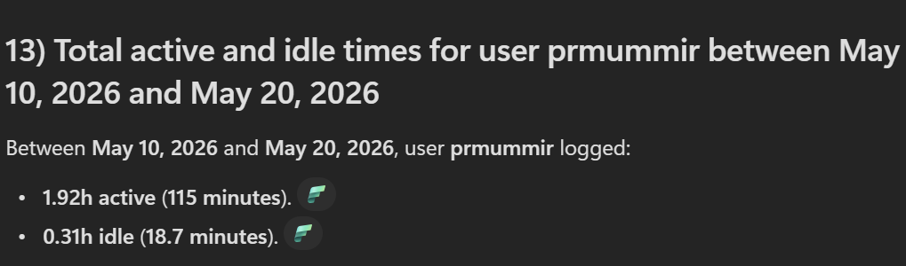

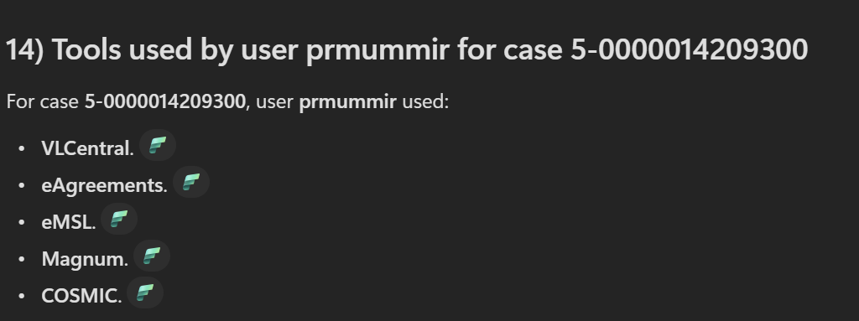

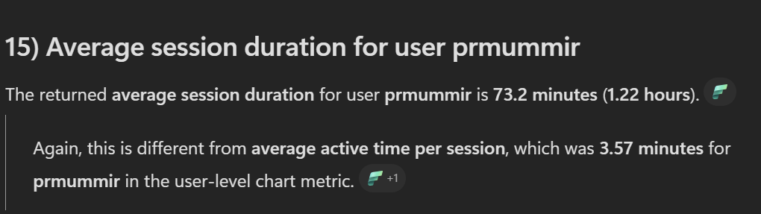



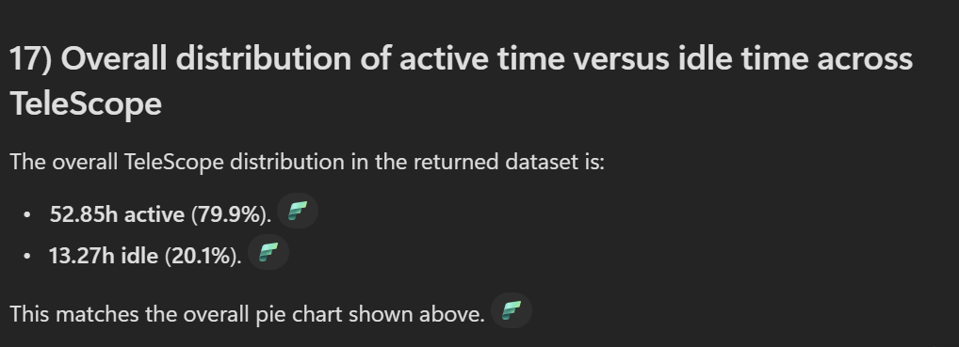

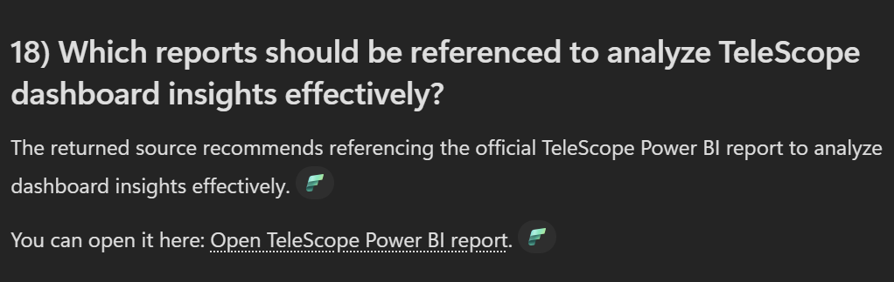

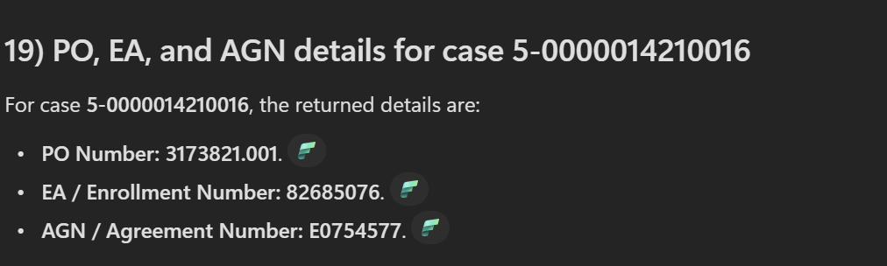

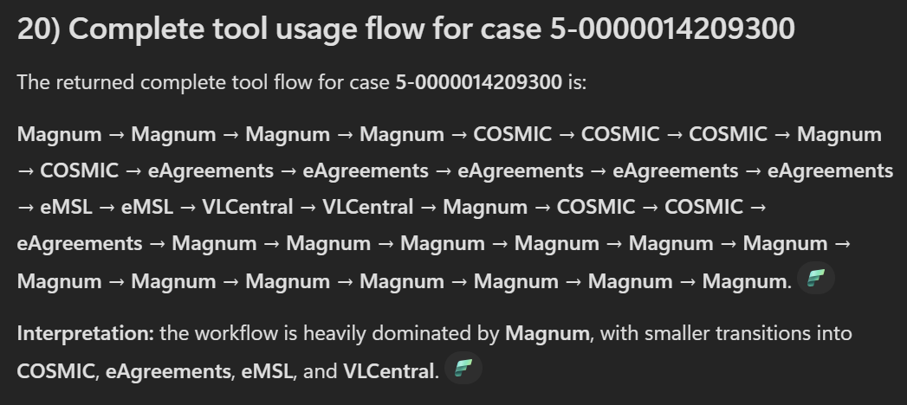

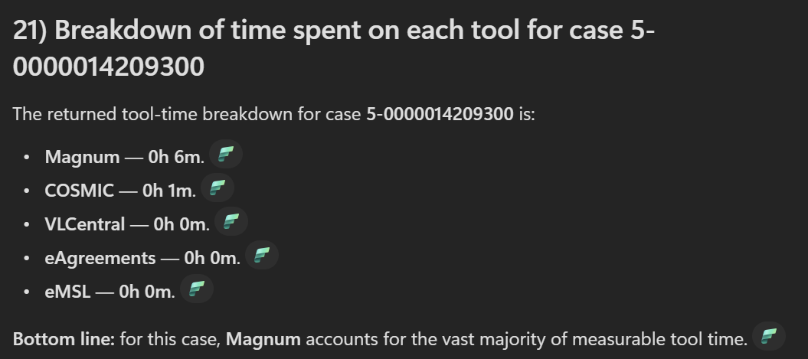

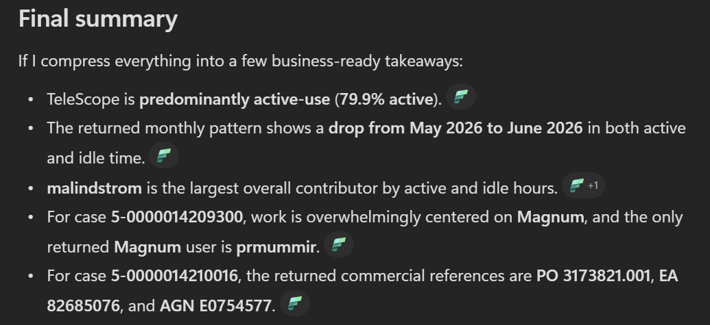

Provide a complete profile for Case ID 5-0000014209300, covering the assigned user's name, their total, active and idle time on this case, their average active time per session compared to other users (show in a bar chart), Compare the % of idle time for all these users. Give all other cases they have handled, the case-level active and idle time, tools used and their sequence, and the associated PO, EN, AGN, and other classification codes. Use visualizations and graphs wherever possible.

