Access and Permissions - TeleScope Analytics
Semantic Model and Data Agent Access – Fabric

Overall Access Summary
Area | Access / Permission Type | Access Guidance
Workspace | Manage access | Workspace access should be managed through Manage access.
Semantic model | RLS | Row-Level Security membership is configured for semantic model access.
Semantic model | Links | Link-based access is available for the semantic model.
Semantic model | Direct access | Direct access should include Build access + View. Edit / Modify access should not be given.
Power BI | Build | Build permission can be provided where required.
Data Agent | Links | Access should be provided through Links. Read access can be given.
Data Agent | Direct access | Access should also be provided through Direct access. Read access can be given.
Lakehouse | Yes | Lakehouse access is marked as Yes.

Semantic Model Access and Permissions
Edit / Modify access should not be given for the semantic model.
Build access can be given so recipients can build content with the data associated with the semantic model.
Semantic model access is captured through RLS, Links, and Direct access as shown in the provided screenshots.

Semantic Model Screenshot Descriptions
Provided Image | Sentence Description
Share semantic model | The screen displays options to allow recipients to share the semantic model, and build content with the data associated with the semantic model. For this access setup, Edit / Modify access should not be given. Build access can be given.
RLS Security | The Row-Level Security page is shown under TeleScope_WorkSpace. The semantic model data access is controlled through RLS membership, where the listed people or groups belong to the role.
Direct access and Links access | The Manage permissions view is shown for TeleScope_Semantic. The screen includes the Links, Direct access, and Access via related items tabs. The Direct access tab lists people and groups with access to the semantic model.

Data Agent Access and Permissions
Access should be given for both Links and Direct access for the Data Agent.
Read access can be given for the Data Agent.
If access is still not working, go to the Data Agent component, open the Share option, provide the required user ID, check the permission levels required, and share it.
Data Agent Access Area | Access Guidance
Links | Provide access through the Links tab. Read and Reshare access can be given.
Direct access | Provide access through the Direct access tab also. Read and Reshare access can be given.
If access is still not working | Go to the Data Agent component, open the Share option, provide the required user ID, check the permission levels required, and share it.

Data Agent Screenshot Description
Image 4: Data Agent Links access: The TeleScope_Agent access page is shown in Power BI. The screen displays the Links and Direct access tabs, with the Links tab selected. The page contains an Add link option and shows existing link rows with columns for Link name, Who has Access, Permissions, Created By, and Creator email. The visible permissions include Read, Reshare, ReadAll, and Read. The page also shows that access to the item is restricted by the Confidential\Internal Only sensitivity label protection policy.

Final Access Statement
For TeleScope_Semantic, users should be granted the required semantic model access without giving Edit / Modify permission. Build access can be provided where users need to create or build content using the semantic model. RLS membership should be maintained for row-level data security, and Direct access / Links should be used as shown in the provided access screens.
For TeleScope_Agent, access should be provided through both Links and Direct access. Read access can be given. If the access does not work after providing Links and Direct access, go directly to the Data Agent component, open the Share option, provide the required user ID, verify the permission levels required, and share it.

Image 1: Share semantic model
The Share semantic model window is shown for TeleScope_Semantic. Edit / Modify access should not be given, and Build access can be given.
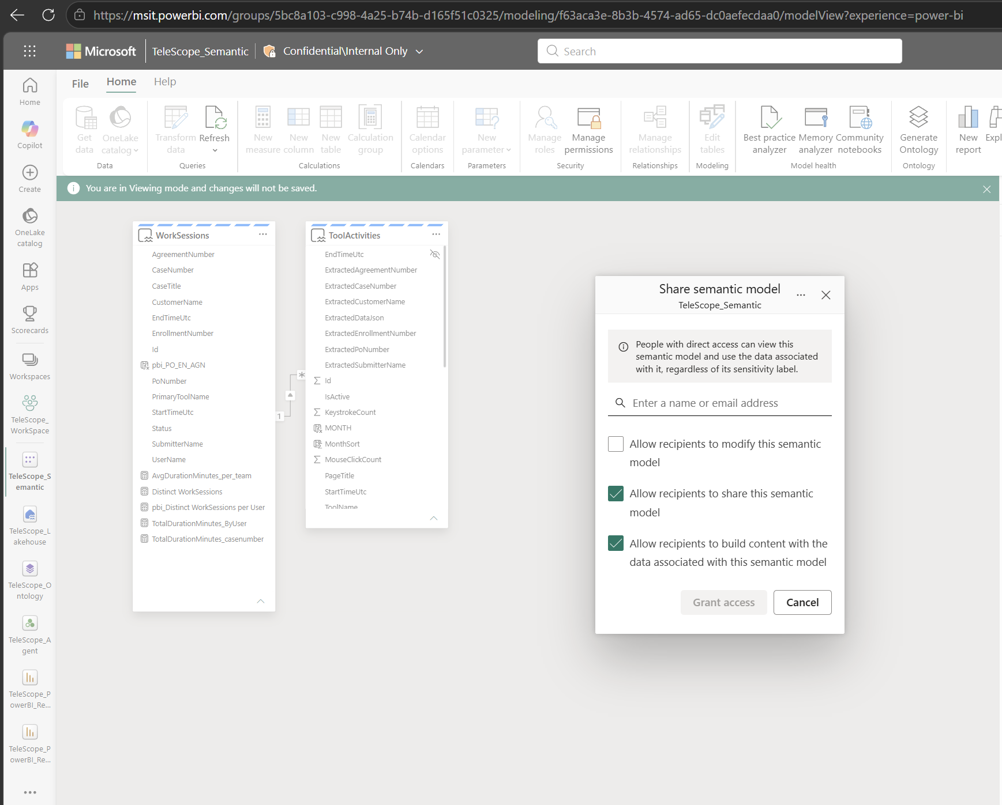

Image 2: RLS Security
The Row-Level Security page is shown under TeleScope_WorkSpace with the role and members listed for semantic model RLS access.
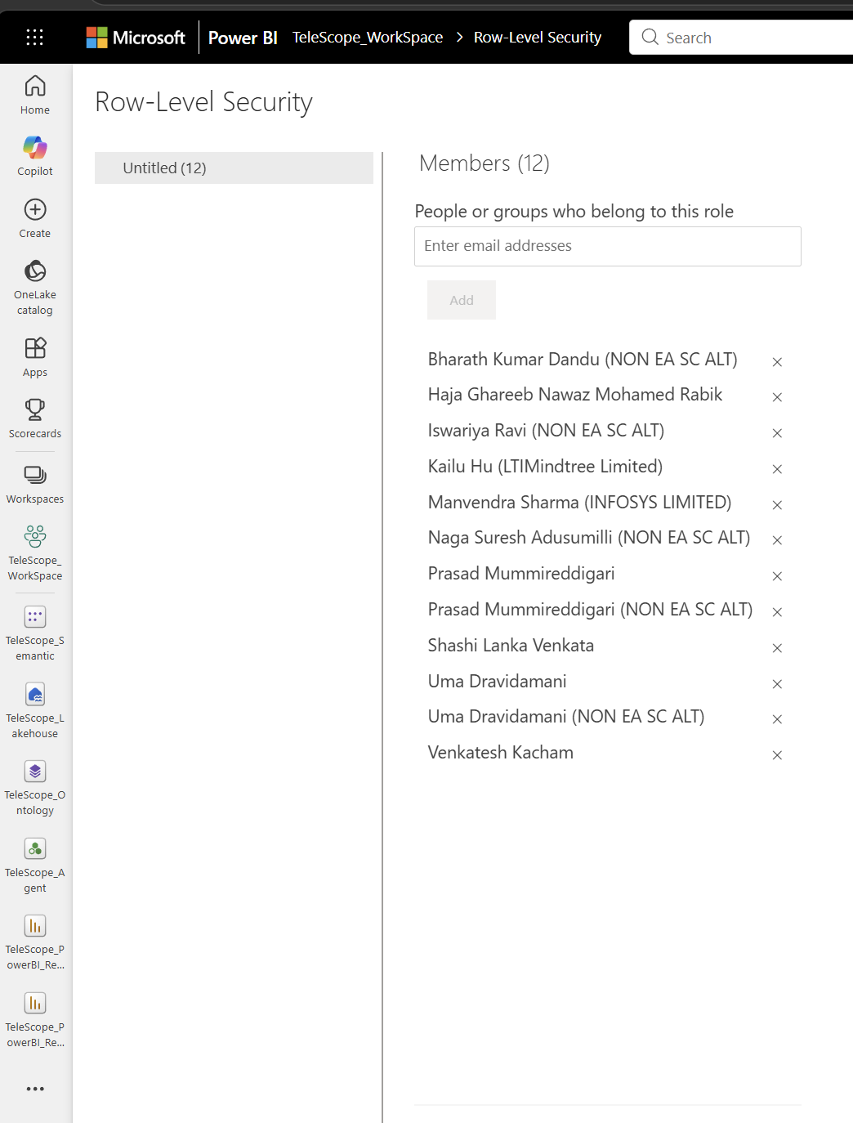

Image 3: Direct access and Links access
The Manage permissions view is shown for TeleScope_Semantic with Links, Direct access, and Access via related items tabs.
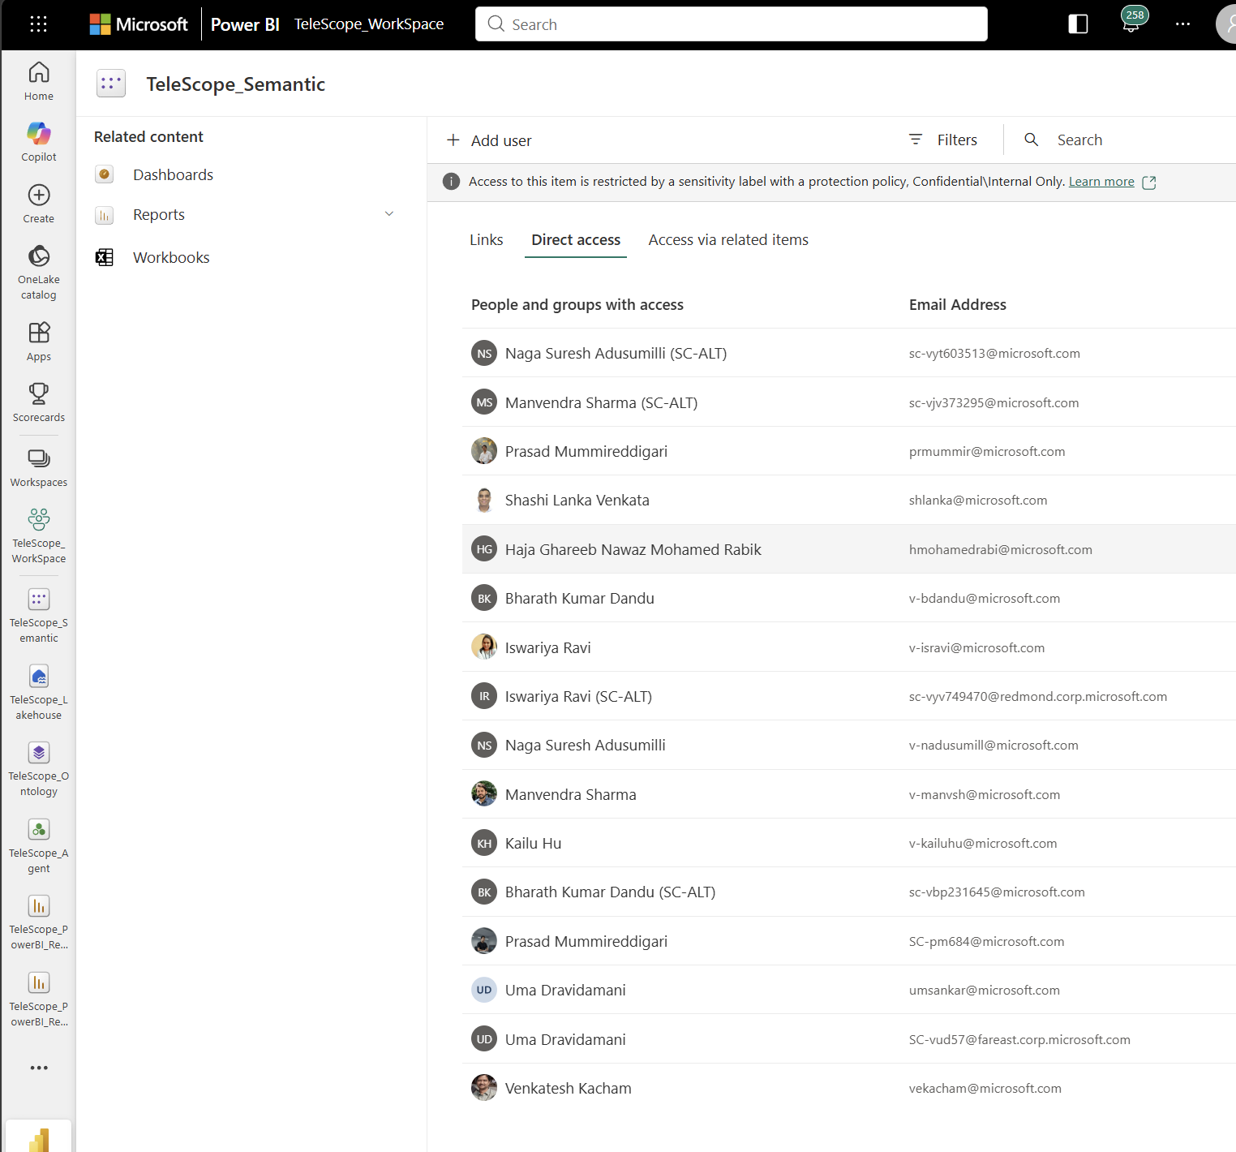

Image 4: Data Agent Links access
The TeleScope_Agent access page is shown with Links and Direct access tabs. Access should be provided through both Links and Direct access. Read and Reshare access can be given.
