FIELD NOTES / RAHULCH.SITE / ARTCRAFT
Twelve programs
in a tab
On October 16, 2026, a photo editor, a spreadsheet, a CAD drafter and nine other open-source apps went live on this site. Each one is a Rust program compiled to WebAssembly. This note covers what they weigh, how they run, and how a file you make in one of them now gets a permanent link.
By Rahul Chaudhary October 16, 2026 Opened in WordCraft
12  applications, one URL each | 383 MB  of WebAssembly in total | 0  installers, accounts or plugins | 1  permanent link per saved file

What went up today
On October 16, twelve applications went up on rahulch.site: a layered photo editor, a vector illustrator, a photo library with a raw developer, a PDF editor, a motion graphics tool, a page layout tool, an interface design tool, a word processor, an audio workstation, a slide tool, a 2D CAD drafter and a spreadsheet. Each one opens from a plain URL.
They come from the ArtCraft project and are licensed MIT or Apache 2.0. Every app is a Rust program. Its interface is drawn by egui and painted on the GPU through wgpu, and the whole program compiles to one WebAssembly module that the browser downloads once and then keeps in its cache.
What it weighs
The twelve modules add up to 383 MB. EffectCraft is the heaviest at 60.0 MB and SoundCraft is the lightest at 12.4 MB. The average is 31.9 MB. WordCraft, the app showing you this page, is 36.3 MB, so this document cost you about that much download the first time, and nothing the second time.
EffectCraft also installs a service worker, so after one visit it opens with no network at all. The other eleven need the network for the first load and then run from cache.
This file lives in a public Git repository, at a path named after its own fingerprint.
Where your files go now
Until tonight, anything you made in these apps stayed in your browser or your Downloads folder. Every app saves by handing the browser a file to download, so a small script on the site now keeps a copy of that file and offers a permalink.
The link is built from the file itself. The script hashes the bytes with SHA-256, keeps the first 12 hex characters, and commits the file to the public craft-files repository at app/id/name. The link names that path, so it can never point at different content later, and saving the same bytes twice gives the same link.
Opening a link reverses the trip. The page fetches the raw file from GitHub and hands it to the app as a drag and drop, the same route a file takes when you drag it in from your desktop. If an app ignores the drop, the next File > Open receives the shared file instead of showing a picker.
HOW A LINK IS MADE
1 You save or export from the app menu, as before. The normal download still happens.
2 The site keeps that file and hashes it. The first 12 hex characters of the hash become its id.
3 One GitHub API call commits it to craft-files. Reading it later needs no token.
4 The link opens the app and drops the file in, on any device.
What this does not do
There is no account system behind any of this. Anyone with a link can open the file and anyone can browse the repository, so private work should stay local. Creating a link needs a GitHub token stored in the browser, which today means only the site owner can make one. Files are capped at 50 MB.

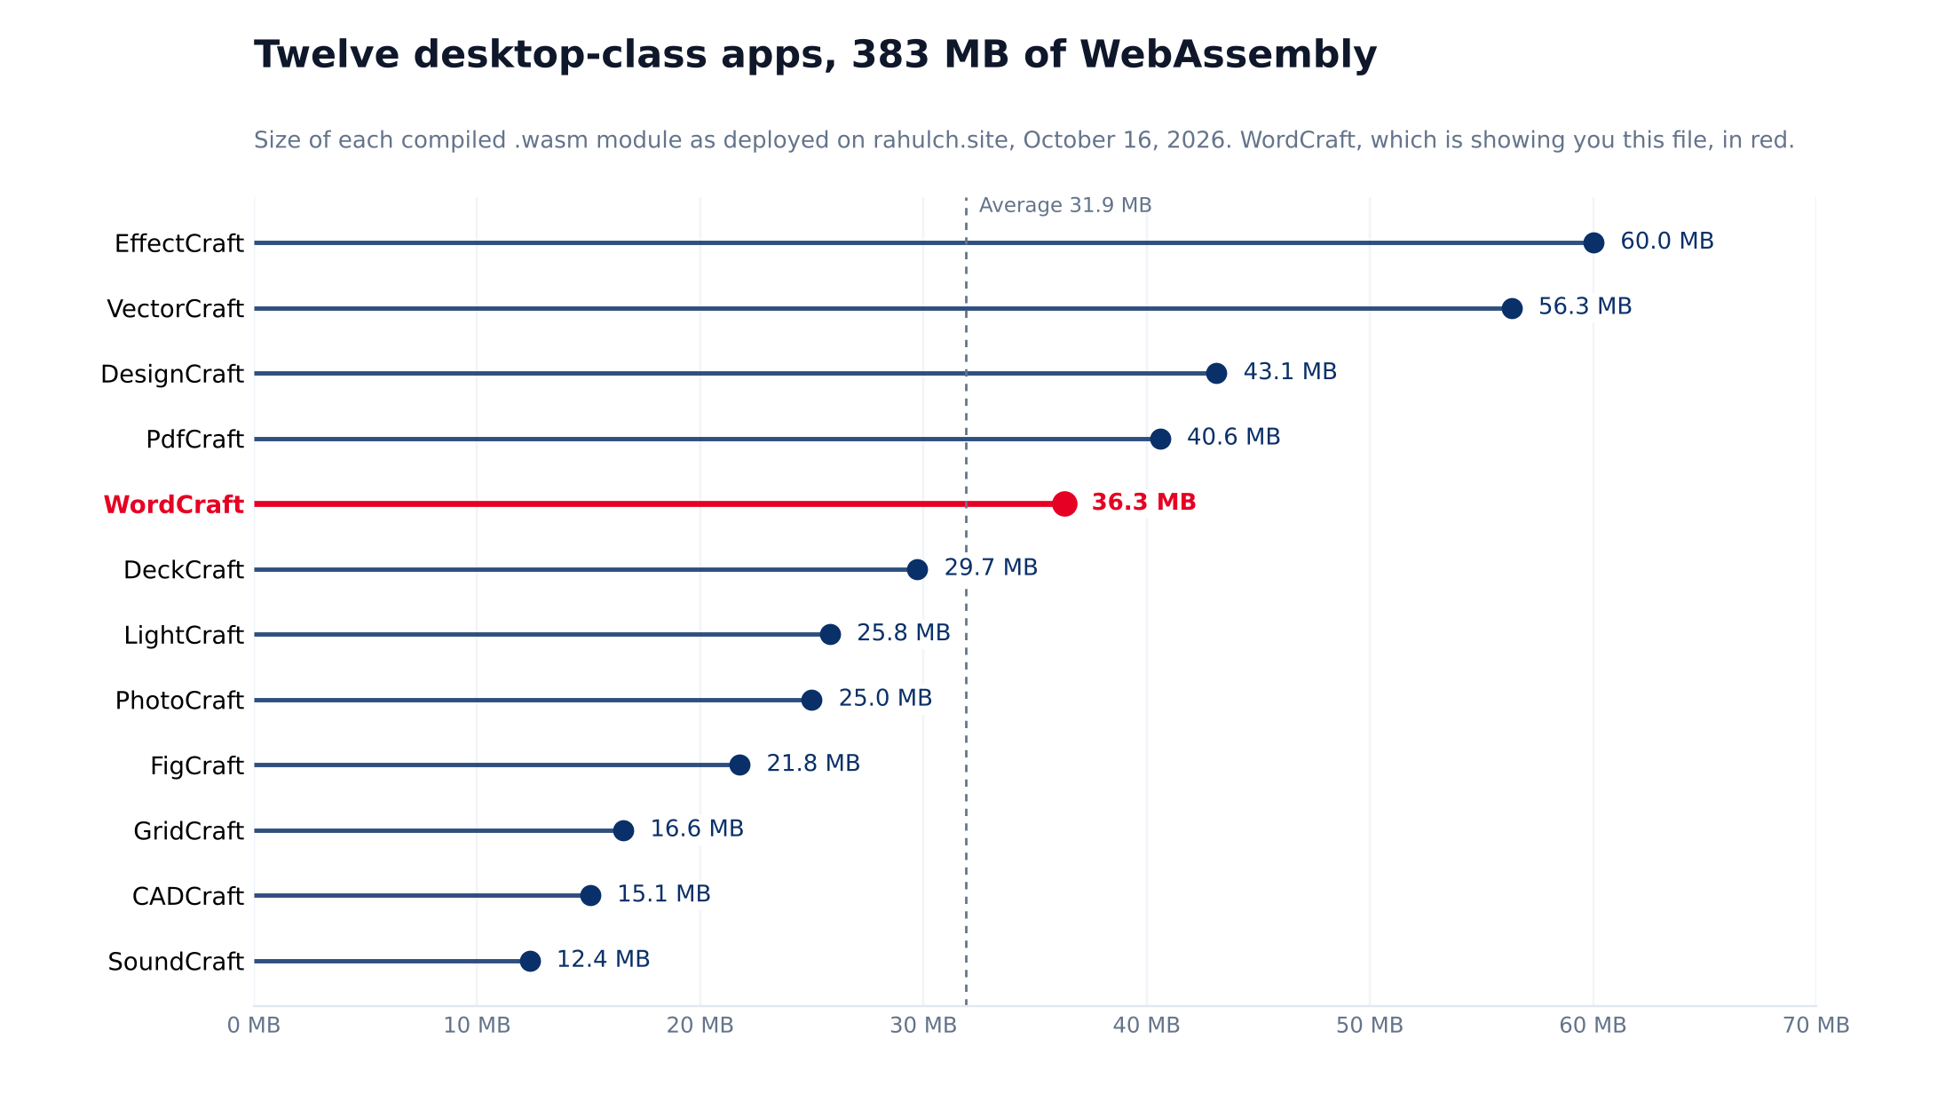
The suite at a glance
APP | WHAT IT DOES | MODULE SIZE | SHARE OF SUITE
EffectCraft | Motion graphics and visual effects | 60.0 MB | 15.7%
VectorCraft | Vector illustration | 56.3 MB | 14.7%
DesignCraft | Page layout with frames | 43.1 MB | 11.3%
PdfCraft | PDF reading, editing and signing | 40.6 MB | 10.6%
WordCraft | Word processing, with mail merge | 36.3 MB | 9.5%
DeckCraft | Slides and presenting | 29.7 MB | 7.8%
LightCraft | Photo library and raw developer | 25.8 MB | 6.7%
PhotoCraft | Layered photo editing | 25.0 MB | 6.5%
FigCraft | Interface design with components | 21.8 MB | 5.7%
GridCraft | Spreadsheets and formulas | 16.6 MB | 4.3%
CADCraft | 2D drafting, reads DXF and DWG | 15.1 MB | 3.9%
SoundCraft | Multitrack audio and MIDI | 12.4 MB | 3.2%
Total | 12 apps, one shared save layer | 382.7 MB | 100.0%
Source: the compiled .wasm files in the vibelogs repository, measured October 16, 2026. Categories come from each app's own interface and description. This file was built as a .docx, committed to craft-files, and opened by its own permalink.

Compiled .wasm files only, in decimal megabytes. JavaScript glue, licenses and fonts add 0.2 to 0.8 MB per app. LightCraft is the exception: it also ships a 16.4 MB Simplified Chinese font.
Twelve hex characters give 2 to the 48th power possible ids, about 281 trillion, which is plenty for one site.

