CollabTracker Installation steps

Table of Contents

A. Ensure the availability of java 1.8 or above in the desktop. 2

B. Execute the CollabTracker installer 2

C. Configure the DocCentrals 3

D. Catalog Server and Extended Server 4

E. Property files & xml 4

E.1. Commons.properties 4

E.2. client.properties 6

E.3. commonSysComponents.properties 6

E.4. server.properties 6

E.5. extdCtlgSrvrForDeckerLite.properties 6

E.6. PulishedRoots.xml 7

E.7. Set up to access googledrive based roots 8

E.8. Additional set up WebDAV roots 8

F. Orchestrators Execution 8

F.1. ClientOrchestrator 8

F.2. ServerOrchestrator 8

F.3. ExtendedServerOrchestrator 8

G. UI Execution 8

## A. Ensure the availability of java 1.8 or above in the desktop.

## B. Execute the CollabTracker installer

Installer file available in https://github.com/vibeeshK/CollabTracker/CollabTracker_Installer_v1.1.jar

Note: Each installation is set up for one desktop user only. Any new user shall install the application separately in a unique installation path.

Installation path shall be writable for the user.

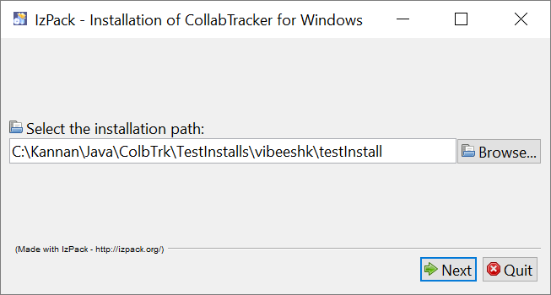

Review license agreement

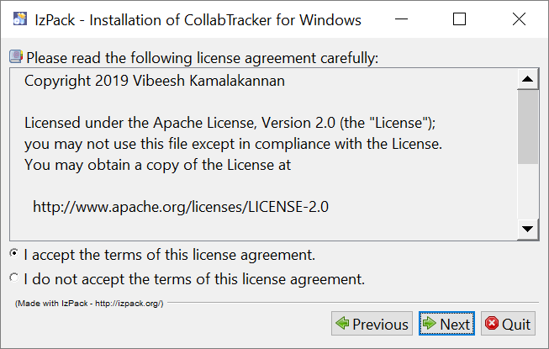

DecktopUserName shall be the user’s desktop login ID. If its for the same use who logged in, the just leave the auto-populated value.

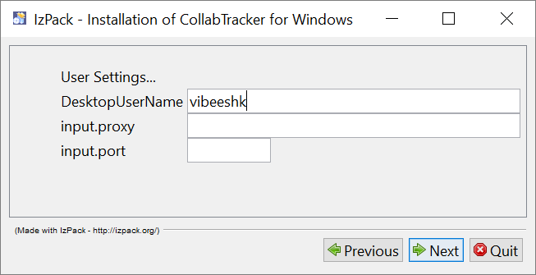

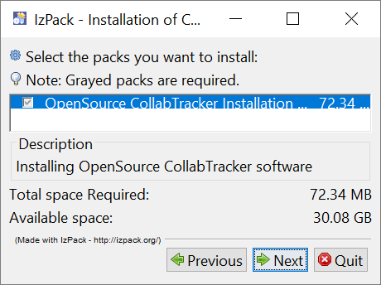

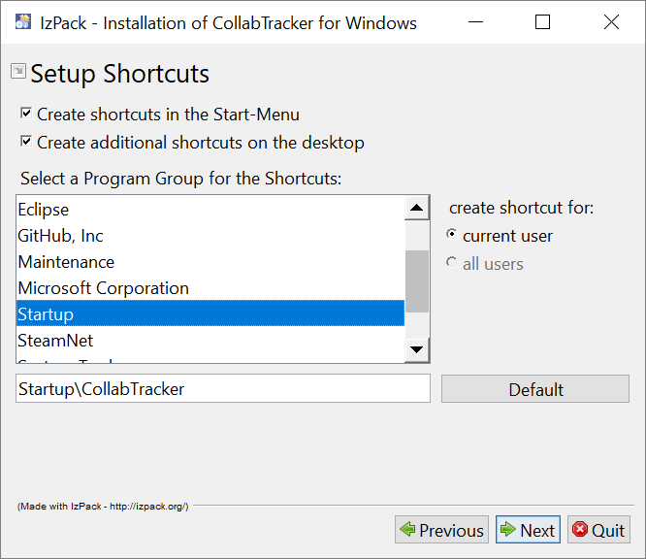

## C. Configure the DocCentral portal, Catalog and Extended servers

Follow the steps of ADMIN’s *initial activities* mentioned in CollabTracker_Simple_Intro.docx.

## D. Property files & xml

*Once the installer is run, check the yellow highlighted items in the below property files and xml’s for additional configurations.*

*All property files are located at the folder: <INSTALL_PATH>\mainJar64Bit\config*

### 

### D.1. Commons.properties

Maintains the common info across all machines. Most of the fields in this properties file are preset prior to or during installation.

Location: On all machines.

<INSTALL_PATH>\mainJar64Bit\config\commons.properties

e.g.: C:\Kannan\Java\ColbTrk\mainJar64Bit\config\commons.properties

installFileFolder=C\:\\Vibeesh\\Java\\ColbTrk (taken care by installer)

configDataFolder=ConfigData (no change required)

###################################################################

######folders and parm within User's Install Folder starts#########

tempfolder=tempFolder (no change required)

newReviewsFolder=newreviews (no change required)

responsesfolderlocal=responsesfolderlocal (no change required)

ContentDownLoadFolder=downloadedcontent (no change required)

newArtifactsFolder=newartifacts (no change required)

downloadedReviewsFolder=downloadedreviews (no change required)

localArchive=archive (no change required)

archiveDupeMax=100 (change based on expected dupes in 1 second)

##################(continued - subfolders)#########################

#folders and content that sit within configDataFolder starts#######

publishedRootsFile=PulishedRoots.xml (no change required)

SubscribedRootNicksFileName=SubscribedRootNicks.xml (no change required)

downloadedCatalogDetailsFile=DownloadedCatalogDetails.json (no change required)

certificates=certificates (no change required)

osHandlers=dynamicJars\\ColbTrkOsHandlers.jar (no change required)

remoteAccessers=dynamicJars\\ColbTrkRemoteAccessers.jar (no change required)

contentHandlers=dynamicJars\\ColbTrkCntHandlers.jar (no change required)

BackgroundImage=BackGroundImage.jpg (change when bored)

ApplicationIcon=CollabTrack.ico (no change required)

rootConfigFolder=rootconfigs (no change required)

###################################################################

#######working content folder within users/username folder#########

artifactsFolder=ColbTrkUserArtifacts (no change required)

###################################################################

###################################################################

#folders and parm at content server starts#########################

catalogDbPublishFilePrefix=catalogDbPublishedCopyOf (no change required)

allMembersReadableFolder=1_allmembersreadable (no change required)

serverSideSideCatalogDbPublishFolder=catalogpublishfolder (no change required)

remoteArtifacts=artifacts (no change required)

responsepickbox=responsepickbox (no change required)

contributorsWritableFolder=2_contributorswritable (no change required)

requestdropbox=requestdropbox (no change required)

contentdropbox=contentdropbox (no change required)

adminBranchRelevance=MyOrg\\General (no change required)

###################################################################

########platform/system root related folders and parm starts#######

#suppressSysCompRefresh valid values: YES NO

(Keeping it as YES will speed up, but you have to change to NO when adding new content type or changes to published root configuration or any config data change from platform root)

suppressSysCompRefresh=NO

sysDbFileLocation=SysDBDownloadFolder\\sysdbfile

sysUpdateLogDoc=ColbTrkUpdatesLog.xml

templatesFolder=templates

###################################################################

##################clientside parameters starts#####################

clientDbFilePath=clientdbfileFolder

clientDbFileName=clientdbfile

clientSideCatalogDbReceiveFolder=ClientSideReceivedCatalogDbs

catalogDownloadTimeGapSec=5 (change as per your refresh frequency needs)

###################################################################

#################connectivity parameters starts####################

(change as required to check and set internet access by the application)

siteToCheckInternet=http\:\/\/www.google.com

httpProxyHost=20.201.110.111 (set by installer. But change when proxy changes)

httpProxyPort=80 (set by installer. But change when proxy changes)

httpsProxyHost=20.201.110.111(set by installer. But change when proxy changes)

httpsProxyPort=80 (set by installer. But change when proxy changes)

###################################################################

### D.2. client.properties

Maintains the info relevant for client side operations

Location: Only on users’ machines and Extended processing servers.

<INSTALL_PATH>\mainJar64Bit\config\commons.properties

e.g.: C:\Kannan\Java\ColbTrk\mainJar64Bit\config\commons.properties

OSHandler=osHandlers.WindowsFileAccesser (Only Windows now; can be extended)

UserName.ODCGglDocCentral=DEMOUSER

UserName.DemoWinContentRoot=DEMOUSER (App-UserName; Set via Root Maintenance UI)

(Admin should create contentDropBox with this name and provide write access on it before user can publish any artifact)

### D.3. commonSysComponents.properties

Maintains the info around component upgrade and user’s chosen Root content repository

Location: On all machines.

<INSTALL_PATH>\mainJar64Bit\config\commonSysComponents.properties

e.g.: C:\Kannan\Java\ColbTrk\mainJar64Bit\config\commonSysComponents.properties

sysCompCurrLocalLogUpdateTm=20190725030716 (taken care by app)

defaultUIRootNick=DemoWinContentRoot (user’s selection via UI)

platformRoot=DemoWinPlatformRoot (Change based on installation specifics)

### D.4. server.properties

Maintains the info for server side operations. Not required at user machines.

Location: Only on the machine where the catalog server orchestrator runs.

<INSTALL_PATH>\mainJar64Bit\config\server.properties

e.g.: C:\Kannan\Java\ColbTrk\mainJar64Bit\config\server.properties

bsSrverFolder=bsSrver (no change required)

serverrootNicks=DemoWinContentRoot (Change based on installation specifics)

serversOwnCopyofCatalogDbLocalFolder=catalogMasterDbFiles (no change required)

serversMasterCopyofCatalogDbPrefix=catalogMasterDbFileOf (no change required)

reqTrackersFolderLocal=reqtrackersfolderlocal (no change required)

versioningFilesFolderLocal=versioningfilesfolderlocal (no change required)

erlMaxVersions=2 (Change based on installation specifics)

inactiveAgingDaysLimit=0 (Change based on installation specifics)

behindSceneFolder=3_behindscene (no change required)

remoteArhive=archivedrequests (no change required)

remoteInactiveERLsArchive=archivedinactiveerls (no change required)

remoteErroredRequests=erroredrequests (no change required)

### D.5. extdCtlgSrvrForDeckerLite.properties

Maintains the info for extended server operations of deckerLite. Not required at user machines

Location: Only on the Extended processing server for DeckerGrouper content Types.

<INSTALL_PATH>\mainJar64Bit\config\extdCtlgSrvrForDeckerLite.properties

e.g.: C:\Kannan\Java\ColbTrk\mainJar64Bit\config\extdCtlgSrvrForDeckerLite.properties

extdSrvrFolder=extdSrvrDeckrLite (no change required)

extededCatalogDbPrefix=catalogXtdDeckrLiteDbFileOf (no change required)

extededCatalogDbLocalFolder=extendedcatalogdbfiles (no change required)

extdSrvrRootNicks=DemoWinContentRoot (Change based on installation specifics)

extdSrvrContentTypes=DeckerLite (Change based on extended process)

xtndHandlers=dynamicJars\\ColbTrkXtndHandlers.jar (no change required)

userName=XTDDECKERLITE (App-UserName; Change as required)

extdSrvrProcessFolder=xtdProcs\\DeckerLite (Change based on extended process)

The above applies to all other extended process properties files.

extdCtlgSrvrForExtendedGrouper.properties

extdCtlgSrvrForStdProcessor.properties

extdCtlgSrvrForTmShProcessor.properties

### E.6. PulishedRoots.xml

This file has to be updated only for new roots. It tells the application the root nick, the root string which is the physical path, the accessor to be used viz. windows file management; google drive; WebDAV

Location: On all machines.

<INSTALL_PATH>\<Desktop-UserName>\ConfigData\PulishedRoots.xml

e.g.: C:\Kannan\Java\ColbTrk\kvasavaiah\ConfigData\PulishedRoots.xml

Note: Only one platform root will be required for any installation.

<Root

RootNick="DemoWinPlatformRoot"

RootType="System" (System Roots are for admin’s use to push new components.

Regular Roots are where regular contents are published.)

RootString="C:\Kannan\Java\ColbTrk\WindowsRoots\DemoWinPlatformRoot"

(Physical Path)

RemoteAccesserType="remoteAccessers.WindowsAccesser"

(Physical Path)

FileSeparator="/" (Node separator of the root)

RequiresInternet="No" (Roots accessibility requirement)

/>

<Root

RootNick=" DemoGShPlatformRoot"

RootType="Regular"

RootString="1m_bP_GX_9GNqc2YvH0If7VWXTxTgbjo8"

(This rootString value is the last node of the URL while navigating to the path of the GoogleDrive folder which is set as the root repository)

RemoteAccesserType="remoteAccessers.GDriveShAccesser"

FileSeparator="/"

RequiresInternet="Yes" (Roots accessibility requirement)

/>

<Root

RootNick="DemoWinContentRoot"

RootType="Regular"

RootString="C:\Kannan\Java\ColbTrk\WindowsRoots\DemoWinContentRoot"

RemoteAccesserType="remoteAccessers.WindowsAccesser"

FileSeparator="\"

RequiresInternet="No" (Roots accessibility requirement)

/>

### D.7. Set up to access googledrive based roots

Copy the credential file of the google drive repository into:

<INSTALL_PATH>\<Desktop-UserName>\ConfigData\rootconfigs\<rootNick>\

with a file name <rootNick>_credentials.json

e.g.: C:\Kannan\Java\ColbTrk\kvasavaiah\ConfigData\rootconfigs\DemoGShContentRoot\ODCGglDocCentral_credentials.json

Refer <https://developers.google.com/drive/api/v3/quickstart/go> for generating Credentials.

### D.8. Additional set up WebDAV roots

The application automatically refreshes the keystore for the required SSL of the root programmatically. WebDAV roots needs thorough testing prior to full usage.

## E. Orchestrators Execution

The orchestrator batch files shall be triggered at start-up of the system each time. Once triggered, the orchestrators will stay alive until manually stopped. Ensure to stop the process before shutting down the machine.

### E.1. ClientOrchestrator

Location: user’s machine and extended processor.

<INSTALL_PATH>\Java\ColbTrk\mainJar64Bit\ColbTrk_ClientOrchestrator.bat

C:\Kannan\Java\ColbTrk\mainJar64Bit\ColbTrk_ClientOrchestrator.bat

### E.2. ServerOrchestrator

Location: Catalog server orchestrating machine.

<INSTALL_PATH>\Java\ColbTrk\mainJar64Bit\ColbTrk_ServerOrchestrator.bat

C:\Kannan\Java\ColbTrk\mainJar64Bit\ColbTrk_ServerOrchestrator.bat

### E.3. ExtendedServerOrchestrator

Location: Extended Process orchestrating machine.

<INSTALL_PATH>\Java\ColbTrk\mainJar64Bit\<ExtendedProcessOrchestrator>.bat

C:\Kannan\Java\ColbTrk\mainJar64Bit\ColbTrk_XtdDeckerProcOrchestrator.bat

## F. UI Execution

After completing all the above steps the application can be invoked using the ColbTrk_ClientUI in the user’s machines.

Location: user’s machine.

<INSTALL_PATH>\Java\ColbTrk\mainJar64Bit\ColbTrk_ClientUI.bat

C:\Kannan\Java\ColbTrk\mainJar64Bit\ColbTrk_ClientUI.bat