DeClouder Installation steps

Table of Contents

A. Ensure the availability of java 1.8 or above in the desktop. 2

B. Execute the oDeClouder installer 2

C. Configure the DocCentral’s 2

D. Catalog Server and Extended Server 2

E. Property files & xml 3

E.1. Commons.properties 3

E.2. client.properties 4

E.3. commonSysComponents.properties 4

E.4. server.properties 4

E.5. extdCtlgSrvrForDeckerLite.properties 5

E.6. PulishedRoots.xml 5

E.7. Set up to access googledrive based roots 6

E.8. Additional set up WebDAV roots 6

F. Orchestrators Execution 6

F.1. ClientOrchestrator 6

F.2. ServerOrchestrator 6

F.3. ExtendedServerOrchestrator 7

G. UI Execution 7

## A. Ensure the availability of java 1.8 or above in the desktop.

## B. Execute the oDeClouder installer

Installer file available in https://github.com/vibeeshK/DeClouder/OpenDeClouderInstaller_v1.0.jar

Installation path shall be writable for the user.

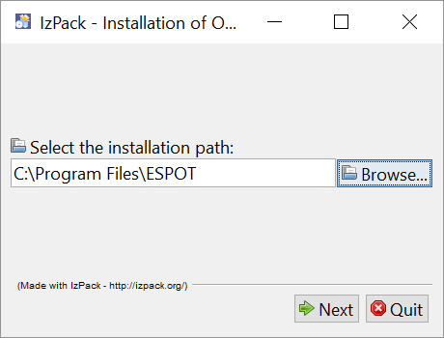

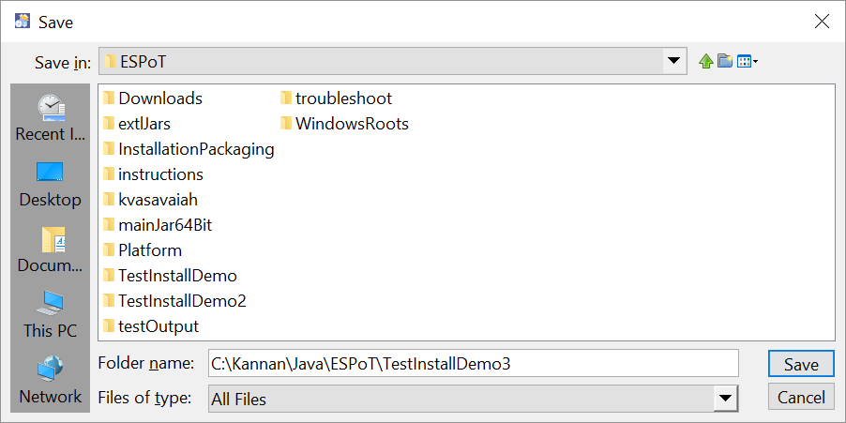

Review license agreement

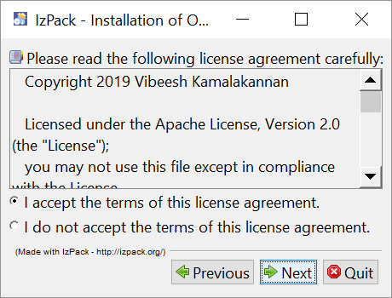

DecktopUserName shall be the authenticating user name on the desktop.

ApplicationUserName is the authorized user in DeClouder application

ExtendedServerUerName is the user name of the extended server processor

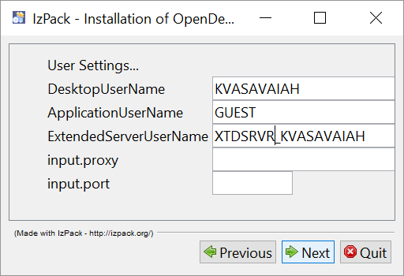

## C. Configure the DocCentrals

Decide on the content DocCentral Root site and location. It can be maintained on a Windows File System or a Google Drive or a WebDAV enabled repository.

All users will require *read* access on all the relevance folders as well as the catalog publish folder. And all authors, requestors and reviewers will need *write* access on Request Drop box and Content Drop box folders. The Server Orchestrator app-userID will require *write* access to catalog publish folder as well.

Decide on the platform DocCentral Root as well. A platform root is required only if you are going to introduce a new content handler. Extend *read* access to all users.

Location: Content Doc Central Servers

Request drop box:

<INSTALL_PATH>\ESPoT\WindowsRoots\DemoWinContentRoot\requestdropbox

e.g. C:\Kannan\Java\ESPoT \WindowsRoots\DemoWinContentRoot\requestdropbox

Content drop box:

<INSTALL_PATH>\WindowsRoots\DemoWinContentRoot\contentdropbox

e.g. C:\Kannan\Java\ESPoT\WindowsRoots\DemoWinContentRoot\contentdropbox

Artifact Relevance Folders:

<INSTALL_PATH>\ESPoT\WindowsRoots\DemoWinContentRoot\<Relevances Braches>

e.g. C:\Kannan\Java\ESPoT\WindowsRoots\DemoWinContentRoot\MyOrg\

## D. Catalog Server and Extended Server

Choose the machines where the Server / ExtendedServer Orchestrators will run.

Update the catalogMaster db. Update the Users table with details of all app-users who can submit request, author or review and admin. Set up all the branches of the artifacts in the Relevance table.

Refer DeClouder_DB_Details.docx document for the database set up and location details.

## E. Property files & xml

*Once the installer is run, check the yellow highlighted items in the below property files and xml’s for additional configurations.*

*All property files are located at the folder: <INSTALL_PATH>\mainJar64Bit\config*

### E.1. Commons.properties

Maintains the common info across all machines. Most of the fields in this properties file are preset prior to or during installation.

Location: On all machines.

<INSTALL_PATH>\mainJar64Bit\config\commons.properties

e.g.: C:\Kannan\Java\ESPoT\mainJar64Bit\config\commons.properties

installFileFolder=C\:\\Kannan\\Java\\ESPoT (taken care by installer)

configDataFolder=ConfigData (no change required)

###################################################################

#folders and content that sit within configDataFolder starts#######

publishedRootsFile=PulishedRoots.xml (no change required)

SubscribedRootNicksFileName=SubscribedRootNicks.xml (no change required)

downloadedCatalogDetailsFile=DownloadedCatalogDetails.xml (no change required)

certificates=certificates (no change required)

#osHandlers=dynamicJars\\osHandlers.jar

osHandlers=dynamicJars\\ESPoTOsHandlers.jar (no change required)

#remoteAccessers=dynamicJars\\remoteAccessers.jar (no change required)

remoteAccessers=dynamicJars\\ESPoTRemoteAccessers.jar (no change required)

#contentHandlers=dynamicJars\\contentHandlers.jar (no change required)

contentHandlers=dynamicJars\\ESPoTCntHandlers.jar (no change required)

BackgroundImage=BackGroundImage.jpg (no change required)

rootConfigFolder=rootconfigs (no change required)

#folders and content that sit within configDataFolder ends#########

###################################################################

artifactsFolder=OpenDeClouderUserArtifacts (no change required)

###################################################################

#folders and content that sit within Artifacts path starts#########

tempfolder=tempFolder (no change required)

newReviewsFolder=newreviews (no change required)

responsesfolderlocal=responsesfolderlocal (no change required)

ContentDownLoadFolder=downloadedcontent (no change required)

newArtifactsFolder=newartifacts (no change required)

downloadedReviewsFolder=downloadedreviews (no change required)

localArchive=archive (no change required)

archiveDupeMax=100 (change based on expected dupes in 1 second)

#folders and content that sit within Artifacts path ends###########

###################################################################

responsepickbox=responsepickbox (no change required)

requestdropbox=requestdropbox (no change required)

sysUpdateLogDoc=ESPoTUpdatesLog.xml

serverSideSideCatalogDbPublishFolder=catalogpublishfolder (no change required)

clientDbFilePath=clientdbfileFolder (no change required)

catalogDbDownloadFolderAtLocal=catalogdbdownloadfolder (no change required)

templatesFolder=templates (no change required)

sysDbFileLocation=SysDBDownloadFolder\\sysdbfile (no change required)

catalogDbPublishFilePrefix=catalogDbPublishedCopyOf (no change required)

remoteArhive=archivedrequests (no change required)

clientDbFileName=clientdbfile (no change required)

clientSideCatalogDbReceiveFolder=ClienSideReceivedCatalogDbs (no change required)

contentdropbox=contentdropbox (no change required)

catalogDownloadTimeGapSec=5 (change as per your refresh frequency needs)

#suppressSysCompRefresh valid values: YES NO

suppressSysCompRefresh=NO (Keeping it as YES will speed up, but you have to change to NO when adding new content type or changes to published root configuration or any config data change from platform root)

httpProxyHost=20.201.110.111 (set by installer. But change when proxy changes)

httpProxyPort=80 (set by installer. But change when proxy changes)

httpsProxyHost=20.201.110.111 (set by installer. But change when proxy changes)

httpsProxyPort=80 (set by installer. But change when proxy changes)

### E.2. client.properties

Maintains the info relevant for client side operations

Location: Only on users’ machines and Extended processing servers.

<INSTALL_PATH>\mainJar64Bit\config\commons.properties

e.g.: C:\Kannan\Java\ESPoT\mainJar64Bit\config\commons.properties

clientMcFolder=clientMc (no change required)

OSHandler=osHandlers.WindowsFileAccesser (Only Windows now; can be extended)

userName=DEMOUSER (App-UserName; Captured by installer)

### E.3. commonSysComponents.properties

Maintains the info around component upgrade and user’s chosen Root content repository

Location: On all machines.

<INSTALL_PATH>\mainJar64Bit\config\commonSysComponents.properties

e.g.: C:\Kannan\Java\ESPoT\mainJar64Bit\config\commonSysComponents.properties

sysCompCurrLocalLogUpdateTm=20190725030716 (taken care by app)

defaultUIRootNick=DemoWinContentRoot (user’s selection via UI)

platformRoot=DemoWinPlatformRoot (Change based on installation specifics)

### E.4. server.properties

Maintains the info for server side operations. Not required at user machines.

Location: Only on the machine where the catalog server orchestrator runs.

<INSTALL_PATH>\mainJar64Bit\config\server.properties

e.g.: C:\Kannan\Java\ESPoT\mainJar64Bit\config\server.properties

bsSrverFolder=bsSrver (no change required)

serverrootNicks=DemoWinContentRoot (Change based on installation specifics)

serversOwnCopyofCatalogDbLocalFolder=catalogMasterDbFiles (no change required)

serversMasterCopyofCatalogDbPrefix=catalogMasterDbFileOf (no change required)

reqTrackersFolderLocal=reqtrackersfolderlocal (no change required)

versioningFilesFolderLocal=versioningfilesfolderlocal (no change required)

erlMaxVersions=2 (Change based on installation specifics)

### E.5. extdCtlgSrvrForDeckerLite.properties

Maintains the info for extended server operations of deckerLite. Not required at user machines

Location: Only on the Extended processing server for DeckerGrouper content Types.

<INSTALL_PATH>\mainJar64Bit\config\extdCtlgSrvrForDeckerLite.properties

e.g.: C:\Kannan\Java\ESPoT\mainJar64Bit\config\extdCtlgSrvrForDeckerLite.properties

extdSrvrFolder=extdSrvrDeckrLite (no change required)

extededCatalogDbPrefix=catalogXtdDeckrLiteDbFileOf (no change required)

extededCatalogDbLocalFolder=extendedcatalogdbfiles (no change required)

extdSrvrRootNicks=DemoWinContentRoot (Change based on installation specifics)

extdSrvrContentTypes=DeckerLite (Change based on extended process)

xtndHandlers=dynamicJars\\ESPoTXtndHandlers.jar (no change required)

userName=xtdgrpr_kvasavaiah (App-UserName; Captured by installer)

extdSrvrProcessFolder=xtdProcs\\DeckerLite (Change based on extended process)

The above applies to any other extended process properties files.

extdCtlgSrvr.properties

extdCtlgSrvrForExtendedGrouper.properties

extdCtlgSrvrForStdProcessor.properties

extdCtlgSrvrForTmShProcessor.properties

### E.6. PulishedRoots.xml

This file has to be updated for any new root. It tells the application the root nick, the root string which is the physical path, the accessor to be used viz. windows file management; google drive; WebDAV

Location: Only on the Extended processing server for DeckerGrouper content Types.

<INSTALL_PATH>\<Desktop-UserName>\ConfigData\PulishedRoots.xml

e.g.: C:\Kannan\Java\ESPoT\kvasavaiah\ConfigData\PulishedRoots.xml

<Root

RootNick="DemoWinPlatformRoot"

RootType="System" (System Roots are for admin’s use to push new components.

Regular Roots are where regular contents are published.)

RootString="C:\Kannan\Java\ESPoT\WindowsRoots\DemoWinPlatformRoot"

(Physical Path)

RemoteAccesserType="remoteAccessers.WindowsAccesser"

(Physical Path)

FileSeparator="/" (Node separator of the root)

/>

<Root

RootNick="ODCGglDocCentral"

RootType="Regular"

RootString="1m_bP_GX_9GNqc2YvH0If7VWXTxTgbjo8"

(This rootString value is the last node of the URL while navigating to the path of the GoogleDrive folder which is set as the root repository)

RemoteAccesserType="remoteAccessers.GDriveShAccesser"

FileSeparator="/"

/>

<Root

RootNick="KKTestRoot"

RootType="Regular"

RootString="https://testaaaaaaaaaaaaaa.aaaaaaaaa.com"

RemoteAccesserType="remoteAccessers.WebDAVAccesser"

FileSeparator="/"

/>

<Root

RootNick="DemoWinContentRoot"

RootType="Regular"

RootString="C:\Kannan\Java\ESPoT\WindowsRoots\DemoWinContentRoot"

RemoteAccesserType="remoteAccessers.WindowsAccesser"

FileSeparator="\"

/>

### E.7. Set up to access googledrive based roots

Copy the credential file of the google drive repository into:

<INSTALL_PATH>\<Desktop-UserName>\ConfigData\rootconfigs\<rootNick>\

with a file name <rootNick>_credentials.json

e.g.: C:\Kannan\Java\ESPoT\kvasavaiah\ConfigData\rootconfigs\ODCGglDocCentral\ODCGglDocCentral_credentials.json

Refer <https://developers.google.com/drive/api/v3/quickstart/go> for generating Credentials.

### E.8. Additional set up WebDAV roots

The application automatically refreshes the keystore for the required SSL of the root programmatically. WebDAV roots needs thorough testing prior to full usage.

## F. Orchestrators Execution

The orchestrator batch files shall be triggered at start-up of the system each time. Once triggered, the orchestrators will stay alive until manually stopped. Ensure to stop the process before shutting down the machine.

### F.1. ClientOrchestrator

Location: user’s machine and extended processor.

<INSTALL_PATH>\Java\ESPoT\mainJar64Bit\ESPoT_ClientOrchestrator.bat

C:\Kannan\Java\ESPoT\mainJar64Bit\ESPoT_ClientOrchestrator.bat

### F.2. ServerOrchestrator

Location: Catalog server orchestrating machine.

<INSTALL_PATH>\Java\ESPoT\mainJar64Bit\ESPoT_ServerOrchestrator.bat

C:\Kannan\Java\ESPoT\mainJar64Bit\ESPoT_ServerOrchestrator.bat

### F.3. ExtendedServerOrchestrator

Location: Extended Process orchestrating machine.

<INSTALL_PATH>\Java\ESPoT\mainJar64Bit\<ExtendedProcessOrchestrator>.bat

C:\Kannan\Java\ESPoT\mainJar64Bit\ESPoT_XtdDeckerProcOrchestrator.bat

## G. UI Execution

After completing all the above steps the application can be invoked using the CatalogDisplay in the user’s machines.

Location: user’s machine.

<INSTALL_PATH>\Java\ESPoT\mainJar64Bit\ESPoT_CatalogDisplay.bat

C:\Kannan\Java\ESPoT\mainJar64Bit\ESPoT_CatalogDisplay.bat