CamPed Dataset and Enriched Camped Dataset
We created a self-acquired dataset called CamPed (Campus Pedestrians because the dataset contains pedestrian images captured within the IIITDM Kancheepuram campus) that included diversities such as different lighting conditions, pedestrians with and without occlusion, multiscale pedestrians, pose variations, pedestrians carrying objects, crowded environments, different view angles, pedestrians with various speeds (normal, fast, jogging, running), pedestrians at a far distance, staircase sequence and bird eye view sequence. All the videos were captured within the IIITDM campus. We have created the dataset in three phases. In the first phase, we recorded videos in a restricted outdoor environment where subjects were limited to eight directions of movement. The number of subjects ranged from one to four, and the videos featured pedestrians wearing different clothing, carrying objects, walking at various speeds (slow, normal, fast, and running), and sometimes occluding each other. We captured videos from different camera positions, including below eyesight, eyesight, low angle, and high angle. We also took videos with slight deviations (left, right) for each direction and captured videos with static and dynamic occlusion featuring two or three people. Videos with different genders were also recorded. In the second phase, we recorded videos in an unconstrained outdoor environment, including different lighting conditions, small and crowded pedestrians, and occlusion. We captured videos of people playing football and basketball with different poses, including day and night lighting conditions. In the third phase, we captured videos in both indoor and outdoor environments in an unconstrained manner. Videos with different variations, such as corridor sequence, staircase sequence, and videos from a bird’s-eye view, were included in this phase. After capturing the videos, we pre-processed them by splitting them based on length. The length of all videos ranged from 5 seconds to 20 seconds. The entire database consists of 1516 videos. We converted videos into frames with 30 fps and created an annotated database of 100K images using the Roboflow tool. Later, we have enriched our existing dataset(Enriched CamPed Dataset) by adding images from the pedestrian detection dataset PnPLO(Person and Person Like Objects). These images feature person-like objects such as statues, human sculptures, puppets, mannequins, scarecrows, robots, and other objects resembling.
Link: https://github.com/RahulRaman2/CamPed-Dataset
Link: RahulRaman2/Enriched-CamPed-Dataset · GitHub
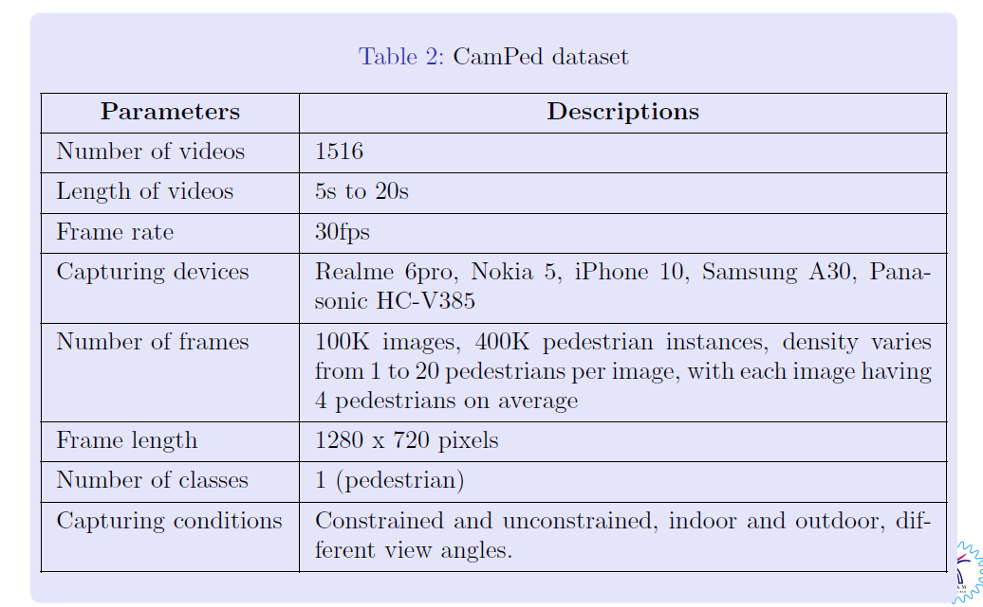
Images:

