4)Create a repository on GitHub (remote system) and write a Python program that performs addition and subtraction of two numbers in main/master branch. Clone this repository to your local system. Then, create a new branch named " local " locally, add functionalities for multiplication and division to the existing program, and push the updated branch back to the remote GitHub repository.
Program
a=float(input("Enter first number: "))
b= float(input("Enter second number: "))
print("Addition =", a + b)
print("Subtraction =", a - b)
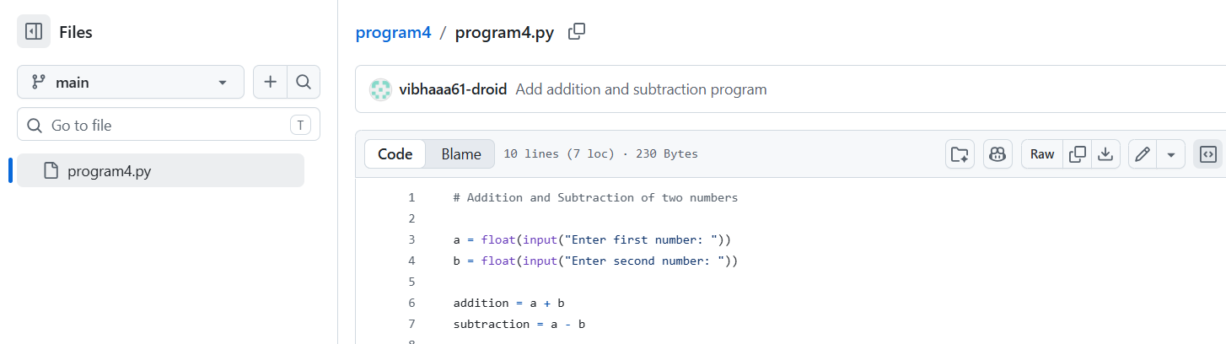
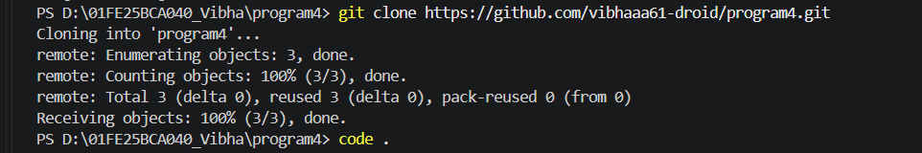
Output :
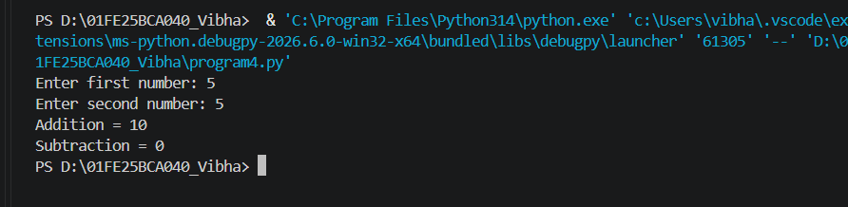
Modified Program:
a=int(input("Enter first number: "))
b=int(input("Enter second number: "))
print("Addition =", a + b)
print("Subtraction =", a - b)
print("Multiplication =", a * b)
print("Division =", a / b)
Output:
