Pascal’s Triangle
Expected Output:
Enter the number of rows: 5 1
1 1
1 2 1
1 3 3 1
1 4 6 4 1

Draw using Coords

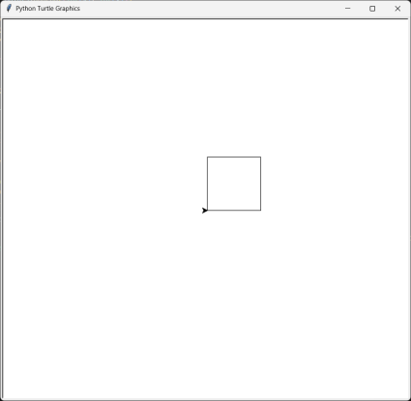
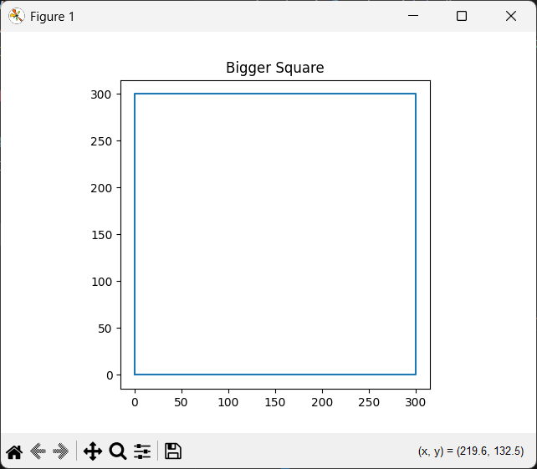

Sockets

Expected Output(Server):

Server listening on 127.0.0.1:5001
Connected by ('127.0.0.1', 54906)
Received message: Top Secret Message!

Expected Output(Client):

Message sent to server.

