**Sending WIFI credentials from client to ESP32 over BLE**

Overview

This project focuses on using an ESP32 microcontroller to establish a Bluetooth Low Energy (BLE) server for securely transmitting WiFi credentials. It enables the ESP32 to receive SSID and password information via BLE from connected devices, facilitating dynamic WiFi network connections. The setup involves creating a customized BLE server to manage communication and store credentials. Upon receiving credentials, the ESP32 attempts to connect to the specified WiFi network. An indicator LED provides visual feedback on the WiFi connection status.

* Installation Instructions

1. **Setting Up Arduino IDE**
   * Download and install the Arduino IDE .
   * Open Arduino IDE and configure settings as necessary for the esp32(refer below for esp32 configuration).
2. **Installing Libraries**
   * Use the Arduino Library Manager to install the following libraries:
     + BLEDevice
     + BLEServer
     + BLEUtils
     + WiFi
3. **Including Libraries**
   * Include all the libraries from sketch🡪Include library🡪 WiFi and Ble

(under esp32 section).

* IProgram Flow

• **Initialization:**

* Begin by initializing the BLE and Serial communication. Set up an indicator LED on GPIO pin 2.

• **BLE Setup:**

* Initialize a BLE server and create a custom service. Define characteristics for SSID and password within this service.

• **Advertising:**

* Start advertising the BLE service to allow other devices to discover and connect.

• **Main Loop Execution:**

* Continuously run the wifi_begin() function in the loop() to manage WiFi connection attempts.

• **WiFi Connection Handling (wifi_begin() function):**

* Check if WiFi is already connected (wifiConnected flag).
* If not connected:
  + Retrieve SSID and password from BLE characteristics.
  + Check if both SSID and password are not empty.
  + Attempt to connect to the WiFi network using received credentials (WiFi.begin()).
  + Wait for up to 10 seconds for the connection (i < 10 loop iteration).
  + If connected (WiFi.status() == WL_CONNECTED), set wifiConnected to true and call wifi_connected().
  + If not connected, set wifiConnected to false and indicate failure.

• **WiFi Connection Indication (wifi_connected() function):**

* Toggle the indicator LED to blink every second when WiFi is successfully connected (wifiConnected == true).

Screenshots

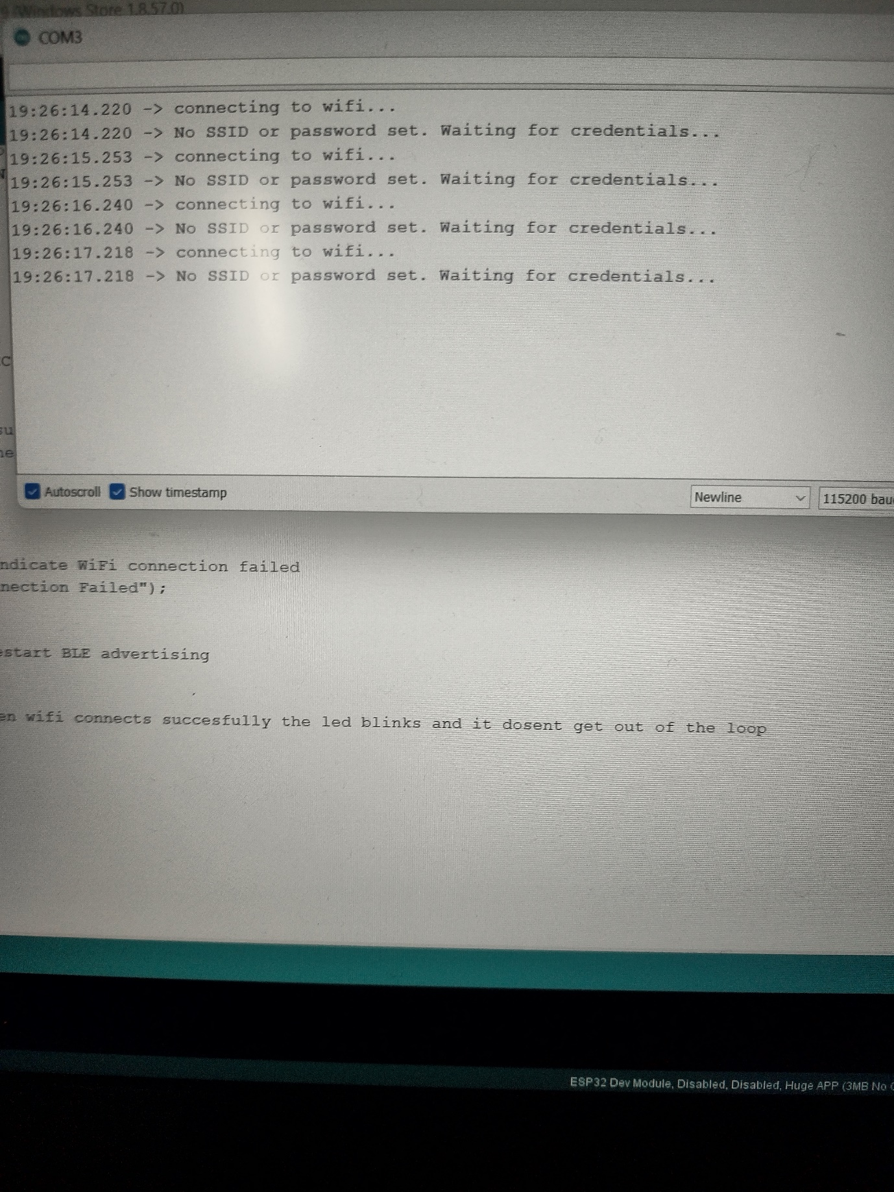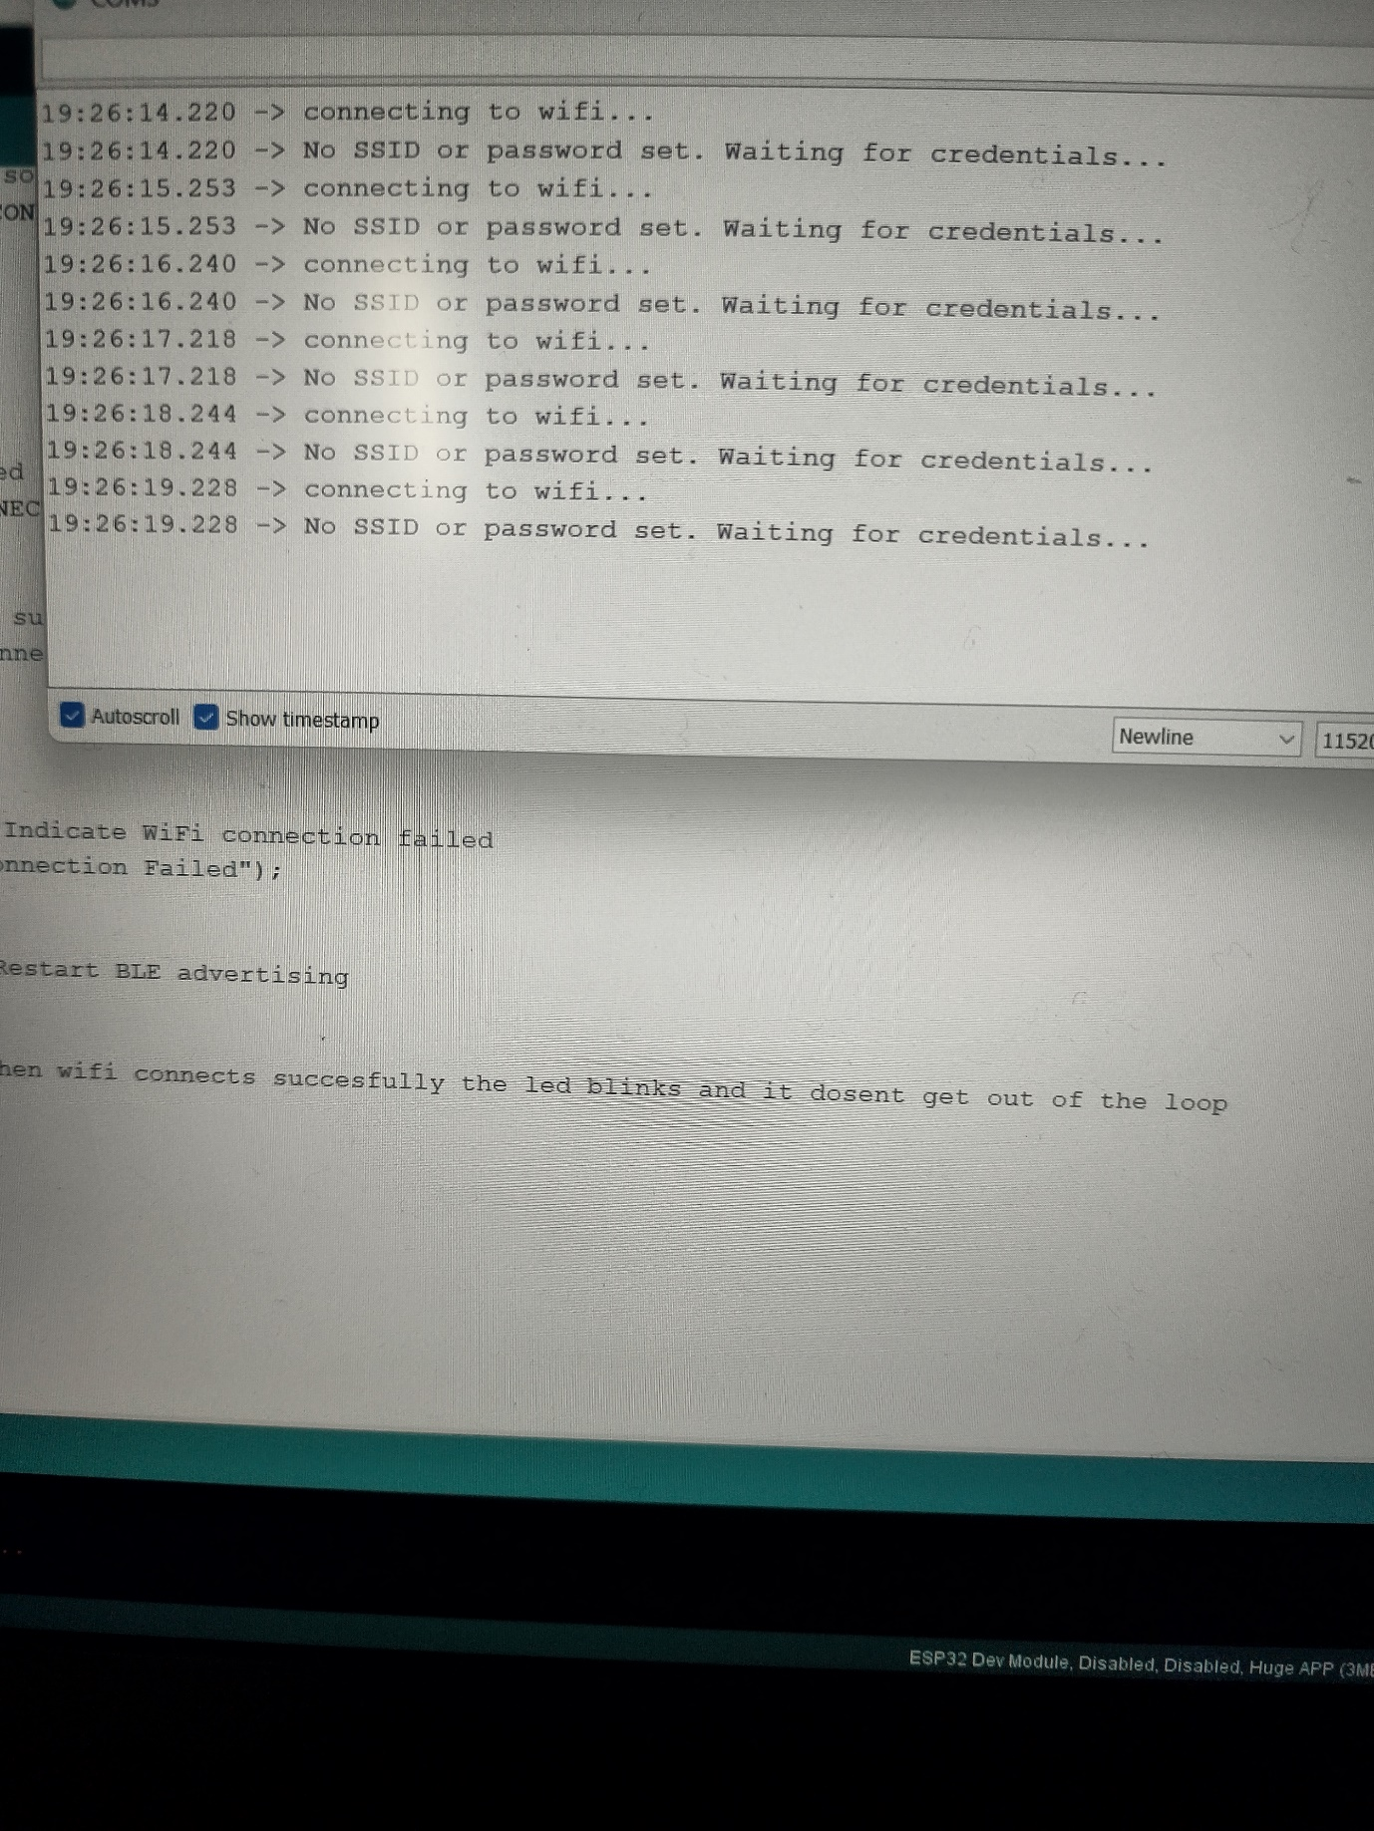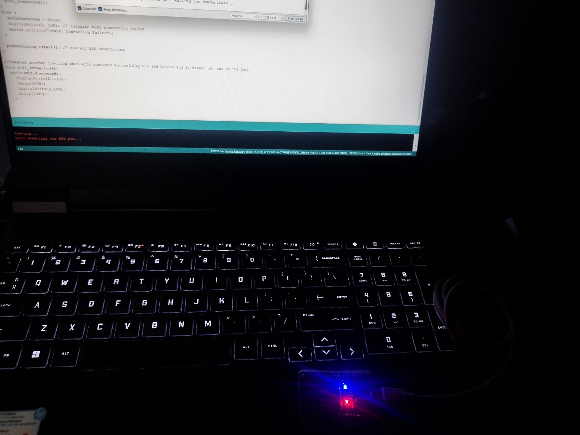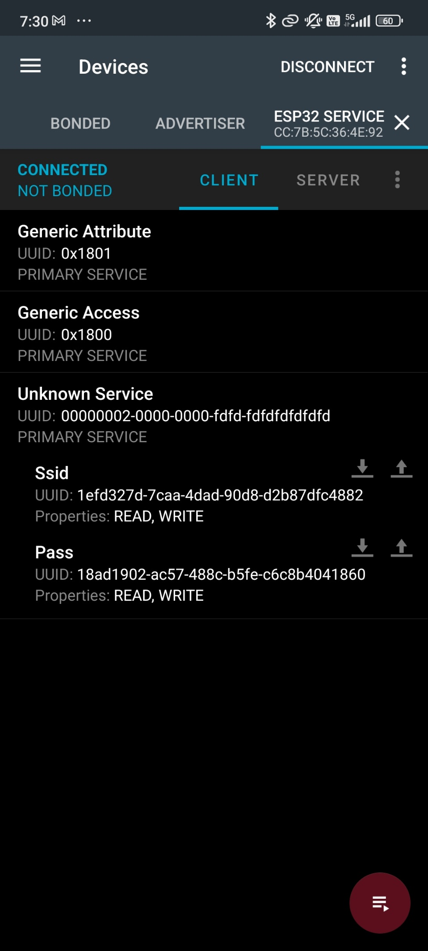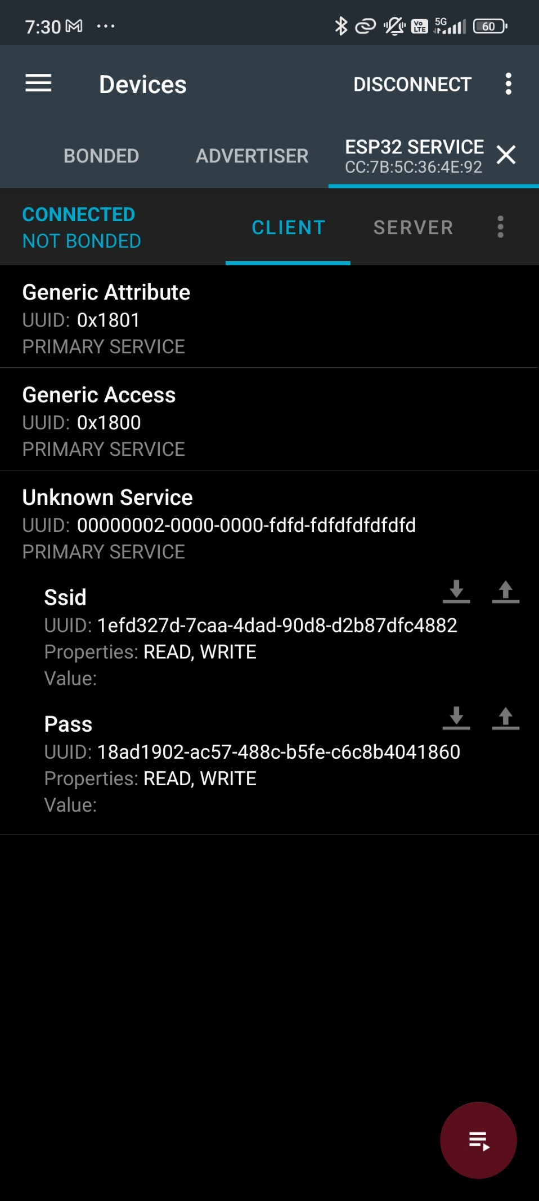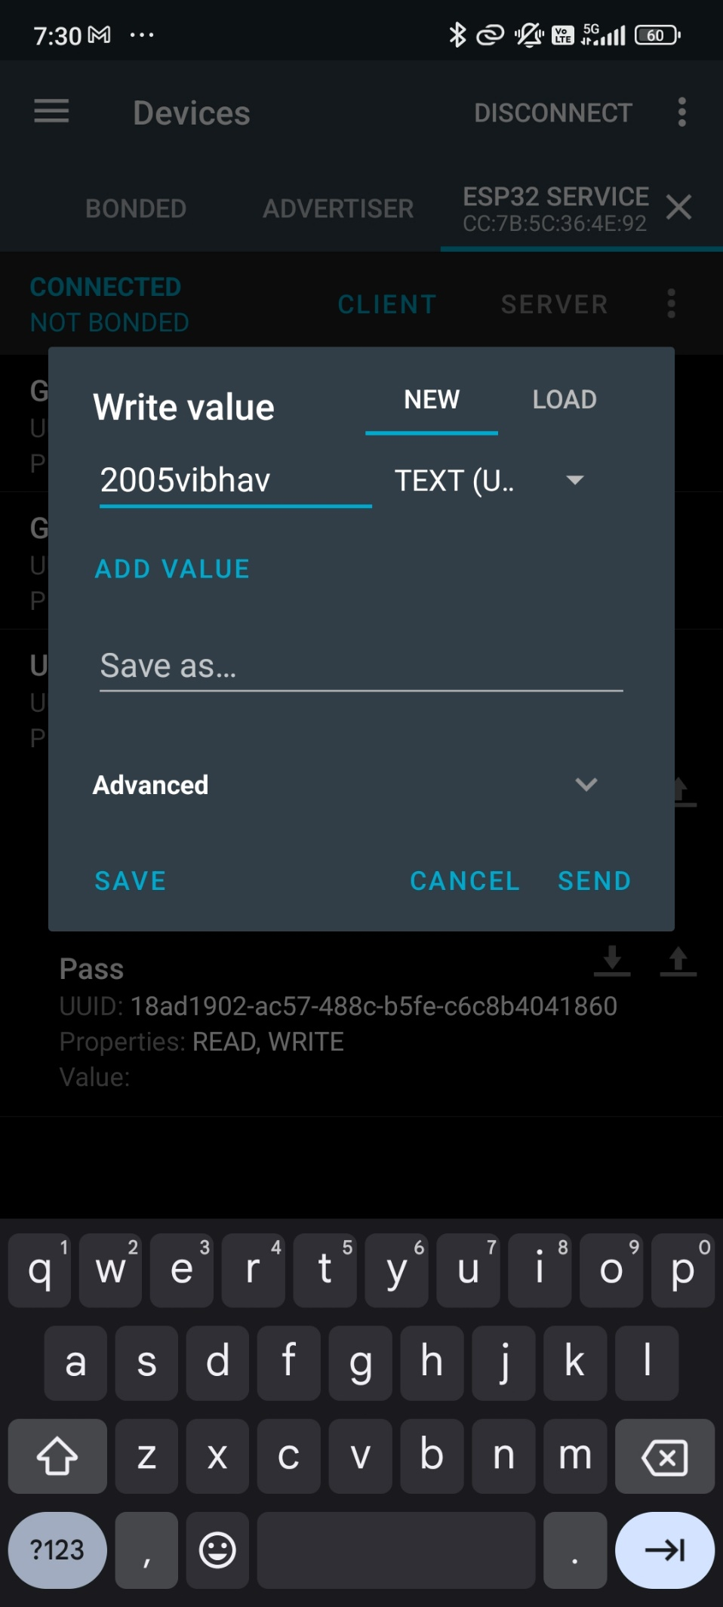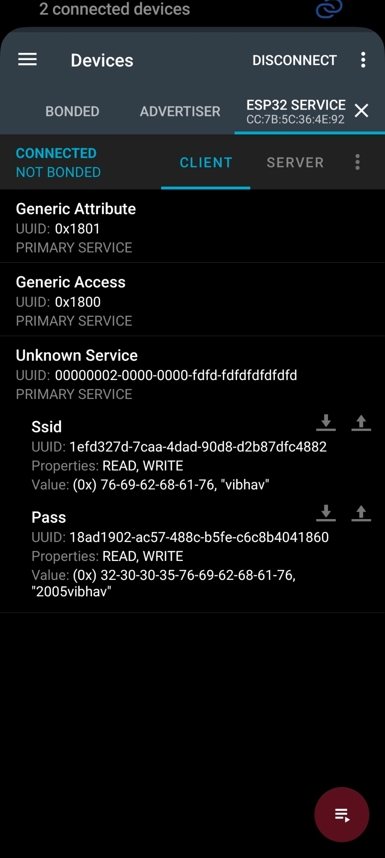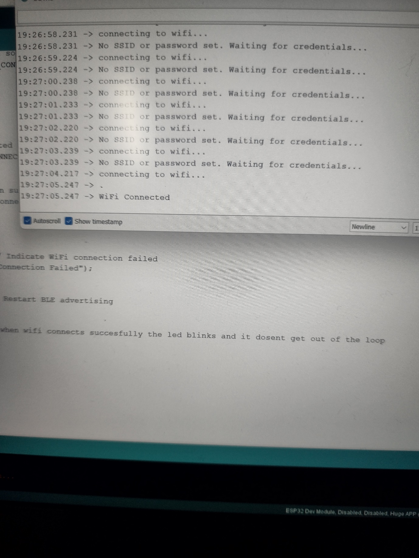

Note (Self Review):

It was my first time working with the BLE I learnt a lot of things during this task I don’t know if this was a simple task or tough but it was an interesting journey that took me to the completion of task.

I took help from a lot of youtube videos , google documentation , websites like silicon labs ,Arduino , Punch through etc and many more , also AI tools like chat-Gpt and Gemeni helped me a lot in achieving the goal by step by step learning.

Additionally I want to mention that I feel like the optional task of sending wifi credentials over ble to achieve wifi connectivity in esp32 , the way I done it is not the most perfect way but somehow I was able to reach the goal.

Thank you for this great opportunity of learning and applying skills practically.