VULNERABILITY ASSESSMENT REPORT
Future Interns – Cyber Security Internship
Submitted By
VIBHAVARI GOLI
CIN ID
FIT/JUN26/CS9221
Internship Domain
Cyber Security
Task Number
Task 1
Organization
Future Interns

TABLE OF CONTENTS
- Introduction
- Objective
- Scope
- Methodology
- Vulnerability Findings
- Risk Assessment
- Recommendations
- Conclusion
- References

1. INTRODUCTION
A Vulnerability Assessment is the process of identifying, analyzing, and reporting security weaknesses present in a website or system. The purpose of this assessment is to understand potential risks and recommend appropriate security improvements.
This report analyzes a publicly available practice website and identifies common security weaknesses from a security assessment perspective.

2. OBJECTIVE
The objectives of this project are:
• Identify common website security weaknesses.
• Evaluate security risks.
• Classify vulnerabilities according to risk level.
• Provide remediation recommendations.
• Improve cyber security awareness.

3. SCOPE
Target Website:
testphp.vulnweb.com
Assessment Type:
Passive Security Assessment
Scope Includes:
• Website accessibility review
• Security header review
• Information disclosure review
• Input validation observations
• General security observations

4. METHODOLOGY
The assessment was performed using the following approach:
- Website inspection using a web browser.
- Analysis of HTTP response behavior.
- Review of visible security controls.
- Identification of potential weaknesses.
- Documentation of findings and recommendations.
Tools Used:
• Browser
• Browser Developer Tools
• Google Search
• GitHub
• Microsoft Word

5. VULNERABILITY FINDINGS
Finding 1
Title: Missing Security Headers
Risk Level: Medium
Description:
Certain security headers were not observed during the assessment. Security headers help protect websites from attacks such as clickjacking and content injection.
Impact:
Attackers may exploit browser behavior to perform malicious activities.
Recommendation:
Implement security headers such as:
• X-Frame-Options
• Content-Security-Policy
• X-Content-Type-Options
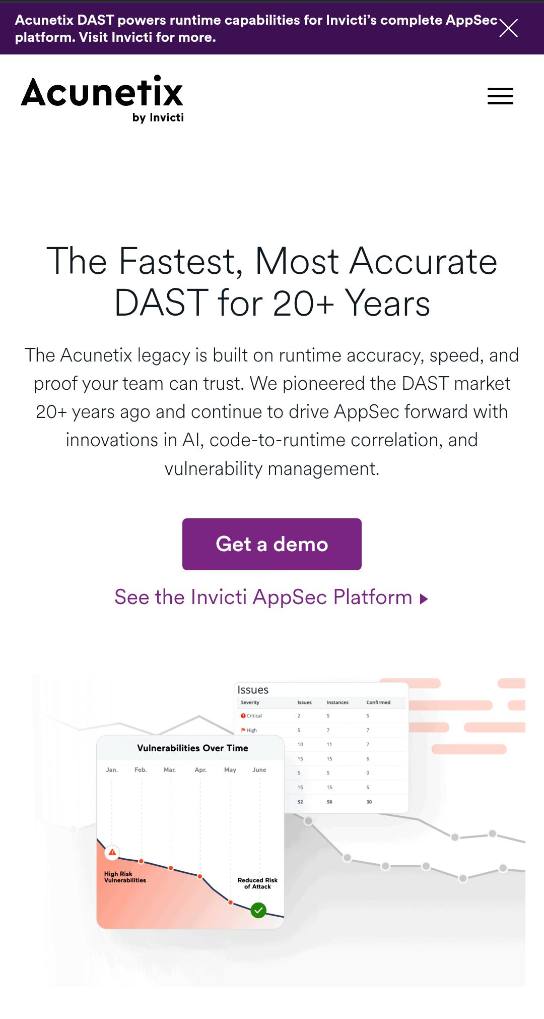

Finding 2
Title: Information Disclosure
Risk Level: Low
Description:
Some technical information about the website environment may be visible to users.
Impact:
Attackers may gather information useful for future attacks.
Recommendation:
Limit unnecessary information exposed through server responses.
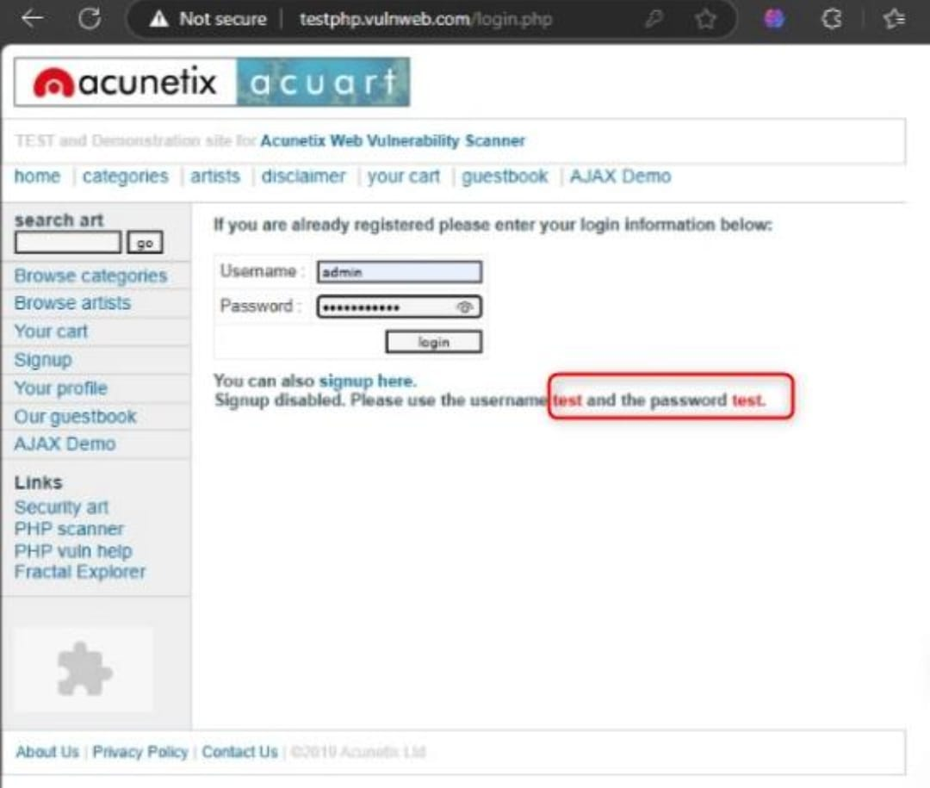

Finding 3
Title: Weak Input Validation
Risk Level: Medium
Description:
User input fields should always be validated properly to prevent malicious data submission.
Impact:
Improper validation may increase security risks.
Recommendation:
Implement server-side validation and input sanitization.
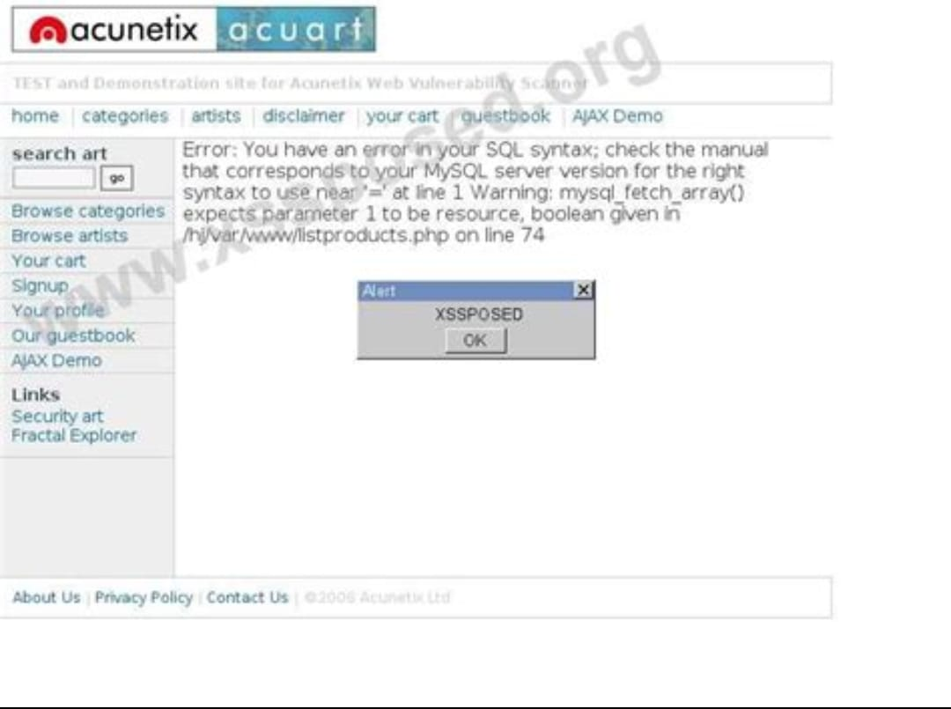

6. RISK ASSESSMENT
Vulnerability | Risk Level
Missing Security Headers | Medium
Information Disclosure | Low
Weak Input Validation | Medium
Overall Risk Rating:
Medium
The website demonstrates several common security concerns that should be addressed to improve overall security posture.

7. RECOMMENDATIONS
The following recommendations are provided:
• Implement security headers.
• Reduce information disclosure.
• Validate all user inputs.
• Conduct periodic security assessments.
• Follow secure coding practices.
• Maintain regular software updates.
• Monitor security events and logs.

8. CONCLUSION
The vulnerability assessment identified several common security weaknesses that may impact website security. While no critical vulnerabilities were identified during this assessment, improvements are recommended to strengthen overall protection.
By implementing the recommendations provided in this report, organizations can significantly improve their cyber security posture and reduce potential security risks.

9. REFERENCES
- OWASP Web Security Testing Guide
- OWASP Top 10
- Web Application Security Best Practices
- Cyber Security Awareness Resources
- Security Assessment Documentation

