API SECURITY RISK ANALYSIS REPORT
Future Interns – Cyber Security Internship
Submitted By
VIBHAVARI GOLI
CIN ID
FIT/JUN26/CS9221
Internship Domain
Cyber Security
Task Number
Task 3
Organization
Future Interns

TABLE OF CONTENTS
- Introduction
- Objective
- Scope
- Methodology
- API Security Findings
- Risk Assessment
- Recommendations
- Conclusion
- References

1. INTRODUCTION
Application Programming Interfaces (APIs) are widely used to enable communication between software applications. APIs exchange large amounts of data and are commonly used in web applications, mobile applications, and cloud services.
Improperly secured APIs may expose sensitive information and create security risks. This report analyzes common API security risks and provides recommendations for improving API security.

2. OBJECTIVE
The objectives of this project are:
• Understand API security concepts.
• Identify common API security risks.
• Analyze potential vulnerabilities.
• Assess security impact.
• Provide remediation recommendations.

3. SCOPE
Target API:
JSONPlaceholder Public API
API URL:
https://jsonplaceholder.typicode.com
Assessment Type:
Passive API Security Review
Scope Includes:
• Data Exposure Review
• Authentication Analysis
• Authorization Review
• Input Validation Review
• General Security Assessment

4. METHODOLOGY
The assessment was performed using the following approach:
- API endpoint review.
- Browser-based API testing.
- Data exposure analysis.
- Security risk identification.
- Documentation of findings and recommendations.
Tools Used:
• Browser
• Browser Developer Tools
• Google Search
• GitHub
• Microsoft Word

5. API SECURITY FINDINGS
Finding 1
Title: Lack of Authentication
Risk Level: Medium
Description:
The public API allows users to access information without authentication. While suitable for testing purposes, production APIs should implement authentication controls.
Impact:
Unauthorized users may access API resources.
Recommendation:
Implement API Keys, OAuth, or Token-Based Authentication.
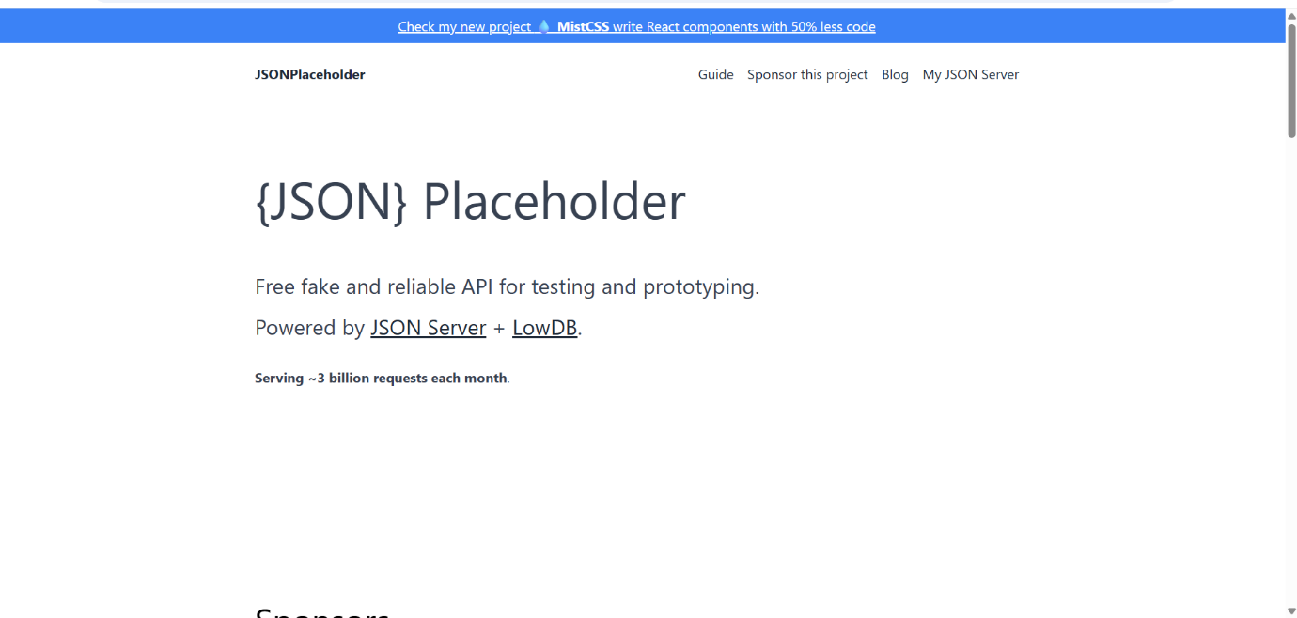

Finding 2
Title: Data Exposure
Risk Level: Low
Description:
The API returns structured data that is publicly accessible. Sensitive information should never be exposed through API responses.
Impact:
Information disclosure risks may occur if sensitive data is included.
Recommendation:
Limit API responses to necessary data only.
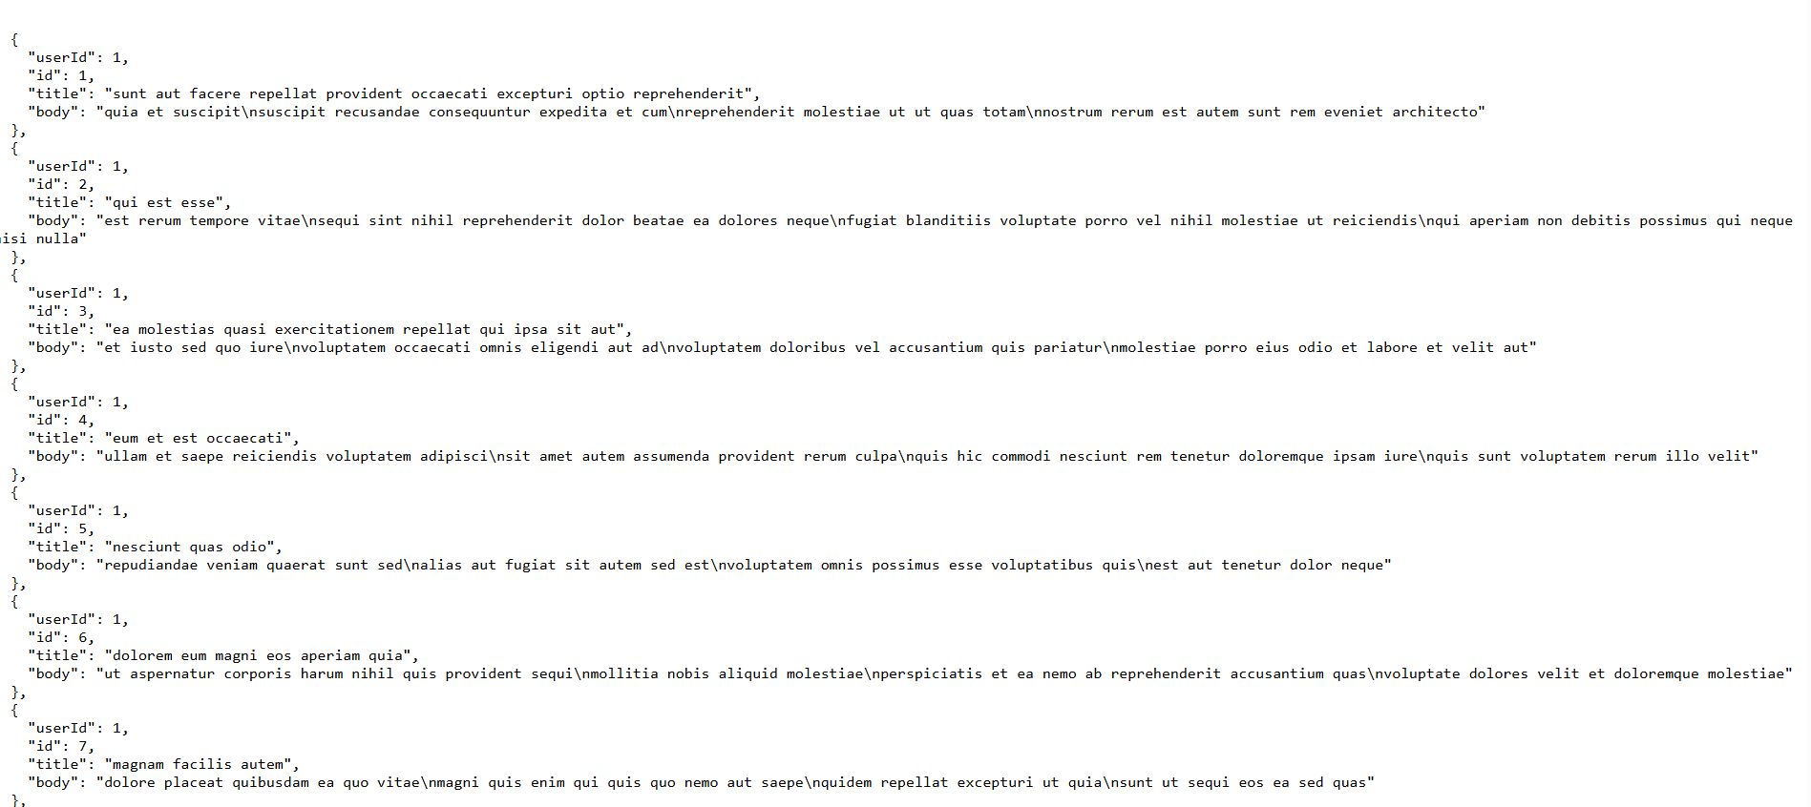

Finding 3
Title: Missing Rate Limiting Controls
Risk Level: Medium
Description:
APIs without rate limiting may be vulnerable to abuse and excessive requests.
Impact:
Attackers may overload services using automated requests.
Recommendation:
Implement request throttling and rate-limiting mechanisms.
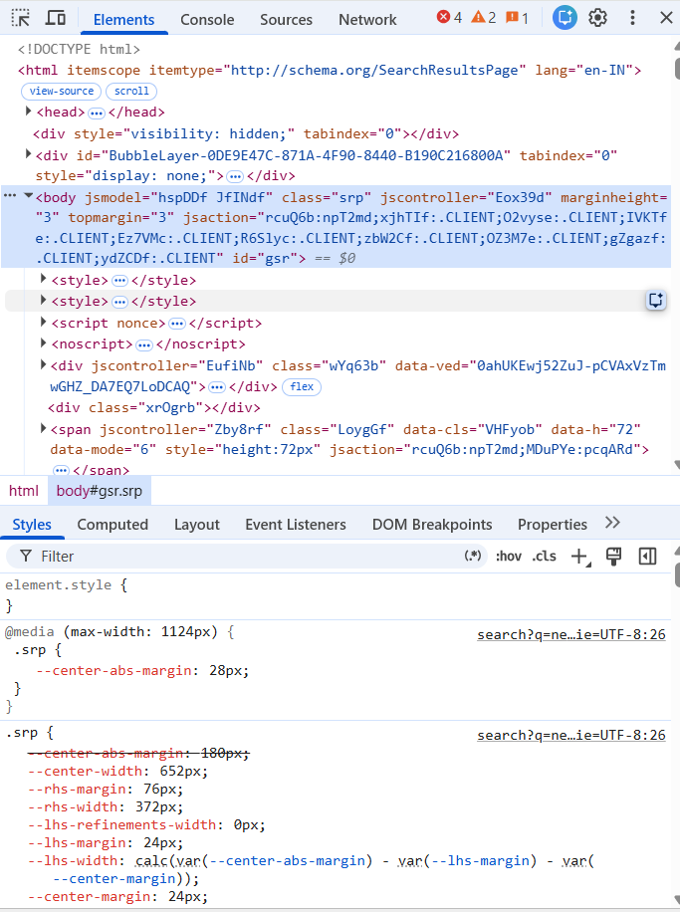

6. RISK ASSESSMENT
Security Risk | Risk Level
Lack of Authentication | Medium
Data Exposure | Low
Missing Rate Limiting | Medium
Overall Risk Rating:
Medium
The identified risks highlight the importance of implementing strong API security controls.

7. RECOMMENDATIONS
The following recommendations are provided:
• Implement secure authentication mechanisms.
• Enforce proper authorization controls.
• Restrict unnecessary data exposure.
• Implement API rate limiting.
• Validate all user inputs.
• Monitor API traffic and logs.
• Conduct regular API security assessments.

8. CONCLUSION
The API Security Risk Analysis identified common security concerns that may affect API-based applications. While the analyzed API is intended for testing and learning purposes, the assessment demonstrates important API security concepts including authentication, data exposure, and rate limiting.
Organizations should implement strong security controls to protect APIs from unauthorized access and misuse.

9. REFERENCES
- OWASP API Security Top 10
- OWASP Security Guidelines
- API Security Best Practices
- JSON Placeholder Documentation
- Cyber Security Awareness Resources

