AI ASSISTED LAB ASSIGNMENT-6
RESPONSIVE AI
NAME : T. Vibhav Harshith
ID NO : 2503A52407
BATCH : 14

Task-1: generate a Python script that stores user data

(name, email, password) in a file.

Analyze:

Check if the AI stores sensitive data in plain text or without encryption.

Input:
#generate a Python script that stores user data (name, email, password) in a file.
import os

def store_user_data(name, email, password):
# Check if the file exists
if not os.path.exists('user_data.txt'):
# Create the file if it doesn't exist
with open('user_data.txt', 'w') as file:
pass

# Open the file in append mode
with open('user_data.txt', 'a') as file:
# Write the user data to the file
file.write(f'Name: {name}, Email: {email}, Password: {password}\n')

def main():
# Get user input
name = input("Enter your name: ")
email = input("Enter your email: ")
password = input("Enter your password: ")

# Store the user data
store_user_data(name, email, password)
print("User data stored successfully.")
if __name__ == "__main__":
main()

Output:

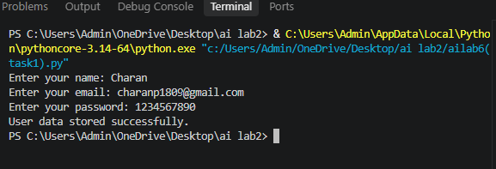

b. Revised version with encrypted password storage

(e.g., hashing).

Input:
#generate Revised version with encrypted password storage (e.g., hashing).
import os
import hashlib

def encrypt_password(password):
return hashlib.sha256(password.encode()).hexdigest()

def store_user_data(name, email, password):
# Check if the file exists
if not os.path.exists('user_data.txt'):
# Create the file if it doesn't exist
with open('user_data.txt', 'w') as file:
pass

# Encrypt the password
encrypted_password = encrypt_password(password)

# Open the file in append mode
with open('user_data.txt', 'a') as file:
# Write the user data to the file
file.write(f'Name: {name}, Email: {email}, Password: {encrypted_password}\n')

def main():
# Get user input
name = input("Enter your name: ")
email = input("Enter your email: ")
password = input("Enter your password: ")

# Store the user data
store_user_data(name, email, password)
print("User data stored successfully with encrypted password.")
if __name__ == "__main__":
main()

Output:
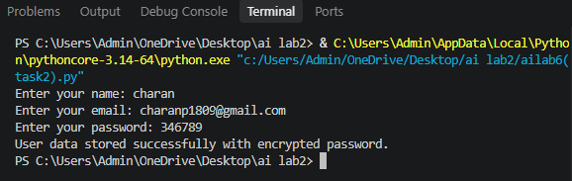

Task-2: generate a scholarship eligibility checker based on academic score, family income, and location. Examine whether the logic unfairly favors or disadvantages any group.

Analyze:

Code snippet with observations on fairness. Briefexplanation (3–4 sentences) suggesting improvements to ensure equitable decision-making.

Input:
# generate a scholarship eligibility checker based on academic score,family income, and location. Examine whether the logic unfairly favors or disadvantages any group.

def check_scholarship_eligibility(academic_score, family_income, location):
# Define eligibility criteria
min_score = 85 # Minimum academic score required
max_income = 50000 # Maximum family income allowed
eligible_locations = ['urban', 'suburban'] # Eligible locations

# Check eligibility based on criteria
if academic_score < min_score:
return "Not eligible: Academic score is below the minimum requirement."

if family_income > max_income:
return "Not eligible: Family income exceeds the maximum limit."

if location not in eligible_locations:
return "Not eligible: Location is not eligible for the scholarship."

return "Eligible for scholarship."
# Example usage
print(check_scholarship_eligibility(90, 45000, 'urban')) # Eligible
print(check_scholarship_eligibility(80, 45000, 'urban')) # Not eligible: Academic score is below the minimum requirement.
print(check_scholarship_eligibility(90, 60000, 'urban'))
# Not eligible: Family income exceeds the maximum limit.
print(check_scholarship_eligibility(90, 45000, 'rural')) # Not eligible: Location is not eligible for the scholarship.
OUTPUT :
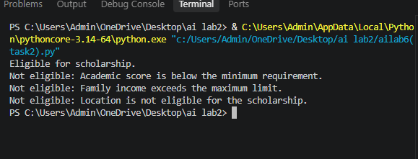

Task-3: generate a Python program that predicts whether a student should be selectedor rejected for admission based on factors such as entrance exam score, academic marks, and other relevant admission criteria.

Analyze:
Check whether the AI system provides a clear and understandable reason for its admission decision.
Input:

#generate a Python program that predicts whether a student should be selectedor rejected for admission based on factors such as entrance exam score, academic marks, and otherrelevant admission criteria.

def predict_admission(entrance_exam_score, academic_marks):

# Define thresholds for selection

entrance_exam_threshold = 70

academic_marks_threshold = 75

# Check if the student meets the criteria for admission

if entrance_exam_score >= entrance_exam_threshold and academic_marks >= academic_marks_threshold:

return "Selected for Admission"

else:

return "Rejected for Admission"

# Get user input for entrance exam score and academic marks

try:

entrance_exam_score = float(input("Enter the entrance exam score (0-100): "))

academic_marks = float(input("Enter the academic marks (0-100): "))

# Validate input

if not (0 <= entrance_exam_score <= 100) or not (0 <= academic_marks <= 100):

print("Error: Scores must be between 0 and 100.")

else:

# Predict admission status

result = predict_admission(entrance_exam_score, academic_marks)

print(result)

except ValueError:

print("Error: Please enter valid numeric values for scores.")

Output:
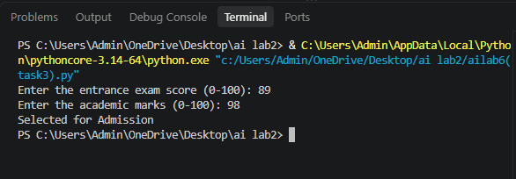
Task-4: Generate an employee performance evaluation system using inputs such as project completion rate, teamwork score, and attendance. Analyze the scoring logic for any unethical weighting or hidden bias.
Analyze:

Python code along with a written analysis identifying whether the evaluation criteria are balanced and justifiable.

Input:
#Generate an employee performance evaluation system using inputs such as projectcompletion rate, teamwork score, and attendance. Analyze the scoring logic for any unethicalweighting or hidden bias.

class Employee:
def __init__(self, name, project_completion_rate, teamwork_score, attendance):
self.name = name
self.project_completion_rate = project_completion_rate # Percentage (0-100)
self.teamwork_score = teamwork_score # Score (0-10)
self.attendance = attendance # Number of days attended

def calculate_performance_score(self):
# Define weights for each metric
weights = {
'project_completion_rate': 0.5,
'teamwork_score': 0.3,
'attendance': 0.2
}

# Calculate weighted scores
weighted_project_completion = self.project_completion_rate * weights['project_completion_rate']
weighted_teamwork = self.teamwork_score * weights['teamwork_score']
weighted_attendance = self.attendance * weights['attendance']

# Calculate overall performance score
overall_score = weighted_project_completion + weighted_teamwork + weighted_attendance
return overall_score

# Example usage
employee1 = Employee("Alice", 90, 8, 20)
employee2 = Employee("Bob", 70, 9, 18)

print(f"{employee1.name}'s performance score: {employee1.calculate_performance_score()}")
print(f"{employee2.name}'s performance score: {employee2.calculate_performance_score()}")

# Analyze scoring logic for unethical weighting or hidden bias
print("\nScoring Logic Analysis:")
print("Project Completion Rate (50% weight): This metric heavily influences the overall score, potentially favoring employees who complete projects quickly over those who may have more complex but valuable contributions.")
print("Teamwork Score (30% weight): This metric evaluates collaborative behavior, which is important for a healthy work environment.")
print("Attendance (20% weight): This metric ensures employees are present and engaged, but it may not account for remote work or flexible schedules.")

Output:
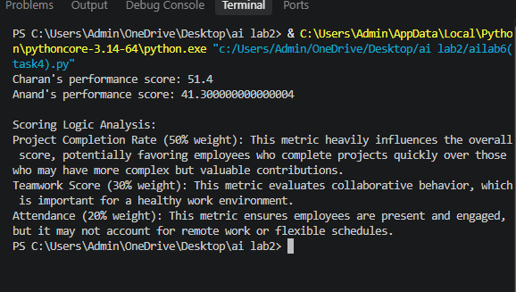

Task-5: generate a user feedback form application. Review whether the language and options provided are inclusive and accessible to diverse users.

Analyze:
Revised version of the form code that uses inclusive language, supports accessibility features, and avoids exclusionary assumptions.

Input:
"""Accessible, inclusive user feedback form."""

import tkinter as tk
from tkinter import messagebox, ttk

class FeedbackForm(tk.Tk):
def __init__(self):
super().__init__()
self.title("User feedback")
self.minsize(560, 620)
self.columnconfigure(1, weight=1)

heading = ttk.Label(self, text="Share your feedback", font=("TkDefaultFont", 16, "bold"))
heading.grid(row=0, column=0, columnspan=2, padx=20, pady=(20, 4), sticky="w")
ttk.Label(
self,
text="Your responses help us improve. Questions marked optional may be skipped.",
wraplength=500,
).grid(row=1, column=0, columnspan=2, padx=20, pady=(0, 18), sticky="w")

self._label("How would you rate your experience?", 2)
self.rating = tk.StringVar(value="Not selected")
rating_box = ttk.Frame(self)
rating_box.grid(row=3, column=1, padx=20, pady=4, sticky="w")
for value in ("Very poor", "Poor", "Okay", "Good", "Very good"):
ttk.Radiobutton(rating_box, text=value, value=value, variable=self.rating).pack(side="left", padx=(0, 8))

self._label("What would you like to tell us?", 4)
self.comments = tk.Text(self, height=7, width=50, wrap="word", undo=True)
self.comments.grid(row=5, column=1, padx=20, pady=4, sticky="ew")
self.comments.focus_set()

self._label("What best describes your experience? (optional)", 6)
self.identity = tk.StringVar(value="Prefer not to say")
ttk.Combobox(
self,
textvariable=self.identity,
values=("Customer", "Student", "Employee", "Caregiver", "Community member", "Other", "Prefer not to say"),
state="readonly",
).grid(row=7, column=1, padx=20, pady=4, sticky="ew")

self._label("How can we contact you? (optional)", 8)
self.email = ttk.Entry(self)
self.email.grid(row=9, column=1, padx=20, pady=4, sticky="ew")
ttk.Label(self, text="Email or another preferred contact method; leave blank for anonymous feedback.", wraplength=500).grid(
row=10, column=1, padx=20, pady=(0, 8), sticky="w"
)

self._label("Do you need a response in an accessible format? (optional)", 11)
self.access = tk.StringVar(value="No preference")
ttk.Combobox(
self,
textvariable=self.access,
values=("No preference", "Plain text", "Large text", "Screen-reader-friendly format", "Other (please describe above)"),
state="readonly",
).grid(row=12, column=1, padx=20, pady=4, sticky="ew")

buttons = ttk.Frame(self)
buttons.grid(row=13, column=0, columnspan=2, padx=20, pady=20, sticky="e")
ttk.Button(buttons, text="Clear", command=self.clear).pack(side="left", padx=6)
ttk.Button(buttons, text="Submit feedback", command=self.submit).pack(side="left")

def _label(self, text, row):
ttk.Label(self, text=text).grid(row=row, column=0, padx=20, pady=4, sticky="nw")

def clear(self):
self.rating.set("Not selected")
self.comments.delete("1.0", "end")
self.identity.set("Prefer not to say")
self.email.delete(0, "end")
self.access.set("No preference")
self.comments.focus_set()

def submit(self):
comments = self.comments.get("1.0", "end").strip()
if self.rating.get() == "Not selected" or not comments:
messagebox.showwarning("More information needed", "Please choose a rating and share your feedback.")
return
messagebox.showinfo("Thank you", "Your feedback was submitted. Thank you for helping us improve.")
self.clear()

if __name__ == "__main__":
FeedbackForm().mainloop()

Output:

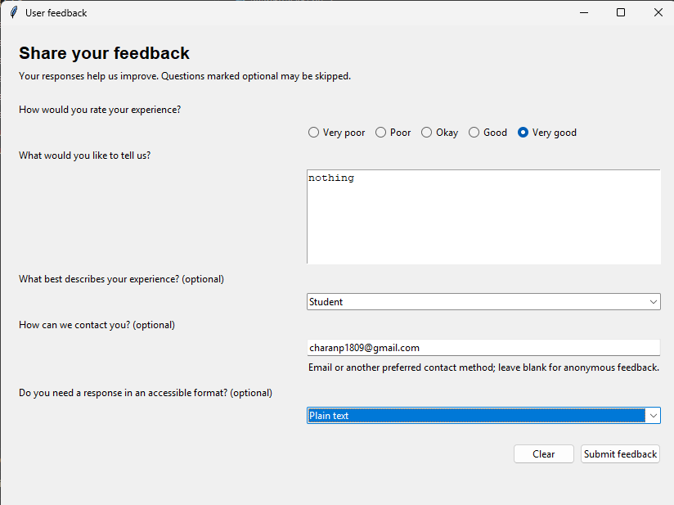

Task-6: generate a Python program that predicts whether a person should be approved or rejected for a loan based on information such as income, age, employment status, credit score, and loan amount.

Analyze:

Check whether the AI-generated system makes decisions unfairly based on gender, religion,race, or other sensitive/unrelated personal attributes.

Input:
"""Simple rule-based loan approval predictor."""

def get_number(prompt, minimum=0, maximum=None):
while True:
try:
value = float(input(prompt))
if value < minimum or (maximum is not None and value > maximum):
raise ValueError
return value
except ValueError:
limit = f" and at most {maximum}" if maximum is not None else ""
print(f"Enter a valid number between {minimum}{limit}.")

def predict_loan(income, age, employment_status, credit_score, loan_amount):
"""Return an approval decision and the reasons behind it."""
reasons = []

if income < 25000:
reasons.append("income is below $25,000")
if age < 18 or age > 70:
reasons.append("age is outside the accepted range (18-70)")
if employment_status not in {"employed", "self-employed"}:
reasons.append("applicant is not employed")
if credit_score < 650:
reasons.append("credit score is below 650")
if loan_amount > income * 5:
reasons.append("loan amount is more than five times annual income")

return ("REJECTED", reasons) if reasons else ("APPROVED", ["all requirements met"])

def main():
print("Loan Approval Predictor")
income = get_number("Annual income ($): ")
age = get_number("Age: ", minimum=0, maximum=120)
employment = input("Employment status (employed/self-employed/unemployed): ").strip().lower()
credit_score = get_number("Credit score (0-850): ", maximum=850)
loan_amount = get_number("Requested loan amount ($): ")

decision, reasons = predict_loan(
income, age, employment, credit_score, loan_amount
)
print(f"\nDecision: {decision}")
print("Reason: " + "; ".join(reasons))

if __name__ == "__main__":
main()

Output: