- Create 2 nodes, one is the master one and other is slave one.
  - We will create 2 ubuntu 20.04 based VMs in our GCP console.
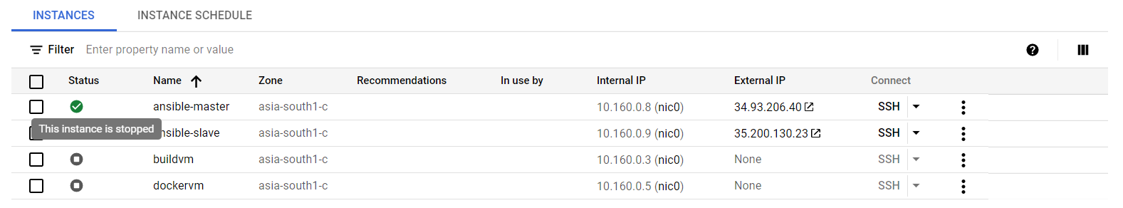
- Configure the master node to enable password less authentication.
  - Issue the following command for ssh agent.
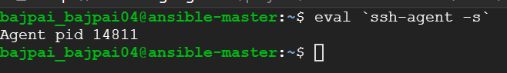
  - Let us configure password less authentication in GCP.
Generate a key value pair in the host VM using ssh-keygen –t RSA –b 2048
Download the public key and add it to the GCP metadata. Also set private key permissions as 400.
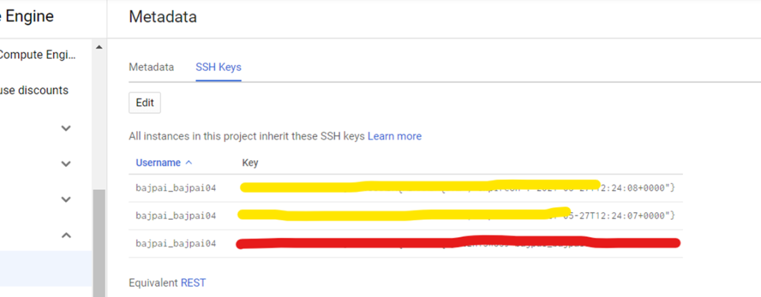
The one masked with red is our key.
Let’s try ssh from our master to slave to validate the same.
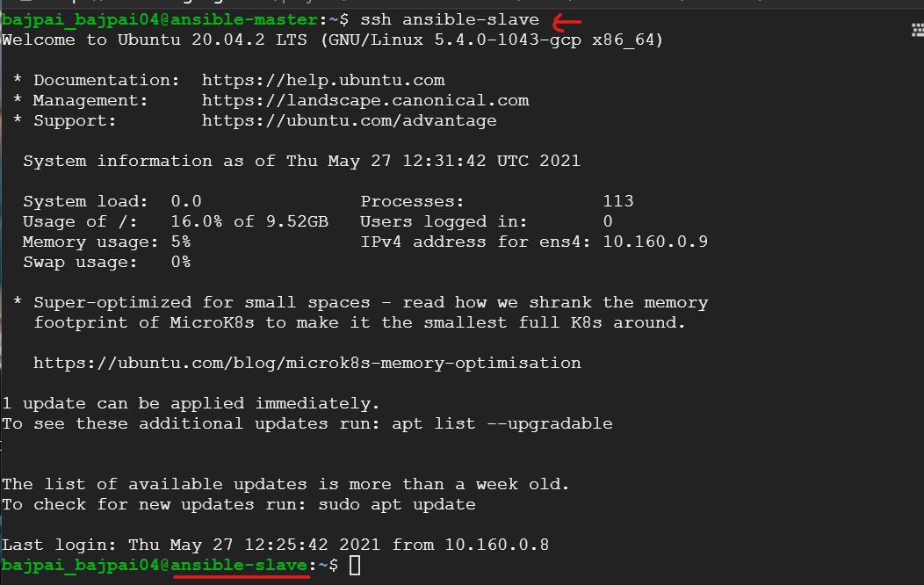
Execute the following step as well:
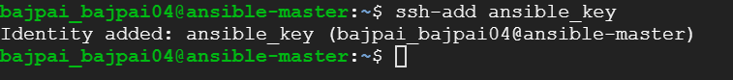
Note: ansible_key must have permissions as 400.
  - Add the following lines to .bashrc(last two lines).
eval `ssh-agent -s`
ssh-add ansible_key
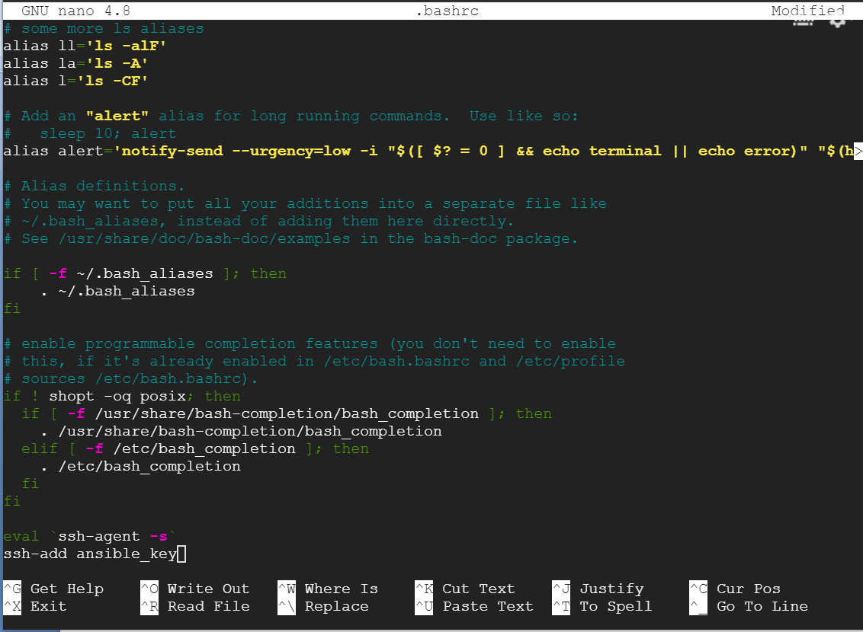
This completes our password less authentication setup.
- Install Ansible on master node.
  - Add the ppa repository.
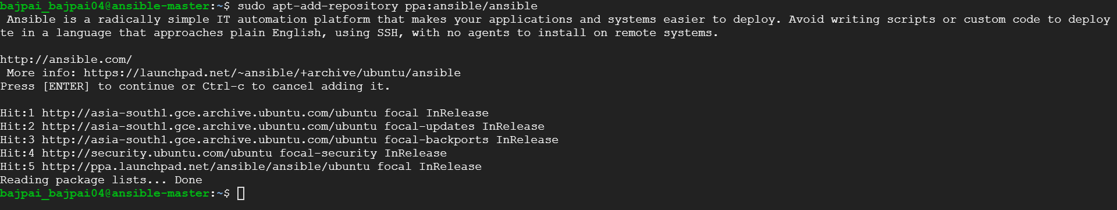
  - Install ansible with sudo apt install ansible and check version after installation with ansible –version.
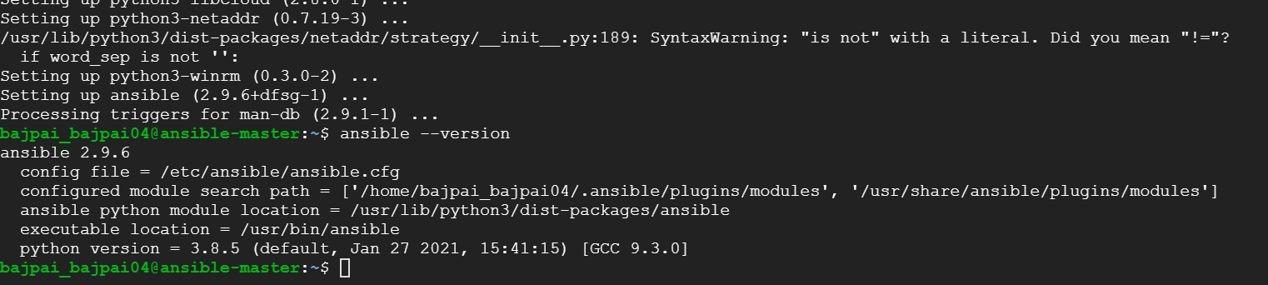
  - Let’s configure our inventory. Use sudo nano /etc/ansible/hosts and append following lines to the file.
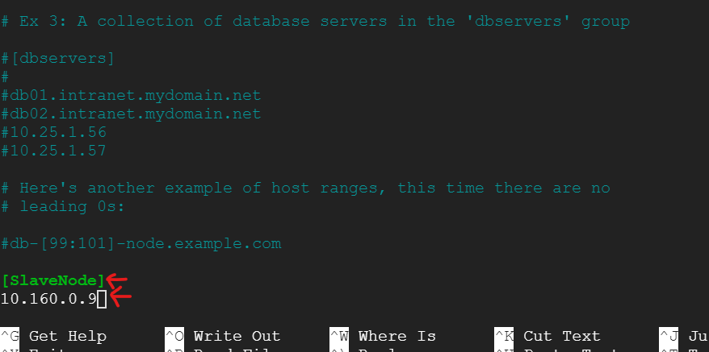
Let’s check if our configuration worked. Use the following command:
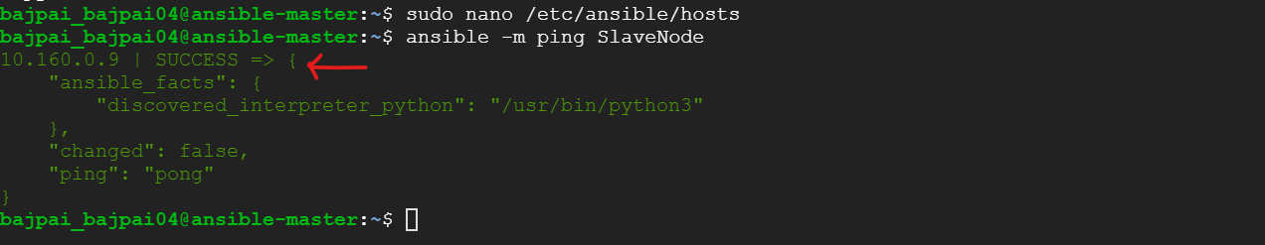

- Write a playbook to install Java, Maven, NGINX and Docker on the slave.
  - Create a playbook file with following content:
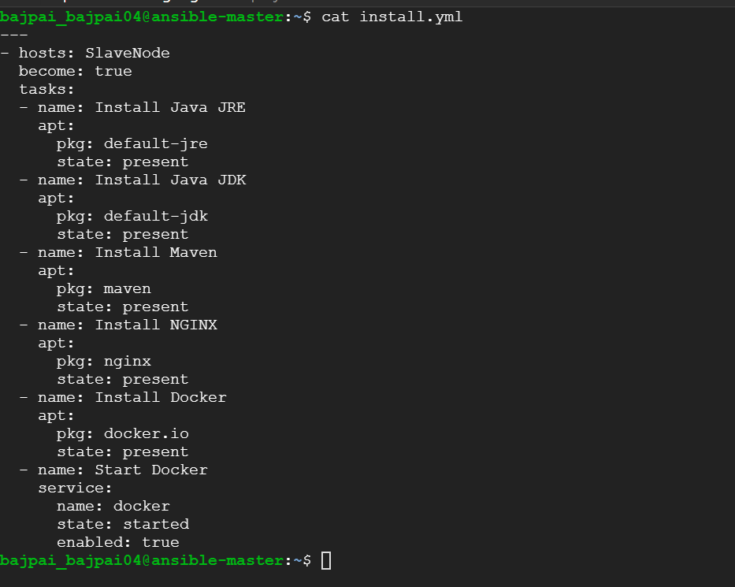
  - Let us check if these tools are present on slave or not.
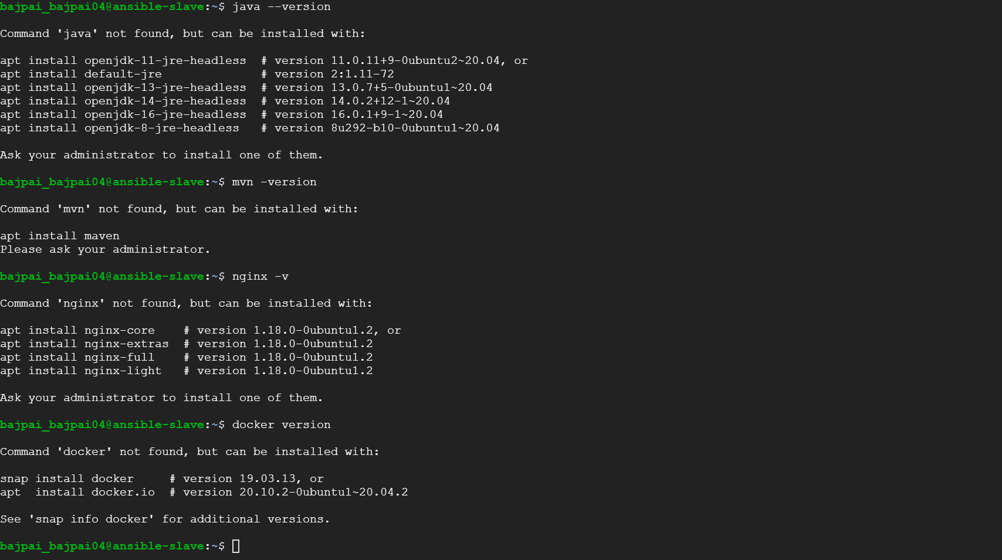
  - Execute the playbook with ansible-playbook install.yml
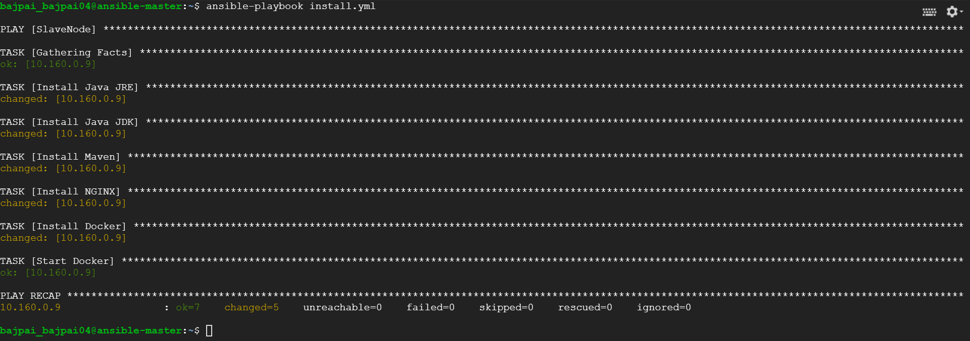

- Configure playbook to deploy the application in the repo.
  - First we need to create the application in order to deploy it using maven. First login to slave node and clone the git repo. The GCP based ubuntu images has git preinstalled.
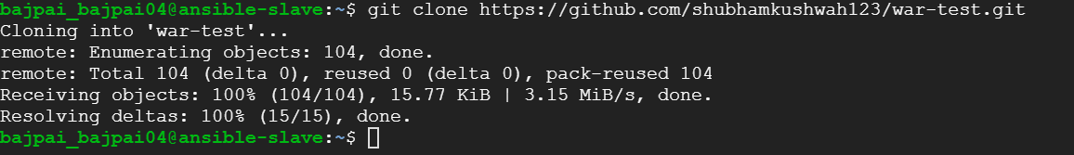
  - Let’s create the following compile_deploy.yml file to build our maven package, build the docker image and deploy the container.
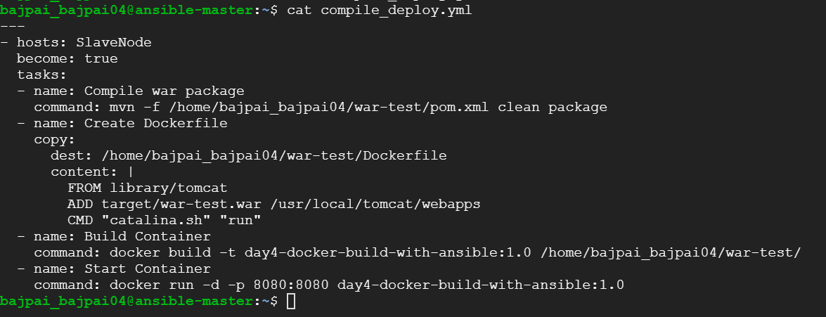
  - Execute this playbook.
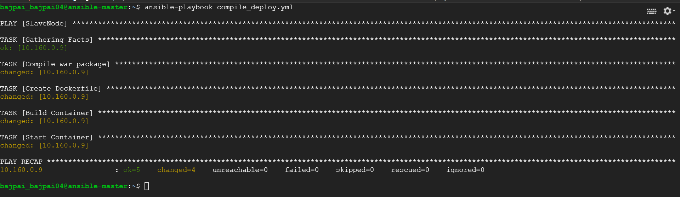
The playbook executed fine.

- Let us now validate the actions by both of our playbooks.
The execution of the second playbook compile_deploy.yml validates our Java, Maven and Docker installation.
Let’s check NGINX. Navigate to http://{IP}:80
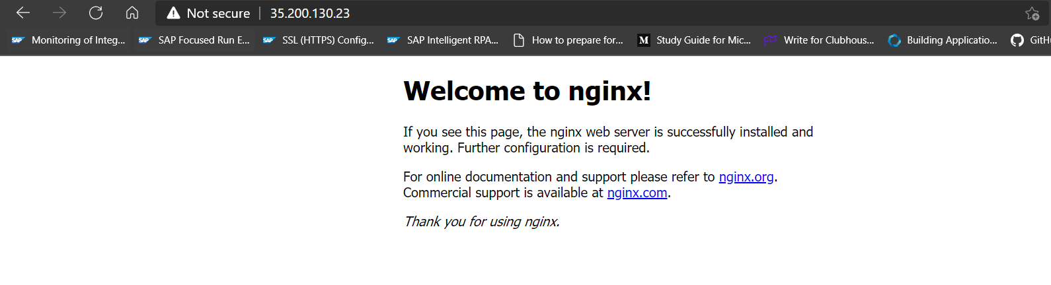
Finally, let us check our war-test application deployed on slave node as a docker container using tomcat as the base image. Navigate to http://{IP}:8080/war-test
