Docker
- Write a docker file to create a docker image for the static page present in the repo using nginx as the base image.
  - Let’s clone the repo first.
Use ‘git clone https://github.com/shubhamkushwah123/bootcamp10.git’
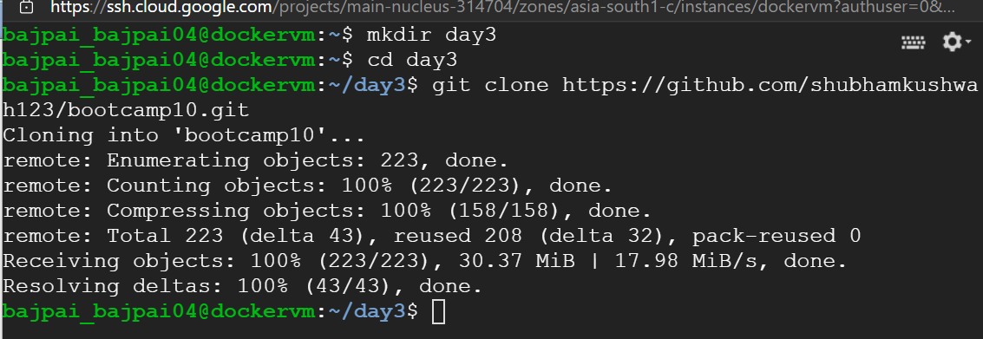
  - Copy the index.html file to a new directory specific to this assignment.
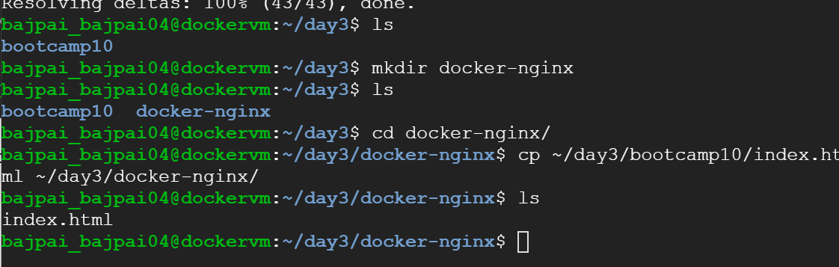
  - Now we will create the docker file.
Type nano Dockerfile

We will use alpine based NGINX image in order to save some space.
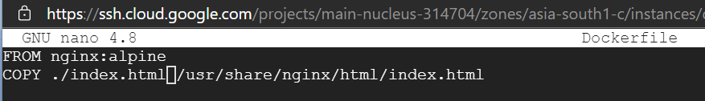
Press Ctrl+x, type Y and hit Enter to save and exit from nano.
  - Now we will build this dockerfile.
We need root privileges in order to interact with docker daemon.
Type sudo –i, this will switch to root user. Now navigate to your directory.

Let us now build the image.
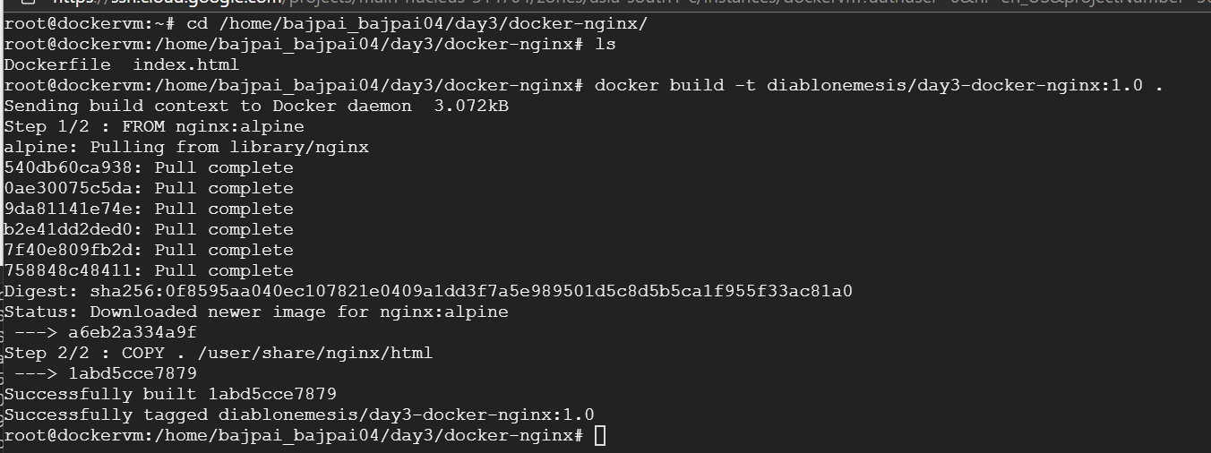
The image is ready. We can also validate the same using docker images
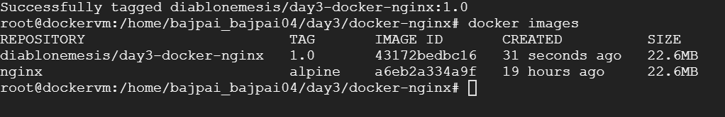

- Push the docker image to the docker hub.
  - To push the image to Docker hub, we need a docker hub account. We will now login to docker hub.
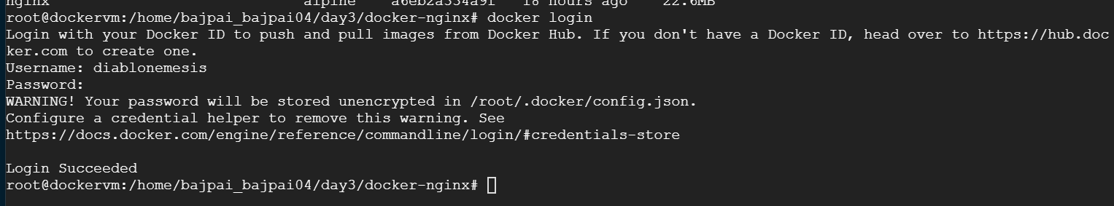
  - Let’s push the image now.
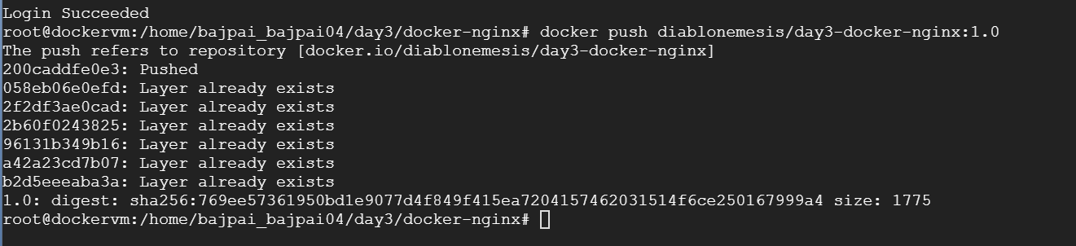
We can check our image in the docker hub as well.
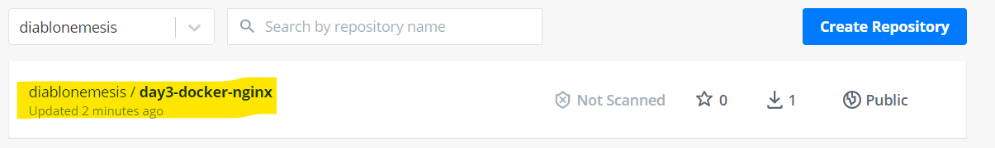

- Pull and run the docker containers on any remote instance.
  - Let us use any other machine to pull this image and run on that instance. We will be using our buildvm that we used for Jenkins and tomcat. We will pull the image as follows:
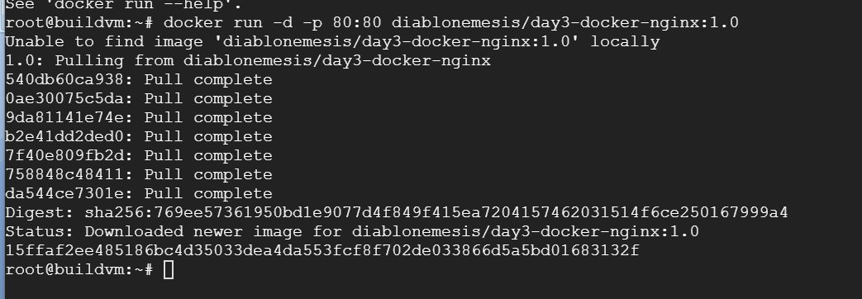
docker run will both pull and run the image. We have mapped host’s port 80 with container’s port 80.

- Access the application from the browser using appropriate URL and port.
  - Our machine’s public IP is 35.200.130.23. Let us browse to http://35.200.130.23:80.
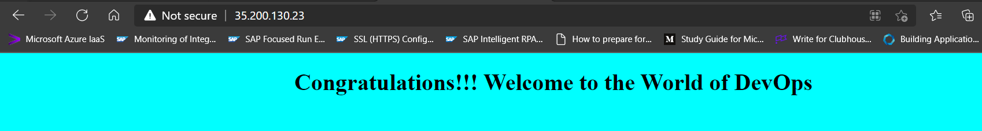
Here we see our application and we are served with our custom index.html instead of the default nginx page.

Docker Compose

- Write a docker-compose.yml file to run the above application container along with a mysql database container together.
  - First we will create a new directory named docker-compose.
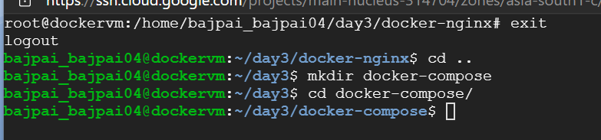
  - We will use the existing bootcamp10 repo but will remove the docker-compose.yml file and will start from scratch.
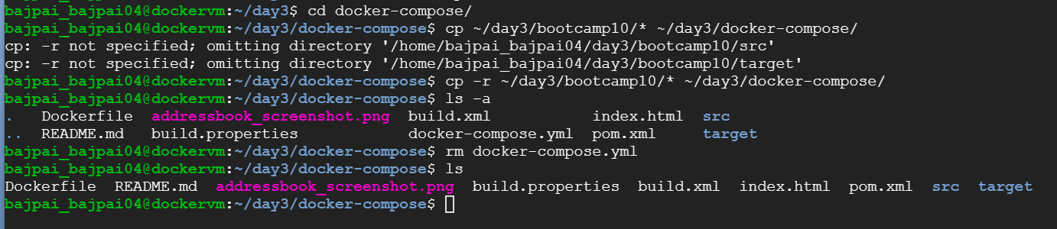
  - We will create a docker image for our addressbook.war file present inside /target directory. Use the following Dockerfile.
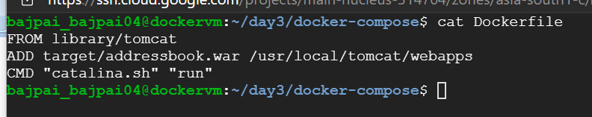
Switch user to root with sudo –i. Build the image.
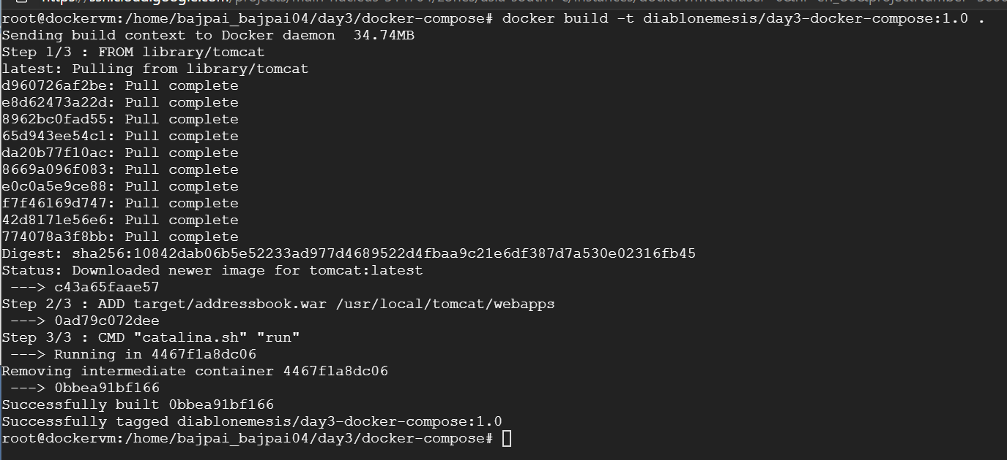
Push image to docker hub.
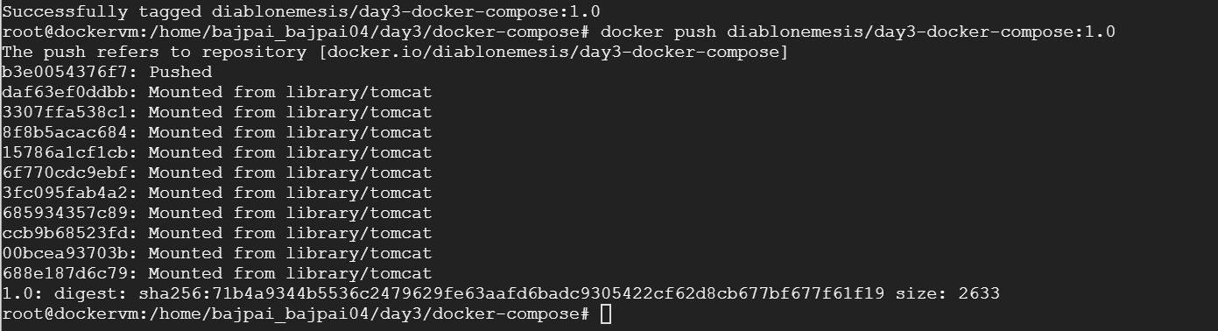
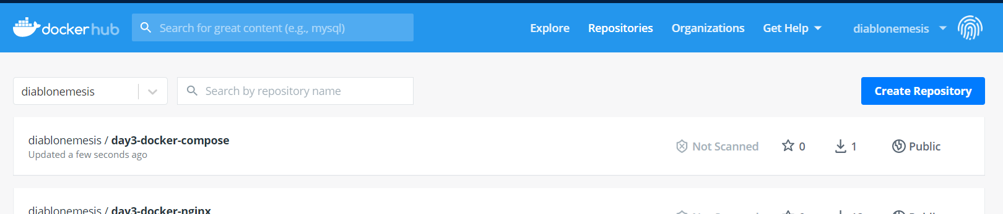
  - Let’s now write the docker-compose.yml file to run this application along with mysql database container.
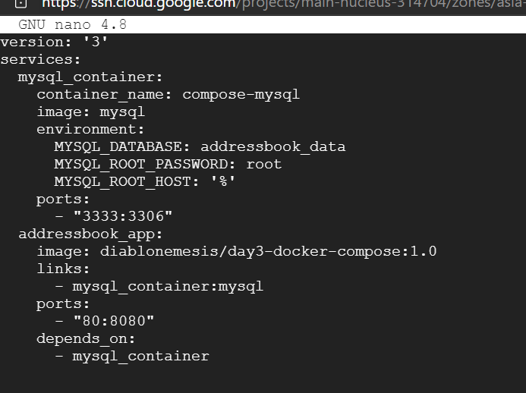
  - Now let’s start our containers.
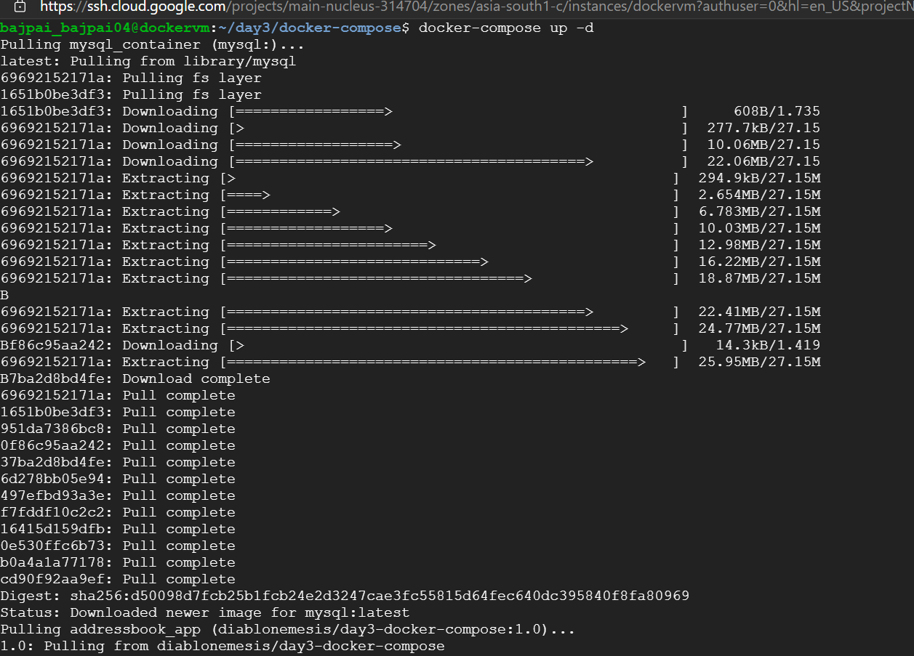
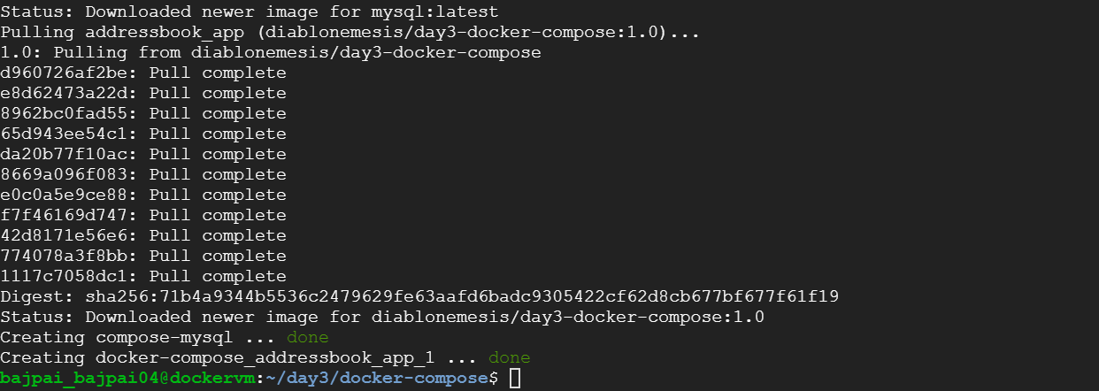
Our containers are up and running. Let’s validate.

Let us check the web application deployed in tomcat. Navigate to IP:80/addressbook.
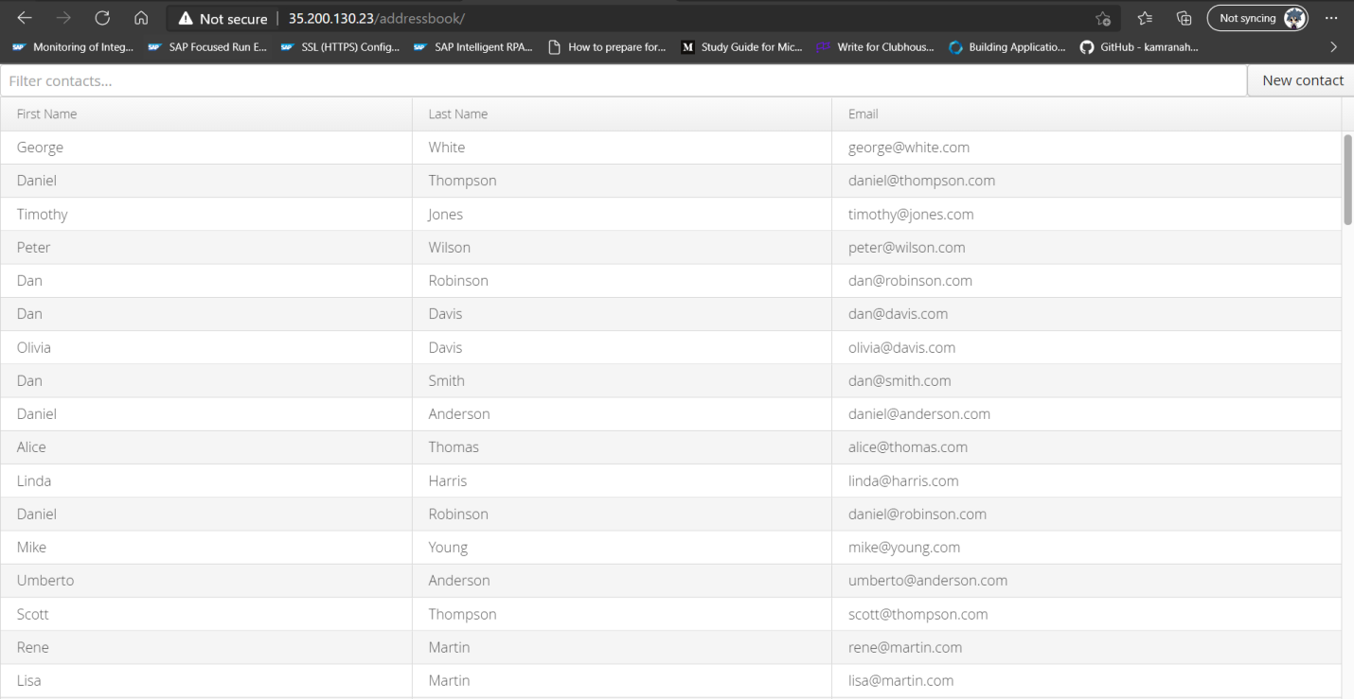

- Connect to mysql container in –it mode and create a table named test having id, name and age as attributes.
  - To open an interactive shell for the mysql_container service, check service name.
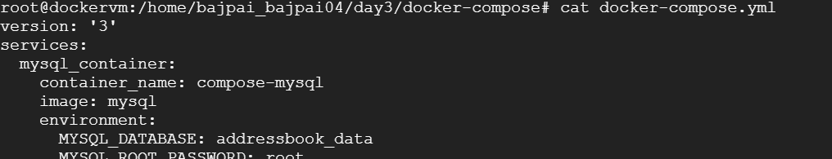
  - We will start the interactive terminal.
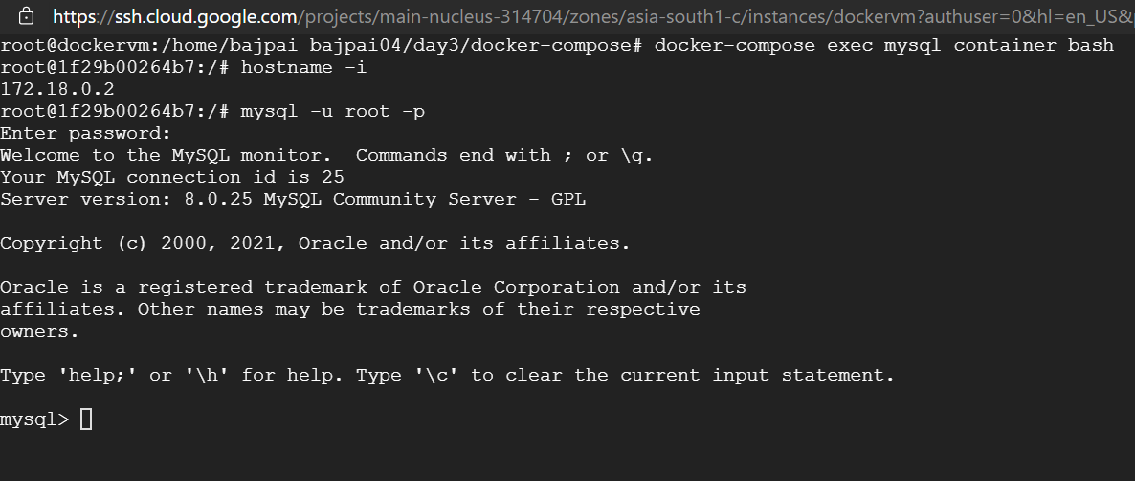
  - Let’s create the test table now along with its attributes.
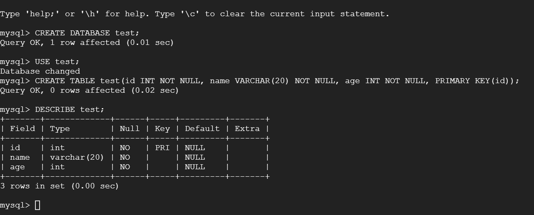
On running DESCRIBE test; we can validate the schema of test table.

