- Create a local git repo for developerA and three files into it:
  - Ubuntu machine with git.
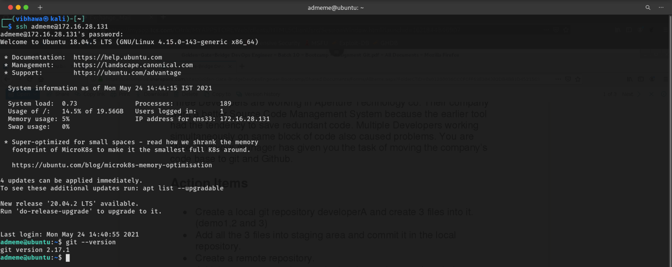
- Created a directory and initialized git. Then created three files.
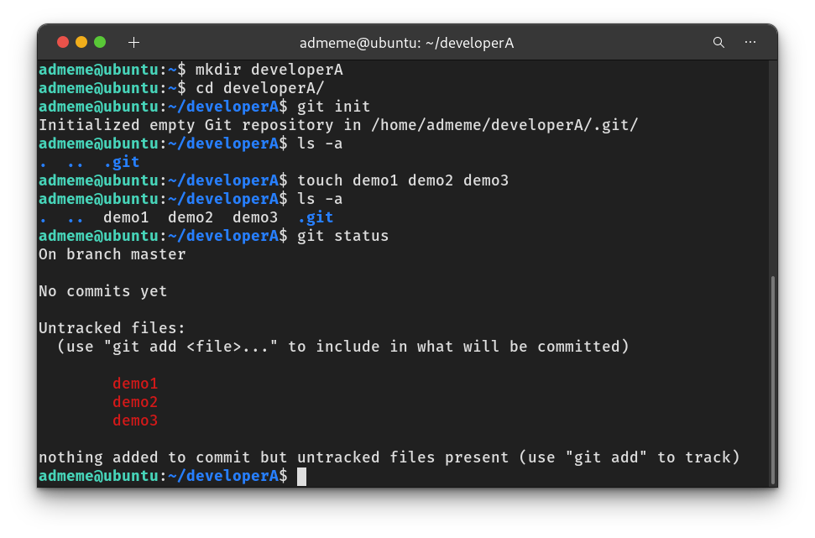

- Add all three files in staging area and commit it in the local repo.
  - Adding files to staging area.
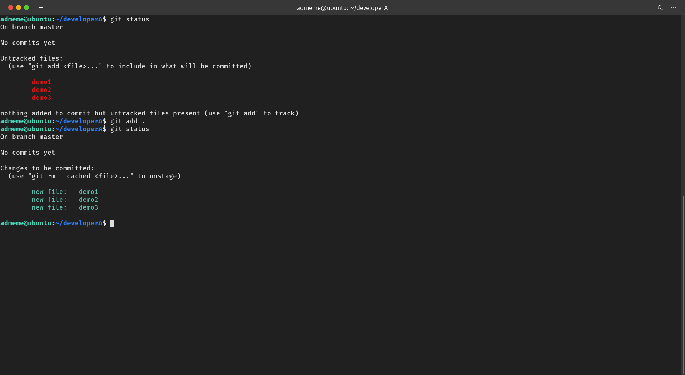
  - Commit the files in local repo.
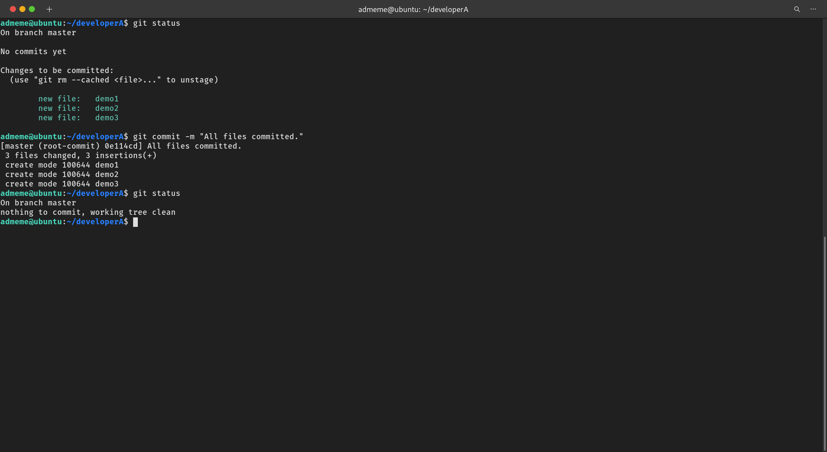

- Create a remote repository.
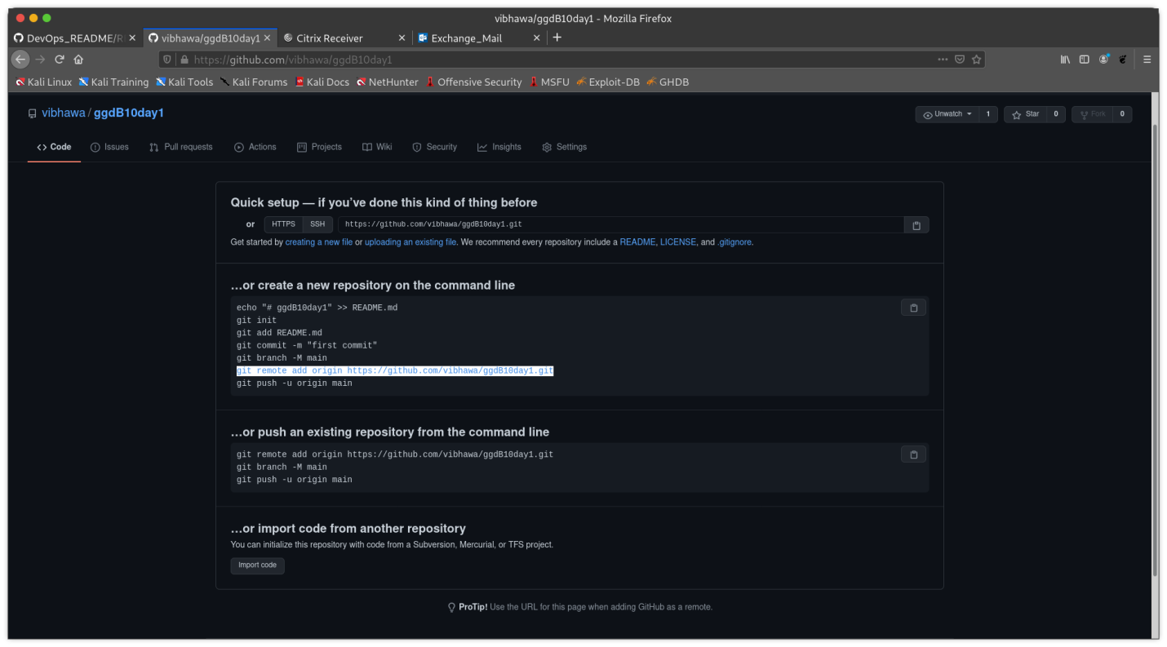

- Add the remote repo to local and push the changes to remote repo from local repo.
  - Add remote repo to local repo.
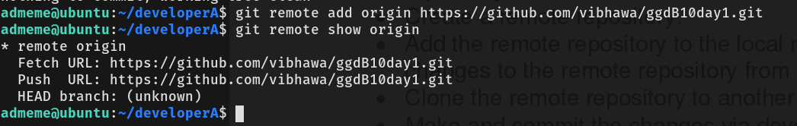
  - Push code from local to remote repo.
Note: No global configuration done for Github credentials due to on-cloud machine (will be disposed after the hands-on).
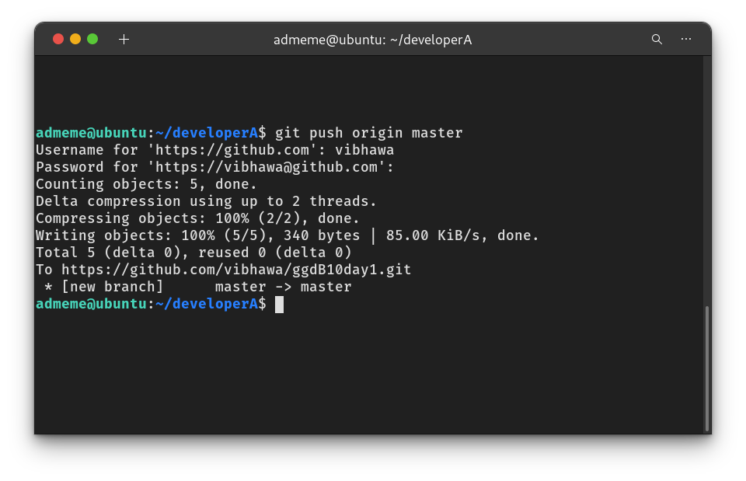

- Clone the remote repo to another folder developerB.
  - Created directory developer and then cloned repo.
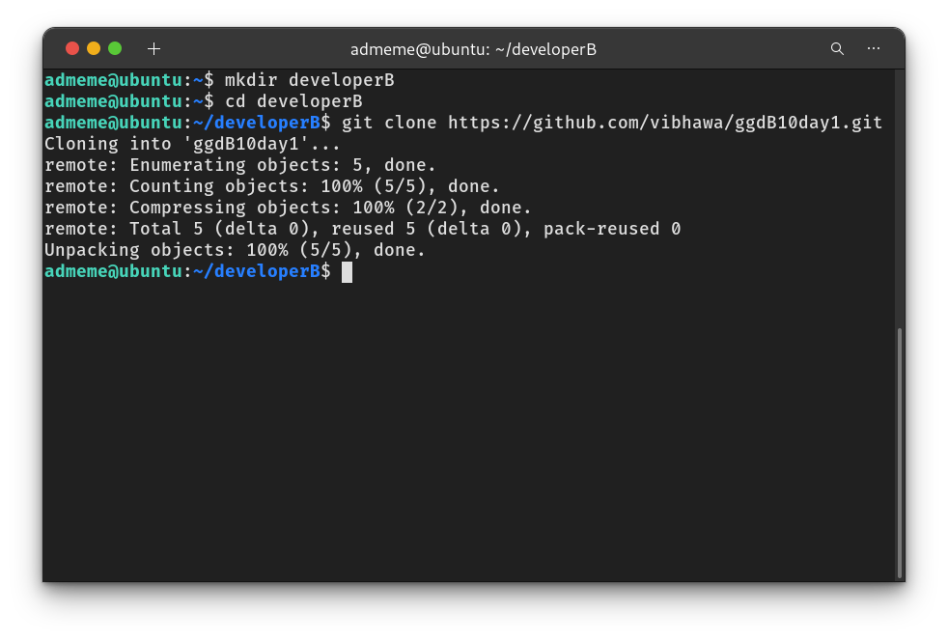

- Make and commit changes via developerB and sync the changes to developerA’s repo.
  - Updated demo1 file from developerB’s repo.
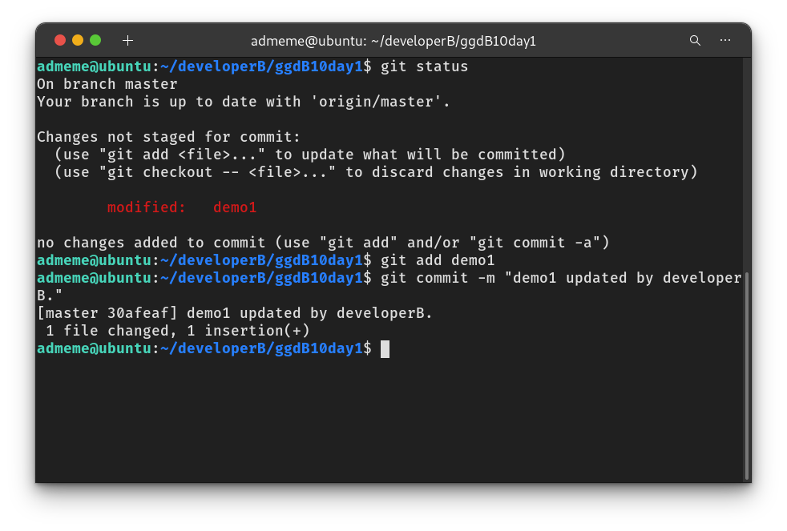
  - Push the changes to remote repo.
Note: No global configuration done for Github credentials due to on-cloud machine(will be disposed after the hands-on).

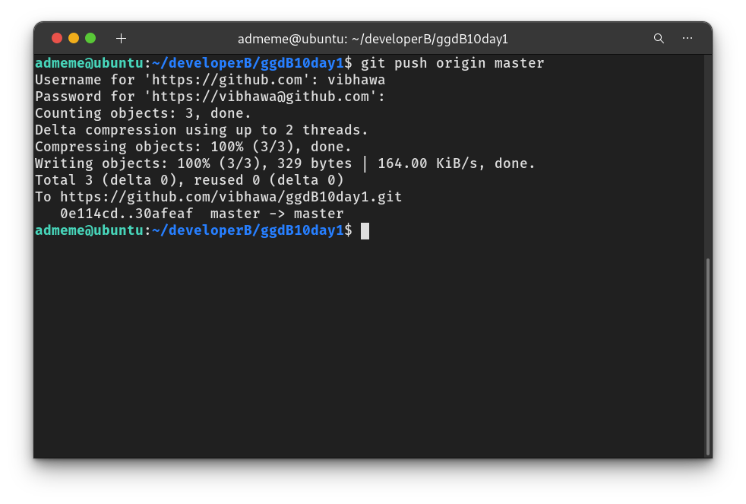
  - Sync developerA’s local repo with new changes.
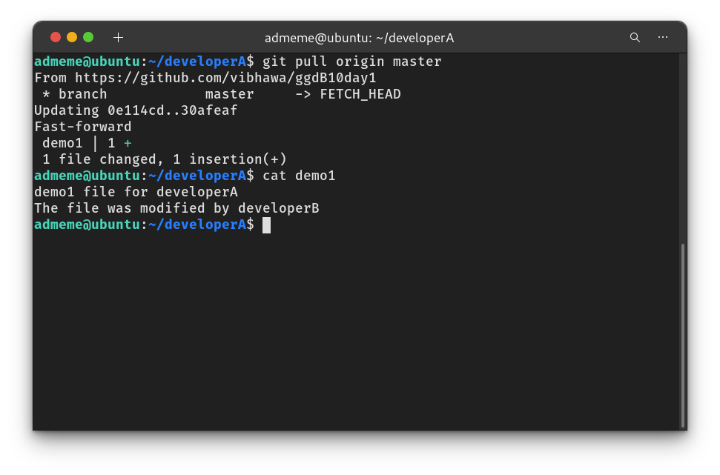

- Create a new branch for a new feature and change the files.
  - Create branch feature1. Switch to feature1.
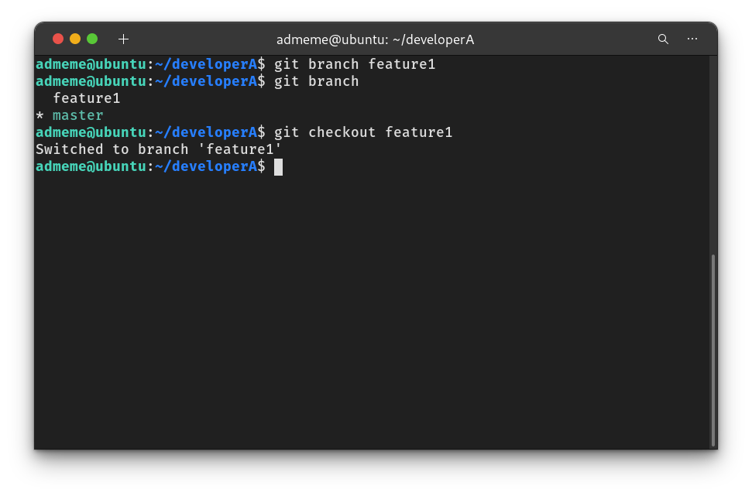
  - Update demo1 file. After updating, committed the file.
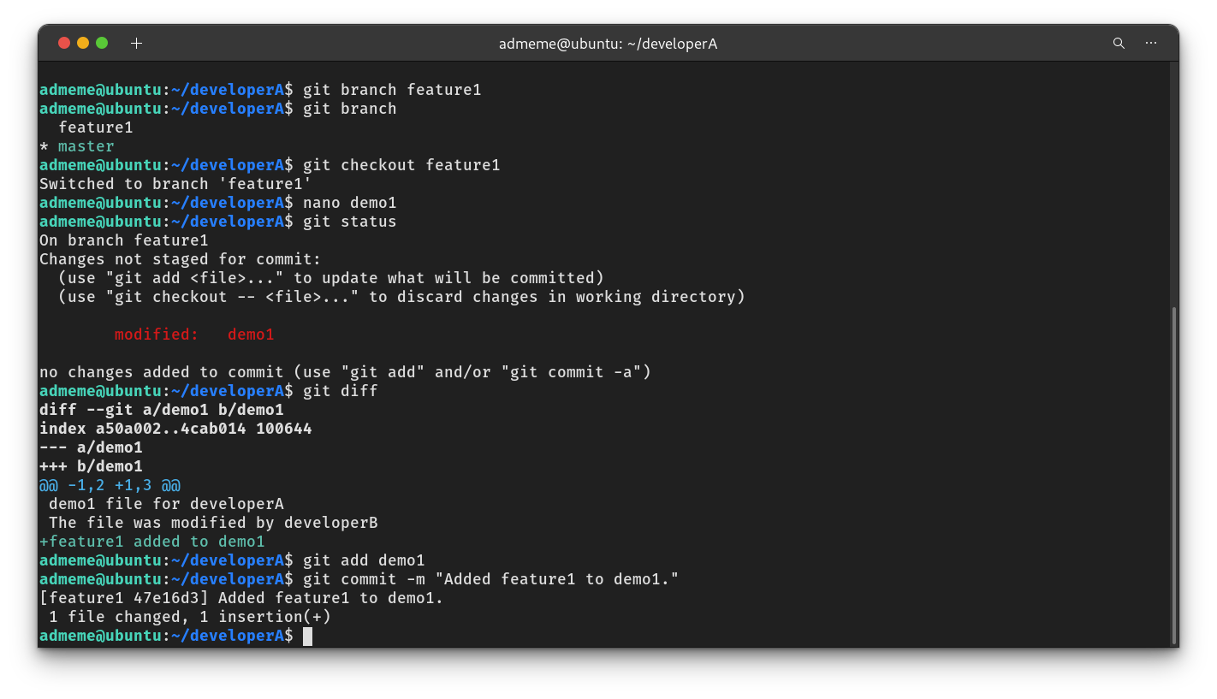

- Merge back to the master branch.
  - Checkout to master and merge feature1.
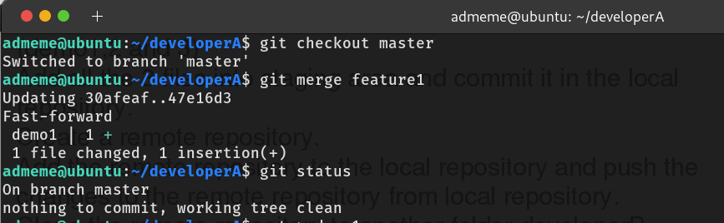
  - Validate the updated demo1 file.
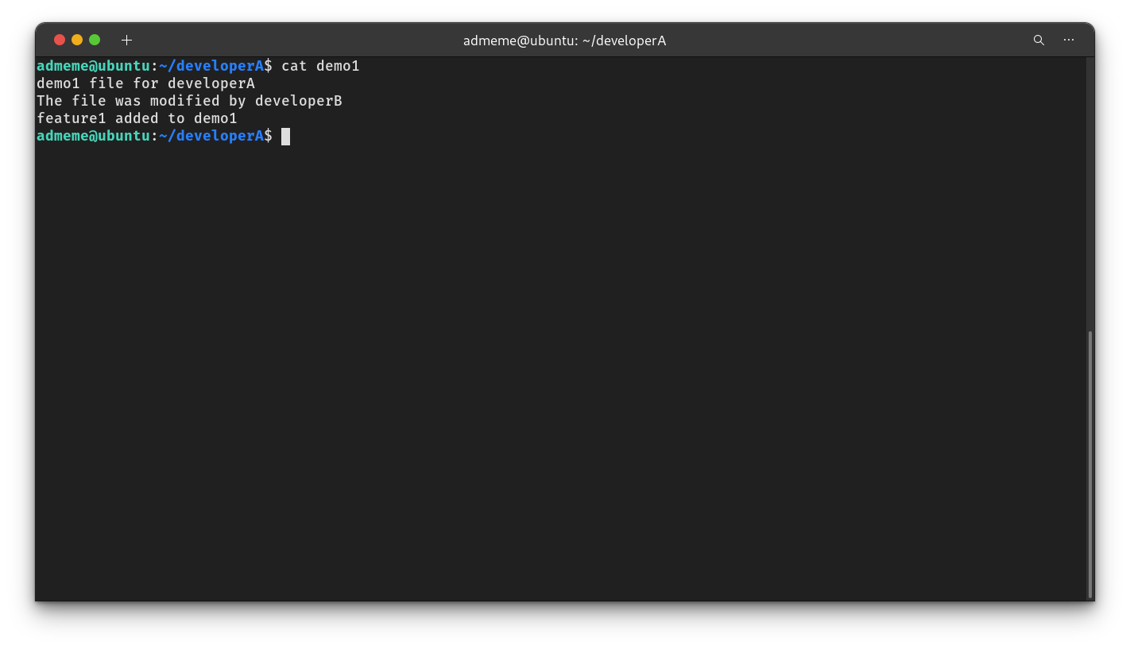
- Delete the feature1 branch after merging.
