GIT
- Create two separate branches from master.
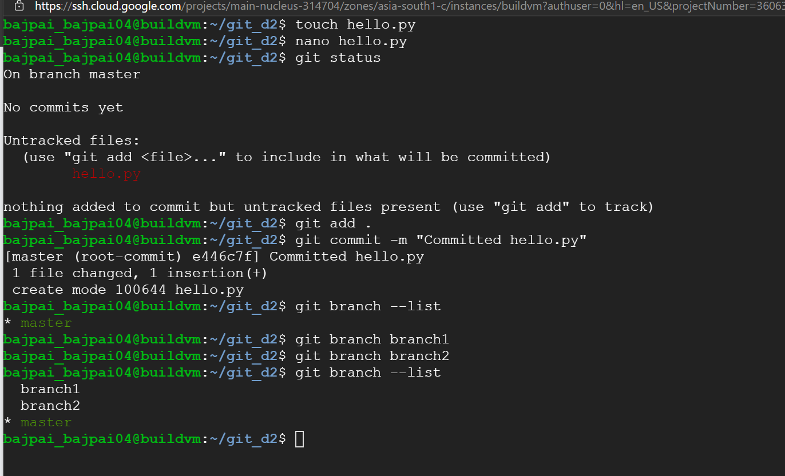
- Make change in the function of the source code in both the branches.
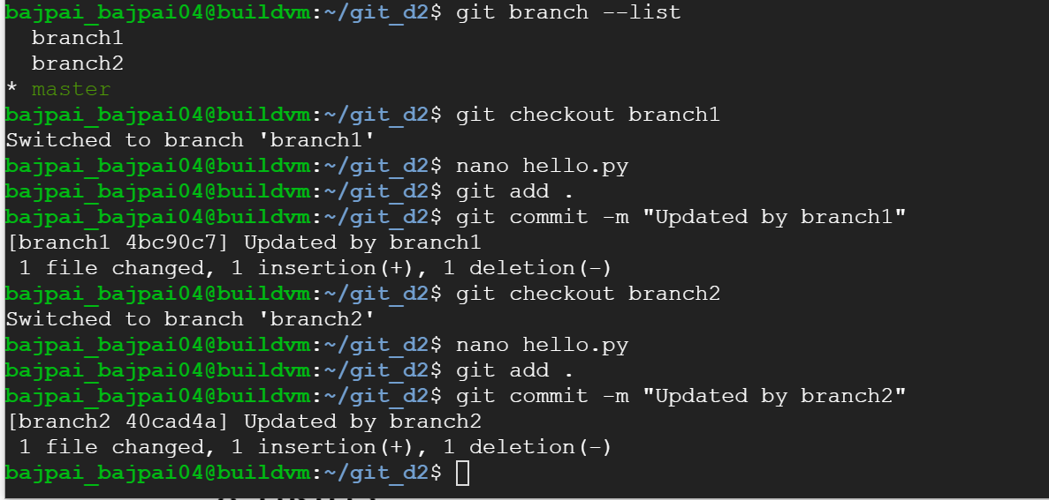

- Merge branch1 into master.
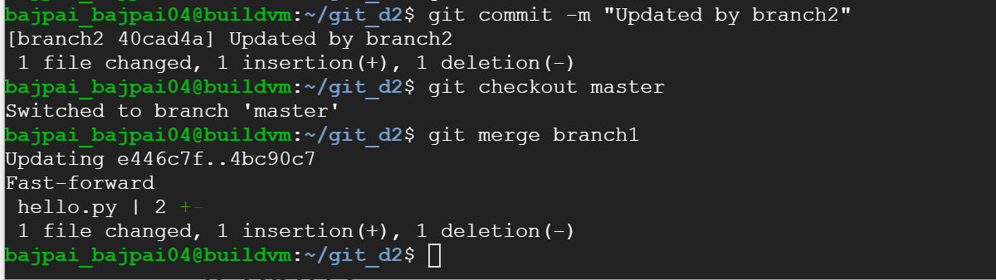
- Try and merge branch2 into the master.
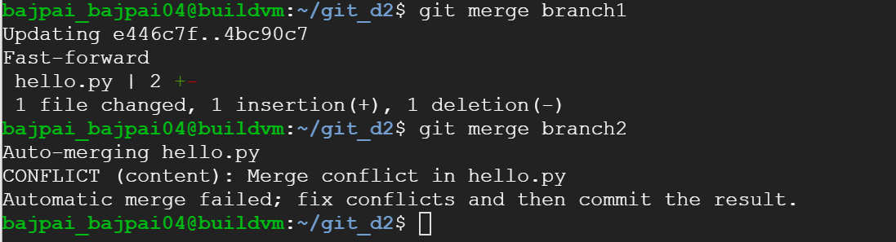
- Install a merge tool of your choice and resolve the merge conflict using git merge tool command.
  - As of now, no merge tool is configured.
  - Let’s configure vimdiff as the merge tool. We need vim. Install using sudo apt install vim. Now we will configure git.
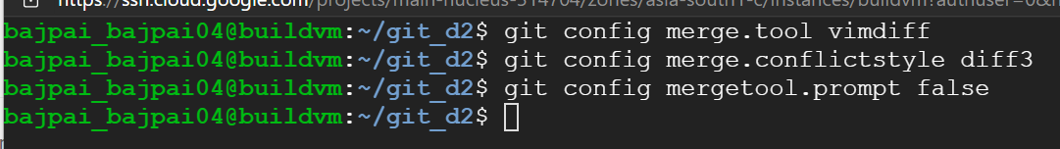
  - Let’s resolve the conflict. We will keep the branch2 updates.
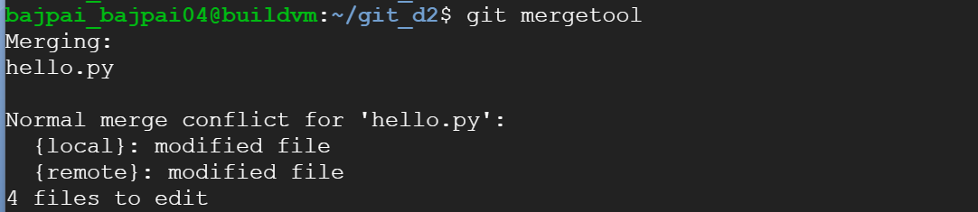
Press Esc :diffget RE :wqa
RE for branch2 which is remote in our case. Use LO for LOCAL and BA for Base.
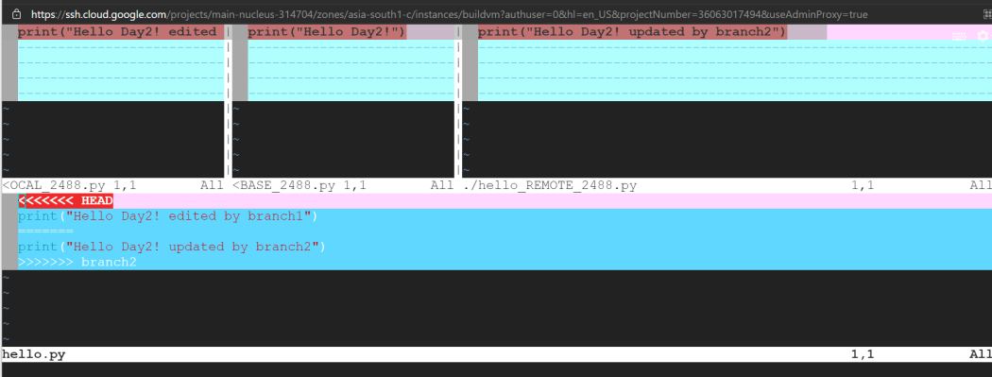
  - Type git commit and edit the message in the popup window to commit.
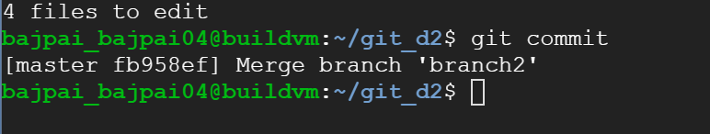
File is merged and committed.
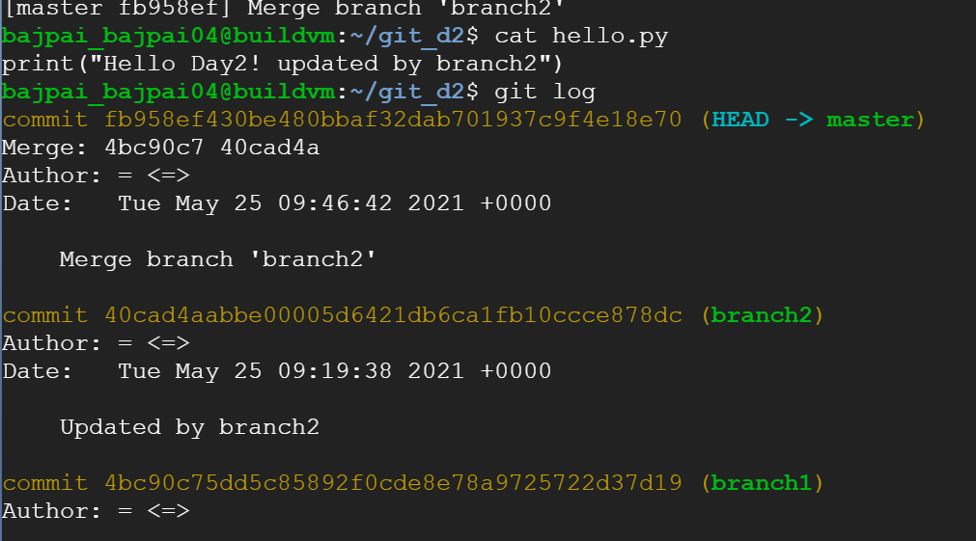

Jenkins
- Create multiple freestyle projects to checkout, build, test, package and deploy the web application in tomcat.
  - Jenkins project to checkout code.
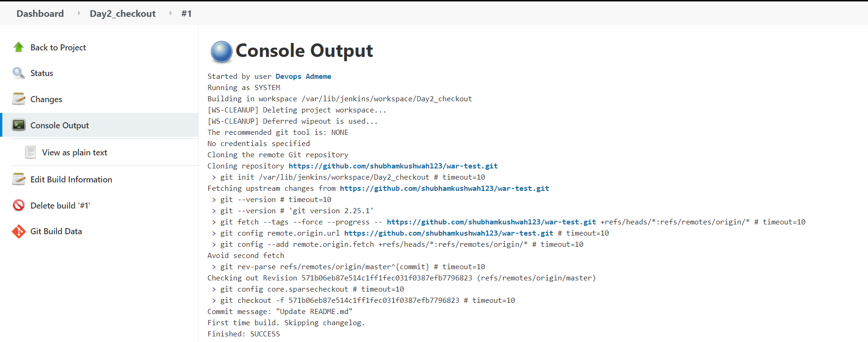
  - Jenkins project to build the checked out code.
We use mvn compile as build action under Execute shell.
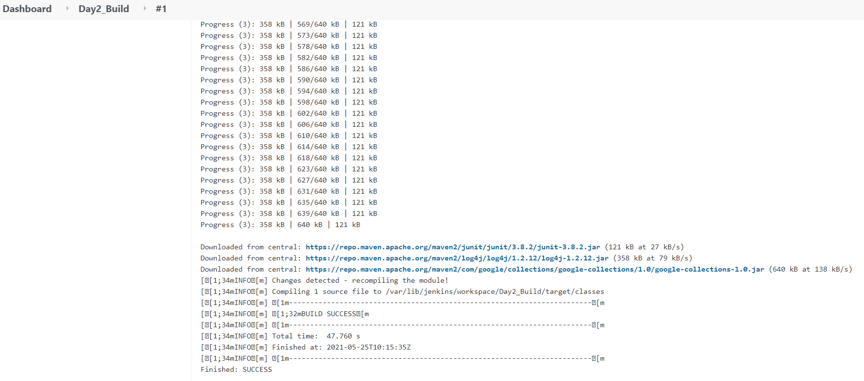
The below file has the logs.
  - Jenkins project to test and package the war.
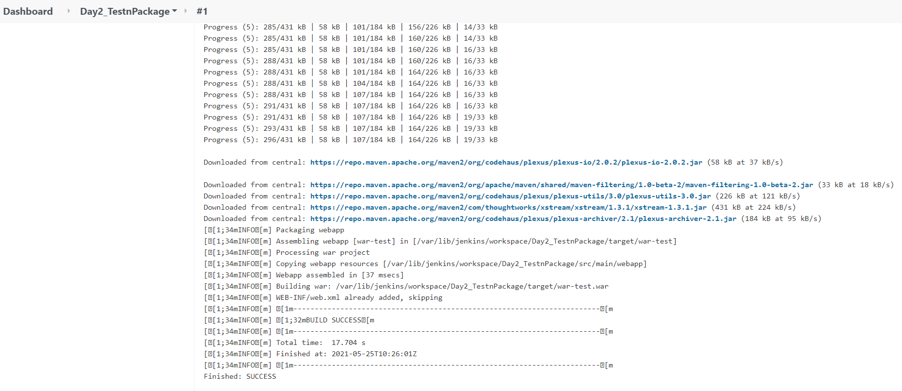
The attached file contains the job logs.
  - Deploy the war to Tomcat.
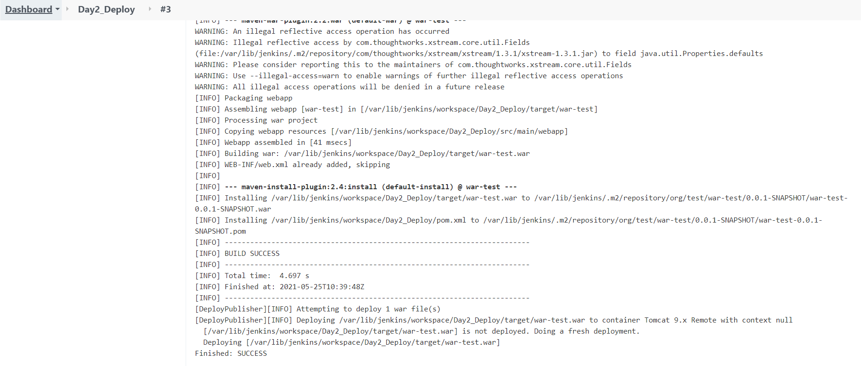
The attached file contains logs for this job.

Application running in tomcat.
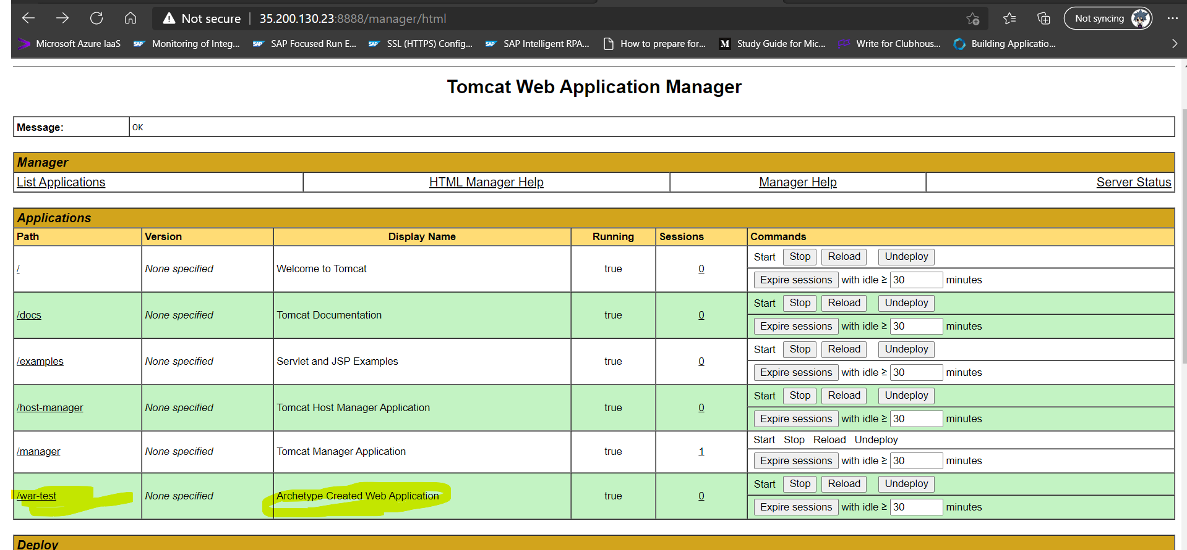
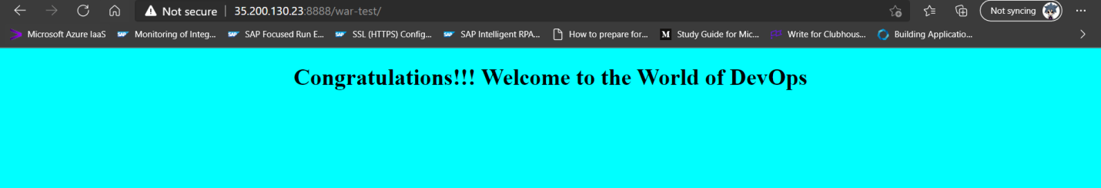

- Build pipeline view:
Use Build Pipeline Plugin.
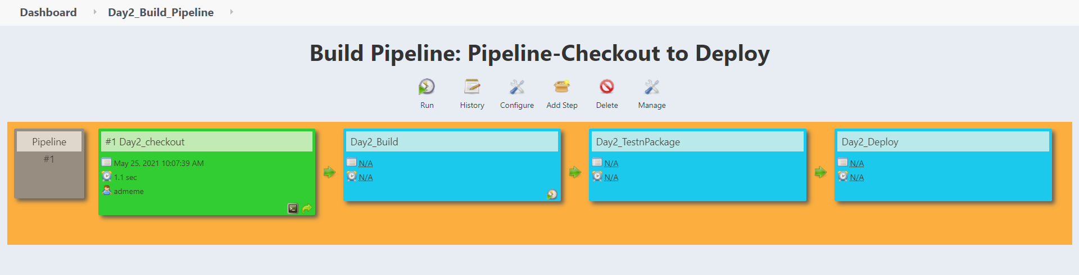
Executing pipeline from the view. Click Run.
Time is in UTC time zone.
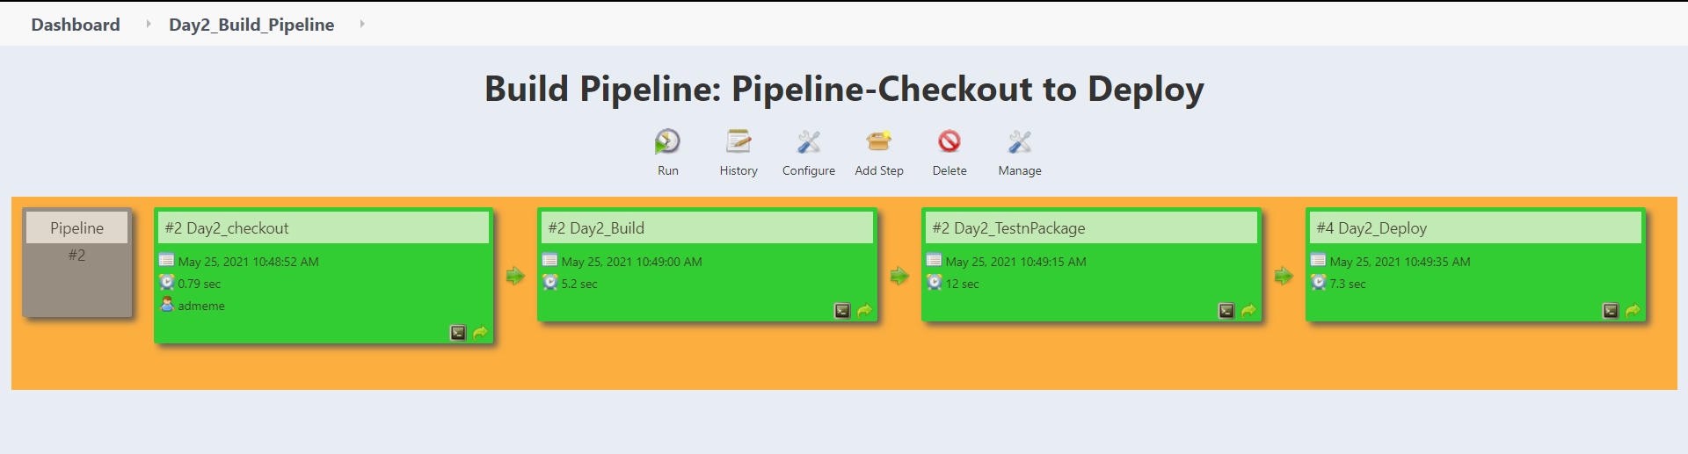

- Configure Maven as a tool in Jenkins environment.
  - Goto Manage Jenkins Global tool configuration Navigate to Maven.
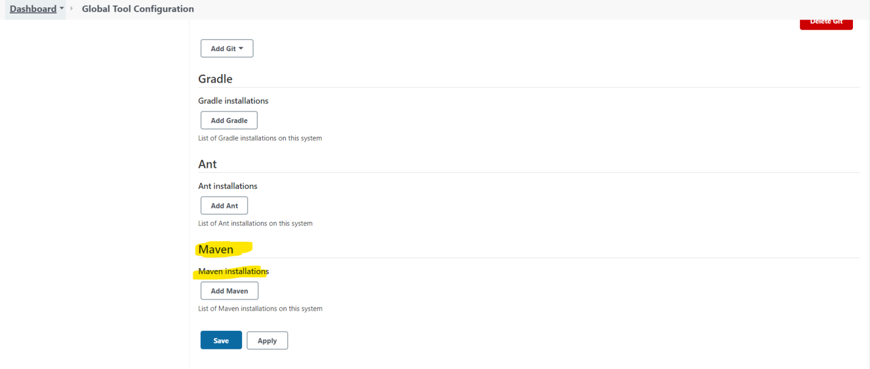
  - Click on Add Maven and give a name. Select version. Click save.
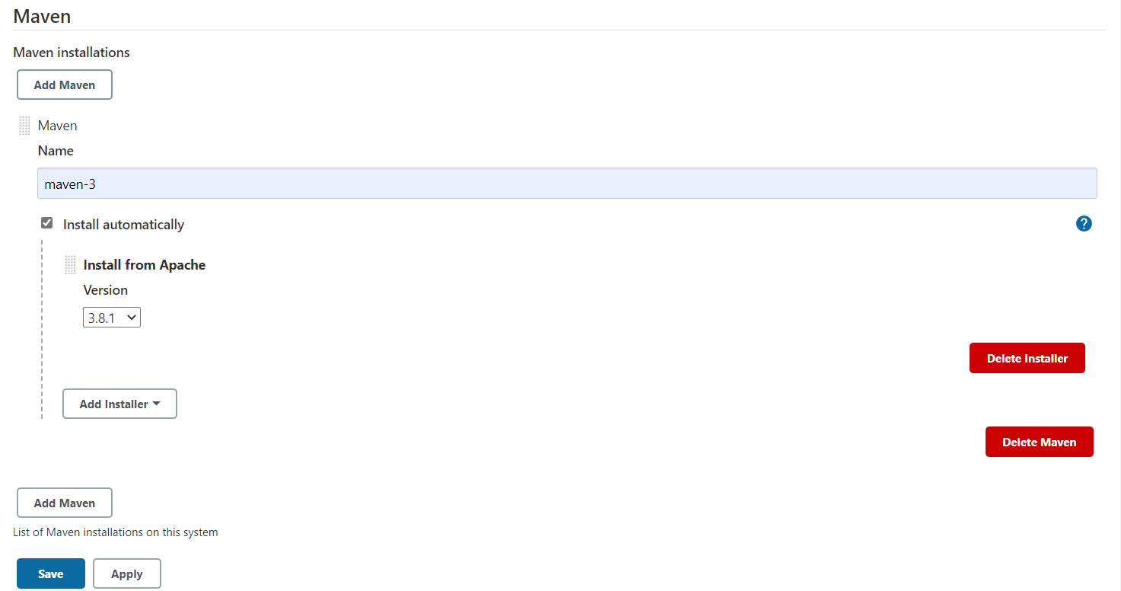
We can validate this with Invoke top-level maven targets under Build section of a job.

- Create a pipeline job and write the script to achieve the same tasks. Pipeline must trigger with a Github webhook upon every commit.
  - Create the pipeline.
Goto New Item Select Pipeline.
Select GitHub hook trigger for GITScm polling under Build Triggers.
Enter the Groovy script under Pipeline section.

Script
pipeline {
agent any

tools {
// Install the Maven version configured as "maven-3" and add it to the path.
maven "maven-3"
}

stages {
stage('Clone') {
steps {
// Get some code from a GitHub repository
git 'https://github.com/vibhawa/war-test.git'
}
}
stage('Build') {
steps {
// Run Maven on a Unix agent.
sh "mvn clean install"
}
}
stage('Deploy'){
steps {
//Syntax generated using pipeline syntax within Jenkins
deploy adapters: [tomcat9(credentialsId: 'tomcat9', path: '', url: 'http://127.0.0.1:8888')], contextPath: null, war: '**/*.war'
}
}
}
}

Click Save.
  - Let’s manually execute the build once. Check the tomcat server, our app is undeployed.
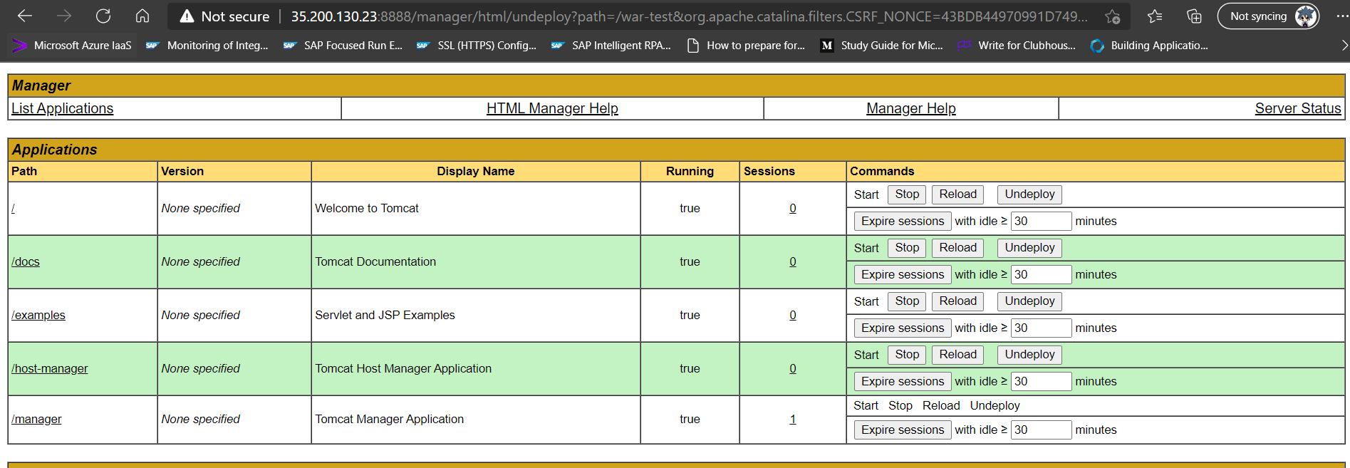

Trigger the build by clicking Build Now in Jenkins.
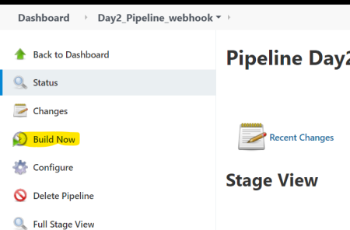
Check the logs, build is successful.
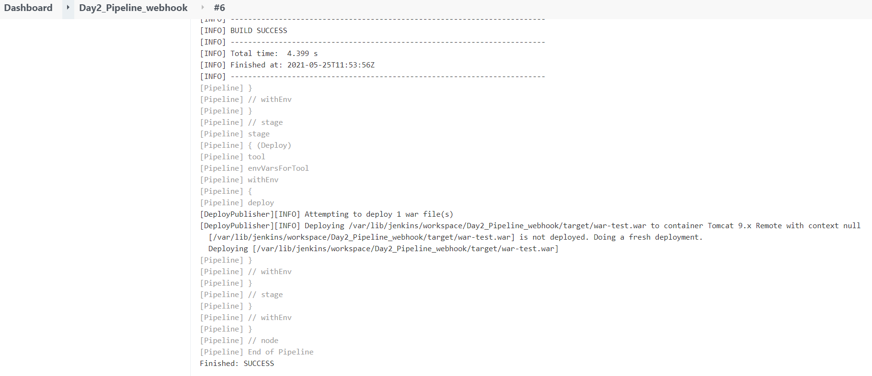
We can check the stage view as well.
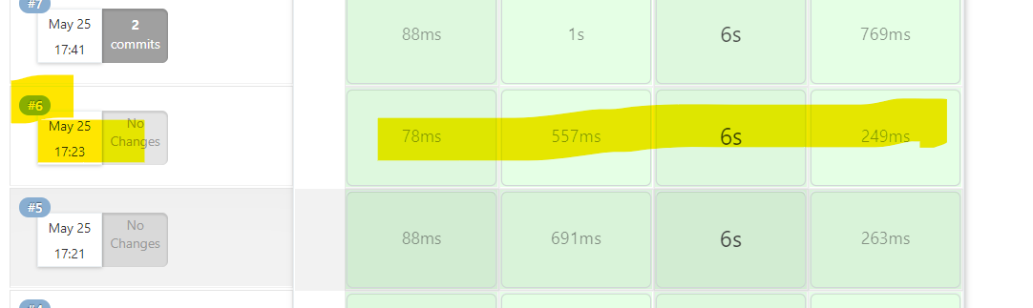

Check tomcat if the app is deployed.
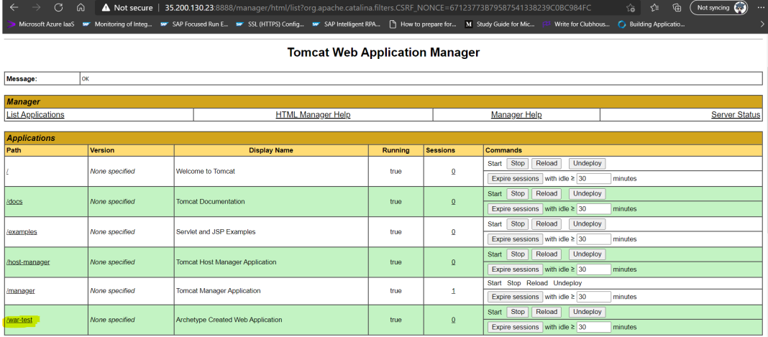
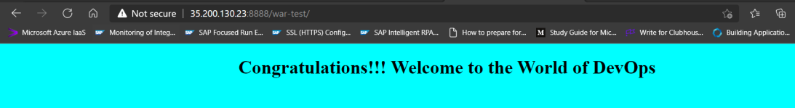
  - Let’s configure webhook in our repo.
Navigate to Settings Webhooks Add webhook.
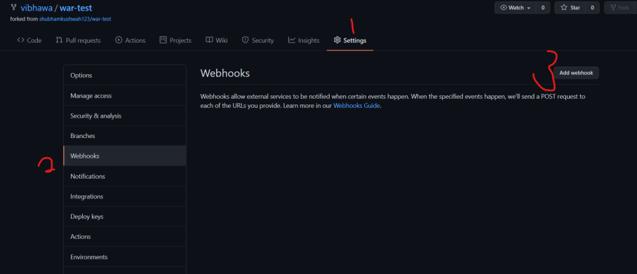
Configure as follows:
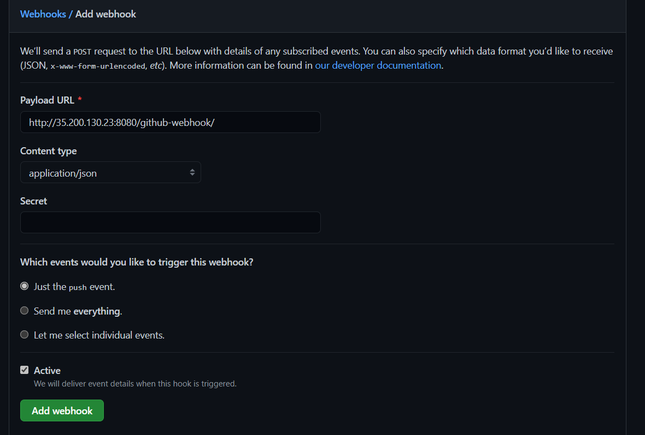
  - Let’s update the source now and push changes to Github for testing webhook.
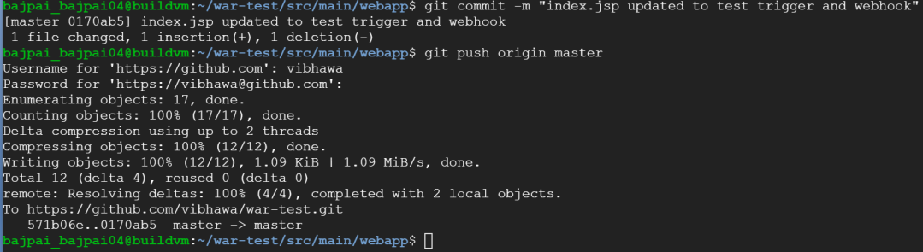
Check the Job. We can see #7 executed on its own due to the webhook event.
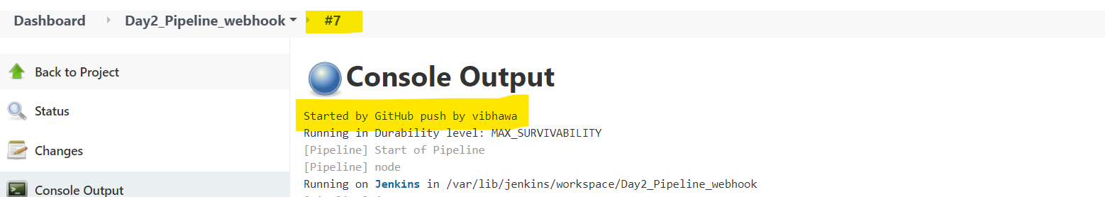
The job is successful.
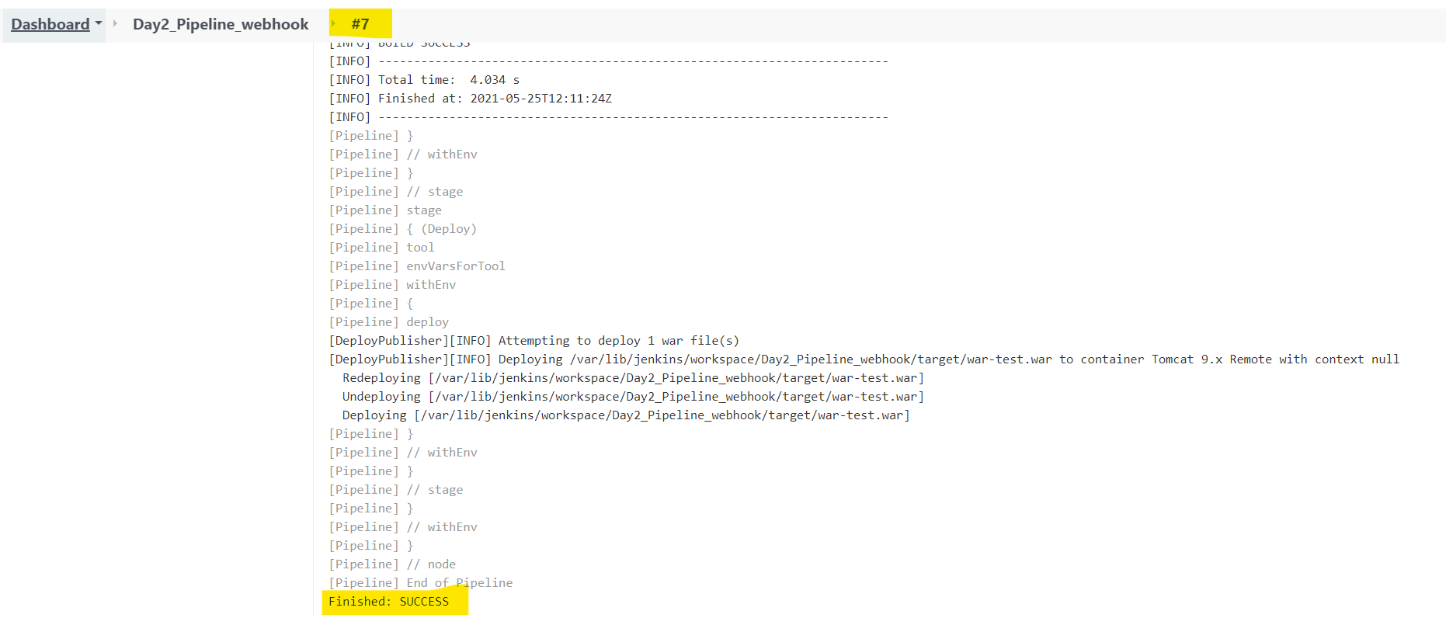
Let’s validate our application.
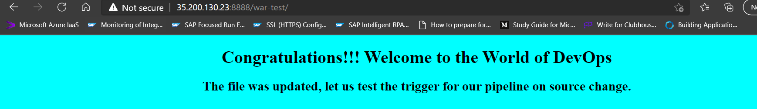
The new changes are reflecting.
We can check the job stage view.
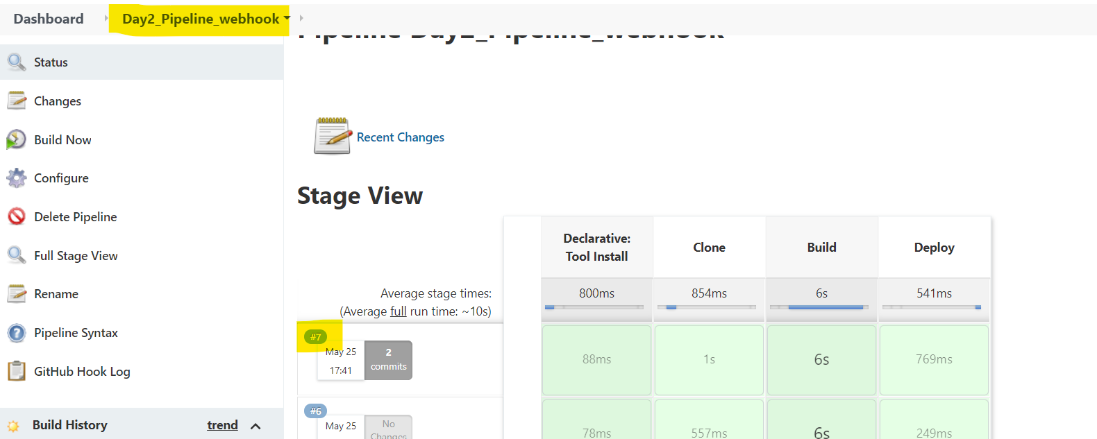
The attached are the logs for this trigger based execution.

