Meta Title: Dynamic Pricing Software for Airbnb Hosts | PropertyFlow
Meta Description: Dynamic pricing software for Airbnb hosts: how AI pricing works, what it looks at, what it costs and what it can't promise. Built for UK short-term lets.
URL: /how-ai-pricing-works-short-term-let-hosts/
Primary Keyword: dynamic pricing software for airbnb hosts
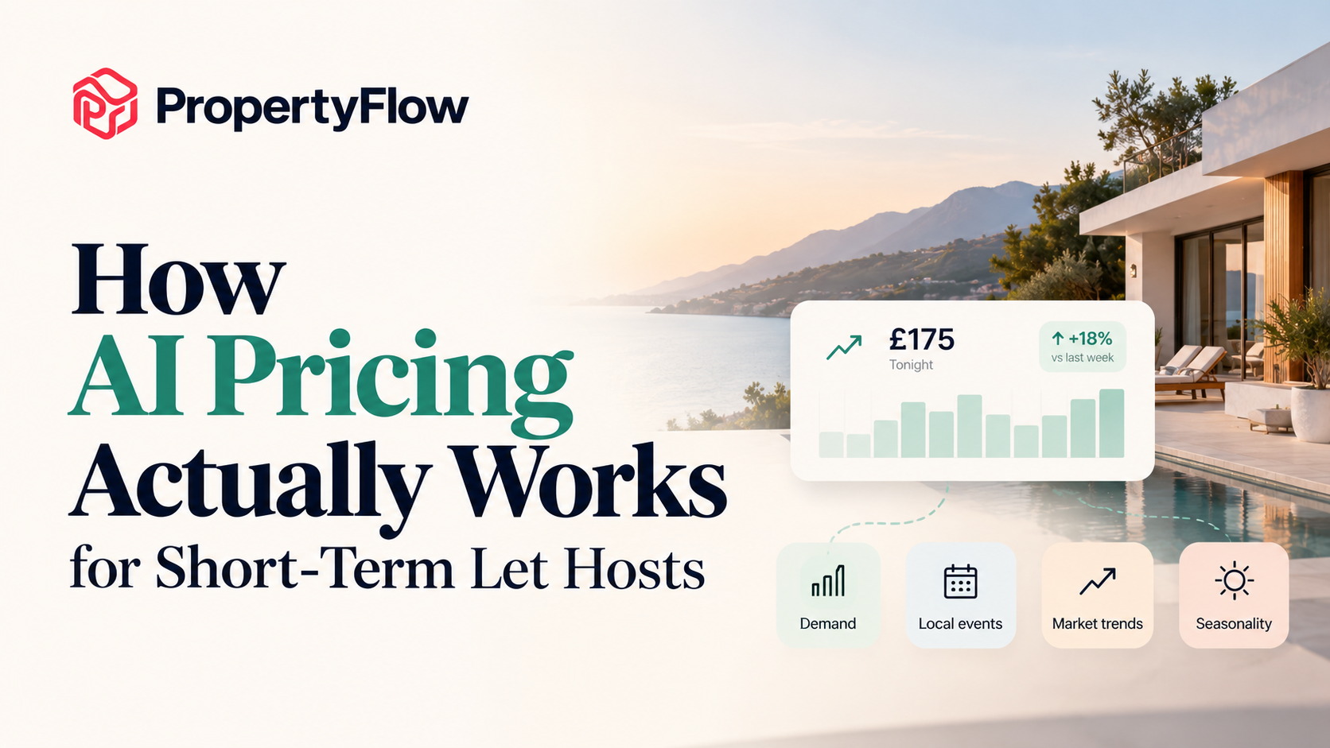

How AI Pricing Actually Works for Short-Term Let Hosts
A guest searches for your property on a Tuesday. Your calendar says the night is available. What should you charge for it? £90? £120? £160?
There is no single answer. Demand, seasons, local events and booking patterns keep changing, and a price that made sense last month may not make sense for the same night next month. That gap between what a night could earn and what you charged is where revenue quietly leaks.
Dynamic pricing software for Airbnb hosts exists to close it. This guide explains the mechanism: what it looks at, how rates move, what you still control, what it costs and what it cannot promise.

What Is Dynamic Pricing Software for Airbnb Hosts?
AI pricing, also called dynamic pricing or revenue management, adjusts a property's nightly rate as demand and market conditions change. The alternative is one fixed rate, or a rate you update by hand whenever you remember.
A simple example: your property is normally £110 a night. A quiet Tuesday may not justify the same rate as a Saturday. A concert nearby can change demand, and a busy August behaves differently from a normal February.
PropertyFlow's AI Cognito Pricing is an AI pricing tool for short-term rentals in the UK. It adjusts nightly rates for demand, season and local events, with per-channel pricing rules. Software can weigh far more information than you could check in a spreadsheet once a week.

How Does AI Pricing Work for Airbnb Hosts?
At a high level, the process looks like this:
Property and market signals - demand picture - nightly rate - applied across your channels
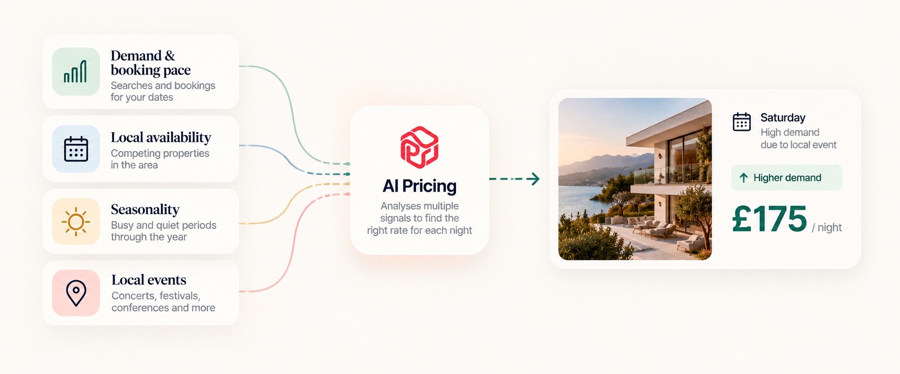(How AI pricing works: demand, availability, seasonality and local events can all contribute to the nightly rate for a property)
The system looks at what is happening around a specific night and adjusts the rate to match. PropertyFlow's pricing looks at:
- Demand and booking pace. If searches and bookings for a weekend pick up, that is a signal.
- Local availability. When competing properties start to fill, rates can respond.
- Seasonality. A destination's busy and quiet periods rarely stay the same all year.
- Local events. Concerts, festivals, sporting fixtures and conferences change demand on specific dates.
- Booking trends. Patterns over time help the system avoid treating every date as unrelated.
Weighting and signals vary between providers, so it is worth asking how any pricing engine works before you rely on it.

Does AI Pricing Change the Price Every Night?
It can. PropertyFlow adjusts nightly rates rather than relying on one static rate.
That does not mean dramatic changes every day. Sometimes the right response to the market is a small change, or none at all. The point is that you are not reviewing every date by hand.
Changing the price on one calendar is manageable. Doing it across seven properties, while also watching demand and upcoming events, is a different job.

What Happens When Demand Changes?
Imagine a Saturday three weeks from now. At first, demand looks ordinary, so the rate sits close to the property's normal range.
Then more people start searching for that weekend. Bookings pick up and nearby availability tightens. The pricing system has new information, so the rate for that night moves.
The same works in reverse. If a date stays unbooked and the market softens, the rate can come down to give that night a better chance of booking.
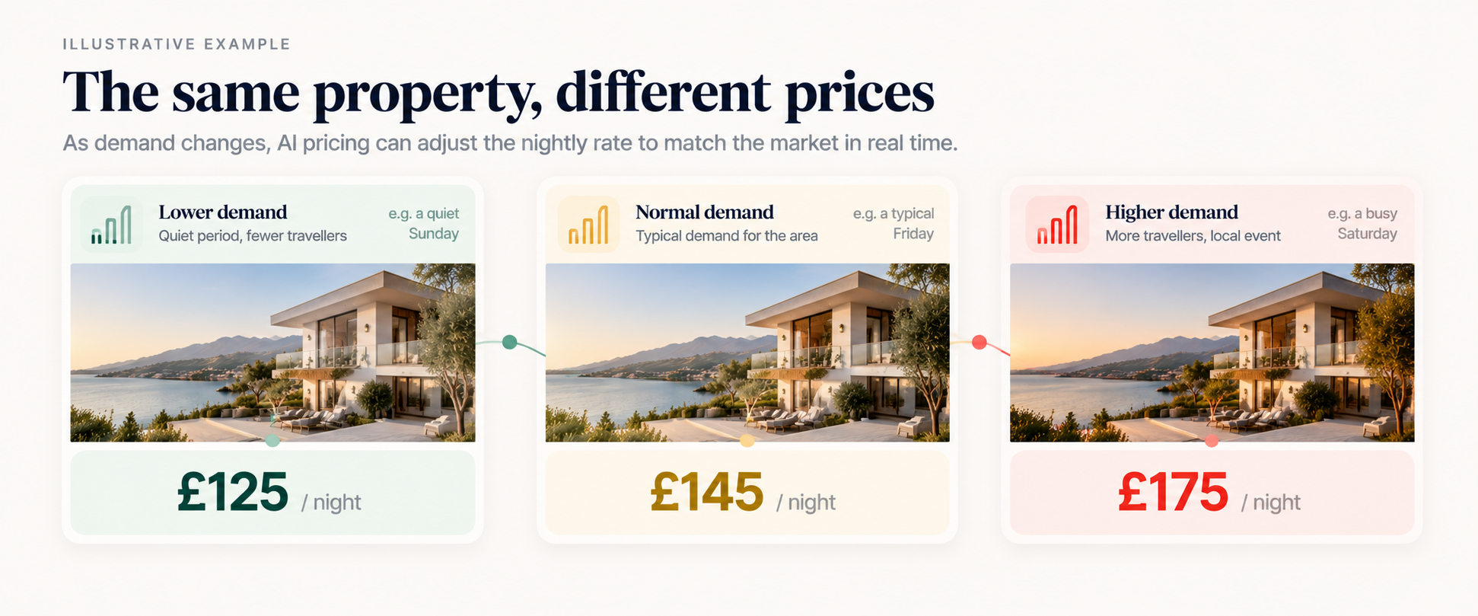(Illustrative example: The same property can have different nightly rates as demand changes across different dates)
A fixed strategy says: "This property costs £120 tonight." Dynamic pricing asks: "What should this night cost given what we know now?" Neither guarantees an outcome, but the second one can respond.

What About Seasonality and Local Events?
Short-term-let demand rarely behaves the same way all year. Summer, school holidays, weekends and quiet midweek periods all look different, and a city can behave differently again during a major event.
The impact of an event is date-specific. You might see ordinary demand on the Tuesday before a festival and far stronger demand on Friday and Saturday. You do not need to remember every seasonal pattern or research every event yourself. AI Cognito Pricing takes both into account when it adjusts rates.

What Do You Still Control?
AI pricing does not replace your judgement about your business. You know things market data does not: a property has just been renovated, or you want to prioritise occupancy for a particular month.
With PropertyFlow, you decide how it is used:
- Which properties use it. You switch AI Cognito Pricing on per property, and you can switch it off per property at any time.
- How rates apply by channel. Per-channel pricing rules let you handle rates differently across booking channels.

If Someone Else Runs Your Day-to-Day
Many hosts hand the daily work to a cleaner, a co-host or a manager, and want pricing to keep working without them. Manual pricing is the task most likely to be forgotten when someone else is busy running the property.
With AI pricing, rates keep adjusting nightly on every property where it is switched on, whoever is covering the guests and the cleans. Revenue and reporting show how each property is performing, so you can check the results in a few minutes instead of managing each calendar.

AI Pricing vs Manual Pricing
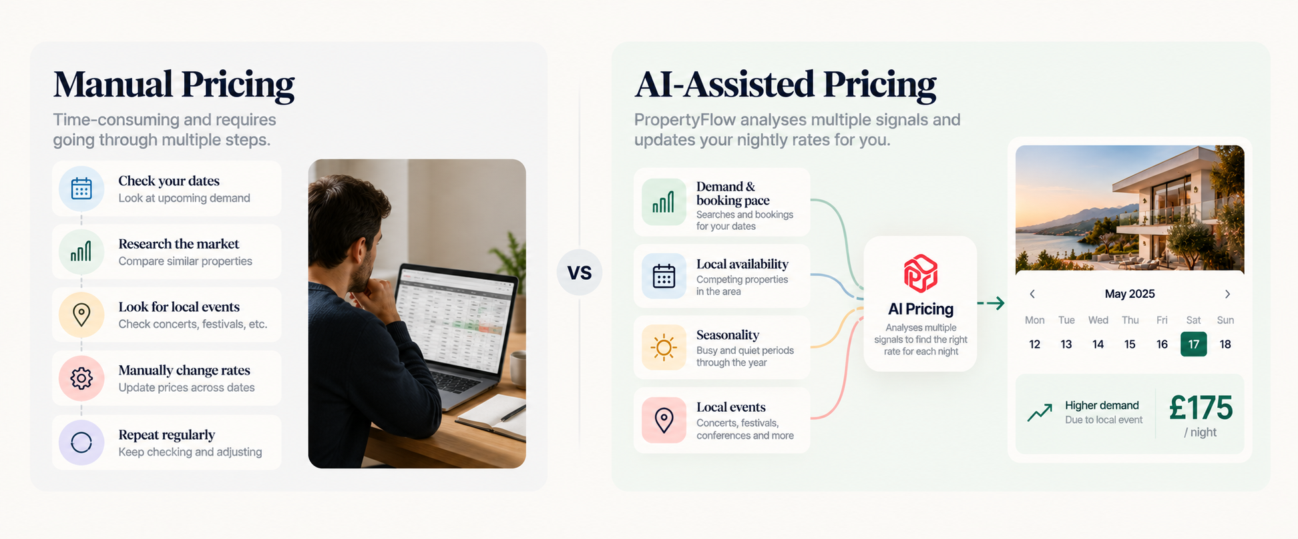(Manual vs AI-assisted pricing: Manual pricing requires repeated checks and rate changes, while AI pricing can analyses multiple signals and adjusts nightly rates on switched-on properties)
Manual pricing | AI-assisted pricing
You check rates by hand | Rates are adjusted nightly by the system
Changes happen when you remember | Runs on every property you switch on
Relies on your own market research | Uses demand, booking pace, availability, season and events
Time grows with every property | The same process runs across your portfolio
Easy to make a one-off change | Per-channel pricing rules add another layer
Neither approach guarantees higher revenue. The difference is how the pricing decision gets made and how much of your time it takes.

Can AI Pricing Guarantee More Revenue?
No. AI pricing can respond to demand signals and market information, but it cannot guarantee any occupancy rate, average nightly rate or revenue figure.
Too many things sit outside the software. Guest behaviour changes, competitors change their rates, and your reviews, amenities and location affect demand. External events can reshape travel patterns overnight.
The honest description is that AI pricing is a way to make pricing decisions with more data and less manual work, not a guaranteed revenue increase. If any provider promises a specific uplift, ask how the figure was calculated and over what period.

AI Pricing vs a Simple Pricing Rule
A simple rule says: "Charge £150 on Fridays and Saturdays," or "Add 20% in July." Rules like these are useful, but they are fixed instructions.
AI-assisted pricing looks at the specific night. As an illustration:
- Friday: £145
- Saturday: £175
- Sunday: £125
The rates reflect expected demand on each date rather than one weekend rule applied to everything. These figures are illustrative, not predictions.

What Does an AI Pricing Tool for Short-Term Rentals Cost?
AI Cognito Pricing is an add-on at £9.99 per property per month plus VAT, charged only on the properties where you switch it on. The core platform is free for every property on your own Airbnb and Booking.com accounts, so pricing is the only per-property charge.
With five properties, AI pricing on two costs £19.98 a month plus VAT. On all five, it costs £49.95 plus VAT. For the full breakdown of what is free, see our guide to a free Airbnb channel manager with 0% commission.

When Does AI Pricing Make Sense?
It depends on how you price today. With one property, and a taste for checking the market yourself, manual pricing may be perfectly workable.
The calculation changes as you add properties. Picture five properties and a day job, checking:
- Five calendars across several channels
- Weekend demand and seasonal shifts
- Local events and upcoming gaps
- Current market rates
Then repeating it next week. The value is not only the rate itself. It is the time saved and the consistency of the process. Because you pay per property, you can start with the ones where pricing matters most and widen it as you grow.

What Should You Ask Before Switching On AI Pricing?
- What data does it use? Know whether it looks at demand, availability, seasonality and events, or something else.
- How often are rates updated? A monthly update works very differently from a nightly one.
- Is it charged per property? This adds up as your portfolio grows.
- Does it work with my channels? A pricing tool is little use if you must copy rates across by hand.
- Can I switch it off? Understand the commitment before you activate it.

AI Pricing Is One Part of the Bigger Picture
A booking affects the calendar, the calendar affects the turnover, and guests need messages. The property needs to stay compliant, and every booking creates a payout. That is why pricing works best inside a broader system.
To compare the wider software landscape, see our guide to short-term rental management software in the UK. PropertyFlow brings together channel management, AI Cognito Pricing, guest messaging, turnover tasks, compliance reminders, financials and reporting.

Frequently Asked Questions
How does AI pricing work for Airbnb?
AI pricing software analyses signals such as demand, booking pace, availability, seasonality and local events, then adjusts nightly rates as conditions change. PropertyFlow's AI Cognito Pricing adjusts rates nightly on every property where it is switched on.
What is dynamic pricing software for Airbnb hosts?
It is software that sets nightly rates for each date based on demand signals and market conditions, rather than one fixed price or manual updates.
Does AI pricing guarantee higher Airbnb revenue?
No. It can respond to demand and market information, but it cannot guarantee higher revenue, occupancy or booking value.
Can I choose which properties use AI pricing?
Yes. You switch AI Cognito Pricing on per property, and you can switch it off per property at any time.
How much does PropertyFlow AI Cognito Pricing cost?
£9.99 per property per month plus VAT, only on the properties where you switch it on. It is an optional add-on, not a charge for using the core platform.
Is AI pricing available for UK short-term lets?
Yes. PropertyFlow is built for UK short-term let hosts, and AI Cognito Pricing adjusts rates for demand, season and local events.

Ready to See It on Your Own Properties?
Connect your own Airbnb and Booking.com accounts free, then switch on AI Cognito Pricing for the properties where it makes the most sense. Explore solution.

