Meta Title: Short Term Rental Management Software UK | PropertyFlow
Recommended URL: /short-term-rental-management-software-uk/
Primary Keyword: short term rental management software uk

Short Term Rental Management Software UK: What It Actually Runs For You
Meta Description: Learn what short-term rental management software does for UK hosts, from channel management and guest messaging to pricing, compliance and reporting.
Running one short-term let can be manageable from a couple of apps. Add another property, then another, and short term rental management software in the UK becomes more relevant as the routine starts to change.
You're checking calendars, replying to guests, changing prices, keeping track of cleaners and trying to remember which documents need renewing.
Short-term rental management software in the UK brings those jobs into one place. Depending on the platform, it can manage bookings and calendars across channels, organise guest messages, adjust pricing, track compliance documents and give you a clearer view of your properties.
The useful part is not having another dashboard to check, but fewer places to check in the first place.

What Short-Term-Let Management Software Actually Does
Short-term-let management software helps hosts manage the day-to-day work behind their properties from one system. You, as host, can use software to bring calendars, guest communication, pricing, turnovers, compliance records and financial information together.
The exact features vary between platforms, but the main jobs usually include:
- Calendar management: See bookings across different platforms in one place.
- Guest messaging: Keep conversations and routine replies organised.
- Pricing: Adjust nightly rates based on demand, seasonality or other factors.
- Turnovers: Keep track of cleaning and preparation between stays.
- Compliance: Store documents and keep an eye on important renewal dates.
- Reporting: See bookings, revenue and property performance without pulling information from several accounts.
For a host with one property, some of these tasks may still be easy to manage manually. As the portfolio grows, keeping everything in sync becomes a different job.
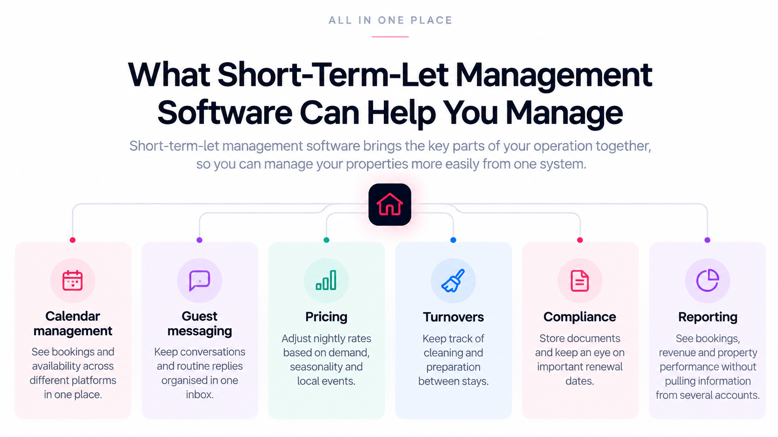(Key areas that short-term-let management software can help hosts manage, including bookings, guest communication, pricing, turnovers, compliance and reporting.)

Manual Management vs. Centralised Software
The biggest difference is how much of the operation sits across separate tools.
Task | Managing It Manually | Managing It With PropertyFlow
Calendar updates | Check and update individual booking platforms | Use Channel Management to manage availability across connected channels from one place
Guest messages | Move between different inboxes and platforms | Keep guest conversations together in one unified inbox
Pricing | Review and change nightly rates manually | Use AI Cognito Pricing to adjust rates based on factors such as demand, seasonality and local events
Compliance records | Track licences, certificates and renewal dates yourself | Store documents and keep track of renewal dates with reminders
Turnovers | Message cleaners and track tasks separately | Coordinate turnover work from the same system
Reporting | Pull figures from different platforms | View property information and financials in one place
Software does not remove every task from the host. It gives those tasks a shared system, which can make the operation easier to follow as more bookings and properties are added.
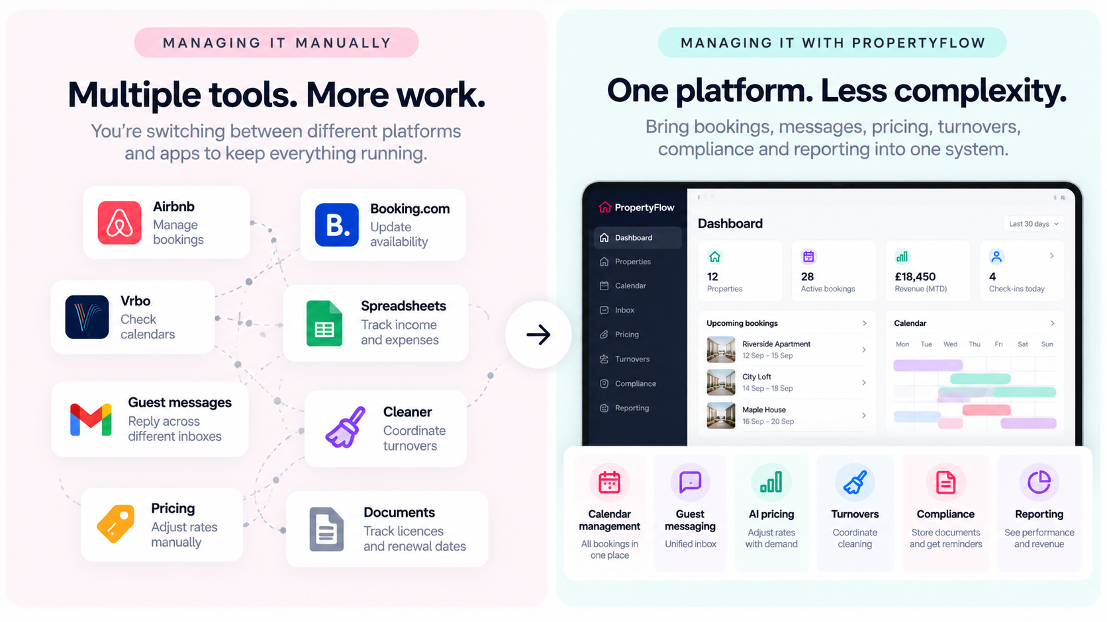(Managing a short-term-let portfolio manually can mean working across multiple tools. PropertyFlow brings key operational tasks into one system)

What to Look for in Short Term Rental Management Software UK
The right features depend on how you run your properties, but there are a few areas worth checking before choosing a platform.

Multiple booking channels
If you advertise on other channels, check whether the software can keep availability and bookings synchronised. A calendar that does not update properly can create avoidable problems, particularly when you are managing several properties.

Guest communication
Look for a system that brings guest conversations together and makes routine messages easier to manage. This becomes particularly useful when several bookings are active at the same time.

Pricing tools
Static rates can mean manually reviewing prices whenever demand changes. Dynamic pricing tools can use factors such as demand, seasonality and local events to help adjust nightly rates.

Reporting and financial information
As the number of properties increases, it becomes harder to understand performance by checking each platform separately. Look for reporting that gives you a clearer view of bookings, payouts and property-level information.

Channel Management: Keeping Every Platform in Sync
A channel manager connects the booking platforms you use and gives you one place to manage availability. For example, if a property is booked on one channel, the availability should be reflected across the other connected channels. This reduces the amount of manual calendar updating a host has to do.
PropertyFlow's channel manager brings channels such as Airbnb, Booking.com and Vrbo into one calendar, so hosts can manage availability without jumping between platforms.
For anyone managing multiple properties, this is one of the first areas worth looking at when comparing software. The question is simple: can you see what is booked, what is available and what needs attention without checking every platform individually?

Dynamic Pricing: What Changes When Rates Adjust With Demand
Pricing is another area that can become repetitive as a portfolio grows.
A host might change rates around weekends, holidays, busy periods or local events. Doing that manually across several properties can take time, particularly when demand changes frequently.
PropertyFlow's AI pricing tool, called Cognito Pricing, adjusts nightly rates using factors such as demand, seasonality and local events.
The important thing to check when choosing any pricing tool is how much control you retain. Hosts may still want to set rules around minimum prices, availability or individual channels, depending on how they operate.

What Kind of Host Actually Needs This Software?
Not every host needs the same level of software. A host with one property and a small number of bookings may be comfortable managing everything directly through Airbnb and a spreadsheet.
The calculation changes when the portfolio starts growing.
Host type | What usually becomes difficult | Where software can help
Growing host | Keeping bookings, messages and prices organised across properties | Centralise the daily operation
Multi-channel host | Updating availability across different platforms | Sync calendars and bookings
Hands-off landlord | Knowing what is happening without handling every task personally | Keep operations and property information visible
Compliance-focused host | Remembering documents and renewal dates | Store records and provide reminders
Small property manager | Coordinating several properties and guests | Bring property operations into one system
For a growing operator, the value may come from having fewer separate systems to manage. For a landlord who wants to stay informed without handling every small task, visibility can matter just as much.
The useful question is not simply how many properties you have. It is how much work is being created by the way those properties are currently managed.

Property Management Software for Short Term Rentals: What Should It Include?
When people search for property management software for short term rentals, they are often looking for more than a booking calendar. A useful platform should bring together the parts of the operation that otherwise sit in different places.
That can include:
- Booking and calendar management
- Guest communication
- Pricing
- Turnover coordination
- Compliance records
- Financial information
- Property-level reporting
The exact mix matters because different hosts have different priorities. A host expanding from two properties to five may care most about calendar and guest management. Someone managing properties on behalf of owners may need stronger reporting and operational visibility.
The best fit is the platform that covers the work you actually need to manage.

How PropertyFlow Fits Into This
PropertyFlow is built as a central platform for running UK short-term lets.
It brings bookings, calendars, guest messages, pricing, turnovers, compliance records and financial information into one system.
For hosts using multiple booking channels, the Channel Manager provides one place to manage availability. AI Cognito Pricing handles dynamic pricing based on factors such as demand, seasonality and local events. The platform also includes document reminders for licences and certificates alongside other tools for managing properties.
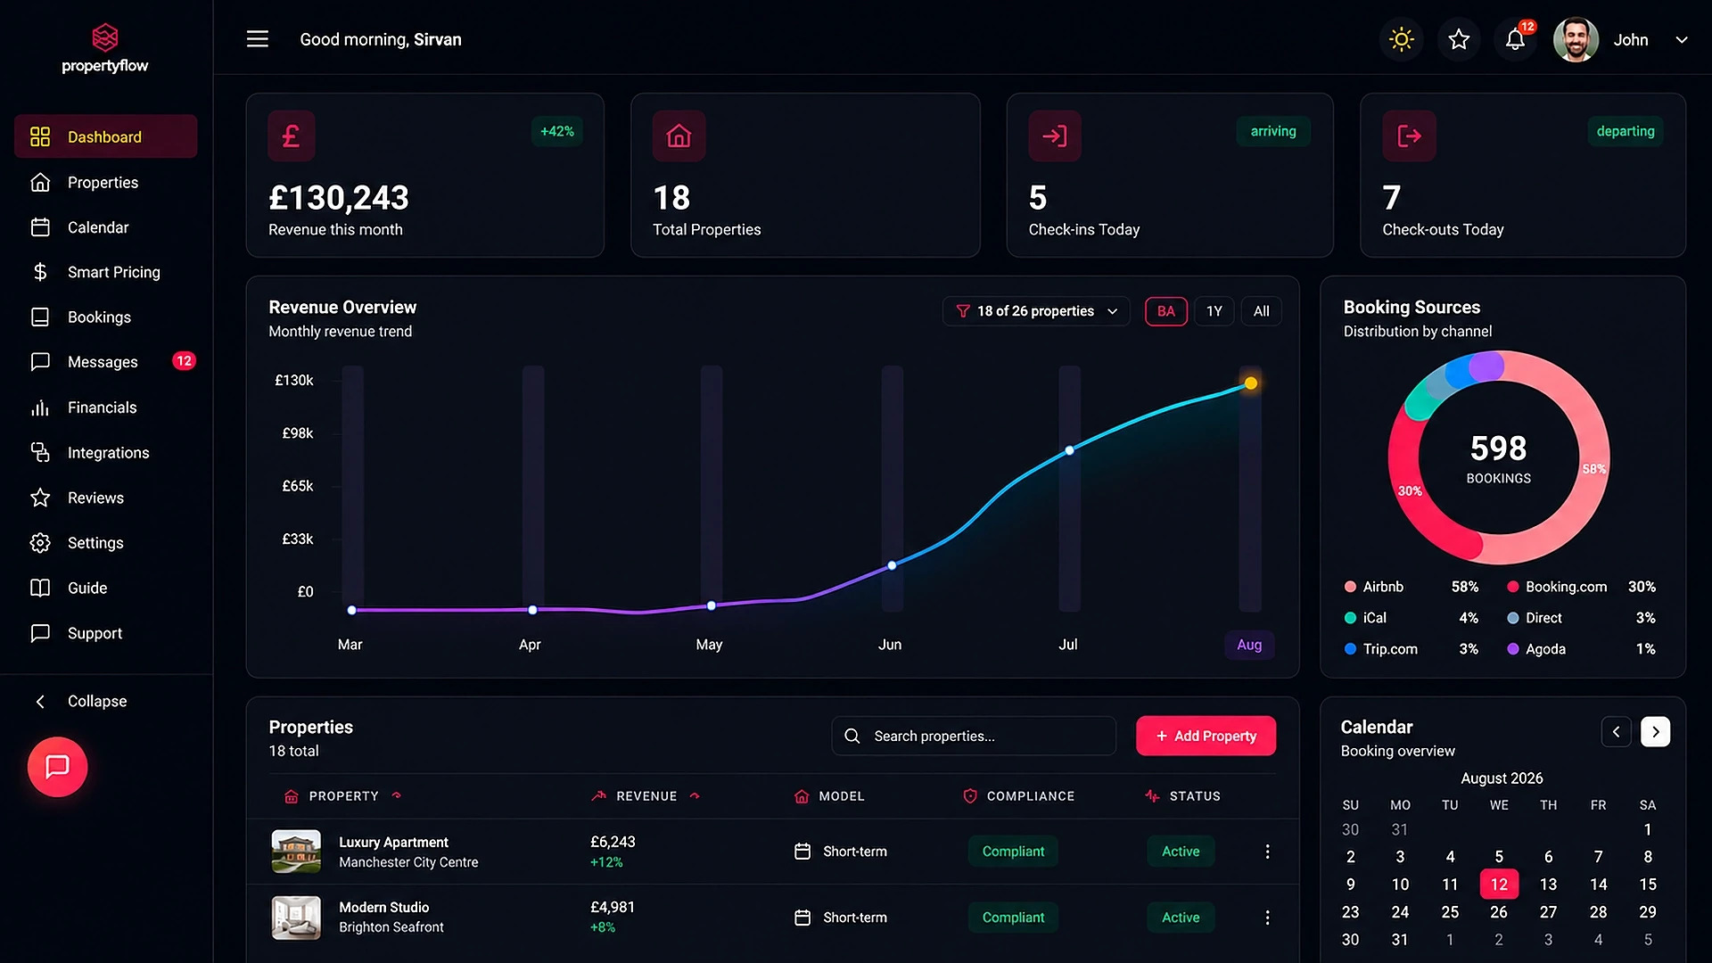
(PropertyFlow dashboard showing properties, bookings, revenue, pricing and compliance in one place)
PropertyFlow is designed for hosts who want to keep running their properties themselves while having the day-to-day operation organised in one place.
For hosts who want to explore the platform, you can start free.

Frequently Asked Questions

What does short-term-let management software actually do?
Short-term-let management software brings the main operational tasks involved in running properties into one system. Depending on the platform, this can include calendars, bookings, guest messages, pricing, turnovers, compliance records and reporting. The aim is to give hosts one place to manage and monitor the operation instead of relying on several separate tools.

Do I need a licence to run an Airbnb in the UK?
It depends on where the property is located and the rules that apply there.
In Scotland, short-term-let licensing is mandatory, and new hosts must obtain a licence before accepting bookings or receiving guests. You can check the current rules in the Scottish Government's short-term-let guidance.
In England, the national registration scheme for short-term lets is being introduced but is not yet in force. The current GOV.UK guidance for self-catering holiday homes in England also explains other requirements, including planning, safety and insurance.
In Wales, visitor accommodation registration opens on 1 October 2026, with providers required to register by 31 March 2027. The current requirements are set out by the Welsh Government.
Because requirements can also vary by local authority, hosts should check the government guidance and their local council before accepting guests.

What is the best property management software for Airbnb hosts UK?
There is no single property management platform that is best for every Airbnb host in the UK. The right choice depends on the number of properties, booking channels, pricing needs, guest communication, reporting requirements and how much of the operation the host wants to manage themselves.
UK hosts should also check that the software supports the channels and compliance requirements relevant to their properties.

Can this kind of software manage multiple platforms at once?
Yes, some short-term-let management platforms can connect multiple booking channels and synchronise availability. This can include platforms such as Airbnb, Booking.com and Vrbo. The exact channels and features depend on the software, so hosts should check which integrations are supported before signing up.

Is short-term-let software worth it for a small host with one or two properties?
It depends on how you currently manage the properties and how much administrative work they create. A small portfolio can often be managed manually, but software can still be useful if you use multiple booking channels, receive a high volume of guest messages or want a clearer system for pricing and compliance records.

Does the software handle pricing changes automatically?
Some platforms offer dynamic pricing tools that automatically adjust rates based on factors such as demand, seasonality and local events. The level of automation varies between products, so hosts should check what pricing rules and controls they can set themselves.

What doesn't short-term-let management software do?
Software can organise and automate parts of the operation, but it does not remove every responsibility from the host. Someone still needs to make decisions about the property, deal with issues that require human judgement and ensure the property meets the relevant legal requirements.
Running a growing short-term-let portfolio means keeping track of more than bookings. There are guests to answer, calendars to update, prices to review, properties to turn around and documents to keep current.
If managing the portfolio is starting to take as much attention as managing the properties themselves, it may be time to look at how the operation is set up.
If you're ready to see how that works in practice, you can start free with PropertyFlow.

