Meta Title: Apply to Become an Airbnb Property Management Partner | PropertyFlow
Meta Description: Apply to become an Airbnb property management partner. Build a management business, keep the landlord relationship and let PropertyFlow run the operation.
URL: /apply-to-become-an-airbnb-property-management-partner/
Primary Keyword: apply to become an airbnb property management partner
Thumbnail:


Apply to Become an Airbnb Property Management Partner: Build a Management Business, Backed by Us
If you already work with landlords, run properties or have a strong local property network, you may have considered building an Airbnb or short-term-let management business.
The difficult part is not always finding another landlord but everything that comes after.
Guest messages. Cleaning. Changeovers. Linen. Maintenance. Listings. Pricing. Compliance. Bookings. Payouts.
The PropertyFlow Partner Programme is built around a simple division of responsibilities where you win landlords, keep the relationship and grow your local portfolio. PropertyFlow runs the operation behind each property. You earn 50% of PropertyFlow's management fee, excluding VAT, on every property you introduce, paid monthly.
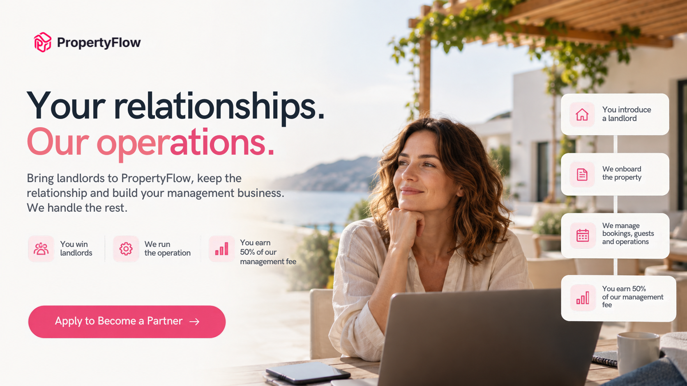(Build the landlord relationships. PropertyFlow runs the operation behind the properties you introduce)
Ultimately, the right question is whether this model fits the kind of management business you want to build. If you’re ready to explore that, you can apply to the PropertyFlow Partner Programme!

What Is the PropertyFlow Partner Programme?
The PropertyFlow Partner Programme is for people who want to build a property management business with the operational infrastructure already in place.
You find landlords and introduce them to PropertyFlow. You keep the relationship with those landlords and work locally to grow your portfolio.
PropertyFlow then contracts with each landlord, holds the relevant licence where required and runs the operational side through its back office and vetted Service Partners.
The process is:
- Apply to become a Partner.
- Introduce landlords to PropertyFlow.
- PropertyFlow contracts with the landlord and handles the operation.
- You earn 50% of PropertyFlow's management fee on each property you introduce.
The programme is application-based. PropertyFlow currently says it accepts around one in five applications.
That makes this a business partnership, not simply another piece of property management software.

What Does a Property Management Partner Actually Do?
The Partner role is centred on relationships and growth.
You find property owners who could benefit from short-term-let management. You speak to them, explain the service, help them understand what is involved and bring suitable properties into the portfolio.
You then remain their local relationship contact.
PropertyFlow's model allows you to trade under your own name and keep that relationship. The landlord contracts with PropertyFlow, while your role remains focused on the relationship and growing the business. A named Portfolio Manager supports the day-to-day operation behind the scenes.
That distinction matters.
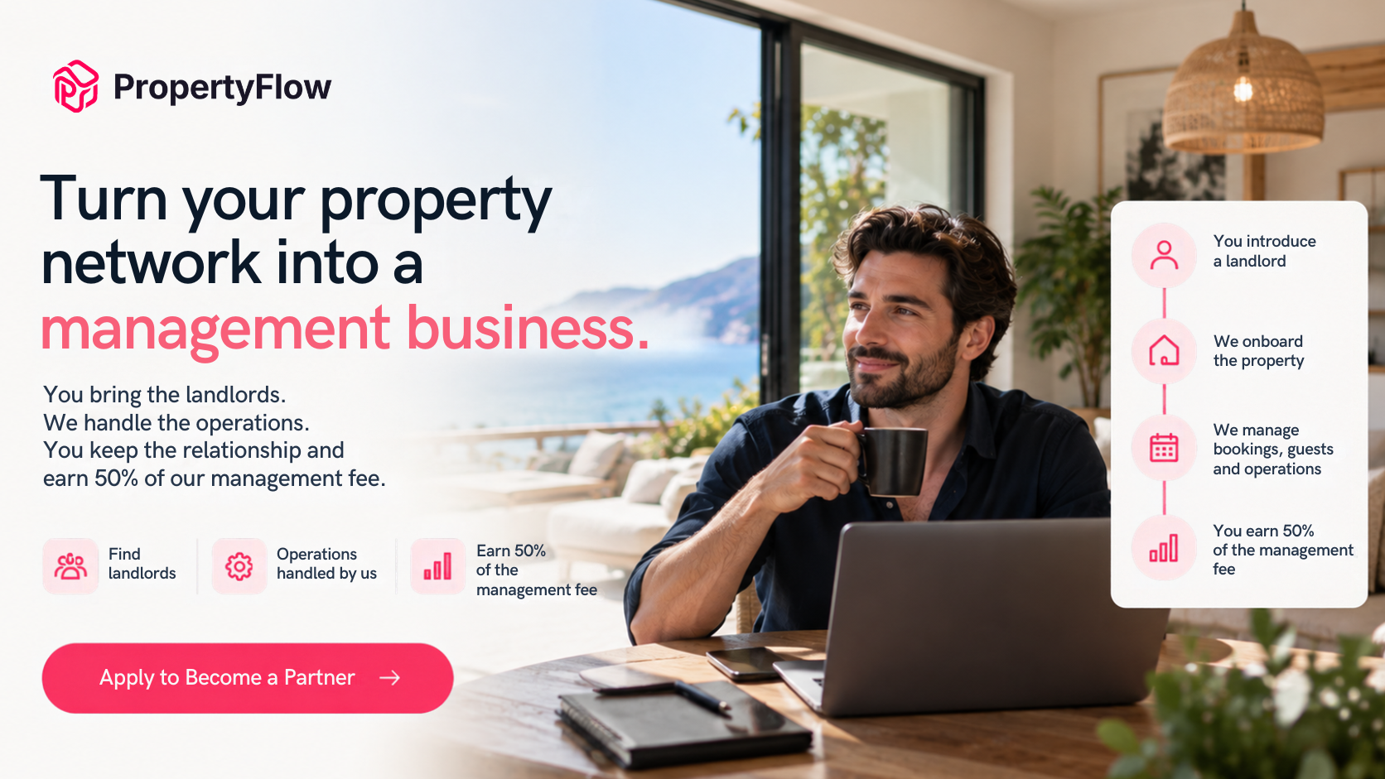(Build a management business around the relationships you already have, while PropertyFlow handles the operational side)
You are not being asked to become the person who answers every guest message at midnight or finds a cleaner because a booking has just been checked out.
Your role is to build the landlord side of the business.

What Does PropertyFlow Handle?
A management business becomes complicated as soon as the number of properties starts growing.
PropertyFlow takes the operational work behind Partner properties and runs it through its platform, back office and Service Partner network.
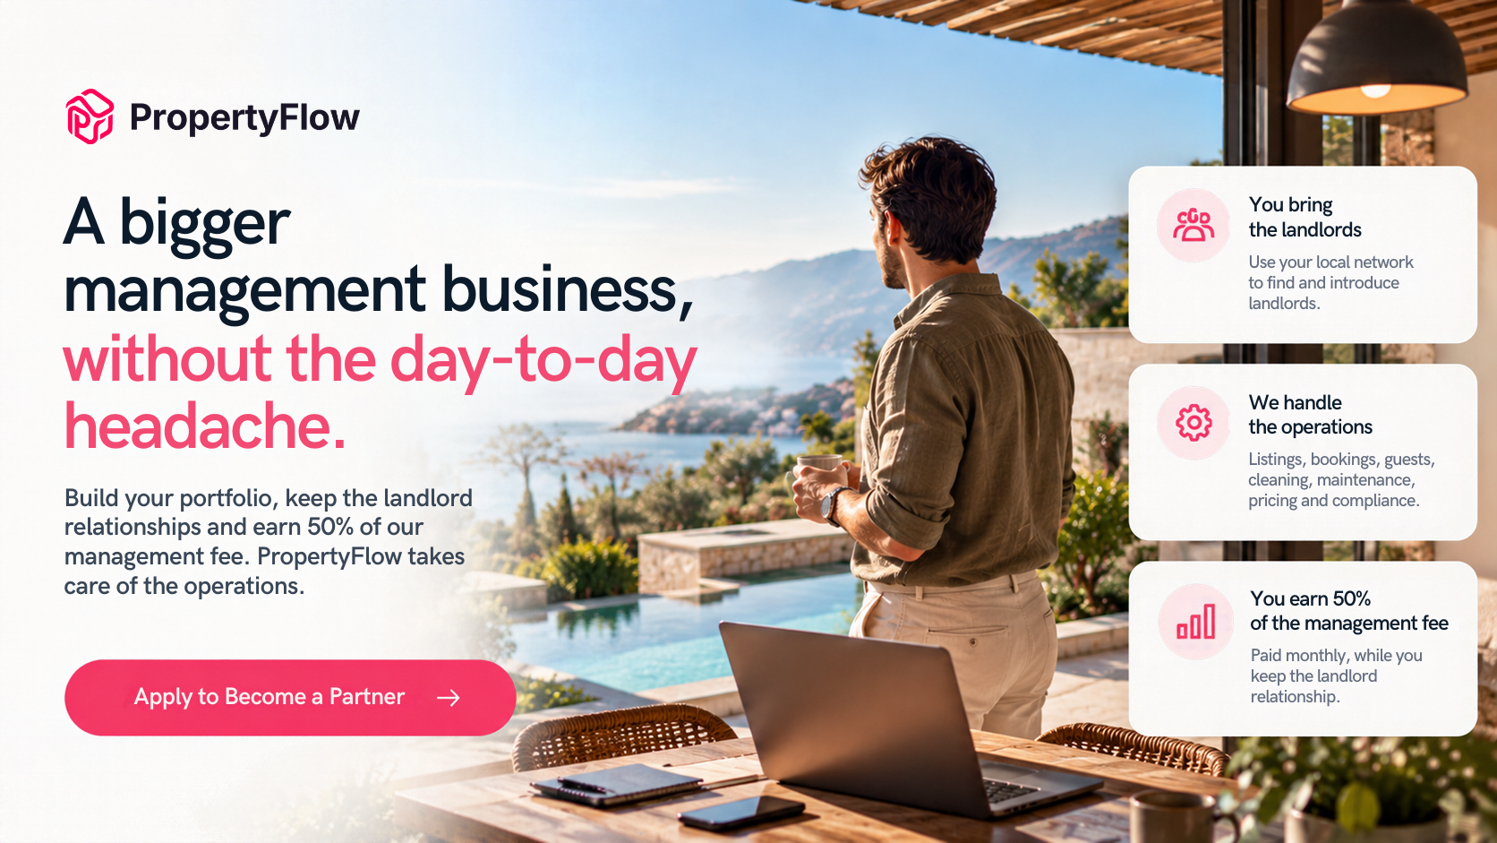(Build your management portfolio while PropertyFlow handles the operational work behind the properties you introduce)

Bookings and listings
PropertyFlow manages listings, channels and bookings for Partner properties.
The back office handles the day-to-day booking operation, while the Partner stays focused on the landlord relationship.

Guest messages
Guest communication is handled through PropertyFlow's AI messenger.
If something needs your attention, you are looped in on the escalation. That means you remain connected to what is happening without having to sit inside the guest inbox all day.

Cleaning and changeovers
PropertyFlow's operational network handles cleaning, changeovers and linen.
The aim is straightforward: when one guest leaves and another arrives, the operational work between those two stays does not become the Partner's problem.

Maintenance and logistics
Maintenance and on-the-ground logistics are also handled through PropertyFlow's Service Partners and Maintenance Partners.
That gives Partners an operating structure they can use as they grow their portfolio.

Pricing
PropertyFlow handles pricing for Partner properties, including AI Cognito Pricing.
The system uses the platform's pricing tools as part of the operation, while the Partner concentrates on finding and managing landlord relationships.

Compliance
PropertyFlow also handles licence applications and renewals for Partner properties where required.
Safety certificates and documents are kept current with the landlord, with reminders sitting within the platform.

How Do Partners Earn?
Partners earn 50% of PropertyFlow's management fee, excluding VAT, on every property they introduce.
The payment is made monthly through a self-billed statement. The landlord's management fee is agreed for each property and set out in the Landlord Agreement.
This is important because the Partner's income is connected to the properties they bring into the business. One landlord can become several properties. One relationship can also lead to further introductions.
The model is therefore built around building a portfolio, not making a one-off referral.
You bring the landlord.
You keep the relationship.
PropertyFlow runs the operation.
You earn from the properties you introduce.

Is This a Property Management Franchise or Network?
If you are researching how to join a property management franchise or network in the UK, it is worth understanding where the PropertyFlow model is different.
This is not presented as a traditional franchise. You trade under your own name and keep the landlord relationship.
PropertyFlow is the contracting party and licence holder for managed properties. Each landlord contracts with PropertyFlow under its standard Landlord Agreement.
You therefore have a local business relationship with the landlord, while PropertyFlow provides the platform, back office and operational infrastructure underneath it.
That can be useful if you want to build a local management business but do not want to create every operational function yourself.

Who Is the Partner Programme For?
The Partner Programme is aimed at people who can build relationships with property owners and grow a management portfolio.

Letting agents
You already speak to landlords and want to add short-term-let management to your business.

Property managers
You understand property management but want more infrastructure behind the short-term-let side of the business.

Property professionals
You have a local network of property owners and see an opportunity to build a management portfolio.

Entrepreneurs with a local market
You know your area, understand property and want to build a business around landlord relationships.
You do not need to be responsible for every operational task to build the business.
What matters is whether you can find landlords, build trust and grow those relationships.

What Happens After You Apply?
The Partner Programme is application-based.
PropertyFlow says it currently accepts around one in five applications, so applying is the starting point for assessing whether the model is a fit.
If you are accepted, you go through onboarding and training before becoming a PropertyFlow Verified Partner.
You also get a named Portfolio Manager who acts as your day-to-day contact inside PropertyFlow. After onboarding and training, Partners receive the PropertyFlow Verified Partner badge.
If you want to understand the process before applying, you can also book a call with PropertyFlow. The company offers a free 30-minute call with no obligation for people interested in the Partner Programme.

What Does the Partnership Look Like Day to Day?
Imagine you have a landlord with two properties.
You have a relationship with the landlord. You discuss their plans, explain the management service and help bring the properties into the portfolio.
After that, PropertyFlow handles the operational side.
The properties are listed and priced. Guests are messaged. Cleaning and changeovers are coordinated. Linen and maintenance are handled through the operational network. Licence applications and renewals are managed where required.
You remain involved when the landlord needs you or when something needs escalation.
And your job does not stop at those first two properties. You can keep finding landlords and growing the portfolio.

What Makes This Different From Running Everything Yourself?
If you build a management business independently, every new property can add another set of operational responsibilities.
You may need cleaners. You need a way to manage bookings. You need guest communication. You need maintenance support. You need compliance processes. You need pricing and reporting systems.
With the Partner Programme, PropertyFlow provides that infrastructure.
If you run everything yourself | With the PropertyFlow Partner Programme
Find landlords | Find and introduce landlords
Build your own operational network | PropertyFlow provides the operational network
Manage guest communication | PropertyFlow handles guest messages
Coordinate cleaning and changeovers | PropertyFlow handles cleaning and changeovers
Manage listings and pricing | PropertyFlow handles listings and AI Cognito Pricing
Build your own compliance process | PropertyFlow handles licence applications and renewals
Manage the landlord relationship | You keep the landlord relationship
Grow the portfolio | You continue finding and introducing properties
The Partner Programme does not remove the need to build a business. It changes where you spend your time.

Build the Business. PropertyFlow Runs the Operation.
A property management business can grow one landlord at a time.
The challenge is making sure the operational side can grow with it.
PropertyFlow gives Partners a platform, back office, operational network and named Portfolio Manager behind the properties they introduce. The Partner remains focused on the part of the business that cannot be automated away: finding landlords, building trust and growing relationships.
If that is the type of property management business you want to build, the next step is to apply.
Apply to become a PropertyFlow Partner
Or, if you want to talk through the model first, book a call with the PropertyFlow team.

Frequently Asked Questions

How do I apply to become an Airbnb property management partner?
The PropertyFlow Partner Programme is application-based. You can apply through the Partner Programme and PropertyFlow will assess whether the partnership is a fit. The company currently says it accepts around one in five applications.

How much does a PropertyFlow Partner earn?
Partners earn 50% of PropertyFlow's management fee, excluding VAT, on every property they introduce. Payments are made monthly through a self-billed statement.

Do Partners find their own landlords?
Yes. The Partner model is built around introducing landlords and maintaining those relationships. PropertyFlow then contracts with the landlord and runs the operational side of the property.

Does PropertyFlow handle cleaning and maintenance?
Yes. Cleaning, changeovers, linen and maintenance are handled through PropertyFlow's back office and vetted Service Partners or Maintenance Partners for Partner properties.

Who holds the licence for a Partner property?
PropertyFlow contracts with the landlord and holds the relevant short-term-let licence or registration where the law requires one. Licence applications and renewals are handled for Partner properties.

Do I need to manage guest messages myself?
No. PropertyFlow's AI messenger handles guest messages, with the Partner looped in when an escalation requires their attention.

Is the Partner Programme the same as PropertyFlow's software?
No. The Partner Programme is a business model for people who want to introduce landlords and build a management portfolio. PropertyFlow provides the platform and operational infrastructure behind those properties.

Ready to Build Your Management Business?
You do not need to build a separate operation for every property you win.
Build the landlord relationships. Grow the portfolio. PropertyFlow runs the operation behind it. Get started now!

