Meta Title: Free Property Management Software for Airbnb Hosts UK | PropertyFlow
Meta Description: Looking for free property management software for Airbnb hosts? See what PropertyFlow includes for your own Airbnb and Booking.com accounts.
Recommended URL: /free-property-management-software-airbnb-hosts-uk/
Primary Keyword: free property management software for airbnb hosts
Thumbnail
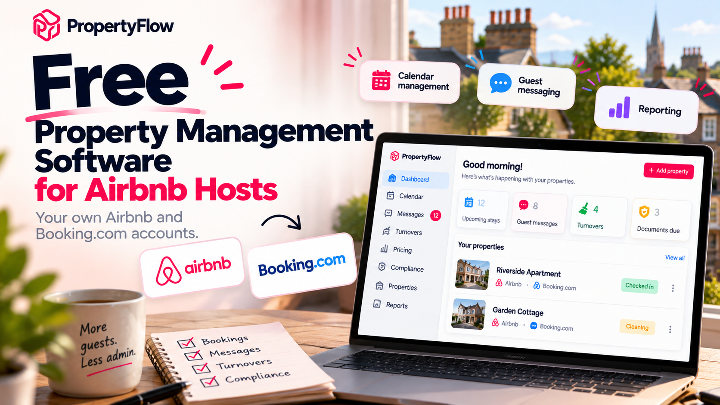

Free Property Management Software for Airbnb Hosts: Your Own Airbnb and Booking.com Accounts
If you're looking for free property management software for your hosts, the first thing to check is what you actually get for free.
Say you have two holiday lets in the UK. One is listed on Airbnb and Booking.com. A booking comes in, a guest sends a message, your cleaner needs to know about the checkout and you need to remember when a certificate expires. None of those jobs is particularly difficult on its own. Keeping all of them in different places is where the admin starts to build up.
PropertyFlow brings those jobs into one system. You can connect both your own Airbnb and Booking.com accounts, add as many properties as you need, and use one inbox, one calendar, AI messaging, automated guest messages, turnover tasks, document reminders and reporting at no platform cost.
So, is there free software for managing Airbnb properties? Yes. But the useful question is what the free platform actually includes and what you pay for when you want additional features.

What Does Free Property Management Software Actually Include?
“Free” can mean very different things from one property software platform to another.
For a short-term-let host, you probably care about a few basic things:
- Can I see my bookings in one place?
- Can I manage guest messages?
- Can I keep track of cleaners?
- Can I remember when documents need renewing?
- Can I see how my properties are performing?
PropertyFlow's core platform is built around those day-to-day jobs.
You can connect your own Airbnb and Booking.com accounts and manage:
- A unified calendar
- A unified guest inbox
- AI messaging
- Automated guest messages
- Turnover tasks
- Document reminders
- Reporting
There is no setup fee, and the core platform is available at no cost when you use your own Airbnb and Booking.com accounts. You can add as many properties as you want on your own channels.
Example: You have two properties and both are listed on Airbnb. A guest books Property A while another guest messages you about Property B. Instead of checking separate calendars and inboxes, both properties can be managed from the same PropertyFlow system.
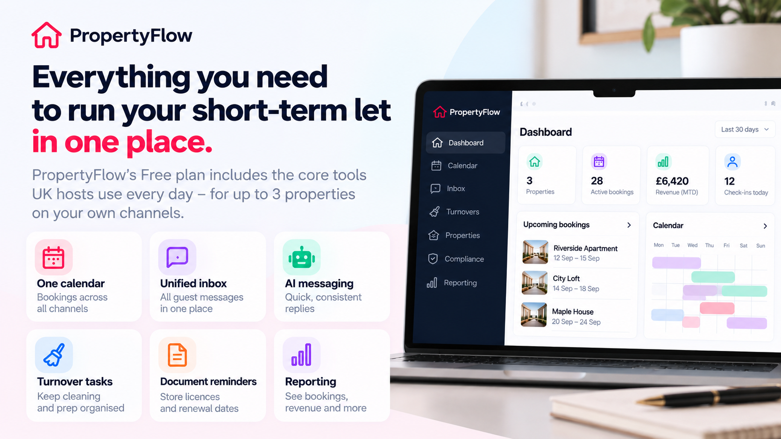
(PropertyFlow brings the main day-to-day tasks of running a short-term let into one place)

Is There Free Software for Managing Airbnb Properties?
Yes, but you need to look at what “free” actually means.
Some software companies use a free plan as an entry point and then charge when you add more properties. PropertyFlow's current model works differently.
You can connect both your own Airbnb and Booking.com accounts and add as many properties as you need without paying a platform subscription.
The core platform includes the tools you need to manage your bookings and day-to-day operations. You only pay when you choose additional services.
AI Cognito Pricing costs £9.99 per property per month plus VAT when you switch it on for a property.
If you use PropertyFlow to bring bookings from additional channels, the charge is 5% plus VAT on each booking PropertyFlow brings.
So you can start by connecting the Airbnb and Booking.com accounts you already use, without paying a platform subscription.

What Can You Manage With PropertyFlow?
The easiest way to understand PropertyFlow is to look at the jobs you are already doing.

Bookings and calendars
PropertyFlow's Channel Manager connects your booking channels and gives you one calendar.
If you have your own Airbnb and Booking.com accounts, you can bring those bookings into the same system. When a booking comes through one connected channel, the relevant dates are reflected across the connected channels. If a guest books your two-bedroom flat on Airbnb from Friday to Monday, you don't then need to remember to block those dates manually on another connected channel. The calendar sync handles that part.

Guest messages
The unified inbox puts guest conversations from your connected channels into one place.
PropertyFlow also includes AI messaging and automated guest messages. AI can help draft replies, while automated messages can handle routine communication around a stay.

Turnovers
Turnover tasks connect cleaning and preparation to the booking operation.
PropertyFlow says a cleaning task can be created when a booking lands and that cleaners can be dispatched when guests leave. Suppose a guest checks out at 10am. Instead of finding the booking, messaging the cleaner and separately tracking whether the job is done, the turnover task sits alongside the property's other operational information.

Documents and reminders
PropertyFlow includes document storage and reminders for licences and certificates. You can upload a document, set its renewal date and receive a reminder when it needs attention.

Reporting
PropertyFlow also includes reporting, giving you a way to see information about your properties without pulling figures manually from several accounts. The platform brings bookings, revenue and other property information into one place, with financials and payouts tied to individual stays.

Is PropertyFlow Really Free for Airbnb Hosts?
Yes. PropertyFlow's core platform costs £0 when you connect your own Airbnb and Booking.com accounts. You can add as many properties as you want on those accounts, with 0% PropertyFlow commission on bookings through your own accounts.
Feature | PropertyFlow
Platform | £0
Number of properties | Unlimited
Own Airbnb account | 0% PropertyFlow commission
Own Booking.com account | 0% PropertyFlow commission
Unified inbox | Included
Unified calendar | Included
AI messaging | Included
Automated guest messages | Included
Turnover tasks | Included
Document reminders | Included
Reporting | Included
AI Cognito Pricing | £9.99/property/month + VAT when switched on
PropertyFlow channels | 5% + VAT on bookings PropertyFlow brings
Setup fee | None
All prices exclude VAT.

What Do You Actually Pay For?
The basic PropertyFlow platform is free. You pay when you choose additional services.
There are currently two main examples.

AI Cognito Pricing
AI Cognito Pricing is an optional add-on costing £9.99 per property per month plus VAT.
It adjusts nightly rates based on factors such as demand, season and local events, with pricing rules that can be set by channel.
Example: You normally charge £120 a night for a property. Demand changes because of a major local event. Instead of checking rates manually and changing them yourself, AI Cognito Pricing can adjust the nightly rate based on its pricing signals.
You choose which properties to switch it on for.

PropertyFlow channels
You can also ask PropertyFlow to list your property on channels you are not already using.
This includes channels such as Vrbo and Agoda, as well as creating a Booking.com listing if you do not already have one. The charge is 5% plus VAT on each booking PropertyFlow brings, on top of that channel's own commission at cost.
Bookings through your own Airbnb and Booking.com accounts have 0% PropertyFlow commission.

What Is 0 Commission Airbnb Software?
The phrase “0 commission Airbnb software” can be confusing because there are two separate things involved: Airbnb's own fees and the software company's fees.
With PropertyFlow, bookings through your own Airbnb account have 0% PropertyFlow commission.
The same applies to bookings through your own Booking.com account.
That does not mean Airbnb or Booking.com themselves charge no fees. It means PropertyFlow does not add its own booking commission when the booking comes through your own connected account.
The distinction looks like this:
Booking route | PropertyFlow charge
Your own Airbnb account | 0%
Your own Booking.com account | 0%
PropertyFlow channel booking | 5% + VAT on the booking PropertyFlow brings
This gives hosts a choice. You can keep using your existing accounts and pay no PropertyFlow booking commission, or switch on PropertyFlow channels when you want additional distribution.

Who Is Free Property Management Software For?
Free property management software can be useful at different stages of running a short-term let.

One-property host
You have one Airbnb and mostly manage it yourself. You may not need a complicated property management system, but having your bookings, guest messages, reminders and turnovers in one place can still reduce the amount of admin you handle manually.

Two- or three-property host
You now have several calendars, more guest conversations and more cleaning tasks. This is where a central system can become more useful because you are managing several properties rather than one booking calendar.

Growing portfolio
You have five, ten or more properties and want to keep the same operating system as the portfolio grows. PropertyFlow's current pricing model allows you to add properties on your own channels without introducing a per-property platform fee. The per-property charge applies only when you switch on AI Cognito Pricing for a property.

Multi-channel host
You list properties on Airbnb and Booking.com and want one place to manage the operation. The Channel Manager gives you one calendar, while the unified inbox brings guest messages together.

Free Software vs Managing Your Airbnb Manually
You don't need property management software to run an Airbnb. For one property with a handful of bookings, you might be perfectly comfortable opening Airbnb, checking your calendar, messaging guests and texting your cleaner.
The difference becomes more noticeable as you add properties, channels and guest messages.
Task | Managing manually | With PropertyFlow
Bookings | Check individual platforms | One calendar
Guest messages | Check separate inboxes | Unified inbox
Routine messages | Send manually | Automated messages
Cleaning | Message cleaner separately | Turnover tasks
Documents | Track dates yourself | Document reminders
Reporting | Pull information together | Reporting in one system
Pricing | Review rates yourself | AI Cognito Pricing when switched on
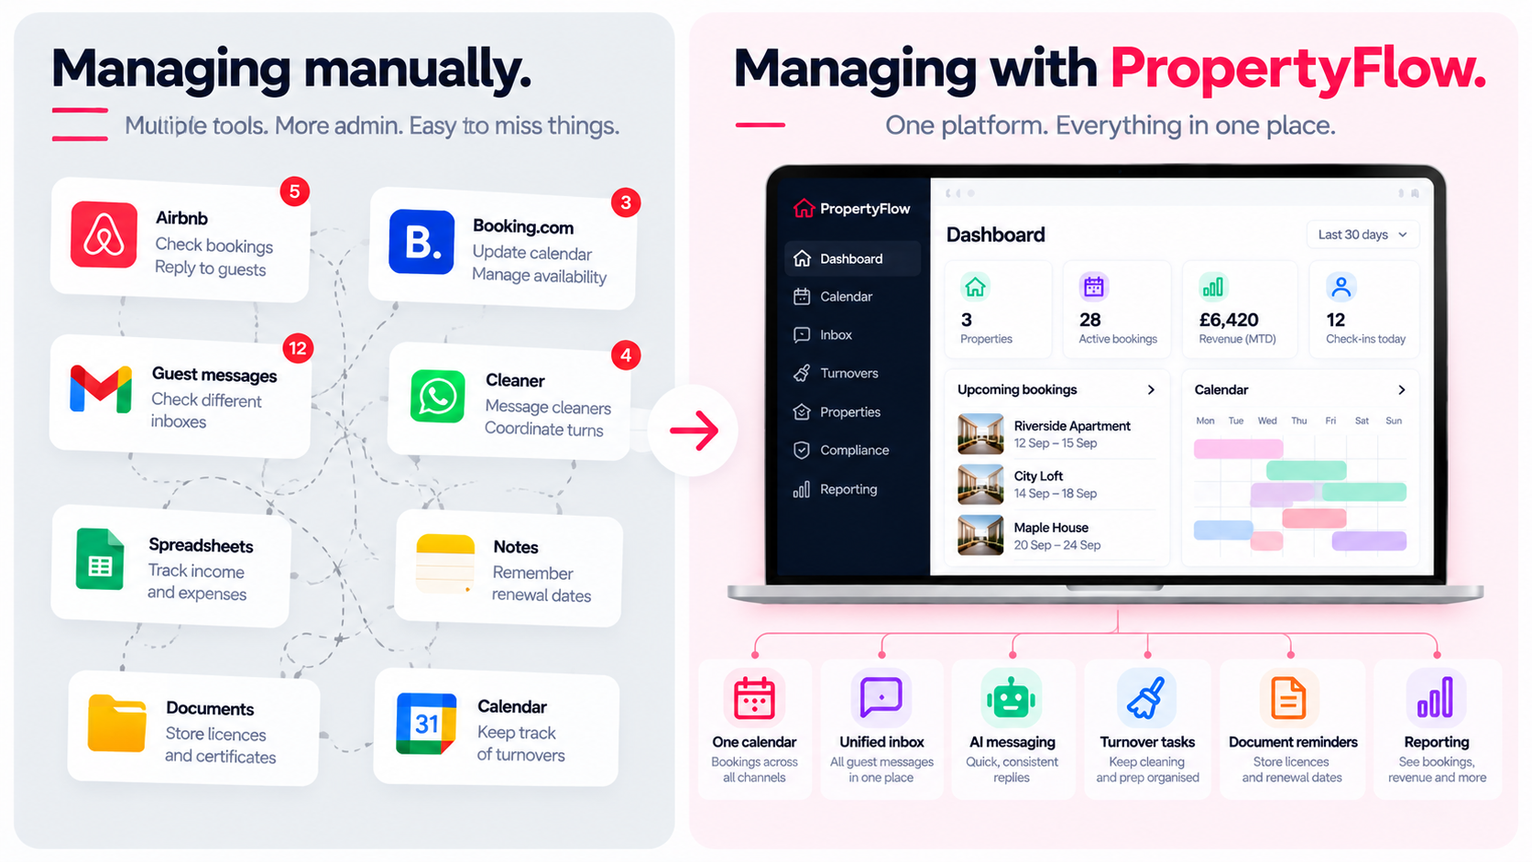
(Managing a short-term-let portfolio manually can mean working across multiple tools. PropertyFlow brings key operational tasks into one system)
None of those tasks is particularly difficult. The issue is having them spread across different places. PropertyFlow's approach is to put those operational jobs into the same system.

How to Start Using PropertyFlow for Free
You can start with the accounts you already use.
Create your PropertyFlow account, add your property and connect your channels.
The basic process is straightforward:
- Add your property
- Connect your Airbnb or Booking.com account
- Bring your bookings and operations into one system
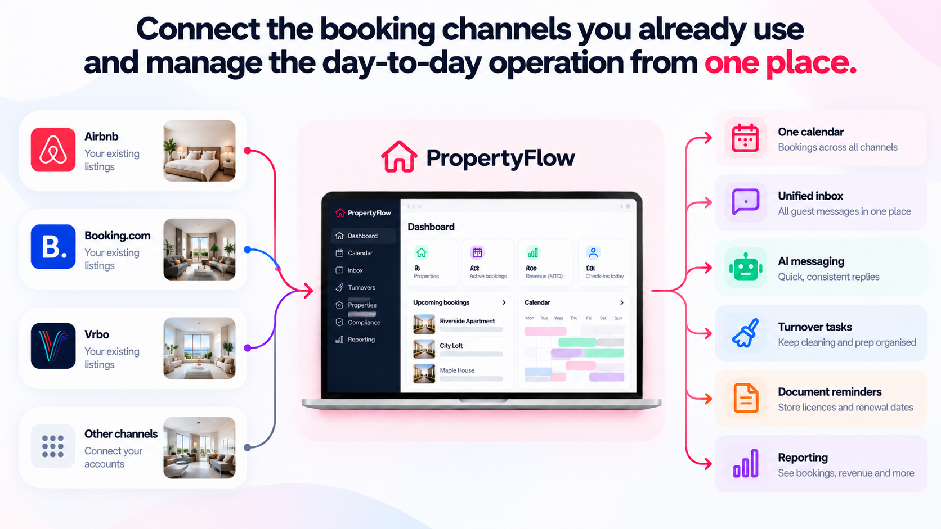
(Connect the booking channels you already use and manage bookings, guest messages, turnovers and other day-to-day tasks from one place)
There is no setup fee and no card is required to get started. You can then decide whether you want to switch on additional services such as AI Cognito Pricing or PropertyFlow channels.

Frequently Asked Questions
1. Is there free software for managing Airbnb properties?
Yes. PropertyFlow allows hosts to connect their own Airbnb and Booking.com accounts and add as many properties as they want at no platform cost. The core platform includes a unified inbox and calendar, AI messaging, automated guest messages, turnover tasks, document reminders and reporting.
2. Is PropertyFlow free for Airbnb hosts?
Yes. The core platform is free when you use your own Airbnb account. PropertyFlow does not charge commission on bookings made through your own Airbnb account.
3. Does PropertyFlow charge commission on my own Airbnb bookings?
No. PropertyFlow charges 0% commission on bookings through your own Airbnb account. PropertyFlow channels have a separate 5% plus VAT charge on bookings that PropertyFlow brings.
4. How many properties can I add to PropertyFlow?
You can add as many properties as you want when running them through your own Airbnb and Booking.com accounts. There is no platform subscription charged per property.
5. Does PropertyFlow include AI pricing for free?
The core platform is free, but AI Cognito Pricing is an optional paid add-on. It costs £9.99 per property per month plus VAT on the properties where you switch it on.
6. Can I use PropertyFlow with Booking.com?
Yes. You can connect your own Booking.com account and manage it alongside your other connected channels through the PropertyFlow platform. Bookings through your own Booking.com account have 0% PropertyFlow commission.
7. Can PropertyFlow help me get bookings from other channels?
Yes. PropertyFlow channels can be switched on when you want additional distribution. PropertyFlow says it can list properties on channels you are not already using, including channels such as Vrbo and Agoda, and can create a Booking.com listing if you do not already have one. The charge is 5% plus VAT on bookings PropertyFlow brings, in addition to the channel's own commission at cost.
8. Is free property management software useful for one property?
It can be. If you are already managing bookings, messages, cleaning, documents and other tasks across different places, a central system can reduce that admin even with a small portfolio.

