Meta Title: Free Airbnb Channel Manager, 0% Commission | PropertyFlow
Meta Description: A free Airbnb channel manager with no commission on your own bookings. See what's included, what's optional and what each add-on costs. Connect for free.
URL: /free-airbnb-channel-manager-0-commission/
Primary Keyword: free airbnb channel manager no commission
Thumbnail:
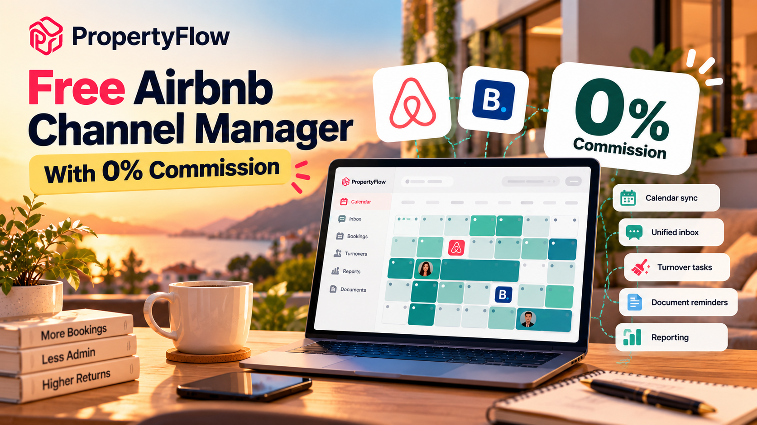

Free Airbnb Channel Manager With 0% Commission: What's Really Included
If you run several short-term lets around a full-time job, you have probably typed “free Airbnb channel manager, no commission” into a search bar. You have also probably noticed that "free" can mean many things: a short trial, a single property, or a fee that appears later.
This page spells out what PropertyFlow includes at no cost, what is optional, and exactly what each optional piece costs. If you are comparing 0 commission Airbnb software, you should be able to see the full picture before you connect anything.
Connect for free: no card required, no setup fees, no lock-in.

The Short Answer
PropertyFlow is free for every property on your own Airbnb and Booking.com accounts, with no limit on how many properties you add. Bookings from your own accounts carry 0% PropertyFlow commission.
You only pay when you switch on an optional service: AI Cognito Pricing is charged per property, while PropertyFlow Channels charges 5% plus VAT on bookings it brings you.

What You Get for £0
Connect the accounts you already have and run every booking, guest message and turnover from one inbox and one calendar. Free means:
- Channel manager. Connect your own Airbnb and Booking.com accounts. A booking on one channel closes the dates on the other, so you avoid double bookings.
- Unified inbox and calendar. Every guest message from every channel in one thread, and every reservation across every property in one multi-calendar view.
- AI messaging and automated guest messages. AI drafts replies, and automated messages go out before check-in and after check-out.
- Turnover tasks. A cleaning task is created the moment a booking lands, and you assign your own cleaners and track completion.
- Document reminders. Upload each licence and certificate once, set its renewal date and get reminded in time.
- Reporting. Revenue, occupancy, bookings and payouts per property.
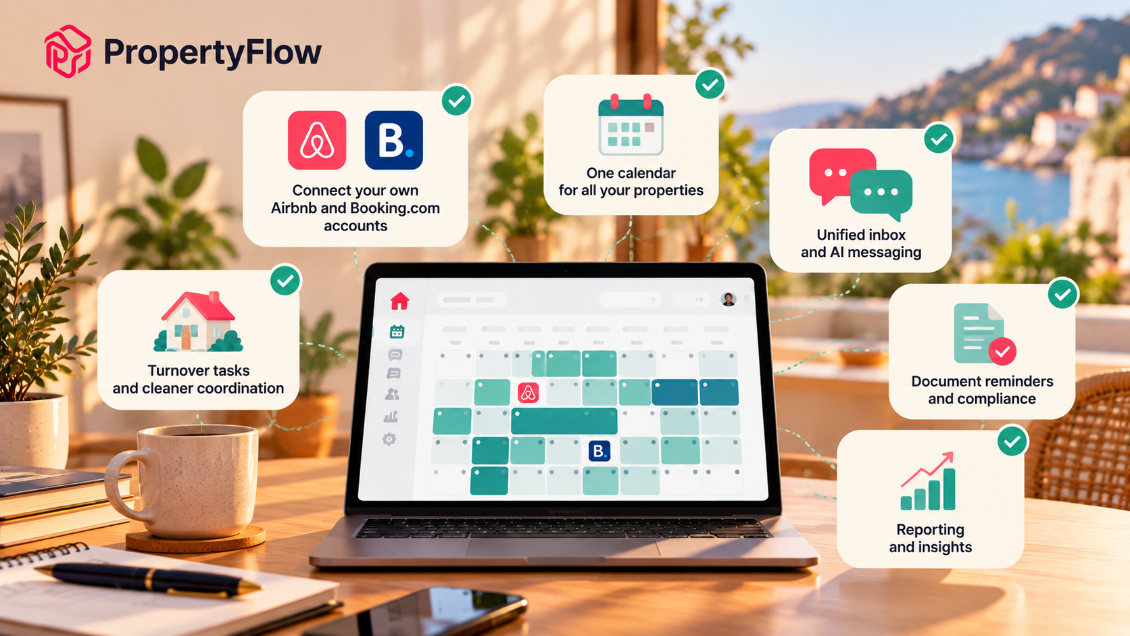(What you get when you connect your own Airbnb and Booking.com accounts to PropertyFlow)
There is no card to enter and nothing to cancel. You can move off it whenever you like.

What Costs Extra
Two things sit outside the free plan, and both are optional.

AI Cognito Pricing: £9.99 per property per month plus VAT
AI Cognito Pricing adjusts nightly rates for demand, season and local events, with per-channel pricing rules. You switch it on per property, so you pay only for the properties where you want it. You can switch it off per property at any time.

PropertyFlow channels: 5% plus VAT per booking we bring
If you want to be listed on channels you are not on yet, such as Vrbo and Agoda, PropertyFlow lists you there. The same applies to a Booking.com listing PropertyFlow creates for you if you do not have one.
The fee is 5% plus VAT of each booking PropertyFlow brings, on top of that channel's own commission at cost. You can switch PropertyFlow channels off whenever you like, and your own Airbnb and Booking.com accounts keep running as they are.

What It Actually Costs: A Few Examples
Numbers are easier than adjectives, so here are three. All prices exclude VAT.
Your situation | PropertyFlow cost
Five properties on your own Airbnb and Booking.com accounts, no add-ons | £0 per month
The same five properties, AI Cognito Pricing on two of them | £19.98 per month
The same five properties, AI Cognito Pricing on all five | £49.95 per month
PropertyFlow channels are charged per booking rather than per month. If a guest books a £500 stay through a channel PropertyFlow brings you, PropertyFlow's fee is £25 plus VAT, in addition to the channel's own commission. A booking of the same size through your own Airbnb account carries 0% PropertyFlow commission.
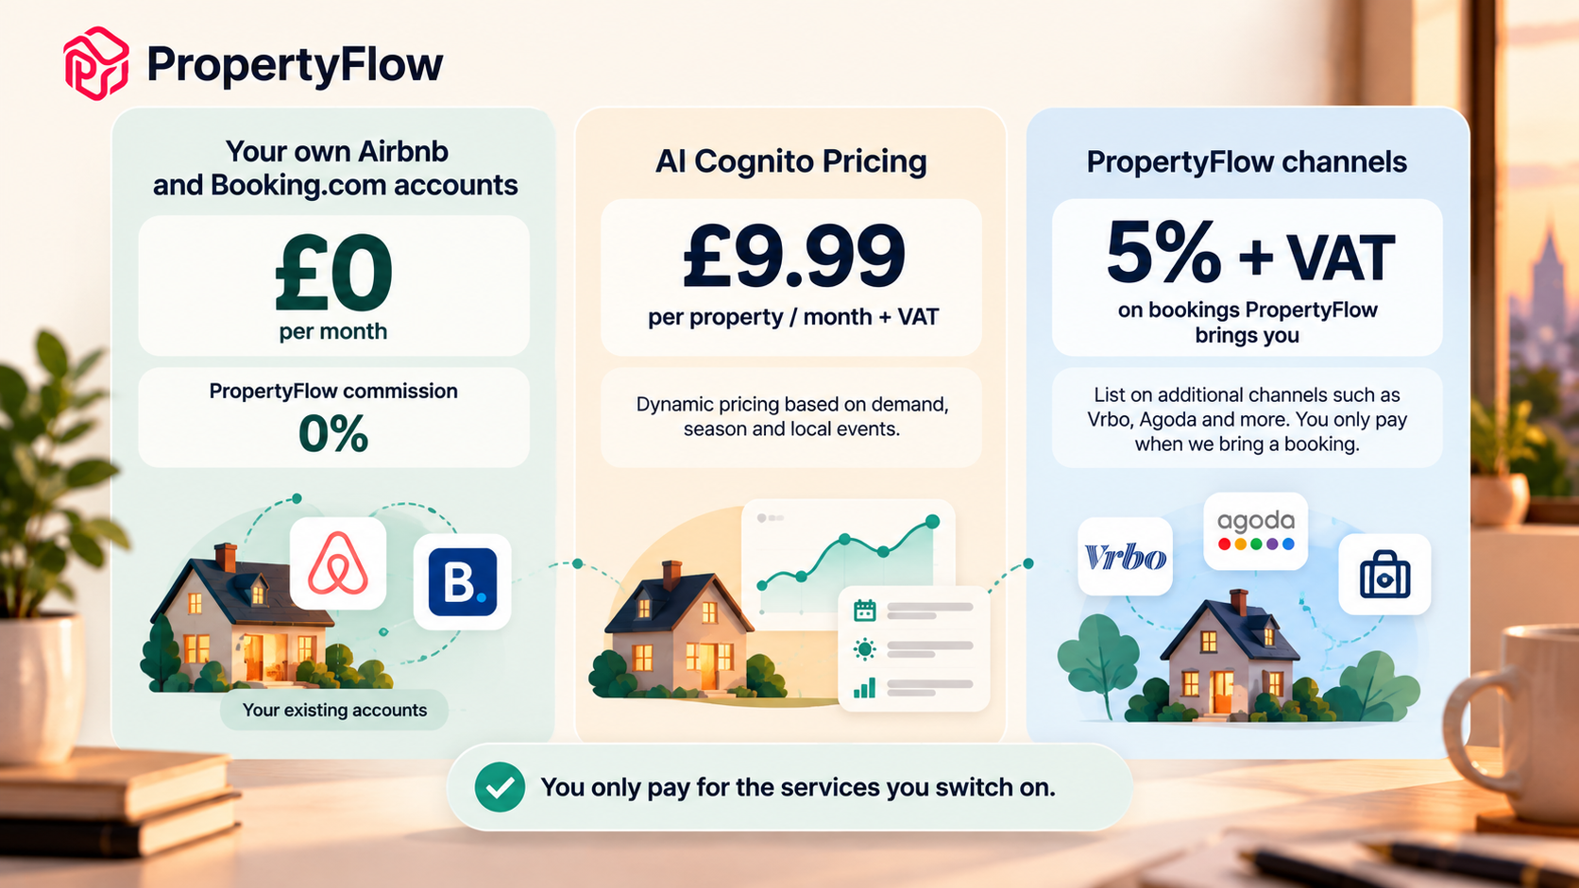(PropertyFlow pricing: your own Airbnb and Booking.com accounts are free, while AI Cognito Pricing and PropertyFlow Channels are optional paid services)

What "0% Commission" Means
The 0% applies to PropertyFlow's commission on bookings that come through your own connected Airbnb and Booking.com accounts. Airbnb and Booking.com still charge their own fees under their own terms, and PropertyFlow does not change that.
It does not mean every service is free. That is why we separate three costs, and why you should do the same when you compare airbnb hosting software with 0 percent commission:
- The core platform, which is free on your own channels.
- AI pricing, which is an add-on per property.
- Extra channels, which are 5% plus VAT of bookings brought.
If a provider cannot show you that breakdown on one page, ask for it before you connect.

Why It Suits a Growing Portfolio
You probably manage your properties around a job, whether you let in Bristol, Bath, Cheltenham, Manchester or a commuter town. You are comfortable with software, and you do your own ground operations: you assign the cleaner, you answer the odd guest question, and you check the numbers in the evening.
For that setup, a channel manager earns its place by removing the repeated checking:
- One calendar, not several. You stop opening each platform to confirm nothing clashes.
- One inbox. Guest messages from every channel arrive in one thread, with automated messages handling the predictable ones.
- Tasks created for you. Each booking creates the cleaning task, so turnovers do not depend on your memory.
- No per-property platform fee. Adding your sixth or seventh property does not raise your platform bill. It only does so if you choose to add AI pricing to it.
You keep control of what you pay. Start on the free plan, and add pricing only on the properties where it is worth £9.99 a month.
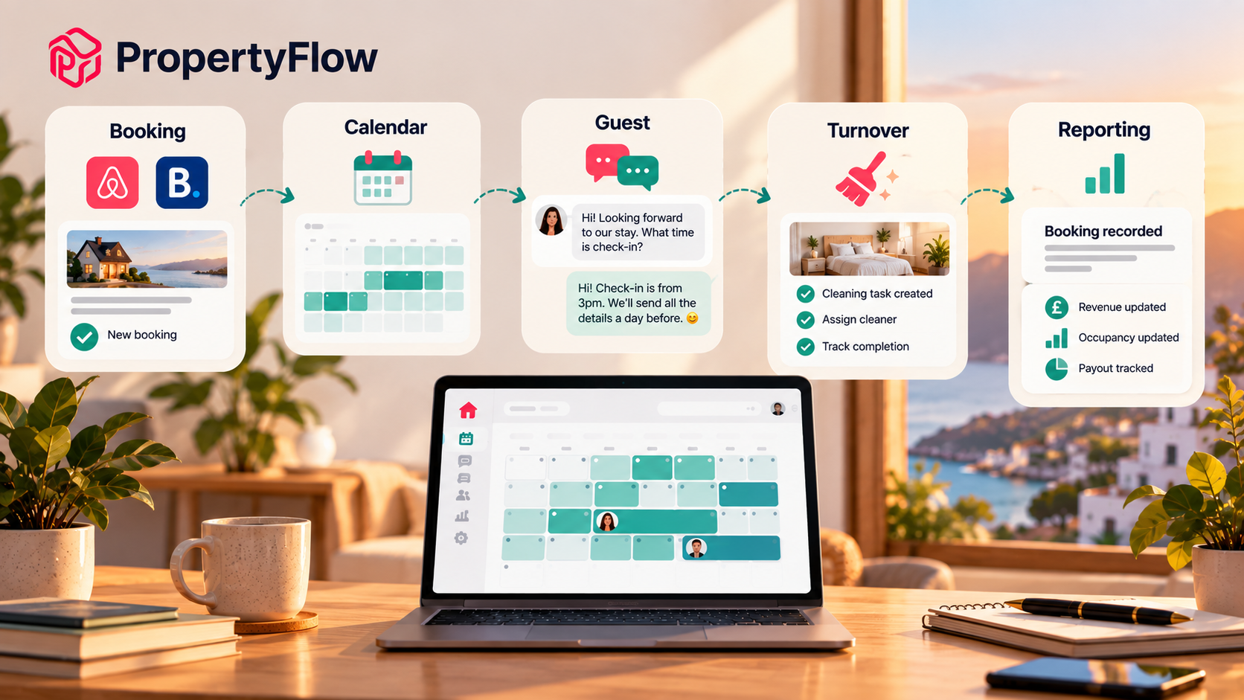 (A single booking can trigger the calendar update, guest communication, turnover task and reporting in one connected workflow)

Compliance, Damage and Insurance: What Is and Is Not Covered
Free software should be clear about its limits, so here they are.
Compliance. Short-term let rules differ by nation and council. PropertyFlow gives you licence and certificate reminders and document storage for each property, with tourist tax configured per council. It does not give legal advice, so confirm what applies to you with your local authority. Applications and renewals are handled for Partner properties only.
Guest damage. Damage is handled under each booking channel's own protection. On your own connected channels, you claim directly with the channel. On PropertyFlow-channel bookings, PropertyFlow pursues the claim for you.
Insurance. PropertyFlow holds Public Liability, Employer's Liability and Professional Indemnity insurance. You should keep your own buildings and contents insurance in place.
Guest vetting. Identity and payment verification is handled by each booking channel. PropertyFlow gives you every guest's details and messages in one place.

How to Connect for Free
- Create your account. No card is required.
- Connect your own Airbnb and Booking.com accounts. They keep running as they are.
- Add only what you want. Switch on AI Cognito Pricing per property, or PropertyFlow channels, whenever it makes sense. Neither is required.

Questions to Ask Any Free Channel Manager
Before you commit to any tool, check the answers to these:
- Is it free for every property, or only the first one or two?
- Is there a commission on bookings from my own accounts?
- Does the free plan include the inbox and calendar, or only syncing?
- Is pricing charged separately, and is that per property?
- Can I switch paid features off again?
- Is there a card requirement, a setup fee or a lock-in?
PropertyFlow's answers: free for every property on your own channels; 0% on your own bookings; inbox, calendar and automated messages included; pricing charged separately per property; add-ons can be switched off; and no card, no setup fees and no lock-in.

Where This Fits in Your Software Stack
A channel manager is one piece. Bookings affect the calendar, the calendar affects turnovers, and guests need messages, compliance and payouts. For the wider picture, see our guide to short-term rental management software in the UK.

Frequently Asked Questions
Is PropertyFlow really a free Airbnb channel manager with no commission?
Yes, on your own accounts. It is free for every property on your own Airbnb and Booking.com accounts, with 0% PropertyFlow commission on those bookings. Optional extras are charged separately.
Do I pay per property?
No. The only per-property charge is AI Cognito Pricing, £9.99 per property per month plus VAT, and only on the properties you switch it on for.
What do I get on the free plan?
One inbox, one calendar, AI messaging, automated guest messages, turnover tasks, document reminders and reporting, for as many properties as you want on your own channels.
What are PropertyFlow channels and what do they cost?
PropertyFlow lists your property on channels you are not on, such as Vrbo and Agoda. The fee is 5% plus VAT of each booking PropertyFlow brings, on top of that channel's own commission at cost. You can switch them off whenever you like.
Does PropertyFlow vet guests?
Identity and payment verification is handled by each booking channel. PropertyFlow gives you every guest's details and messages in one place.
What happens if a guest damages my property?
It is handled under each booking channel's own protection. On your own connected channels you claim directly with the channel. On PropertyFlow-channel bookings, PropertyFlow pursues it for you.
Does PropertyFlow help with licensing?
Every host gets licence and certificate reminders and document storage. Rules vary by nation and council, and PropertyFlow does not give legal advice.

Ready to Connect?
Bring the accounts you already have, see your bookings in one place, and add only what you need. Connect for free
Prefer to talk it through first? Book a call.

