Meta Title: Best Short-Term Let Management Software UK | PropertyFlow
Meta Description: Choosing short-term let management software in the UK? Compare the features, pricing, automation and support that matter before you choose a platform.
Recommended URL: /best-short-term-let-management-software-uk/
Primary keyword: best short term let management software uk
Thumbnail:
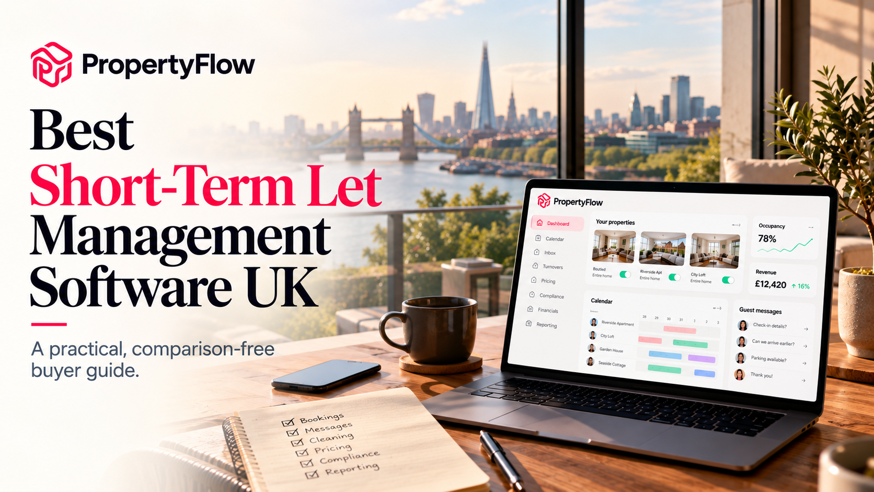

Best Short-Term Let Management Software UK: What to Look For Before You Choose
There is a point in running a short-term let when the bookings stop being the hard part.
The hard part is everything around them.
A guest books at breakfast. Another asks about check-in. A cleaner wants confirmation. One property needs a new price. A certificate is coming up for renewal. Then you realise you have checked Airbnb, Booking.com, WhatsApp and a spreadsheet before 10am.
If you have one property, you can probably live with that.
With five, ten or twenty properties, the same system starts to become a full-time job.
That is where short-term let management software earns its keep.
But choosing one is not about finding the platform with the biggest feature list. It is about finding software that removes the work that is actually slowing your business down, and understanding what you will pay as your portfolio grows.
This guide walks through what to look for, how to compare pricing and the questions worth asking before you move your properties onto a new system.

What Is Short-Term Let Management Software?
Short-term let management software, often called a property management system or PMS, brings the operational side of a holiday-let business into one place.
Depending on the platform, that can include:
- Booking and calendar management
- Channel management
- Guest messaging
- Automated communications
- Cleaning and turnover tasks
- Dynamic pricing
- Compliance and document reminders
- Revenue reporting
- Payout tracking
- Owner statements
The important word is management.
A calendar on its own does not manage a property. Neither does an inbox. The useful software connects the jobs together.
A booking comes in. The calendar updates. A turnover is created. The guest receives the relevant message. The booking appears in your financial records.
That is what you are really buying: less manual coordination between all the moving parts of a booking.
PropertyFlow brings those functions into one platform, including channel management, guest messaging, turnovers, pricing, compliance and financials.

How Do You Choose Short-Term Rental Software?
Start with your operation, not the software itself. Before comparing platforms, write down the jobs you currently do manually.
For example:
Your current job | What software should help with
Checking several booking calendars | Channel management
Answering the same guest questions | Automated and AI messaging
Sending cleaner instructions | Turnover management
Changing nightly rates | Dynamic pricing
Remembering certificate renewals | Document reminders
Matching payouts to bookings | Financials and reporting
Preparing owner statements | Owner reporting
Now ask a second question:
What happens when you add another property?
If adding property number six means another spreadsheet, another inbox and another collection of WhatsApp messages, the system is not really scaling with you.
Good software should make the next property easier to operate, not simply give you another login.

What Features Should I Look for in Property Management Software?
For most UK short-term-let businesses, there are seven areas worth examining closely.
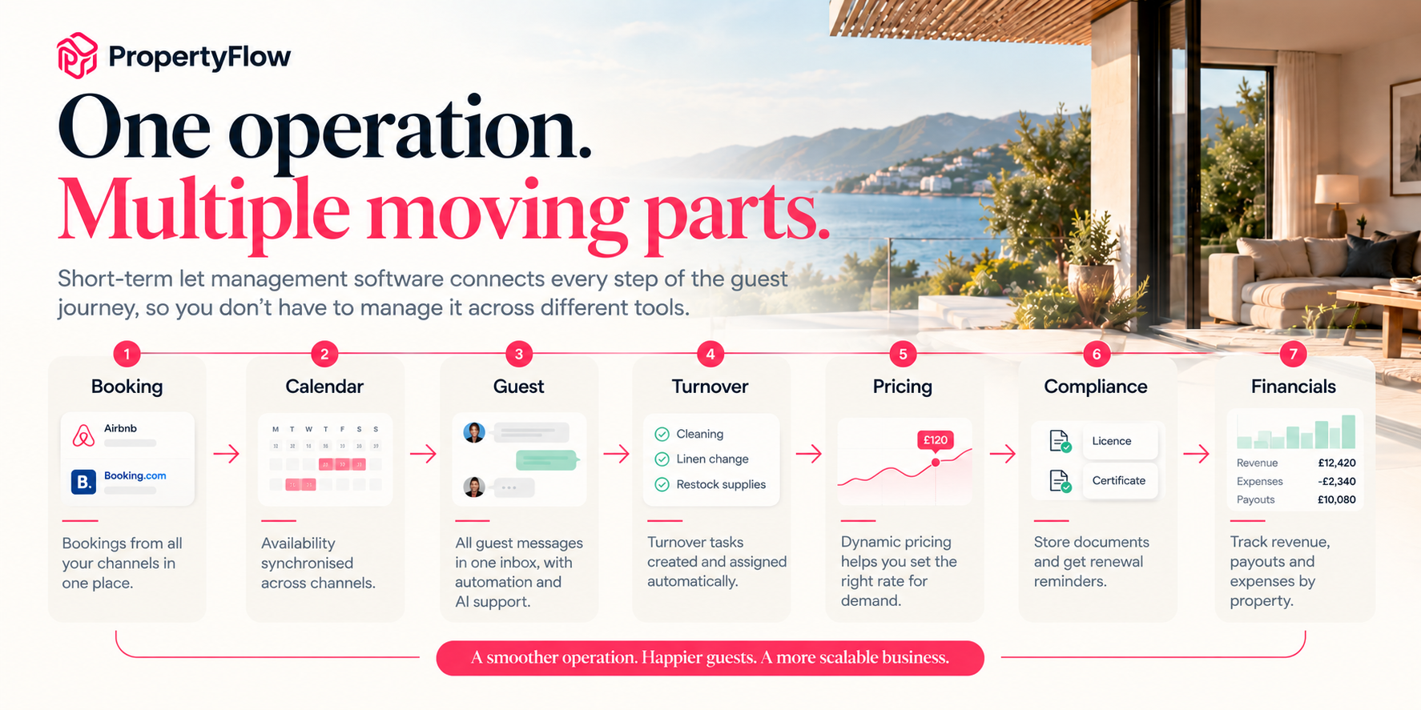(A short-term-let operation connects bookings, calendars, guest communication, turnovers, pricing, compliance and financials)
Feature | What it should do | Why it matters
Channel management | Keep availability and bookings synchronised | Reduces manual calendar work
Unified inbox | Bring guest conversations together | Makes messages easier to manage
Turnover management | Create and track cleaning tasks | Keeps changeovers organised
Pricing | Help adjust rates to demand | Reduces manual pricing work
Compliance | Store documents and track renewals | Keeps important dates visible
Reporting | Show performance by property | Makes decisions easier
Financials | Track payouts, expenses and statements | Cuts reconciliation work
Do not stop at the tick box.
Two platforms can both claim to offer “automated messaging” while giving you very different levels of control.
That is why the next step is to look at how each feature works in practice.

Channel Management: Can It Keep Your Calendars in Sync?
This is one of the first things to check if you list properties across multiple booking platforms.
Imagine you have three properties listed on Airbnb and Booking.com.
A guest books Property A on one platform.
Your software should know that immediately.
The dates should close everywhere else. You should not need to open another platform and update the calendar yourself.
PropertyFlow's Channel Manager connects booking channels to a single calendar, so reservations made on one channel can block the relevant dates across the others.
When comparing software, ask:
- Which channels does it support?
- How quickly do bookings sync?
- Can I connect accounts I already use?
- Can I add more channels later?
- Can I see every property in one calendar?
The last question becomes particularly important as the portfolio grows.

Guest Messaging: How Much of Your Inbox Can You Take Off Your Hands?
Guest communication is one of those jobs that looks small until you count it.
“Where is the key?”
“What time is check-in?”
“Can we leave our bags?”
“Is there parking?”
“Can we check out later?”
You may have answered each question dozens of times.
A unified inbox brings messages from different channels into one place. PropertyFlow also provides AI-assisted messaging and automated guest communications.
The useful distinction here is between automation and control.
You want software to handle repetitive communication without making it difficult for you to step in when a guest has a question that needs a human answer.
Before choosing a platform, test:
- Can messages be scheduled?
- Can you create templates?
- Can you see all channels together?
- Can you review AI-generated replies?
- Can you manually take over a conversation?
If the answer to all five is yes, the system can take a meaningful amount of inbox work off your plate.

Turnover Management: What Happens After Checkout?
A booking system tells you that someone is leaving.
A useful operations system should also help you deal with what happens next.
The property needs cleaning.
Linen needs changing.
Supplies may need restocking.
The next guest is arriving.
PropertyFlow's Turnovers & Team feature creates turnover tasks around bookings and lets teams assign and track the work.
This matters more as you grow because cleaning is rarely an isolated task.
A late checkout can affect a cleaner. A cancelled booking can change the schedule. A new reservation can create another turnover. Your software should reflect those changes. A good test during a demo is simple:
Book a property, change the booking and cancel it. What happens to the operational tasks?
That tells you more than a feature page will.

Dynamic Pricing: Does the Software Help You Set the Right Rate?
Pricing is another area where manual management gets harder with scale.
You might know roughly what your property should charge on a normal Tuesday.
But what about a busy weekend? A local event? A change in demand? A quiet period?
Dynamic pricing tools use data to help adjust nightly rates as conditions change.
PropertyFlow's AI Cognito Pricing is designed to adjust rates based on demand, season and local events.
Ask:
- What data does it use?
- How often are rates updated?
- Can I see or change the suggested price?
- Can I set pricing rules?
- Is it included in the base plan?
- Is the charge applied to every property?
With PropertyFlow's current pricing model, AI Cognito Pricing is £9.99 per property per month plus VAT when switched on.
That makes it worth calculating against your actual portfolio rather than treating “AI pricing” as a generic feature.

Compliance: Can You Keep Track of the Paperwork?
This is one of the least exciting parts of running a short-term let. It is also one of the easiest to forget.
Licences. Certificates. Renewal dates. Property documents.
The software you choose should make it obvious what has been uploaded, what is expiring and which property it belongs to.
PropertyFlow includes document storage and reminders for licences and certificates. For Partner properties, licence applications and renewals are handled by the PropertyFlow team.
There is an important distinction here:
Does the software remind you about compliance, or does the provider actually handle it?
Those are two very different services.
For self-managed properties, reminders may be all you need.
If you are managing properties for owners, you may need a more involved workflow.

Financials: Can You Explain Where the Money Went?
This becomes increasingly important when you have several properties.
You need to know what came in, which channel paid it, what expenses were incurred and what each property actually generated.
If you manage properties for other people, there is another question:
Can you produce a clear owner statement without rebuilding the numbers manually?
PropertyFlow's Financials & Payouts system tracks payouts by channel and stay, ties expenses to the relevant stay and creates property-level owner statements.
That can make month-end reporting considerably easier.
When comparing platforms, ask to see the actual financial workflow.
Do not settle for “yes, we have reporting.”
Ask:
“Show me the report I would send to the owner.”
That is the useful test.

What Happens When You Add More Properties?
This is probably the most important question for anyone buying software for a growing portfolio.
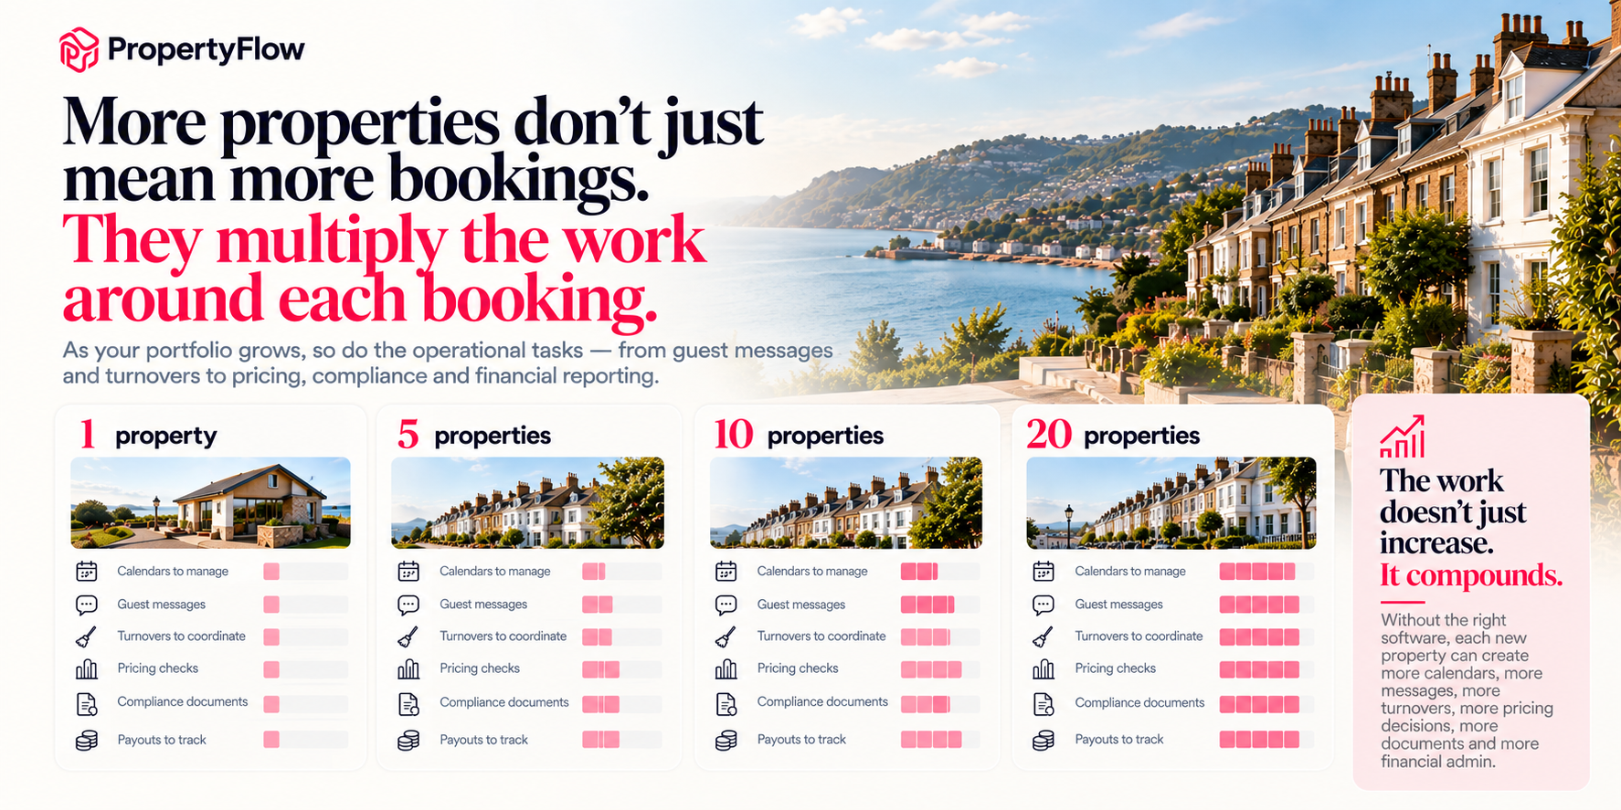(As your short-term let portfolio grows, so does the operational workload. More properties mean more calendars, guest messages, turnovers, pricing checks, compliance documents and payouts to manage)
A system might work perfectly with two properties.
What happens at ten?
Or twenty?
Look at:
- Pricing per property
- Channel limits
- User limits
- Automation limits
- Reporting
- Team access
- Owner access
- Support
- Data migration
- Whether you can add properties without changing systems
The best software for your business today is not necessarily the software that makes sense when your portfolio doubles.
You want to know the next step before you take it.

How Much Does Short-Term Let Management Software Cost in the UK?
There is no single pricing model across the market.
Some platforms charge per property. Others charge for particular features, users, bookings or channels.
So compare the total cost of running your actual portfolio, not the headline subscription.
For PropertyFlow, there is no property-count gate. You can use your own Airbnb and Booking.com accounts without a platform fee, regardless of how many properties you manage.
PropertyFlow option | Current pricing | What you get
Your own Airbnb & Booking.com accounts | £0 | Core platform, unified inbox and calendar, AI messaging, automated guest messages, turnovers, reminders and reporting
AI Cognito Pricing | £9.99/property/month + VAT | AI-assisted pricing when switched on
PropertyFlow channels | 5% + VAT per booking brought | Additional channels managed through PropertyFlow
Setup | £0 | No setup fee
Contract | No lock-in | Add-ons can be switched on or off
PropertyFlow's current homepage says hosts can run their portfolio on their own Airbnb and Booking.com accounts at no platform cost, with 0% PropertyFlow commission on bookings through those own accounts. PropertyFlow channels cost 5% + VAT on bookings brought by those channels, in addition to the relevant channel's own commission.
One thing worth checking carefully when comparing providers is what “free” actually means.
A free platform may still charge for additional channels, pricing, users or bookings. A £50 monthly subscription may look expensive until you discover it replaces three other tools.
Price the whole operation.

PropertyFlow Pricing: What Do You Actually Pay For?
PropertyFlow's current model is built around the idea of starting with the core platform and switching on additional services when you need them.
You can connect your own Airbnb and Booking.com accounts at no platform cost.
The core platform includes:
- Unified inbox
- Unified calendar
- AI messaging
- Automated guest messages
- Turnover tasks
- Document reminders
- Reporting
Then there are optional services.
AI Cognito Pricing: £9.99 per property per month + VAT when switched on.
PropertyFlow channels: 5% + VAT on bookings brought through those channels.
That structure matters because it lets you separate two decisions:
How do I want to run my existing bookings?
and
Do I want PropertyFlow to bring me additional bookings?
Those do not have to be the same decision.
See PropertyFlow's current pricing

Should You Choose Software Based on Features or Price?
Neither on its own.
A £0 platform that leaves you manually doing four hours of admin every week is not necessarily cheaper.
Likewise, an expensive platform packed with tools you never use may not make sense.
Think about cost per problem solved.
If the software saves you:
- Two hours of guest messaging
- Several hours of calendar administration
- Cleaner coordination
- Monthly financial reconciliation
- Compliance tracking
then you have something tangible to compare against the subscription.
For a growing portfolio, time is part of the software cost.

What Should You Ask Before Signing Up?
If you are seriously considering a platform, do not just book a generic demo.
Take your own workflow with you.
Ask the salesperson to show you:

A booking
“What happens from the moment a booking arrives?”

A guest message
“Show me how this conversation appears and how automation works.”

A turnover
“Show me what happens when the guest checks out.”

A price change
“Show me how pricing is updated.”

A certificate
“Show me where I store it and how I get reminded.”

A payout
“Show me how I know what this booking actually generated.”

Another property
“Now show me what changes when I add five more properties.”
That final question is particularly revealing.

What If You Manage Properties for Other Owners?
The requirements change once you are managing somebody else's property.
You may need:
- Owner statements
- Property-level financials
- Maintenance tracking
- Compliance records
- Clear communication
- Portfolio-wide reporting
- Access for your team
- A way to separate one owner's property from another's
PropertyFlow's Managing for Owners tools are designed around this workflow, including owner reporting, financial visibility, maintenance management, communication and compliance records.
The key question is whether the software can support delegation.
If another person takes over guest messages tomorrow, can they understand what is happening?
If someone else handles turnovers, can they see their tasks?
If an owner asks for a statement, can you produce it without digging through three spreadsheets?
Good software should make those handovers easier.

When Is It Time to Stop Managing Short-Term Lets Manually?
There is no magic property number.
For some hosts, it happens at three properties.
For others, it takes ten.
The better signal is operational friction.
You may be ready for dedicated software if:
- You check multiple calendars every day.
- You repeat the same guest replies constantly.
- Cleaners are coordinated through scattered messages.
- You manually change prices across several properties.
- You keep licences and certificates in folders or email.
- You spend hours matching payouts to bookings.
- You have started hiring people but the operation still depends on you.
- Adding another property makes you worry about how much more work it will create.
That last one is worth paying attention to.
If every new property creates a proportional amount of new admin, your operating system has become the bottleneck.

Is PropertyFlow the Right Fit for a Growing UK Short-Term-Let Portfolio?
PropertyFlow is designed around the operational side of UK short-term lets: channels, calendars, guest communication, pricing, turnovers, compliance and financials in one system.
It can work with the Airbnb and Booking.com accounts you already have, while PropertyFlow channels are available if you want additional distribution.
For a host who wants to remain hands-on, the platform provides the operational tools in one place.
For a business managing properties for owners, the financial, reporting and operational features become more important.
And for someone considering a more hands-off management model, PropertyFlow also has a Partner Programme where PropertyFlow handles operations for introduced properties. That is a different model from simply using the software, so it is worth treating it as a separate decision.

Frequently Asked Questions
What is the best short-term let management software in the UK?
There is no single platform that is right for every short-term-let business. The useful comparison is based on the number of properties, booking channels, operational workload, pricing requirements, reporting needs and whether you manage your own properties or properties for owners.
What features should I look for in property management software?
The main features to assess are channel management, calendar syncing, guest messaging, automation, turnover management, pricing, compliance, reporting and financial management. Property managers should also look closely at owner statements, team workflows and portfolio reporting.
How much does short-term rental software cost?
It depends on the provider and pricing model. Check the total cost, including per-property charges, booking commissions, paid add-ons, additional channels, users and VAT.
PropertyFlow's current pricing is £0 for hosts using their own Airbnb and Booking.com accounts, while AI Cognito Pricing costs £9.99 per property per month plus VAT when switched on. PropertyFlow channels charge 5% plus VAT on bookings they bring.
Can I use my existing Airbnb and Booking.com accounts with PropertyFlow?
Yes. PropertyFlow allows hosts to connect their own Airbnb and Booking.com accounts. Bookings through those own accounts have 0% PropertyFlow commission.
Do I need property management software for one property?
Not necessarily. A single property can often be managed manually. Software becomes useful when you want to centralise calendars, automate repetitive guest communication, organise turnovers or keep compliance documents in one place.
When should I move from spreadsheets to property management software?
The number of properties is less important than the amount of administration. If you are regularly updating multiple calendars, answering repetitive messages, coordinating cleaners, checking payouts or tracking compliance manually, dedicated software can remove a significant amount of operational work.
Is property management software worth paying for?
It can be, particularly when the software removes recurring work from your operation. The sensible way to assess it is to compare the total monthly cost with the hours of administration it removes and the operational mistakes it helps prevent.

Ready to Compare?
Property management software is ultimately an operating decision.
The right platform should make your existing portfolio easier to run, give you room to add properties and make the work easier to hand over when you stop doing everything yourself.
PropertyFlow brings bookings, calendars, guest communication, turnovers, pricing, compliance and financials into one system, with the option to use your own channels or add PropertyFlow channels as your needs change.

