**CDAC Feb 2015**

**LAB 2**

Q7. D FLIP-FLOP

Name: Bhrigu Bhargava

PRN: 150240133004

**D FLIP-FLOP**

# Design Approach:

# In electronics, a flip-flop or latch is a circuit that has two stable states and can be used to store state information. A flip-flop is a beatable multi-vibrator. The circuit can be made to change state by signals applied to one or more control inputs and will have one or two outputs. It is the basic storage element in sequential logic. Flip-flops and latches are a fundamental building block of digital electronics systems used in computers, communications, and many other types of systems.

# Circuit Diagram:

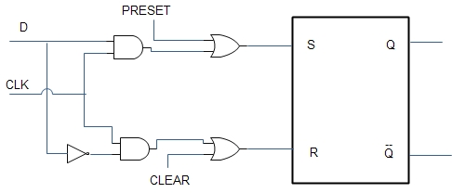

**Fig 1:- Circuit Diagram of D latch**

**Block Diagram:**

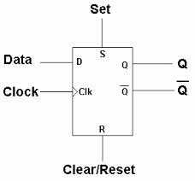

**Fig 2:- Block Diagram of D latch**

**Truth Table:**

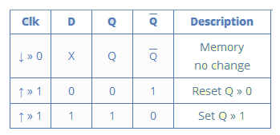

**Source Code:**

module dff1 (output op,input d,clk,rst);

dl d1 (opt,d,~clk,rst);

dl d2 (op,opt,clk,rst);

endmodule

module dff2 (output reg op, input d,clk,rst);

always@(posedge clk)

begin

if (rst==1'b1)

op<=1'b0;

else

op<=d;

end

endmodule

**Synthesis:**

1. RTL Schematic

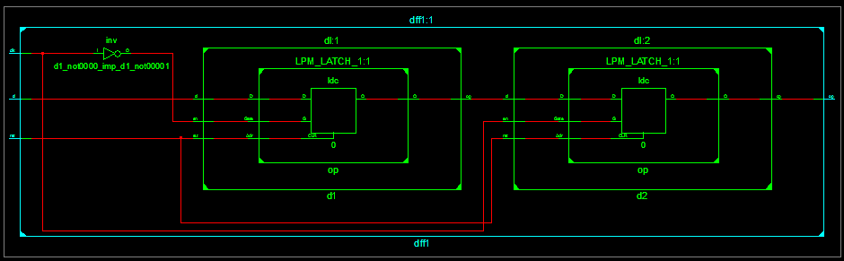

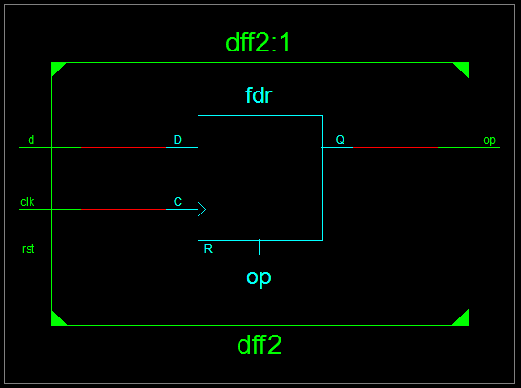

1. Block Diagram

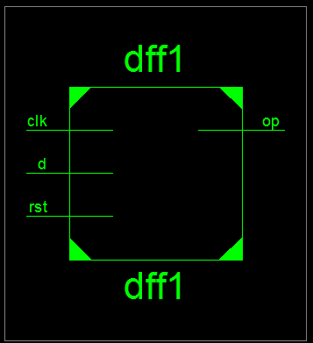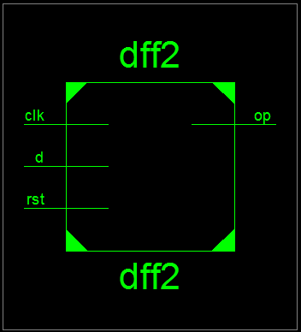

1. Tech Schematic

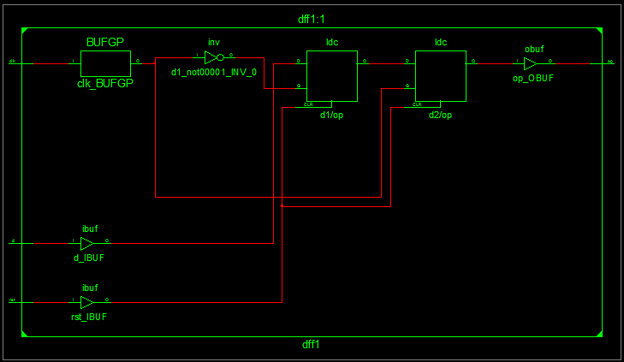

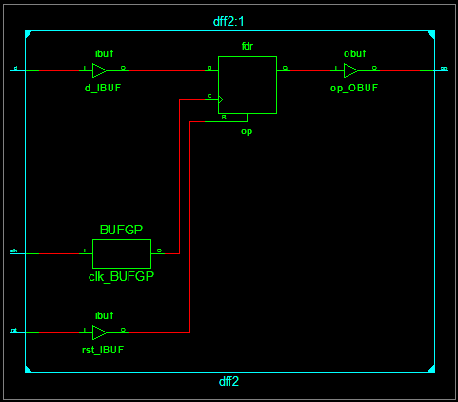

1. Simulation Waveform Result

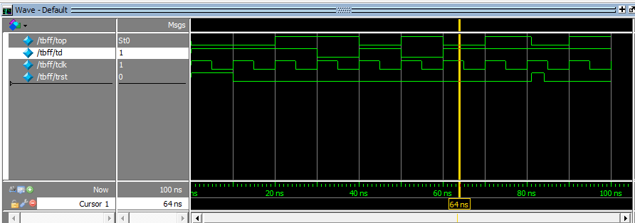

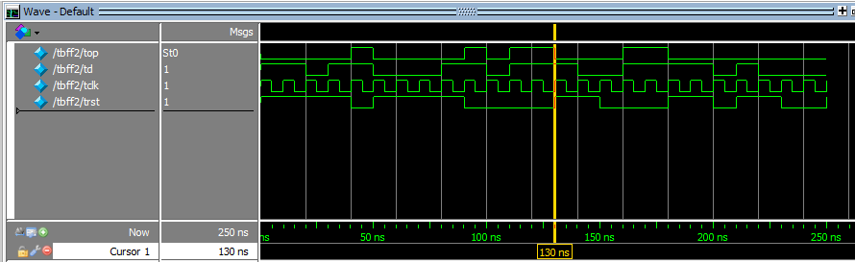

**Error:**

None.

**Verified by:**

Dharamveer Chundawat (150240133007)