**Smart Home Automation :** basic idea

* From : vinayak koshti

Block Diagram :

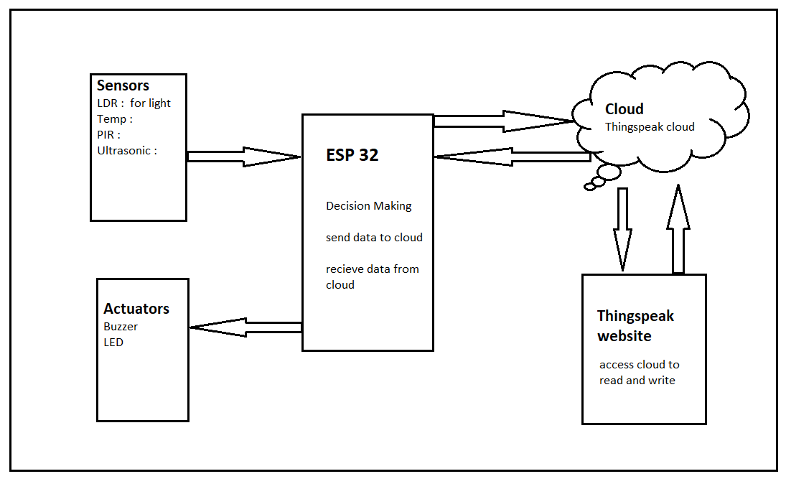

**Sensors** :

**LDR** : to turn on Lights automatically when there is dark and some one inside room

**Temperature** : if temperature according to threshold turn on ac like.

**PIR** : for security purpose or to check someone in room

**Ultrasonic sensor** : to count no. people in room or to get distance.

**Actuators**

Buzzer : to set alarm or buzz to get attention

**ESP32**

It have wifi to connect over AP

Getting data from sensor process it make decision and send it to cloud

**Cloud**

Get the data from esp32 and show It on Thingspeak or from thingspeak to esp32