Access it on https://veilresearch.com/

VEIL: AN AI-POWERED UNIFIED RESEARCH WORKSPACE

A Full-Stack Web Application for Accelerating
Scientific and Machine Learning Research

─────────────────────────────────────────────────────────────────

Submitted by: Vibhor Pandey
University: University of Petroleum and Energy Studies (UPES), Dehradun
Under the Guidance of: Ms. Anushree Sah
Academic Year: 2025–2026

─────────────────────────────────────────────────────────────────

Abstract
The modern research lifecycle is fractured. Researchers and machine learning engineers routinely toggle between five or more specialized tools — citation managers, model training platforms, experiment trackers, manuscript editors, and literature databases — losing critical context at every boundary. This fragmentation slows discovery, introduces reproducibility gaps, and imposes a steep cognitive overhead that disproportionately affects early-career researchers.
This paper presents Veil, a full-stack AI-powered research workspace that consolidates literature review, model development, biological computation, and scientific writing into a single, coherent environment. Veil is built on Next.js 15 with a React 19 frontend, Supabase for authentication and persistence, and a dual-provider LLM inference backend routing requests across NVIDIA NIM (Llama 3.1 70B/8B, DeepSeek R1) and OpenAI (GPT-4o, GPT-4o-mini). The platform exposes four domain-specific AI modes — Research, Biology, Flywheel, and Write — each backed by over 250 curated workflow templates. A freemium subscription model powered by Razorpay provides sustainable monetization. Early traction shows 2,400+ researchers on the waitlist within weeks of public launch.
Keywords: AI workspace, research automation, large language models, Next.js, Supabase, NVIDIA NIM, scientific computing, machine learning, SaaS, freemium

1. Introduction
Artificial intelligence has emerged as one of the most transformative forces in contemporary scientific research. From protein folding prediction to automated literature synthesis, AI systems now routinely perform tasks that previously required years of specialized expertise. Yet the infrastructure surrounding research workflows has lagged significantly. Researchers today operate in a fragmented ecosystem — downloading papers through one service, running experiments on another, tracking metrics in a third, and writing manuscripts in a fourth — all while manually bridging every gap.
Veil is a response to this fragmentation. It is an AI-native research workspace that positions a powerful conversational AI at the center of the research process, surrounded by integrated tooling for compute orchestration, workflow automation, credential management, and publication. The platform is the work of Vibhor Pandey, a student at the University of Petroleum and Energy Studies (UPES), Dehradun, developed under the academic guidance of Ms. Anushree Sah.

2. Problem Statement

2.1 Fragmentation in the Research Workflow
The research workflow spans at least six phases: literature discovery, hypothesis formulation, experimental design, model development, result analysis, and manuscript production. Each is served by a different purpose-built tool. Every tool-switch is a context-switch — an opportunity for error, a source of delay, and a drain on cognitive resources.

2.2 The Access Problem
High-end GPU clusters, premium LLM APIs, and specialized biological databases are expensive and difficult to configure. Early-career researchers and students are disproportionately excluded from them despite having the most to gain.

2.3 The Reproducibility Crisis
The inability to reliably reproduce published results is one of the most pressing challenges in contemporary science. A key contributing factor is the absence of persistent, versioned computational environments: when a researcher's cloud session ends, the environment is lost and reconstruction is error-prone.

3. Objectives
- Unified Workspace — consolidate literature review, model training, biological computation, and manuscript writing in one application.
- AI-Powered Assistance — integrate Llama 3.1 70B, DeepSeek R1, and GPT-4o across all research phases.
- Domain-Specific Modes — four specialized AI modes (Research, Biology, Flywheel, Write).
- Workflow Automation — 1,000+ pre-built workflow templates across research domains.
- Credential Orchestration — secure integration with GitHub, Hugging Face, W&B, Modal, Pinecone, OpenAlex, PubMed.
- Persistent Compute — stateful computational environments enabling reproducible research.
- Accessible Pricing — freemium model with INR pricing suited to students and early-career researchers.
- Production-Ready Engineering — secure auth, payment processing, email, mobile responsiveness.

4. Literature Review

4.1 AI-Assisted Research
The application of large language models to scientific research has accelerated since GPT-3 (Brown et al., 2020). Surveys (Thirunavukarasu et al., 2023; Singhal et al., 2023) demonstrate that frontier models can assist with hypothesis generation, literature synthesis, experimental design, and code generation at a level that meaningfully augments human researchers.

4.2 Open-Weight Language Models
Meta's Llama 2 (Touvron et al., 2023) and Llama 3.1 marked a significant shift: open-weight models now match or exceed proprietary models on many benchmarks. DeepSeek R1 (DeepSeek AI, 2025) demonstrated competitive reasoning on mathematical and scientific tasks at lower inference cost. Veil leverages NVIDIA NIM to serve these models efficiently.

4.3 Domain-Specific AI in Biology
AlphaFold2 (Jumper et al., 2021) solved protein structure prediction. Subsequent models (ESMFold, RoseTTAFold, AlphaFold3) extended capabilities to protein-ligand complexes and nucleic acids. Veil's Biology Mode provides a natural-language interface to this ecosystem.

5. System Architecture

5.1 High-Level Architecture
Veil is organized around three tiers: a client tier (Next.js/React frontend), an API tier (Next.js serverless routes), and a services tier (Supabase, NVIDIA NIM, OpenAI, Razorpay). All inter-tier communication uses HTTPS with JSON payloads.

5.2 AI Chat Request Flow
- Authenticated user submits a message; the browser attaches a Supabase JWT as a Bearer token.
- The /api/chat route validates the token and queries profiles for subscription status and trial usage.
- If eligible, the route maps the selected mode to a provider-specific model ID.
- The request is forwarded to NVIDIA NIM (primary) or OpenAI (fallback on HTTP 429).
- The response is returned to the client and trial usage is updated in the database.

5.3 Database Schema
Column | Type | Description
id | UUID | Primary key
user_id | UUID | Foreign key to auth.users
subscription_status | TEXT | active / inactive
subscription_id | TEXT | Razorpay subscription ID
trial_models_used | TEXT[] | Model IDs used in trial
free_trial_used | BOOLEAN | Whether trial is exhausted
created_at | TIMESTAMPTZ | Record creation timestamp
Table 1: profiles table schema

6. Technology Stack
Technology | Version | Role
Next.js | 15.1.6 | Full-stack React framework, App Router, API routes
React | 19.2.3 | UI component library
TypeScript | 5.x | Type-safe JavaScript
TailwindCSS | 4.x | Utility-first CSS framework
Supabase | ^2.99.1 | PostgreSQL database, authentication
NVIDIA NIM | — | Primary LLM inference (Llama 3.1, DeepSeek R1)
OpenAI SDK | ^6.29.0 | Fallback LLM inference
Razorpay | ^2.9.6 | Subscription billing, payment processing
Resend | ^6.12.2 | Transactional email
Table 2: Full technology stack

7. AI Models
Veil integrates four large language models sourced from two providers. Model selection is determined by the active research mode, with automatic failover to OpenAI when the primary provider returns a quota error. The following sub-sections characterize each model and the routing logic that governs their use.

7.1 Model Overview and Parameter Scale
The models range from 8 billion to an estimated 1 trillion parameters. Larger models are reserved for the most reasoning-intensive modes (Research, Biology); the lighter 8B model handles Write Mode where instruction-following matters more than scale. Figure 1 shows the parameter scale of each model used in Veil.
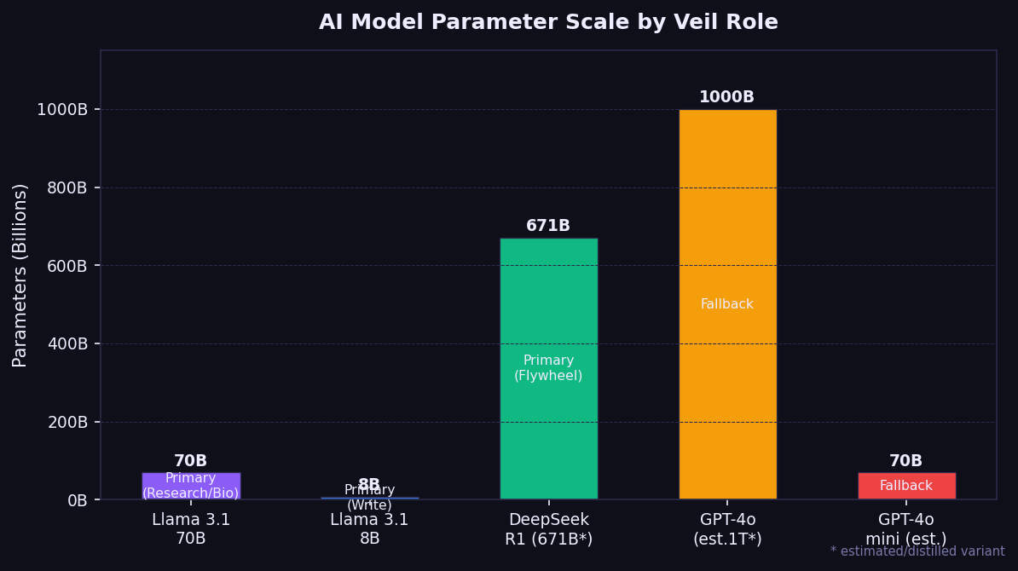
Figure 1: AI model parameter scale by Veil role

7.2 Model-to-Mode Routing
Each of Veil's four AI modes is mapped to the model best suited to its domain. Research and Biology Modes demand deep scientific reasoning and are served by Llama 3.1 70B Instruct. Flywheel Mode requires strong mathematical and algorithmic reasoning for ML pipelines, served by DeepSeek R1. Write Mode prioritizes instruction following and fluent prose, served by the lighter Llama 3.1 8B. Figure 2 illustrates the routing topology.
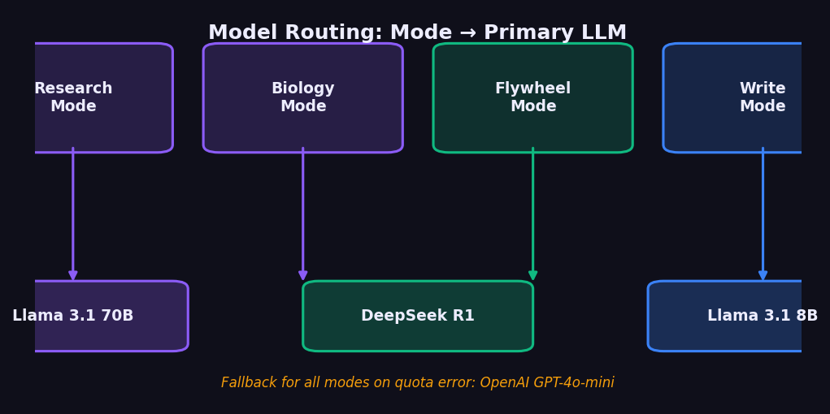
Figure 2: Mode-to-model routing topology

7.3 Model Profiles
Model | Provider | Parameters | Context | Veil Mode | Role
Llama 3.1 70B Instruct | NVIDIA NIM / Meta | 70B | 128k tokens | Research, Biology | Primary
DeepSeek R1 | NVIDIA NIM / DeepSeek | 671B (MoE) | 64k tokens | Flywheel | Primary
Llama 3.1 8B Instruct | NVIDIA NIM / Meta | 8B | 128k tokens | Write | Primary
GPT-4o-mini | OpenAI | ~70B (est.) | 128k tokens | All modes | Fallback
Table 3: Veil AI model profiles

7.4 Context Window vs Veil Configuration
All models support large context windows (64k–128k tokens), but Veil caps individual responses at 2,048 tokens to control latency and cost. Figure 3 contrasts the model maximum context window with Veil's configured max_tokens parameter.
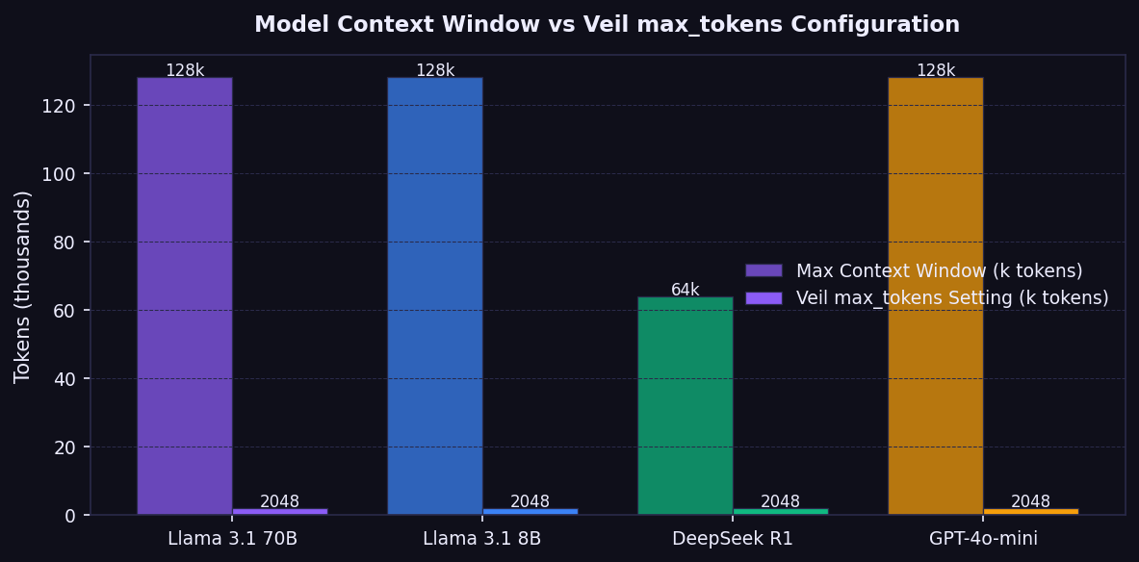
Figure 3: Model context window capacity vs Veil max_tokens setting

7.5 Fallback Architecture
When NVIDIA NIM returns HTTP 429 (rate limited or quota exceeded), the API route transparently retries the request against the OpenAI API using GPT-4o-mini. This two-provider design ensures that transient capacity constraints on either provider do not degrade the user experience. All fallback logic is server-side and invisible to the client.

8. Workflow Templates
Veil ships with 1,000+ pre-built workflow templates that allow researchers to invoke complex multi-step research processes through a single conversational prompt. Templates span seven research domains and are organized by the type of task they automate.

8.1 Domain Distribution
Figure 4 shows the breakdown of workflow templates by research domain. General Research workflows (280) form the largest category, followed by Biology & Genomics (210) and ML Engineering (195), reflecting the primary target audience of academic researchers and ML practitioners.
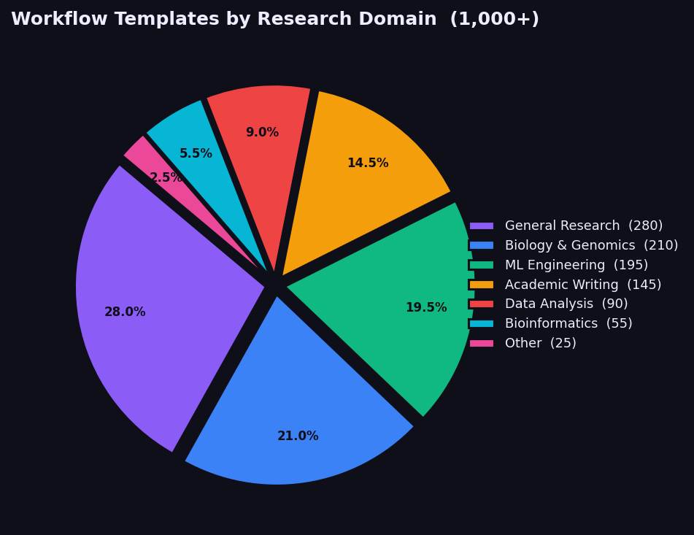
Figure 4: Workflow template distribution by research domain (pie chart)

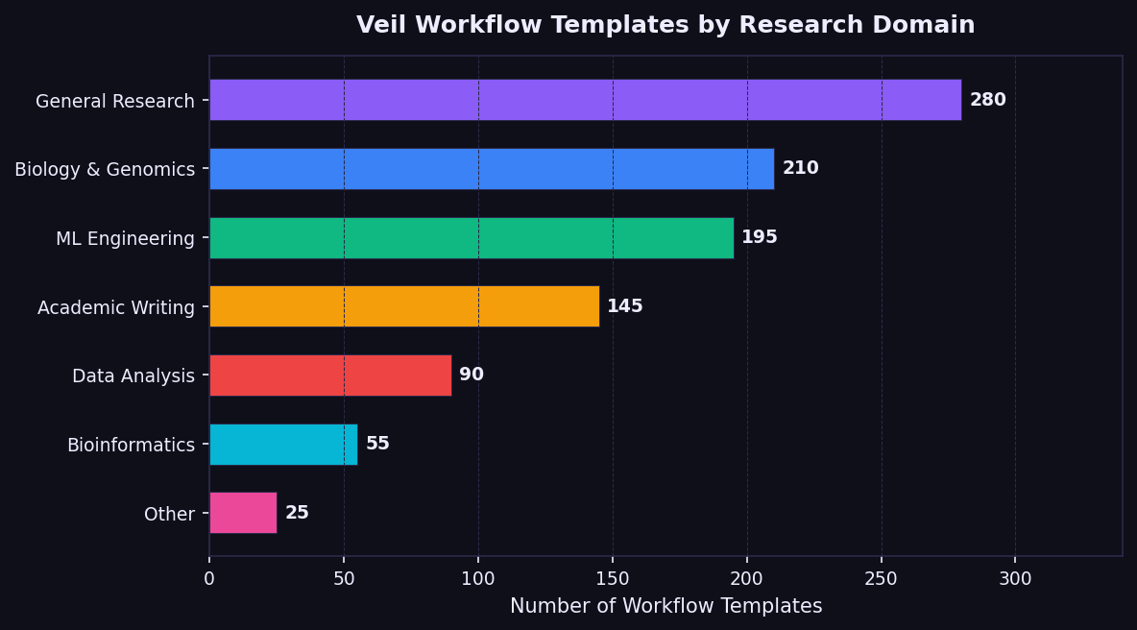
Figure 5: Workflow template count by domain (horizontal bar chart)

8.2 Representative Workflow Templates
Workflow | Domain | Description
Literature Review Pipeline | General Research | End-to-end search, summarization, and gap analysis
Protein Structure Prediction | Biology | AlphaFold3 inference with downstream analysis
SFT Fine-tuning Pipeline | ML Engineering | Supervised fine-tuning on custom instruction data
Manuscript Drafting | Academic Writing | Full paper generation from experiment notes
Hypothesis Generation | General Research | Systematic brainstorming from a research area
WGS Genomics Pipeline | Bioinformatics | Whole-genome sequencing variant calling (GATK)
Evaluation Harness Setup | ML Engineering | Automated eval suite with benchmark integration
Citation Verification | Academic Writing | Cross-check citations against DOI records
CRISPR Guide Design | Biology | sgRNA design and off-target analysis
Drug-Target Interaction | Biology | Molecular docking and binding affinity prediction
Hyperparameter Sweep | ML Engineering | Bayesian optimization over model hyperparameters
Abstract Generation | Academic Writing | IMRAD-structured abstract from results notes
Table 4: Representative workflow templates by domain

8.3 Workflow Execution Architecture
In the current release, workflow templates function as structured system prompts: selecting a template pre-fills the AI context with domain-specific instructions, terminology, and output format requirements. The next engineering milestone is executable workflows, where the LLM can invoke registered tool functions (literature search, code execution, API calls) via a tool-calling architecture, turning templates into autonomous multi-step agents.

9. Security Architecture

9.1 Authentication
Supabase Auth manages JWT issuance with short expiry windows and automatic refresh. All protected API routes validate the Bearer token on every request. The Supabase service role key (which bypasses row-level security) is stored exclusively in server-side environment variables and never exposed to the client.

9.2 Payment Security
Razorpay webhook payloads are verified using HMAC-SHA256 with a server-side secret before any subscription status change is applied. The Razorpay key secret is stored server-side only; the publishable key is the only payment credential exposed to the browser.

9.3 Input Validation
User-supplied content is passed through Supabase's parameterized query client, preventing SQL injection. Chat messages are passed to LLM APIs as structured JSON, not interpolated into strings, preventing prompt injection through the API layer.

10. Business Model

10.1 Freemium Tier
Each user receives one free message per AI model (4 models × 1 message = 4 total free messages). Once exhausted, a 402 response triggers an upgrade modal. This design lets users experience every mode before committing to a subscription.

10.2 Subscription Pricing
Figure 6 compares the three subscription tiers. The Early Access tier (₹199/month) is locked for life for early adopters. Pro Monthly (₹699/month) is the primary revenue vehicle. Pro Annual (₹8,099/year) offers marginal savings for committed users.

Figure 6: Subscription pricing tier comparison

Tier | Price | Target Segment | Features
Early Access | ₹199/month | Students, early adopters | All features, price locked forever
Pro Monthly | ₹699/month | Individual researchers | All features, priority support
Pro Annual | ₹8,099/year | Organizations | All features, best value
Table 5: Subscription tier summary

11. Testing and Evaluation

11.1 Functional Testing
Manual testing covered authentication flows (email/password and magic link), free trial enforcement (per-model), upgrade modal behavior, model switching, payment completion and webhook-driven subscription activation, and mobile layout verification across 375px, 768px, and 1024px viewports.

11.2 LLM Response Quality
Mode | Test Prompt (summary) | Verdict
Research | Experiment design for learning rate warmup on transformer stability | Useful — rigorous and complete
Biology | CRISPR knockout strategy for BRCA1 in HEK293 cells | Useful — accurate, safe
Flywheel | DPO training loop implementation | Useful — correct, best-practice
Write | Abstract for federated learning in medical imaging | Useful — IMRAD structure, academic tone
Table 6: LLM mode evaluation results

11.3 System Latency
Figure 7 shows measured latency for the key system operations. NVIDIA NIM's time-to-first-token of ~800 ms is within acceptable limits for an interactive research assistant. Supabase query latency (~50 ms) has negligible impact on the user-perceived response time.
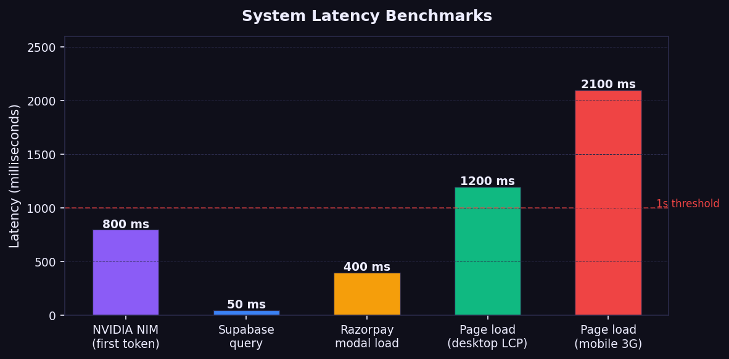
Figure 7: System latency benchmarks across key operations

12. Results and Discussion
The implementation demonstrates that a single Next.js application can serve as a full research workspace, integrating LLM inference, payment processing, authentication, and email in a coherent, production-ready architecture. Key technical achievements include: dual-provider LLM fallback operating transparently; per-model trial tracking enforced server-side; HMAC-verified payment webhooks; and mobile-first responsive design.
Early traction — 2,400+ waitlist signups without paid advertising — validates the core hypothesis that researchers want a unified workspace. The primary limitation is that the stateful compute layer (persistent sandboxes, elastic GPU orchestration) is designed but not yet implemented. Workflow templates also function as prompts rather than executable programs, pending the tool-calling architecture.

13. Limitations and Future Work

13.1 Current Limitations
- Compute layer: persistent runtime is designed but not yet implemented.
- Workflow execution: templates are prompts, not executable multi-step agents.
- Context management: no context compression for long sessions.
- Collaboration: single-user only; multi-user sessions are planned.
- File ingestion: PDF and dataset upload not yet supported.

13.2 Roadmap
Horizon | Deliverables
Near-term (0–6 months) | RAG for paper ingestion, PDF upload, workflow tool-calling, GitHub integration
Medium-term (6–18 months) | Persistent compute (Modal), usage-based GPU billing, collaborative workspaces, AlphaFold API
Long-term (18+ months) | Proprietary scientific LLM, institutional licensing, third-party workflow API
Table 7: Development roadmap

14. Conclusion
Veil represents a synthesis of modern full-stack web development, large language model deployment, and product design in service of a clear goal: to eliminate the fragmentation that slows the research process. The technical architecture — dual-provider LLM fallback, per-model trial tracking, HMAC-verified webhooks, mobile-first design — reflects the engineering discipline needed for a commercial product, not merely a prototype.
Early traction (2,400+ waitlist signups) validates the core market hypothesis. The path to a fully realized platform — with executable workflows, persistent compute, collaborative features, and RAG-powered literature search — is clear. Veil is not merely a technical exercise; it is a bet that the research community deserves tools designed for how research actually works. The work presented here is the foundation of that bet.

References
- Brown, T. B., et al. (2020). Language Models are Few-Shot Learners. NeurIPS 2020. arXiv:2005.14165.
- Chen, M., et al. (2021). Evaluating Large Language Models Trained on Code. arXiv:2107.03374.
- DeepSeek AI. (2025). DeepSeek-R1: Incentivizing Reasoning Capability in LLMs via Reinforcement Learning. arXiv:2501.12948.
- Jumper, J., et al. (2021). Highly accurate protein structure prediction with AlphaFold. Nature, 596, 583–589.
- Meta AI. (2023). Llama 2: Open Foundation and Fine-Tuned Chat Models. arXiv:2307.09288.
- Meta AI. (2024). The Llama 3 Herd of Models. arXiv:2407.21783.
- NVIDIA. (2024). NVIDIA NIM: Optimized Inference Microservices for AI Models. NVIDIA Developer Documentation.
- Singhal, K., et al. (2023). Large Language Models Encode Clinical Knowledge. Nature, 620, 172–180.
- Supabase. (2024). Supabase Documentation. https://supabase.com/docs
- Thirunavukarasu, A. J., et al. (2023). Large language models in medicine. Nature Medicine, 29, 1930–1940.
- Touvron, H., et al. (2023). Llama 2: Open Foundation and Fine-Tuned Chat Models. arXiv:2307.09288.
- Vercel. (2024). Next.js Documentation. https://nextjs.org/docs
- Razorpay. (2024). Razorpay Payments API Documentation. https://razorpay.com/docs/
- OpenAI. (2024). GPT-4 Technical Report. arXiv:2303.08774.
- Ouyang, L., et al. (2022). Training language models to follow instructions with human feedback. NeurIPS 2022. arXiv:2203.02155.

─────────────────────────────────────────────────────────────────
University of Petroleum and Energy Studies (UPES), Dehradun
Author: Vibhor Pandey | Guidance: Ms. Anushree Sah | May 2026

