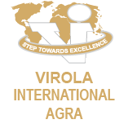
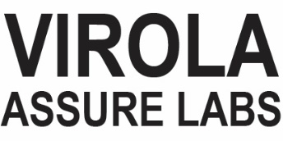

CERTIFICATE OF ANALYSIS (CoA)

PRODUCT s BATCH DETAILS

Product Name | TTS | REPORT No. | 11-26-27 BOND STRENGTH TEST (METHOD: SATRA TM 281)
ARTICLE NO. | TTS-0012 | Date | 30/05/2026
SOLE | Mixed Material | CUSTOMER | TESTING

TESTING PARAMETERS | STANDARD PARAMETERS | RESULTS

TESTING METHOD | Bond Strength Test (Method: SATRA TM 281)
TEMPERATURE
HUMIDITY
CLIENT SPECIFICATION | ≥ 4.00 N/mm

5.00

4.50

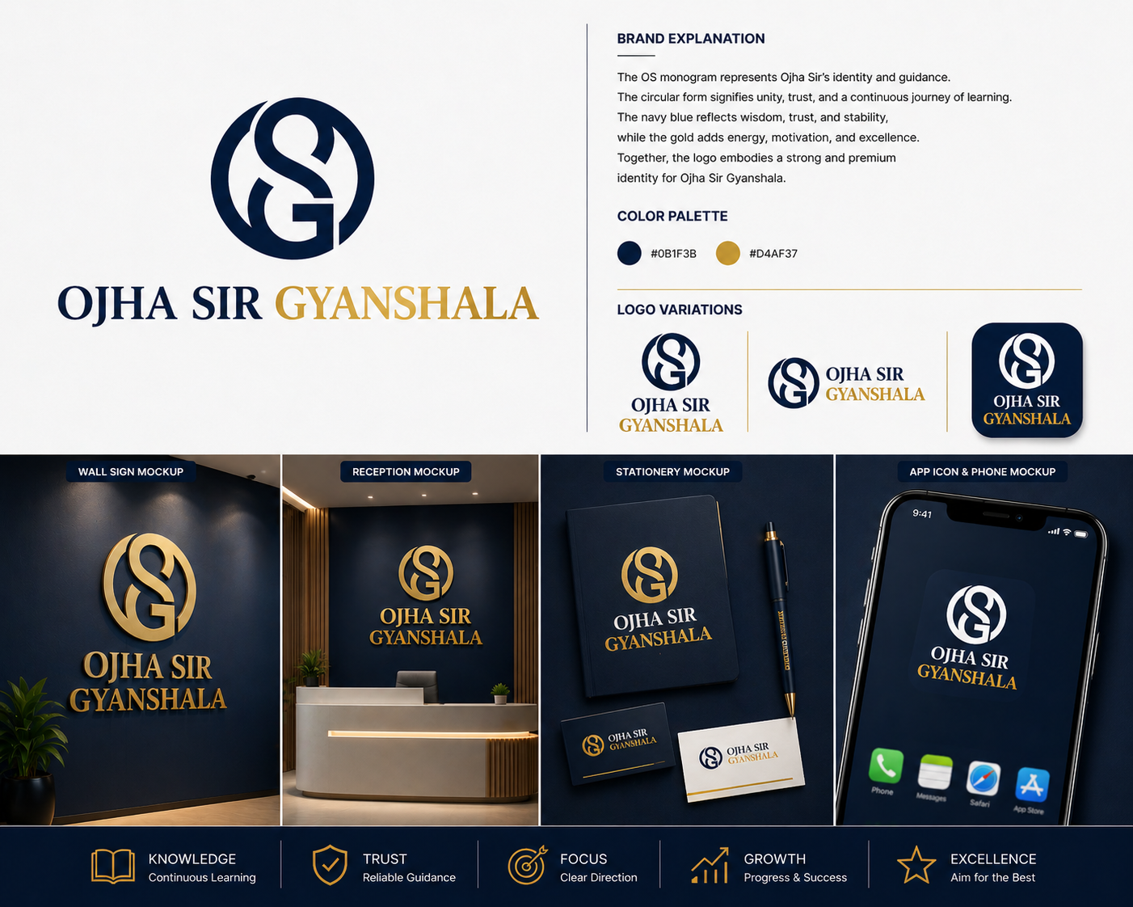

5.00

4.50

5.00

4.50

5.00

4.50

4.50

4.50

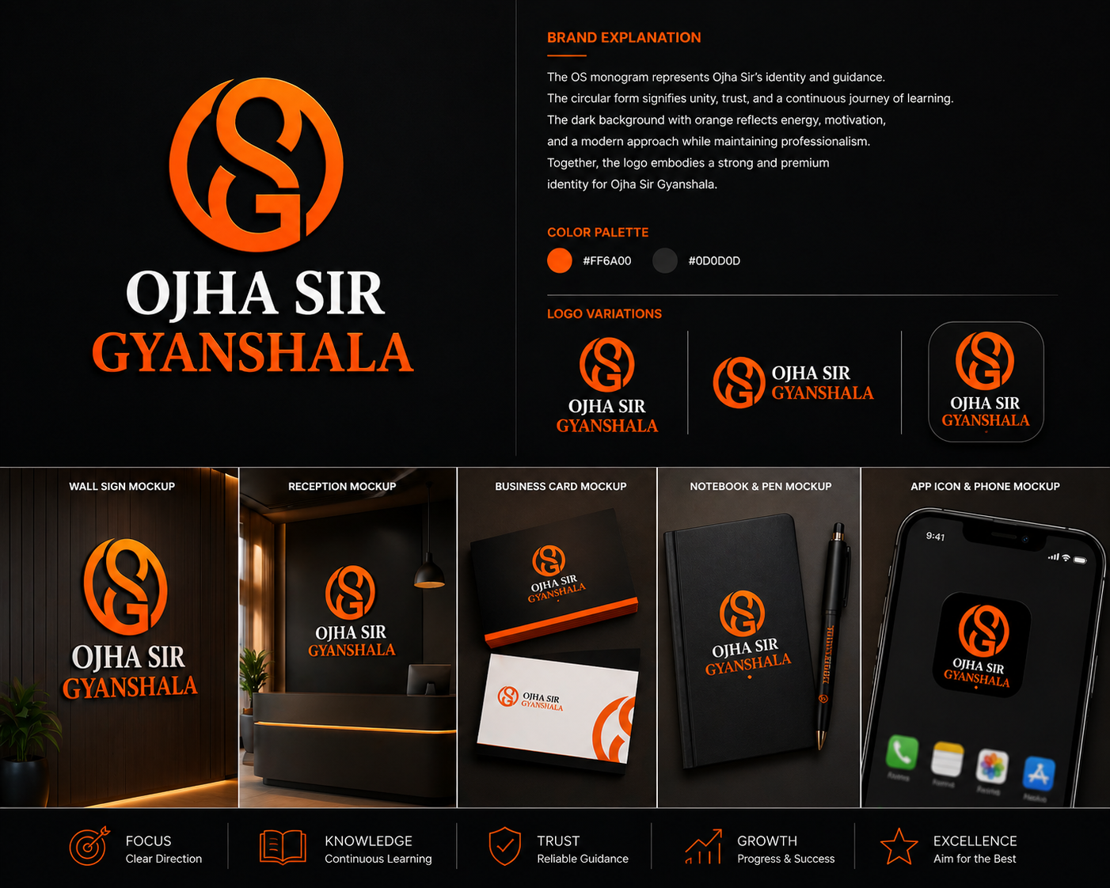

4.50

4.50

4.50

4.50

4.50

4.50

RESULT | PASS

Comments

Tested By:
Reviewed By:
Reviewed By:
Approved By (L1)
Approved By (L2)

Senior Lab Analyst
Quality Assurance Manager
Product Manager / QA Manager
Management Approval Level 1
Management Approval Level 2

This Certificate of Analysis is issued for informational purposes only. Please read the disclaimer on the reverse page before use.”

DISCLAIMER
This Certificate of Analysis (“CoA”) has been prepared by VIROLA ASSURE LABS, a division of VIROLA GROUP, based on samples tested under controlled laboratory conditions using standard procedures, industry-accepted methodologies, and internal testing protocols. The information, results, findings, and observations provided herein are generated solely for VIROLA’s internal quality control purposes and are intended strictly for informational reference only.
By accepting or using this CoA, the recipient acknowledges and agrees to the following terms and limitations:

Non-Warranty Statement

VIROLA GROUP, including VIROLA ASSURE LABS, makes no express or implied warranties regarding the accuracy, completeness, merchantability, fitness for a particular purpose, or suitability of the information, results, or data contained herein.
This CoA does not represent or imply any guarantee, certification, or warranty that the entire batch, lot, shipment, or material meets any particular specification, performance parameter, or customer requirement.

Scope Limitation

The results pertain exclusively to the specific sample(s) tested and cannot be assumed to represent the quality, performance, durability, or safety of the entire batch, consignment, or any other material supplied.
VIROLA ASSURE LABS does not warrant or confirm compliance with any statutory, regulatory, or customer-specific standards unless explicitly stated in writing.

Independent Verification

Recipients are strongly advised to conduct their own independent testing, verification, and due diligence prior to any usage, processing, resale, or incorporation of the materials or products into any application.
This CoA must not be treated as a substitute for third-party testing, product certification, or regulatory approvals.

Limitation of Liability

VIROLA GROUP, including VIROLA ASSURE LABS, shall not be liable for any direct, indirect, incidental, special, consequential, or punitive damages, including but not limited to loss of business, revenue, goodwill, production delays, or reputational harm, arising out of or in connection with the use, reliance, or interpretation of this CoA.
The recipient assumes full responsibility for any decision, usage, or process based on the contents of this report.

No Endorsement or Certification

This CoA does not represent any endorsement, approval, or certification by VIROLA GROUP of any material, supplier, or product.

No statement within this document should be construed as regulatory compliance certification, statutory clearance, or customer acceptance guarantee.

Indemnity

The recipient agrees to indemnify, defend, and hold harmless VIROLA GROUP, its affiliates, employees, and representatives from and against any claims, liabilities, losses, damages, or costs arising from or related to the reliance on this CoA.

Jurisdiction

Any disputes arising from or in connection with this CoA shall be subject to the exclusive jurisdiction of the competent courts at Kolkata, India, and governed by the laws of India.

Internal Use Emphasis

This document is issued strictly for VIROLA ’s internal quality control purposes and should not be construed as an externally binding certification, warranty, or guarantee of performance.
In case this CoA is shared with customers, vendors, or third parties, it shall remain an internal quality reference document only and shall not be relied upon as a basis for any legal, commercial, or operational claims against VIROLA GROUP.

Important Notice:

By accepting, viewing, or using this Certificate of Analysis, you explicitly confirm that you have read, understood, and agreed to all the above terms, and that VIROLA GROUP, including VIROLA ASSURE LABS, bears no liability whatsoever for any consequence arising from its usage.

