**Information Feature Extraction from Images with Occluded Objects**

Thesis submitted on completion of Summer Internship (2017) at the Indian Institute of Remote Sensing, Dehradun.

**Submitted By:**

Vibhu Agrawal

M.Sc. (Hons.) Mathematics and B.E. (Hons.) Electronics and Communication

4th Year  
BITS Pilani, Hyderabad Campus

**Submitted To:**

Dr. Vandita Srivastava

Scientist/Engineer – SF

Urban and Regional Studies Department

Indian Institute of Remote Sensing, ISRO

August, 2017

**Acknowledgements**

It is a genuine pleasure to express my deepest gratitude to my guide and mentor, Dr. Vandita Srivastava, who gave me the opportunity to work under her, and guided me throughout the duration of my time at the Indian Institute of Remote Sensing, Dehradun. Her timely support, scholarly advice and meticulous scrutiny have been the greatest contributors towards the completion of my work.

I thank my father and my brother for their support and encouragement throughout the duration of my internship. Without them, this would not have been possible.

I would like to thank my fellow interns at IIRS, especially Krishna, JP and Abhijeet, for making my time at IIRS memorable.

Vibhu Agrawal

**Abstract**

Computation of the missing portions of an image containing occluded objects is needed in an increasing amount of machine and computer vision applications, as well as in fields like remote sensing and biomedical image processing. Many methods have been proposed over the years for segmentation and estimation of overlapping objects. This thesis focuses on objects that are convex in nature and may be estimated by an elliptical mathematical model. A method has been proposed to segment, identify and complete individual convex objects that can be estimated by an ellipse.   
  
Images are first converted to binary images, i.e. the image is divided into its foreground and background using appropriate method. This is a subjective approach and methods and parameters vary across different data sets. The pivotal step to the proposed approach is the efficient detection of probable individual objects in the image, and is done through the estimation of seed-points, i.e. markers for individual objects. Seed-points are estimated using fast radial symmetry transform. This algorithm works on the principle that the area inside an object should be radially symmetrical which is true for any regular convex shape. Having estimated the seed-point locations, the next step is to link each edge pixel to a seed-point relevant to the edge, effectively segmenting the entire image into its constituent objects. The edge-points are linked to the seed-points using a relevance metric using distance metric and gradient metric, with an additional condition regarding convexity added to make the algorithm very accurate. Now, a list of pixels linked to each seed-point is created, and an ellipse is fitted for each seed-point using the edge-points linked to the seed-point by direct ellipse fit method, which is a very fast and non-iterative method for ellipse fitting.   
  
The missing areas may be completed using circular or elliptical arcs, depending to the dataset. Each object in the image is given a unique identity, and the overlaps for each object with every other object is recorded, and the data is analyzed for mean, median and standard deviation. This process is automated for a large number of different parameters, and an accurate result is obtained.

Key words: Overlapping objects, occluded objects, image processing, elliptical, convex objects

Contents

1 Introduction 6

1.1 Background 6

1.2 Objective 6

1.3 Structure of the Thesis 7

2 Literature Review 8

2.1 Methods of Segmentation 8

2.1.1 Threshold-Based Models 8

2.1.2 Histogram-Based Methods 9

2.1.3 Edge-Based Methods 9

2.1.4 Region-Based Methods 10

2.1.5 Morphological Operations 11

2.2 Existing work on segmentation of occluding objects 12

2.3 Existing work on completion of incomplete objects 14

3 Methodology 15

3.1 Methods Used 15

3.1.1 Seed-Point Estimation 15

3.1.2 Edge-to-Seed-point Association 19

3.1.3 Extrapolation of Data to Complete the Objects 21

3.2 Proposed Algorithm 26

4 Flowchart 32

32

5 Results and Discussion 33

5.1 Methods and Results 33

5.2 Discussion 34

6 Conclusion 36

7 References 37

8 Appendix 41

8.1 Image 1 (Radius range 7 to 18) 41

8.2 Image 2 (Radius range 10 to 17) 42

8.3 Image 3 (Radius range 3 to 20) 43

8.4 Image 4 (Radius range 10 to 30) 44

8.5 Image 5 (Radius range 10 to 22) 45

# 1 Introduction

## Background

In the field of computer vision, segmentation of images is the process of partitioning a digital image into segments on the basis of criterion including but not limited to color, intensity and texture. To be more precise, image segmentation is the process of assigning a label to each pixel of the image such that pixels with the same label share some specified common characteristics. The goal is to simplify the representation of image into something more meaningful and easier to analyze. [1]

Image segmentation finds massive application in computer vision, in fields like medical imaging, remote sensing, machine vision, object detection and the like. Due to the vast application of segmentation, a large amount of research has been carried out on the subject in the past few years.

Segmentation of occluded objects reveals the limitations the standard methods applied in image segmentation. The unavailability of data in the overlapping parts of the image is usually a large enough handicap that new methods have to be developed in order to obtain desirable results.

The thesis project focuses on the separation of occluded objects in an image, and the completion of the missing parts in individual objects through extrapolation of data.

## Objective

The objective of this thesis project was to develop a robust algorithm which could detect individual objects, segment the occluded regions of the image, complete the missing parts of each object and analyze the overlapping regions of the various detected objects. The focus was convex, binary objects which are clearly distinguishable from the background, and the general shape of objects was known to be an ellipse. The leading works on the subject were studied, and by applying various methods on datasets, results were obtained. Improvements to the existing methods were proposed and tested, and finally a robust algorithm was developed which provided satisfactory results.

## 1.3 Structure of the Thesis

This thesis is divided into 5 sections as follows. Chapter 2 discusses the literature related to this work, and describes some commonly used segmentation techniques. Chapter 3 describes in detail the methods that were used and tested to arrive at the final algorithm. It also discusses the proposed algorithm sequentially and in detail. The results and the conclusion have been presented in Chapter 4. Chapter 5 contains the references used in this thesis.

# 2 Literature Review

## 2.1 Methods of Segmentation

Segmentation of digital images is one of the most basic concepts in digital image processing. It constitutes separating the image into categories, and assigning pixels with tags such that pixels with the same tag share similar characteristics. The images are segmented on the basis of color, intensity, texture or other such factors. In the following parts of the report, we briefly review popular techniques in segmentation.

### 2.1.1 Threshold-Based Models

Thresholding is the simplest form of segmentation. Thresholding is used to create a binary image from a grayscale image. It refers to the replacement of each pixel with a black pixel if the image intensity at the pixel is less than some specified constant (threshold value), or a white pixel if the intensity is more than that constant. The most important part of threshold-based segmentation is the threshold value.

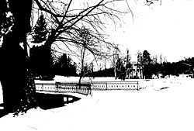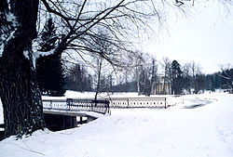

**Figure 1.** A threshold based segmentation model. (a) Original Image (b) Thresholded Image [2]

Threshold-based segmentation only takes in account the pixel values, and does not consider any spatial properties of the image. The most important part of threshold-based segmentation is the threshold value.

### 2.1.2 Histogram-Based Methods

Histogram-based segmentation models are often more efficient than other typically used methods, as they require only one pass through the pixels. Peaks and valleys are detected in a histogram computed for all the pixels in the image, using color and intensity as the measure, and the image is divided into cluster. Histograms are then computed for each cluster, and they are then further divided into clusters. Recursively, this process is repeated until no more smaller clusters can be formed, and thus the image is segmented. [3] A limitation to this method is that for a particular image, histogram peaks and valleys may not be easy to identify, thus rendering this model useless.

### 2.1.3 Edge-Based Methods

Edge detection is a well-developed field within image processing. Often, region boundaries and edges are closely related, as there are sharp changes in values of intensity at the region boundaries. This method is based on the philosophy that each object is contained within a closed border that can be detected using the intensity values. This method is often combined with thresholding to get sharper intensity changes at the boundaries, making it easier to detect edges. The most commonly used edge-detection algorithms are Sobel [4], Canny [5], Prewitt [6], Roberts [7] and Laplacian [22] [23] of Gaussian edge detectors.

**Figure 2.** Canny edge detection applied to a photograph [8]

### 2.1.4 Region-Based Methods

Region-based methods are based on the assumption that neighboring pixels within a region have similar intensity values. The common procedure is to pixel-wise compare all the pixels to their neighboring pixels for a pre-specified homogeneity condition. These methods are often preceded by noise removal algorithms as the presence of noise can significantly decrease the quality of segmentation.

Region-based methods can be classified into: Region-growing algorithms [9] and region-splitting-merging algorithms [10].

Region-growing algorithms start with a set of seed points and proceed to add adjacent pixels to the region if they satisfy a certain criteria. The process continues until all pixels have been checked for the seed point.

Region-splitting-merging algorithms are iterative in nature. They divide the image into disjoint sections, and then merge adjacent sections with very similar properties, and divide some sections further if they do not have similar properties. The process continues until all the pixels in one section have similar properties.

### 2.1.5 Morphological Operations

In binary morphology, an image is viewed as a subset of an Euclidean space $R^{d}$ or the integer grid $Z^{d}$, for some dimension d. A binary structuring element is defined using which the operations are performed. The basic operations in morphology are given as follows (Let E be a Euclidean space or an integer grid, and A a binary image in E):

* Erosion: The erosion of the binary image A by the structuring element B is defined by $A⊝B=\left\{z∈E\right|B_{z}⊆A\}$ where Bz is the translation of B by the vector z, i.e., $B_{z}=\left\{b+z\right|b∈B\}, ∀z∈E$.
* Dilation: The dilation of A by a structuring element B is defined by $A⨁B=\bigcup_{a∈A}{A_{b} }$. The dilation is commutative, and is also given by $A⨁B=B⨁A=\bigcup_{b∈B}{B_{a} }$.
* Opening: The opening of A by B is obtained by the erosion of A by B, followed by dilation of the resulting image by B $A∘B=(A⊝B)⨁B$
* 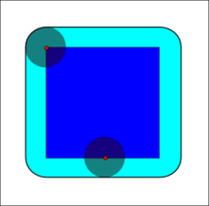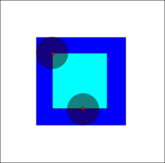Closing: The closing of A by B is obtained by the dilation of A by B, followed by erosion of the resulting structure by B $A∙B=\left(A⨁B\right)⊝B$

The erosion of the dark-blue square by a disk, resulting in the light-blue square.

The dilation of the dark-blue square by a disk, resulting in the light-blue square with rounded corners.

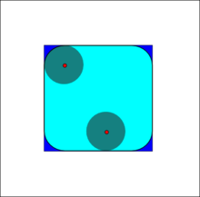

The closing of the dark-blue shape (union of two squares) by a disk, resulting in the union of the dark-blue shape and the light-blue areas.

The opening of the dark-blue square by a disk, resulting in the light-blue square with round corners.

## 2.2 Existing work on segmentation of occluding objects

The segmentation of occluding objects finds a variety of applications in the domain of image processing. Although the aim of this project was to compute and complete the missing overlapped areas of objects in an image, a lot of existing work in the field of segmentation was used in the original or modified form to obtain the final result. Significant works in the domain are discussed here.

In [27], Ballard et al propose a generalized Hough transform, which may be used to detect any arbitrary shape. The method is robust to rotation, scale changes and figure ground reversals. This method fails to give satisfactory results when overlap and the number of objects overlapping is significant.

In [11], Bai et al propose a method to split touching cells in a two part algorithm: contour pre-processing and ellipse processing. The contour is smoothed using polygon approximation. Concave points are extracted using geometrical properties and finally contour pre-processing divides the entire contour into segments using concave points. Ellipse processing fits ellipses in the various segments, and then all ellipses belonging to the same cell are merged and a larger ellipse is formed for each cell. The ellipses are merged taking into consideration some predefined properties. All ellipses are finally refined by including all the unprocessed segments as well.

In [12], Park et al propose a method that analyses partially overlapping nanoparticles. A two-step approach is taken: the first is the separation of particles, and the second is the simultaneous execution of contour inference and shape classification. A modified ultimate-erosion method is used along with edge-to-marker association to separate the nanoparticles. The second step uses the set of evidences to model a Gaussian mixture on B-splines, which gives the missing contour and particle shape.

In [13], Shu et al provide an approach for the segmentation of overlapping cell nuclei in digital histopathology images. The method works in a three step form: global thresholding to separate foreground from background, detection of seed-points using morphological filtering and region-growing, and finally seeded watershed. A post-processing then eliminates pixels falsely marked as parts of nuclei.

In [14], Zafari et al propose a method for segmentation of partially overlapping nanoparticles with a convex shape silhouette. It is a two-step method: contour evidence extraction and contour estimation. Contour segments are extracted using concave points from a binary image, and the segments belonging to the same objects are grouped. Each group is then subjected to a non-linear ellipse fitting algorithm and ellipses are obtained.

In [15], Zafari et al propose a method for segmentation of clustered partially overlapping objects whose shape may be approximated using an ellipse. Silhouette images are used with foreground separated from background. It is a three-step method: seed-point extraction using bounded erosion and fast radial symmetry transform. Contour evidence is created using the extracted seed-points and finally contours of the objects are estimated by fitting ellipses in the contour evidence.

## 2.3 Existing work on completion of incomplete objects

After successfully segmenting the objects in the image, the primary object is to complete the missing, occluded or degraded parts of the individual objects.

In [24], Sekular et al discuss various combination of shapes that might be used to complete the missing region of an object. Psychological viewpoint is considered the primary ground for selecting the right method.

In [25], Periera et al discuss a symmetry based approach to the problem of completion. An axis of symmetry is defined near each missing region and the missing information is obtained to be the copy of the data on the other side of the axis.

In [26], Zabrodosky et al propose a symmetry based approach, but differs from Periera et al, as this approach relies on finding the center of symmetry for each object.

# 3 Methodology

As discussed in the literature review, many methods exist for the segmentation of occluded convex objects, but segmentation falls a crucial step short of our desired result. Fitting an ellipse in each object results in the loss of existing data. This section of the report discusses the various methods and steps that were implemented, tested and then either discarded or used according to the results.

## 3.1 Methods Used

Two main methods were tested, one with the assumption that the objects are near circular, and the second with the assumption that the objects are elliptical. Both of these methods were dependent largely on the estimation of seed points, making the seed-point extraction a very crucial step.

A seed point can be defined as an estimated geometric center of an object in the image. The primary goal with regard to seed-point estimation is to mark each object with a unique identity, and then proceed accordingly. The seed-point estimation is the most important piece of information required in order to efficiently arrive at the end result.

### 3.1.1 Seed-Point Estimation

**(a) Distance Transform**

Distance transform [16] is a commonly used method in image processing which essentially replaces the pixel value with its distance to the nearest background i.e., non-zero pixel. Local maximas usually correspond to approximate seed-point regions, and thus seed points and number of objects may be calculated using this method.

$$d\left(x,y\right)=\sqrt{{(x-x^{'})}^{2}+{(y-y^{'})}^{2}}$$

Where d(x,y) is the distance of the point (x,y) from its nearest non zero point (x’,y’).

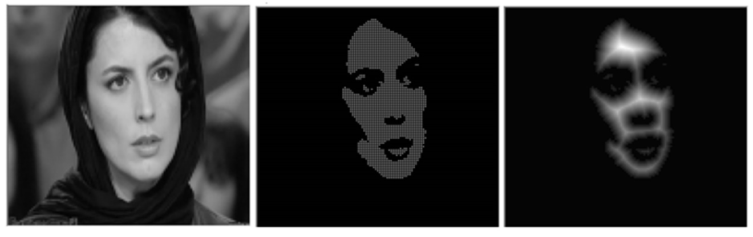This method works considerably well when the overlap in objects is low. In higher overlaps, local maximas are not separable for separate objects, and hence seed-points cannot be found.

**Figure 3.** Distance Transform. (a) Original Image, (b)Thresholded Image, (c) Distance Transform performed on thresholded image

**(b) Fast Radial Symmetry Transform**

Fast Radial Symmetry Transform [17] (mentioned as FRS henceforth) transforms the original image into an image that highlights regions of probably radial symmetry of the image gradient. For the current problem, FRS works appreciably as the objects in consideration are elliptical, i.e. radially symmetric.

Each pixel in the image gives a vote for symmetry at a specific distance *m* in the range of [rmin=­­ , rmax]. For a gradient image *g*, FRS determines positively affected pixels and negatively affected pixels, and constructs two images: orientation projection image On and magnitude projection image Mn.

After the two images are constructed, the radial symmetry contribution Sm for the range [rmin, rmax] is calculated by convolution of Fm with a two dimensional Gaussian Am,

Where Fm is calculated as

$$F_{m}\left(x,y\right)=\frac{M_{m}(x,y)}{k_{m}}{\left(\frac{\left|{\overline{O}}_{m}(x,y)\right|}{k_{m}}\right)}^{α}$$

Where α and km are radial strictness and scaling factor respectively, which normalize Mm  and Om across the different radii. Om­ is defined as

$${\overline{O}}_{m}=\left\{\begin{aligned}O_{m}\left(x,y\right), if O_{m}\left(x,y\right)<k_{m}, \\ k_{m}, otherwise\end{aligned}\right.$$

The final FRS transform is calculated by the average of symmetry contributions over all the radii in the given range i.e. $m∈\left[r_{min, }r_{max }\right]$.

$$S=\frac{1}{\left|N\right|}\sum_{m∈\left[r_{min, }r_{max }\right]}{S_{m}}$$

The transformed image is then thresholded, and *regionprops* function in MATLAB [21] is used to estimate seed-points from the FRS transformed image.

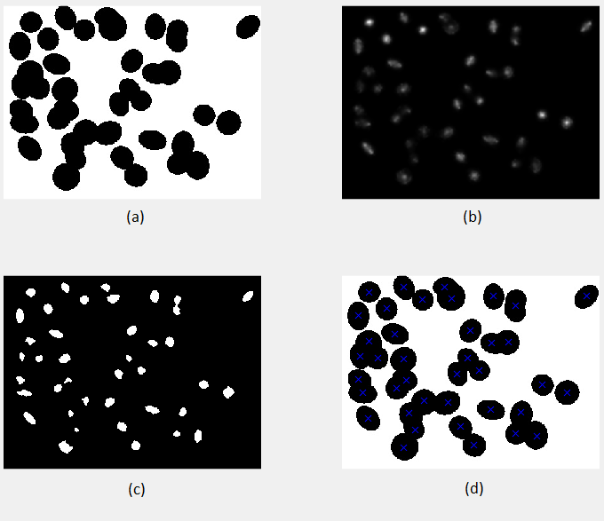

**Figure 4.** (a)Original image, (b) FRS Transformed image, (c) Thresholded FRS image, (d)Seed point detection (radius [12,22])

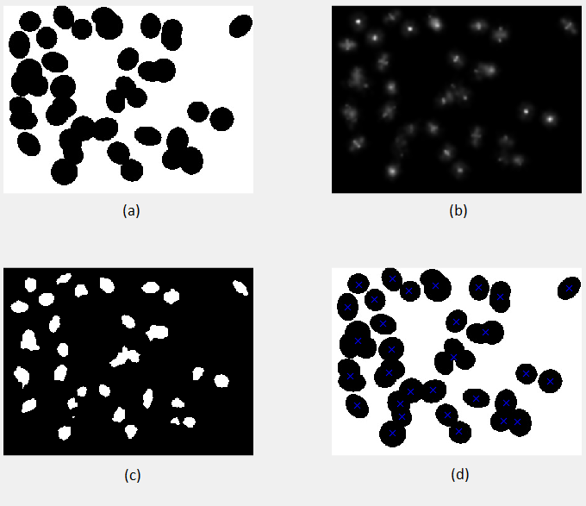

**Figure 5.** (a)Original image, (b) FRS Transformed image, (c) Thresholded FRS image, (d)Seed point detection (radius [15,30])

### 3.1.2 Edge-to-Seed-point Association

A method defined in [12] was used. The method defines two metrics: a distance metric and a gradient metric. The two metrics are then used to compute a relevance metric, which consequently gives the most relevant seed-point for each edge-pixel.

For an edge-point, two parameters are calculated for each seed-point: the distance from the seed-point, and the cosine of the angle between the gradient direction at the edge-point and the line connecting the seed-point to the edge-point. The two parameters are then normalized and the relevance metric is calculated.

$$rel\left(e_{k},s_{j}\right)= \frac{1-λ}{1+dist\left(e_{k},s_{j}\right)}+λ\frac{div\left(e_{k},s_{j}\right)+1}{2},$$

Where $dist\left(e_{k},s_{j}\right)$ is the Euclidean distance from the edge-point to the seed-point, and

$$div\left(e_{k},s_{j}\right)= \frac{g\left(e_{k}\right)l\left(e_{k},s_{j}\right)}{\left\|g\left(e_{k}\right)\right\|\left\|l\left(e_{k},s_{j}\right)\right\|}$$

Where it is assumed that all pixels on the line joining the edge-point to the seed-point $l\left(e_{k},s_{j}\right)$ lie on the image foreground $M$.

$$g\left(e_{k}\right)=\left\{\begin{aligned}\left|e_{k}- s_{j}\right|, if l\left(e_{k},s_{j}\right)⊂M \\ ∞, otherwise\end{aligned}\right.$$

To reduce the amount of computation required, only those seed-points are considered which lie in a circular region defined as a small multiple of the rmax parameter about the edge-point. This results in the number of seed-points checked per edge-point to reduce drastically making the algorithm much more efficient.

To remove erroneous association, an important addition to the algorithm is proposed. For each pair of seed-point and edge-point being considered, a line segment is drawn from a dilated edge-map. If the line segment encounters a non-zero pixel, i.e, if the line segment crosses another edge pixel, then the seed-point is not considered for that particular edge-point, and the algorithm moves on to the next seed-point.

Finally, the seed-point with the highest relevance metric for the edge-point is linked to the seed-point.

### 

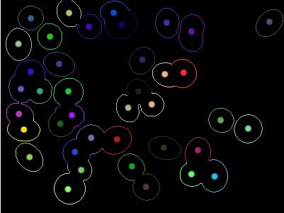

**Figure 6.** Edges associated to seed-points and depicted in unique colors from Figure 4(a)

### 3.1.3 Extrapolation of Data to Complete the Objects

Two approaches have been tried here: first for near circular objects, and second for elliptical objects.

**(a) For Near-Circular Objects**

The missing regions for each object (the set of edge-points associated to each seed-point) can be estimated satisfactorily by completing the missing region with a circular arc. First, the end-points of each segment in the edge-map of are calculated. Then, for each pair of edge points $(x_{1},y_{1})$ and $(x_{2},y_{2})$, the seed-point $(s_{x},s_{y})$ linked to the segment is projected on the perpendicular bisector of the pair of points to make it equidistant from both.

$$x_{3}= \frac{(x_{1}+x_{2})}{2},$$

$$y_{3}= \frac{(y_{1}+y_{2})}{2},$$

$$m= \frac{\left(x_{1}-x_{2}\right)}{\left(y_{2}-y_{1}\right)},$$

$$h=s_{x}-m((ms_{x}-s_{y}+y_{3}-mx_{3})/(m^{2}+1))$$

$$k=s_{y}+((ms_{x}-s_{y}+y_{3}-mx_{3})/(m^{2}+1))$$

The new seed-point $(s_{x}^{'},s_{y}^{'})$ is defined as

$$\left(s_{x}^{'},s_{y}^{'}\right)=\left\{\begin{aligned}\left(x_{3},y_{3}\right), if m=∞, \\ \left(h,k\right), otherwise\end{aligned}\right.$$

A circular arc is then drawn between the two points $(x_{1},y_{1})$ and $(x_{2},y_{2})$, with the center of the arc at $(s_{x}^{'},s_{y}^{'})$.

**(b) For Elliptical Objects**

In the case of elliptical objects, for each seed-point an ellipse is estimated using the set of points linked to the point by fitting ellipses into the sets of data. Ellipse fitting is a commonly used approach to estimate the missing parts of objects when the general shape is known to be elliptical. [18] An algebraic method of fitting an ellipse was used which is described in [19]. Any ellipse can be described by a second order quadratic equation

$$F\left(x,y\right)={ax}^{2}+bxy+{cy}^{2}+dx+ey+f=0$$

With a constraint of

$$b^{2}-4ac<0$$

Where a, b, c, d, e, f are coefficients and (x, y) are the coordinates of the points lying on the ellipse. The equation can also be written as a product of two vectors in the form

$$F_{a}\left(x\right)=x.a=0$$

Where

$$a={\left[a,b,c,d,e,f\right]}^{T}$$

$$x=\left[x^{2},xy,y^{2},x,y,1\right]$$

The most efficient way to solve this equation is to minimize the sum of squared algebraic distances of the points to the conic which is represented by the above coefficients. For the set of points ${(x}_{i},y_{i}), i=1,2……N$, the minimization problem is defined as

$$\min_{a}{\sum_{i=1}^{N}{{F\left(x_{i},y_{i}\right)}^{2}=\min_{a}{\sum_{i=1}^{N}{(}}}}{F_{a}(x_{i})}^{2})=\min_{a}{\sum_{i=1}^{N}{(x_{i}.{a)}^{2}}}$$

Under appropriate scaling, the constraint for ellipse can be defined as

$$4ac-b^{2}=1$$

And the problem can be formulated as $\min_{a}{{\left\|Da\right\|}^{2}}$ subject to $a^{T}Ca=1$

Where **D** is the design matrix of size Nx6 representing the least square minimization,

$$D=\left(\begin{matrix}x_{1}^{2} & x_{1}y_{1} & y_{1}^{2} & x_{1} & y_{1} & 1 \\ ⋮ & ⋮ & ⋮ & ⋮ & ⋮ & ⋮ \\ x_{i}^{2} & x_{i}y_{i} & y_{i}^{2} & x_{i} & y_{i} & 1 \\ ⋮ & ⋮ & ⋮ & ⋮ & ⋮ & ⋮ \\ x_{N}^{2} & x_{N}y_{N} & y_{N}^{2} & x_{N} & y_{N} & 1\end{matrix}\right)$$

And **C** is the constraint matrix of size 6x6,

$$C=\left(\begin{matrix}0 & 0 & 2 & 0 & 0 & 0 \\ 0 & -1 & 0 & 0 & 0 & 0 \\ 2 & 0 & 0 & 0 & 0 & 0 \\ 0 & 0 & 0 & 0 & 0 & 0 \\ 0 & 0 & 0 & 0 & 0 & 0 \\ 0 & 0 & 0 & 0 & 0 & 0\end{matrix}\right)$$

By applying Lagrange multipliers, we get the following conditions for optimal solution for **a**

$$Sa=λCa$$

$$a^{T}Ca=1$$

where S is the scatter matrix of size 6x6.

$$S=\left(\begin{matrix}S_{x^{4}} & S_{x^{3}y} & S_{x^{2}y^{2}} & S_{x^{3}} & S_{x^{2}y} & S_{x^{2}} \\ S_{x^{3}y} & S_{x^{2}y^{2}} & S_{{xy}^{3}} & S_{x^{2}y} & S_{{xy}^{2}} & S_{xy} \\ S_{x^{2}y^{2}} & S_{{xy}^{3}} & S_{y^{4}} & S_{{xy}^{2}} & S_{y^{3}} & S_{y^{2}} \\ S_{x^{3}} & S_{x^{2}y} & S_{{xy}^{2}} & S_{x^{3}} & S_{xy} & S_{x} \\ S_{x^{2}y} & S_{{xy}^{2}} & S_{y^{3}} & S_{xy} & S_{y^{2}} & S_{y} \\ S_{x^{2}} & S_{xy} & S_{y^{2}} & S_{x} & S_{y} & 1\end{matrix}\right)$$

Where operator *S* denotes the sum

$$S_{x^{a}y^{b}}=\sum_{i=1}^{N}{x_{i}^{a}y_{i}^{b}}$$

Solving the system taking into consideration the various constraints, we get the solution. The final method used is based on an improvement of this method proposed in [20].

We decompose **D** into

$$D=\left(D_{1} | D_{2}\right)$$

Where

$D_{1}=\left(\begin{matrix}x_{1}^{2} & x_{1}y_{1} & y_{1}^{2} \\ ⋮ & ⋮ & ⋮ \\ x_{i}^{2} & x_{i}y_{i} & y_{i}^{2} \\ ⋮ & ⋮ & ⋮ \\ x_{N}^{2} & x_{N}y_{N} & y_{N}^{2}\end{matrix}\right)$ And $D_{2}=\left(\begin{matrix}x_{1} & y_{1} & 1 \\ ⋮ & ⋮ & ⋮ \\ x_{i} & y_{i} & 1 \\ ⋮ & ⋮ & ⋮ \\ x_{N} & y_{N} & 1\end{matrix}\right)$

The scatter matrix **S** is split as

$S=\left(\begin{matrix}S_{1} & S_{2} \\ S_{2}^{T} & S_{3}\end{matrix}\right)$ where $\begin{matrix}S_{1}={D_{1}^{T}D}_{1} \\ S_{2}={D_{1}^{T}D}_{2} \\ S_{3}={D_{2}^{T}D}_{2}\end{matrix}$

The constraint matrix **C** is split as

$C=\left(\begin{matrix}C_{1} & 0 \\ 0 & 0\end{matrix}\right)$ where $C_{1}=\left(\begin{matrix}0 & 0 & 2 \\ 0 & -1 & 0 \\ 2 & 0 & 0\end{matrix}\right)$

We split the vector of coefficients **a** into

$$a=\left(\frac{a_{1}}{a_{2}}\right) where a_{1}=\left(\begin{matrix}a \\ b \\ c\end{matrix}\right) and a_{2}=\left(\begin{matrix}d \\ e \\ f\end{matrix}\right)$$

Then the problem changes to

$$\left(\begin{matrix}S_{1} & S_{2} \\ S_{2}^{T} & S_{3}\end{matrix}\right)\left(\begin{matrix}a_{1} \\ a_{2}\end{matrix}\right)= λ\left(\begin{matrix}C_{1} & 0 \\ 0 & 0\end{matrix}\right) \left(\begin{matrix}a_{1} \\ a_{2}\end{matrix}\right)$$

Which is equivalent to

$$S_{1}a_{1}+{ S}_{2}a_{2}=λC_{1}a_{1}$$

$$S_{2}^{T}a_{1}+S_{3}a_{2}=0$$

Then,

$$a_{2}=-S_{3}^{-1}S_{2}^{T}a_{1}$$

$$\left(S_{1}-S_{2}S_{3}^{-1}S_{2}^{T}\right)a_{1}=λC_{1}a_{1}$$

$$C_{1}^{-1}\left(S_{1}-S_{2}S_{3}^{-1}S_{2}^{T}\right)a_{1}=λa_{1}$$

Due to the shape of the matrix C, we get

$$a_{1}^{T}C_{1}a_{1}=1$$

Finally, we solve the following equations to get the coefficients:

$$M=C_{1}^{-1}(S_{1}-S_{2}S_{3}^{-1}S_{2}^{T})$$

$$Ma_{1}=λa_{1}$$

$$a_{1}^{T}C_{1}a_{1}=1$$

$$a_{2}=-S_{3}^{-1}S_{2}^{T}a_{1}$$

$$a=\left(\frac{a_{1}}{a_{2}}\right)$$

## 3.2 Proposed Algorithm

An algorithm is proposed using the methods defined in the previous section. The method is a three-step procedure, excluding pre-processing and analysis.

1. Pre-processing

A binary image is required for the algorithm. Colored or grayscale images are converted to binary silhouette images using appropriate threshold values. The threshold values are chosen by trial and error, as the values differ dramatically for different images due to contrast, color, brightness and other factors. To construct the edge map, Laplacian-of-Gaussian [22] [23] method is used.

1. Seed-point Estimation

Seed points are estimated using the Fast Radial Symmetry transform. A range of minimum and maximum radii are given, and the algorithm runs for various pairs of rmin and rmax. The transformed image is then thresholded to a binary image, eroded to remove erroneous segments and then is subjected to centroid detection using the *regionprops* [21] functionality of MATLAB.

1. Edge-to-Seed-point Association

For each edge-point on the edge-map developed in (1), we find a relevance metric for each seed-point within a specified radius, using the distance metric and the gradient metric. The seed-point with the maximum relevance is linked to the edge-point.

1. Ellipse Fitting

Ellipses are fitted into the various sets of points for each seed-point using the Direct Ellipse Fitting algorithm described in the previous section. The ellipses are drawn between all the missing segments for each object, keeping the original data from the edge-map intact. This is important, as all the previous works on the subject lose the original data, and only use the fitted ellipse.

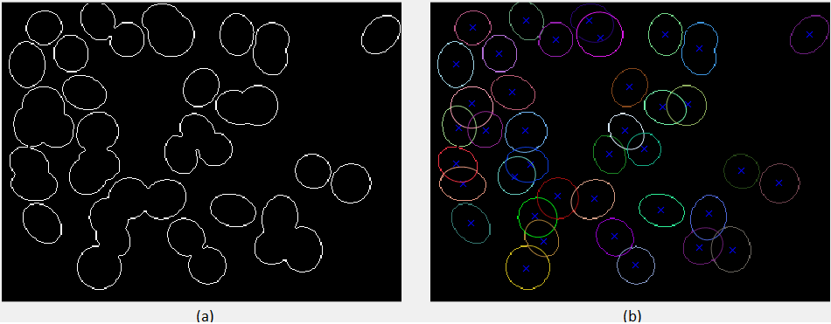

**Figure 7.** (a) Edge map of figure 4(a), (b) Ellipse Fitted in areas of missing data

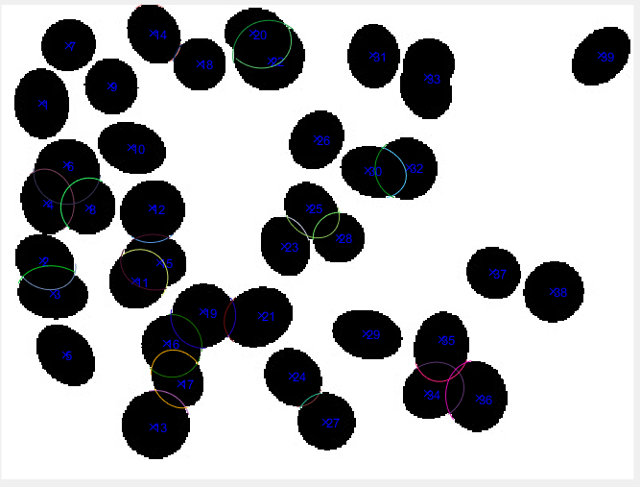

**Figure 8.** Missing information about boundaries drawn over the original image

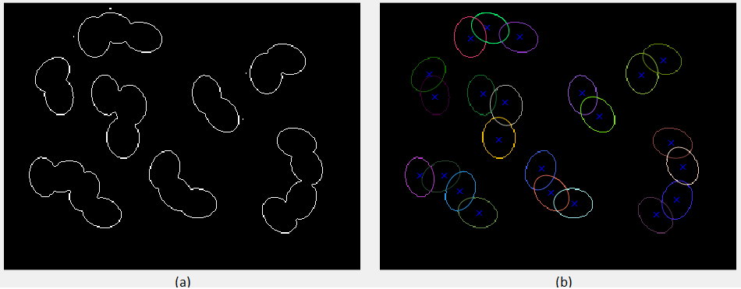

**Figure 9.** (a) Edge map of a binary figure, (b) Ellipse Fitted in areas of missing data

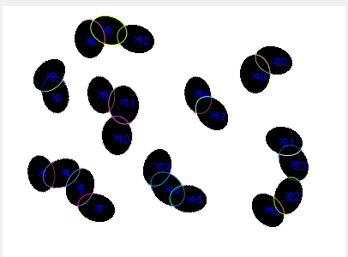

**Figure 10.** Missing information about boundaries drawn over the original image

1. Analysis of Overlapping Regions

The eccentricities and areas of all objects are calculated. Each pixel is assigned its degree of overlap, i.e., the number of ellipses the pixel lies in. Area of overlap for each object is calculated. A matrix is created of size k x k (where k is the number of objects in the image), which contains each object’s overlap with every other object. An excel file is created which contains the eccentricity, overlap area, overlap area percentage, non-overlap area, non-overlap area percentage and their means, medians and standard-deviations.

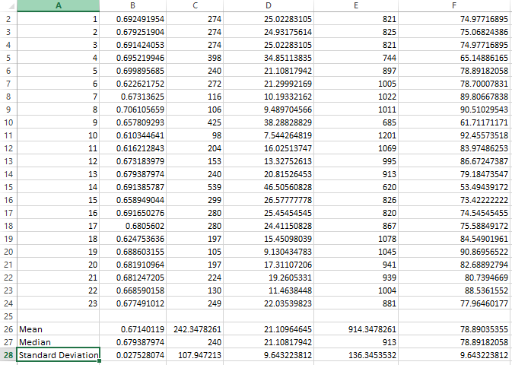

**Figure 11.** Result of computation of area statistics for Figure 8, saved in an MS Excel file (.xlsx format) for Figure 10

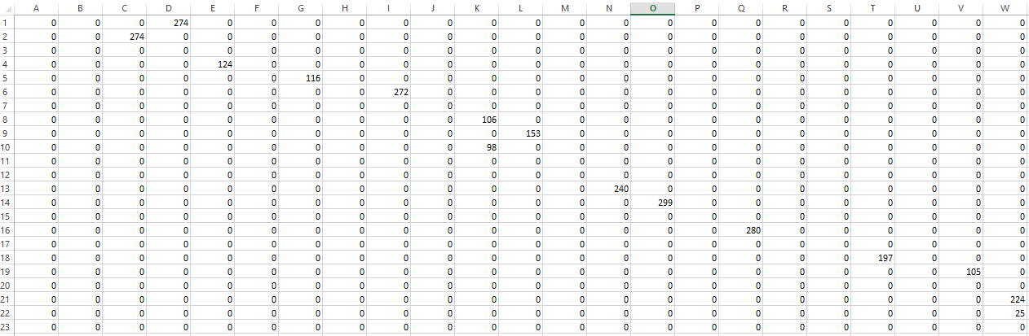

**Figure 12.** Result of computation of overlap of each object for figure 8, saved in an MS Excel file (.xlsx format) (information stored in the upper triangle) for figure 10

The program removes any existing .xlsx file of the same name and creates a fresh spreadsheet for each iteration. Each filename contains the name of the image and the radii range upon which the algorithm is being performed.

# 4 Flowchart

Is radius range allowed?

Change radius range

Display image with completed objects

Analyze data about the missing regions in the image and store in a separate file

Use regionprops to detect centroids, store centroid locations as seed-points

Perform edge-to-seed-point association using distance and gradient metric

Perform Fast Radial Symmetry transform, then threshold and erode

Generate edge-map of image using LoG method

Convert image to binary image using thresholding

**Start**

# 

No

Yes

**Stop**

Fit ellipse or circle in each object’s missing region

Store analysis results in separate .xlsx file

# 5 Results and Discussion

## 5.1 Methods and Results

A three-step algorithm was proposed wherein given a binary silhouette image, the seed-points are estimated, edges are linked to probable seed-points, ellipse are fitted using the gathered data and finally missing parts of the objects are completed by drawing segments of the ellipse.

The seed-points are estimated using the Fast Radial Symmetry transform, morphological erosion, and thresholding. The edge-points are linked to their most probable seed-points, using a relevance metric consisting of a distance metric and a gradient metric, with the extra condition that the line joining the seed-point and the edge-point should not pass through any other edge-point. The set of edge-points for each seed-point is used to fit an ellipse using the Ellipse Direct Fit method, and the missing regions of each object are completed using elliptical arcs drawn between pair of boundary points for each missing portion. The overlaps for each object are calculated, both individually and with every other object, and the data is stored in an excel file created when the program is executed. The mean, median and standard deviations are calculated for each set of data stored in the excel file.

The method performs better than the existing methods discussed in the literature review, while keeping the original data of the edge-map intact and completing the missing portions efficiently.

## 5.2 Discussion

The results are satisfactory and at least at par to the state-of-the-art methods that exist for the given problem. The standard methods of segmentation all fail due to primary nature of occlusion and also the uncertain size and shape of individual objects. The existing works on the subject each deal with different data sets, and no general solution exists that gives satisfactory results for every image. Hence, the objective here was to design an efficient algorithm for segmentation, completion and analysis of objects that can be estimated by an ellipse or a circle.

Various difficulties were encountered at the different stages of the procedure. Initially, binarization of the image is a challenge unto itself, and can only be overcome by trial and error as no global method can exist to find the perfect threshold value. The process may be shortened by using information from a histogram. Once binarized, the next step is to detect seed points. Water-shed algorithm works well for relatively regular objects, but fails for complex shapes. It does not perform well for multiple-overlapping objects. Morphological operations too fail when the overlap is high. Hence, Fast Radial Symmetry algorithm is used. The downside of FRS is its runtime, which may be reduced by parallel processing. Difficulties in the linking of edge-points to seed-points included wrong linkage and no linkage at all. This was overcome by introducing an extra condition that the line segment joining an edge-point to a seed-point should not pass through another foreground pixel. This dramatically improved the results. Finally, a circle or an ellipse may be fitted into the missing regions as per requirement.

The results are reliable and reproducible with certain limitations. The algorithm might not work well when the objects overlap too much, as too little data would be available to estimate the missing regions. The second, and less important, limitation is when the objects stray too much from a general elliptical shape, as then the estimated shape cannot be determined except by learning methods.

Further development may be carried out on this work primarily to make it more computationally efficient. Parallel processing using a GPU would greatly reduce the run-time of the algorithm. Further analysis may be carried out from a statistical perspective in order to gain a better understanding of trends in the data.

# 6 Conclusion

The method proposed in this thesis is essentially a three-step method for computing and completing the portions of objects missing due to overlap between multiple objects. To arrive at the final algorithm, state-of-the-art techniques in the field were studied, and the various methods were evaluated.

Results of segmentation were used to extrapolate the data gathered from the edge-map of the image to complete the missing portions. The approach consists of seed-point detection using Fast Radial Symmetry on a binarized silhouette image, edge-to-seed-point association using an improved relevance metric, and finally extrapolation of data using ellipse fitting by Direct Ellipse Fitting method.

The algorithm works satisfactorily and is at-par with the leading works in the area of study.

# 7 References

[1] Linda G. Shapiro and George C. Stockman (2001): “Computer Vision”, pp 279-325, New Jersey, Prentice-Hall, ISBN 0-13-030796-3

[2] Thresholding (image processing) Retrieved August -2017 from https://en.wikipedia.org/wiki/Thresholding_(image_processing)

[3] Ohlander, Ron; Price, Keith; Reddy, D. Raj (1978). "Picture Segmentation Using a Recursive Region Splitting Method". Computer Graphics and Image Processing. 8 (3): 313–333. doi:10.1016/0146-664X(78)90060-6

[4] N Senthilkumaran and R Rajesh. Edge detection techniques for image segmentation–a survey of soft computing approaches. International Journal of Recent Trends in Engineering, 1(2):250–254, 2009.

[5] John Canny. A computational approach to edge detection. IEEE Transactions on Pattern Analysis and Machine Intelligence, 8(6):679–698, 1986.

[6] Judith MS Prewitt. Object enhancement and extraction. Picture processing and Psychopictorics, 10(1):15–19, 1970.

[7] Lawrence Gilman Roberts. Machine Perception of Three-Dimensional Soups. PhD thesis, Massachusetts Institute of Technology, 1963.

[8] Wikipedia, 2017. Edge Detection. Retrieved August, 2017 from <https://en.wikipedia.org/wiki/Edge_detection>

[9] Rolf Adams and Leanne Bischof. Seeded region growing. IEEE Transaction on Pattern Analysis and Machine Intelligence, 16(6):641–647, 1994.

[10] S. L. Horowitz and T. Pavlidis. Picture Segmentation by a directed split-and-merge procedure. Proceedings of the 2nd International Joint Conference on Pattern Recognition, pages 424–433, 1974.

[11] Bai, Xiangzhi, Changming Sun, and Fugen Zhou. "Splitting touching cells based on concave points and ellipse fitting." Pattern recognition 42, no. 11 (2009): 2434-2446.

[12] Park, Chiwoo, Jianhua Z. Huang, Jim X. Ji, and Yu Ding. "Segmentation, inference and classification of partially overlapping nanoparticles." IEEE transactions on pattern analysis and machine intelligence 35, no. 3 (2013): 1-1.

[13] Shu, Jie, Hao Fu, Guoping Qiu, Philip Kaye, and Mohammad Ilyas. "Segmenting overlapping cell nuclei in digital histopathology images." In Engineering in Medicine and Biology Society (EMBC), 2013 35th Annual International Conference of the IEEE, pp. 5445-5448. IEEE, 2013.

[14] Zafari, Sahar, Tuomas Eerola, Jouni Sampo, Heikki Kälviäinen, and Heikki Haario. "Segmentation of partially overlapping nanoparticles using concave points." In International Symposium on Visual Computing, pp. 187-197. Springer, Cham, 2015.

[15] Zafari, Sahar, Tuomas Eerola, Jouni Sampo, Heikki Kälviäinen, and Heikki Haario. "Segmentation of overlapping elliptical objects in silhouette images." IEEE Transactions on Image Processing 24, no. 12 (2015): 5942-5952.

[16] Azriel Rosenfeld and John L. Pfaltz. Sequential operations in digital picture processing. Journal of the ACM, 13(4):471–494, 1966.

[17] Gareth Loy and Alexander Zelinsky. Fast radial symmetry for detecting points of interest. IEEE Transactions on Pattern Analysis and Machine Intelligence, 25(8):959–973, 2003.

[18] Sonal Kothari, Qaiser Chaudry, and May D Wang. Automated cell counting and cluster segmentation using concavity detection and ellipse fitting techniques. In IEEE International Symposium on Biomedical Imaging (ISBI), pages 795–798, 2009.

[19] Fitzgibbon, Andrew, Maurizio Pilu, and Robert B. Fisher. "Direct least square fitting of ellipses." IEEE Transactions on pattern analysis and machine intelligence 21, no. 5 (1999): 476-480.

[20] Halır, Radim, and Jan Flusser. "Numerically stable direct least squares fitting of ellipses." In Proc. 6th International Conference in Central Europe on Computer Graphics and Visualization. WSCG, vol. 98, pp. 125-132. 1998.

[21] Mathworks. (2017). Image Processing Toolbox (r2017a). [Retrieved August 2017], from <https://in.mathworks.com/help/images/ref/regionprops.html>

[22] Kong, Hui, Hatice Cinar Akakin, and Sanjay E. Sarma. "A generalized Laplacian of Gaussian filter for blob detection and its applications." IEEE transactions on cybernetics 43, no. 6 (2013): 1719-1733.

[23] Collins, Robert T. "Mean-shift blob tracking through scale space." In Computer Vision and Pattern Recognition, 2003. Proceedings. 2003 IEEE Computer Society Conference on, vol. 2, pp. II-234. IEEE, 2003.

[24] Sekuler, A.B., Gold, J.M., Murray, R.F. and Bennett, P.J., 2000. Visual completion of partly occluded objects: Insights from behavioral studies. Neuro-Ophtalmology, 23, pp.165-168.

[25] Pereira, T., Leme, R.P., Velho, L. and Lewiner, T., 2009. Symmetry-based Completion. In GRAPP (pp. 39-45).

[26] Zabrodsky, H., Peleg, S. and Avnir, D., 1993, June. Completion of occluded shapes using symmetry. In CVPR (pp. 678-679).

[27] Ballard, D.H., 1981. Generalizing the Hough transform to detect arbitrary shapes. Pattern recognition, 13(2), pp.111-122.

# 8 Appendix

## 8.1 Image 1 (Radius range 7 to 18)

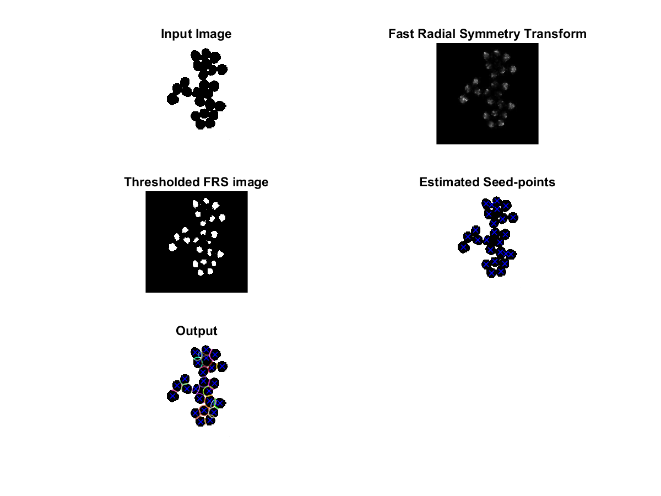

## 8.2 Image 2 (Radius range 10 to 17)

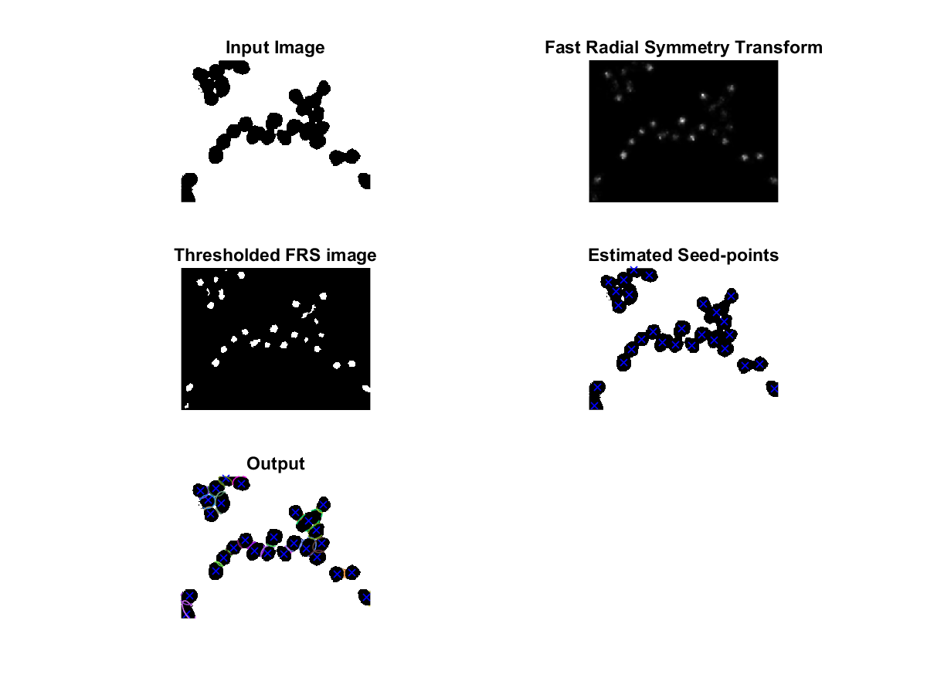

## 8.3 Image 3 (Radius range 3 to 20)

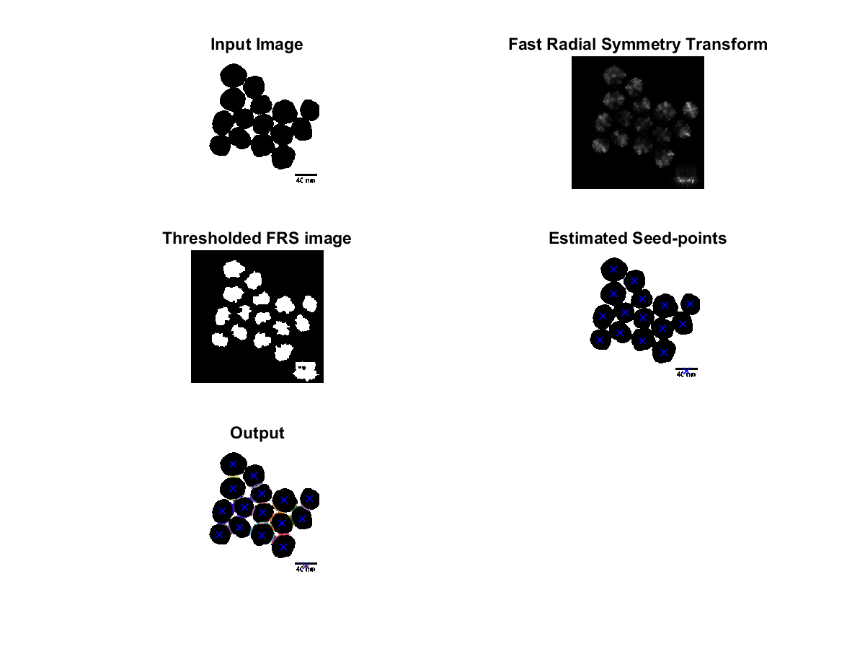

## 8.4 Image 4 (Radius range 10 to 30)

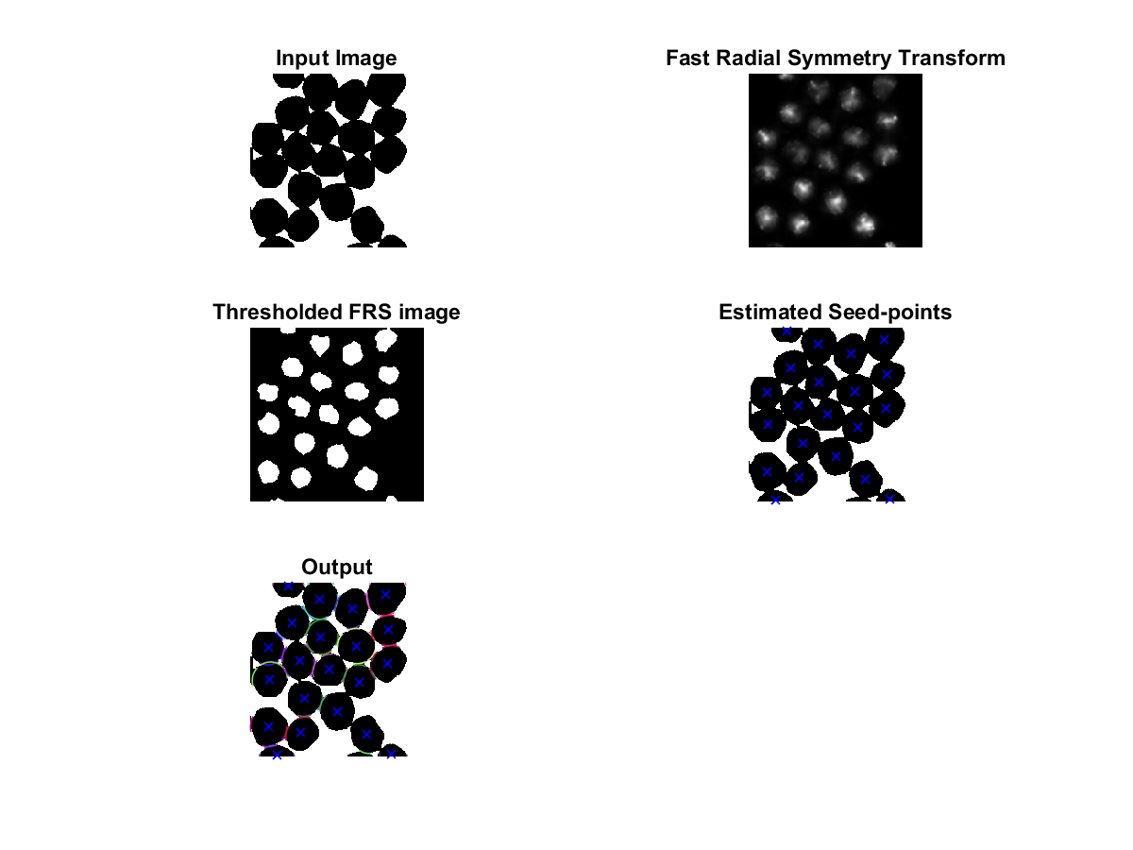

## 8.5 Image 5 (Radius range 10 to 22)

