# Application running

For running application follow below details:

* Download the solution from GitHub
* After downloading the application in local system ,Run the solution file

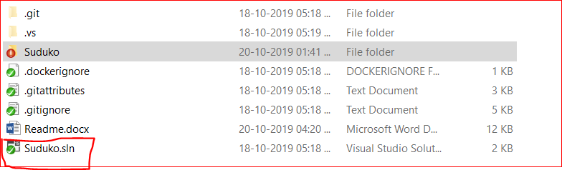

*For running solution prerequisites: visual studio 2017 and above*

* After running application select the Sudoku dropdown which you wanted to solve.
* Click on solve button. Select Sudoku will be solved
* After solve button is clicked, Sudoku will be filled with correct values.

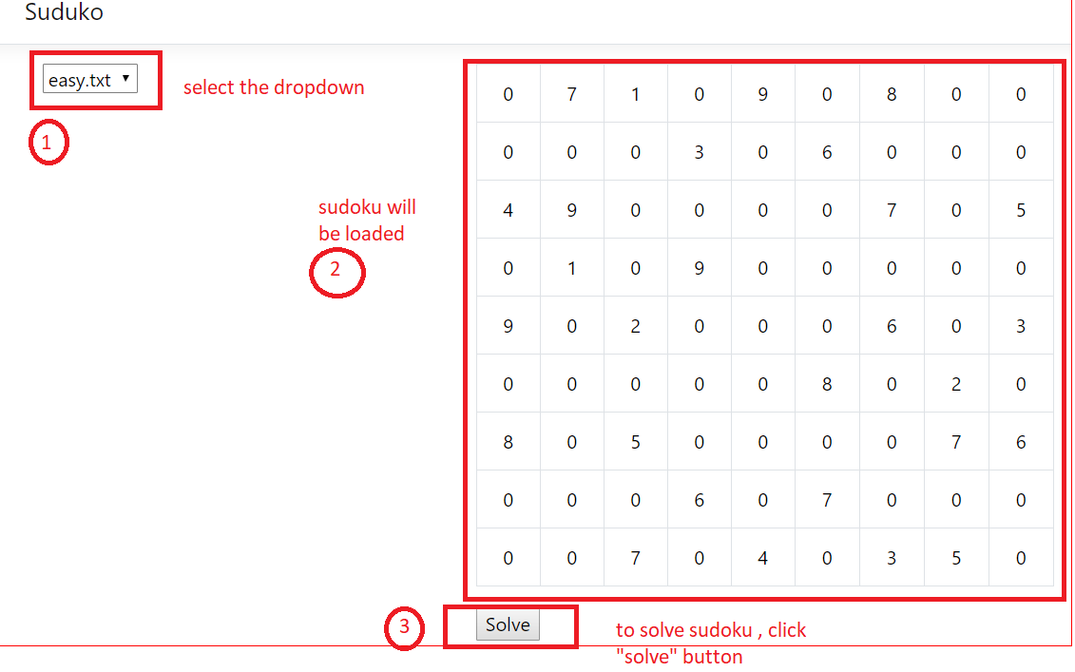

# Upload New Sudoku

To upload new Sudoku puzzle, user need to create the puzzle in text file format. Please follow below steps:

* Create a text file with comma separated 81 (9*9) int values, and provide some name to file.

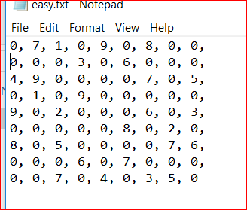

*This process can be automated with saving in database.*

* Place the file in project directory folder (. /suduko/suduko/sudokoData)

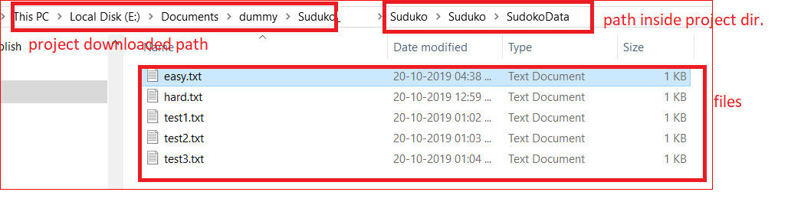

* Refresh browser to see now file names in dropdown list

