**Assignment - String practice**

**1. WAP to reverse a String.**

**Input: “iNeuron”**

**Output: “norueNi”**

Code -

import java.util.Scanner;

public class HelloWorld{

public static void main(String []args){

Scanner sc = new Scanner(Sytem.in);

StringBuilder s = new StringBuilder("");

s.append(sc.nextLine());

s.reverse();

System.out.println(s);

}

}

Output –

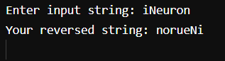

**2. WAP to reverse a sentence while preserving the position.**

**Input : “Think Twice”**

**Output : “kniht eciwt”**

Code –

public class HelloWorld {

public static void main(String []args) {

String str = "Think Twice";

System.out.print(str);

char[] s = str.toLowerCase().toCharArray();

char[] r = new char[s.length];

int rnextIndex = 0;

int start = 0;

for(int i=0; i<s.length; i++) {

if(s[i]==' ' || i==(s.length)-1 ) {

for(int j=((s[i]==' ')?i-1:i) ; j>=start; j--) {

r[rnextIndex] = s[j];

rnextIndex++;

}

if(s[i]==' ') {

r[rnextIndex]=' ';

rnextIndex++;

}

start=i+1;

}

}

System.out.println();

for(int i=0; i<s.length; i++) {

System.out.print(r[i]);

}

}

}

Output-

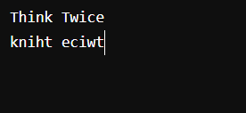

**3. WAP to check if the String is Anagram or not.**

Code –

import java.util.Arrays;

public class HelloWorld {

public static void main(String []args) {

String a="helloworld";

String b="wohelorld";

char[] first = a.toCharArray();

char[] second = b.toCharArray();

if(first.length == second.length){

Arrays.sort(first);

Arrays.sort(second);

for(int i=0; i<first.length;i++){

if(first[i] != second[i]){

System.out.println("Not Anagram");

}

}

System.out.println("Anagram");

}

System.out.println("Not Anagram");

}

}

Output –

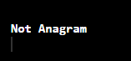

**4. WAP to check if the String is a Pangram or not.**

Code –

public class HelloWorld{

public static void main(String []args){

String s ="Fix problem quickly with galvanized jets.";

boolean r = true;

s = s.toLowerCase();

for (char i = 'a'; i<='z';i++){

if(! s.contains(String.valueOf(i))){

r=false;

break;

}

}

if(r){

System.out.print("Panagram");

} else {

System.out.print("Not Panagram");

}

}

}

Output –



**5. WAP to print repeatedly occurring characters in the given String.**

Code –

public class Example {

public static void main(String argu[]) {

String str = "ruhee firoz";

char[] carray = str.toCharArray();

System.out.println("The string is:" + str);

System.out.print("Duplicate Characters in above string are: ");

for (int i = 0; i < str.length(); i++) {

for (int j = i + 1; j < str.length(); j++) {

if (carray[i] == carray[j]) {

System.out.print(carray[j] + " ");

break;

}

}

}

}

}

Output –

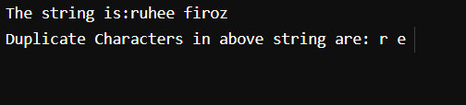

**6. WAP to sort a String Alphabetically.**

Code –

public class HelloWorld {

public static void main(String []args) {

String a="helloworld";

char[] first = a.toCharArray();

Arrays.sort(first);

System.out.println(String.copyValueOf(first));

}

}

Output –

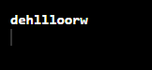

**7. WAP to count the number of Vowels and Consonants of a String value.**

Code –

public class Example {

public static void main(String argu[]) {

String str = "ruhee firoz";

char[] a = (str.toLowerCase()).toCharArray();

int v = 0, c =0;

for(int i = 0; i<a.length; i++) {

switch(a[i]) {

case 'a':

case 'e':

case 'i':

case 'o':

case 'u':

v++;

default:

c++;

}

}

System.out.println("Vowels: "+v+"\nConsonants: "+c);

}

}

Output –

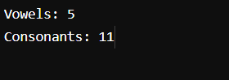

**8. WAP to count number of special characters.**

Code –

public class Example {

public static void main(String argu[]) {

String s = "#e$R%t^2#d$a #e#d$f@v^h";

// char[] a = (str.toLowerCase()).toCharArray();

int c =0;

for(int i = 0; i<s.length(); i++) {

if (!Character.isDigit(s.charAt(i))

&& !Character.isLetter(s.charAt(i))

&& !Character.isWhitespace(s.charAt(i))) {

c++;

}

}

System.out.println("Special Characters: "+c);

}

}

Output –

