* ICE Chat module provides chat engagement, reporting and analytics as well as allows managing operator accounts and other administrative functionality.
* It is an effective sales and support tool with various functionalities for the roles of Operator/Chat representative, Supervisor and Admin.

ICE Chat provides an efficient solution to interact on real time basis with the visitors.

This section gives a detail description of Agent/Operator Console from Chat Initiation to Log Out.

## 1. Log In

1. Enter the URL: <https://go.enterice.com/?sd=ice> in the browser to access Single Log in Application (SLAPP). SLAPP is a common Log In window for all the ICE Users.
2. Enter the Organization ID, User name and Password, and click 2016-01-29_14-28-03.png to access the Agent console.

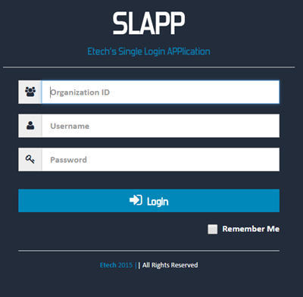

1. Once you log in SLAPP successfully, the Operator console gets displayed.

**2. Operator Console**

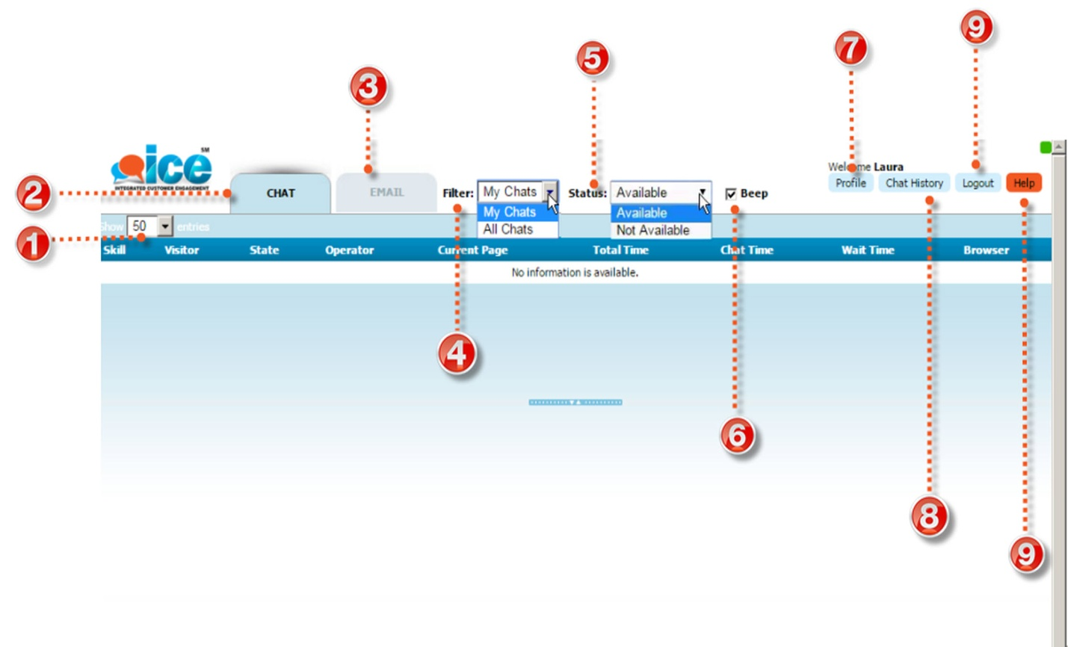

|  |  |
| --- | --- |
| C:\Users\VDEVAD~1\AppData\Local\Temp\SNAGHTML1df353.PNG | Dropdown allows to select the number of **entries** shown in the Operator console chat grid |
| C:\Users\VDEVAD~1\AppData\Local\Temp\SNAGHTML1c2184.PNG | Click **Chat** to enable **ICE Chat interaction console** |
| C:\Users\VDEVAD~1\AppData\Local\Temp\SNAGHTML1f4cc8.PNG | Click **Email** to enable **ICE Email interaction console** |
|  | Click on **Filter** to Filter Chats in the chat grid. You may choose **All Chats** or **My Chats** from the drop down   1. **My Chats :** allows to view the chats handled by the operator himself. 2. **All Chats** **:** gives chat information of the all operators in chat mode, and provides details about the visitor's browsing the company's website. As highlighted in the image below, it shows the **InSite** status of the visitor's currently browsing the website. 2016-03-01_15-37-16.jpg |
| C:\Users\VDEVAD~1\AppData\Local\Temp\SNAGHTML39b5e7.PNG | Change the **status** from dropdown to receive new Chats. |
|  | Tick on check box to activate **Beep** option and receive alerts on new chat messages. |
| C:\Users\VDEVAD~1\AppData\Local\Temp\SNAGHTML3b60c6.PNG | Open **profile** dialog to view User information and **Reset password.**  *Note: User personal information can be changed by Admin only* |
|  | **Chat History** can be viewed in a new window once you click on it. |
| C:\Users\VDEVAD~1\AppData\Local\Temp\SNAGHTMLdf236c.PNG | Click on **Logout** to exit from the operator console.  *Note: Please refer the logout section* |
|  | **Help** |