
YUVAINTERN
WEEK 3 INTERNSHIP REPORT
FEATURE ENGINEERING
Food Processing & Nutrition Dataset
Name | Vibhuti Prajapati
Program | Master of Computer Applications (MCA)
Institution | UIT-RGPV
Internship Role | Data Science Intern
Organization | Yuva Intern
Task | Week 3 – Feature Engineering
Dataset | Food Processing / Nutrition Dataset
Submission Date | 3 September 2026


Prepared from the completed Week 3 Jupyter Notebook and final feature-engineered CSV dataset.

1. Introduction
This report documents the Week 3 Feature Engineering task performed on a food processing and nutrition dataset. The purpose of feature engineering was to transform existing cleaned nutrition variables into meaningful derived features that can provide additional information for exploratory analysis and future machine-learning workflows.
The work was performed after preparing the dataset by handling missing values, removing duplicate records, removing unnecessary identifier/free-text fields, and applying IQR-based outlier capping. Eight new numerical features were then created and evaluated.

2. Objectives
- Understand the cleaned food nutrition dataset and identify useful relationships among existing variables.
- Brainstorm meaningful derived nutrition features.
- Create new numerical features using combinations, ratios, and energy-based calculations.
- Evaluate the resulting features using descriptive statistics and validation checks.
- Ensure the engineered features contain no missing or infinite values.
- Export the final feature-engineered dataset for future analysis and machine-learning use.

3. Dataset Overview
Dataset Metric | Value
Original rows | 9,804
Original columns | 20
Rows after duplicate removal | 9,771
Columns before feature engineering | 17
Final CSV rows | 9,771
Final CSV columns | 25
Final missing values | 0
Final duplicate rows | 0
Engineered features | 8
The original notebook loaded 9,804 records and 20 columns. After numerical/categorical missing-value treatment, removal of unnecessary fields, duplicate removal, and outlier capping, 9,771 records remained for feature engineering. The final CSV contains 25 columns, including the eight newly engineered features.

4. Preprocessing Performed Before Feature Engineering
Step | Approach
Missing-value handling | Numerical nutrition fields were filled using their median; categorical fields were filled using the mode.
Unnecessary columns | code, product_name and ingredients_text were removed from the analytical dataset.
Duplicate removal | 33 duplicate rows were detected at the preprocessing stage and removed.
Outlier treatment | IQR-based clipping was applied to the selected nutrition columns.
Data validation | The dataset was checked for missing values and duplicates before feature engineering.
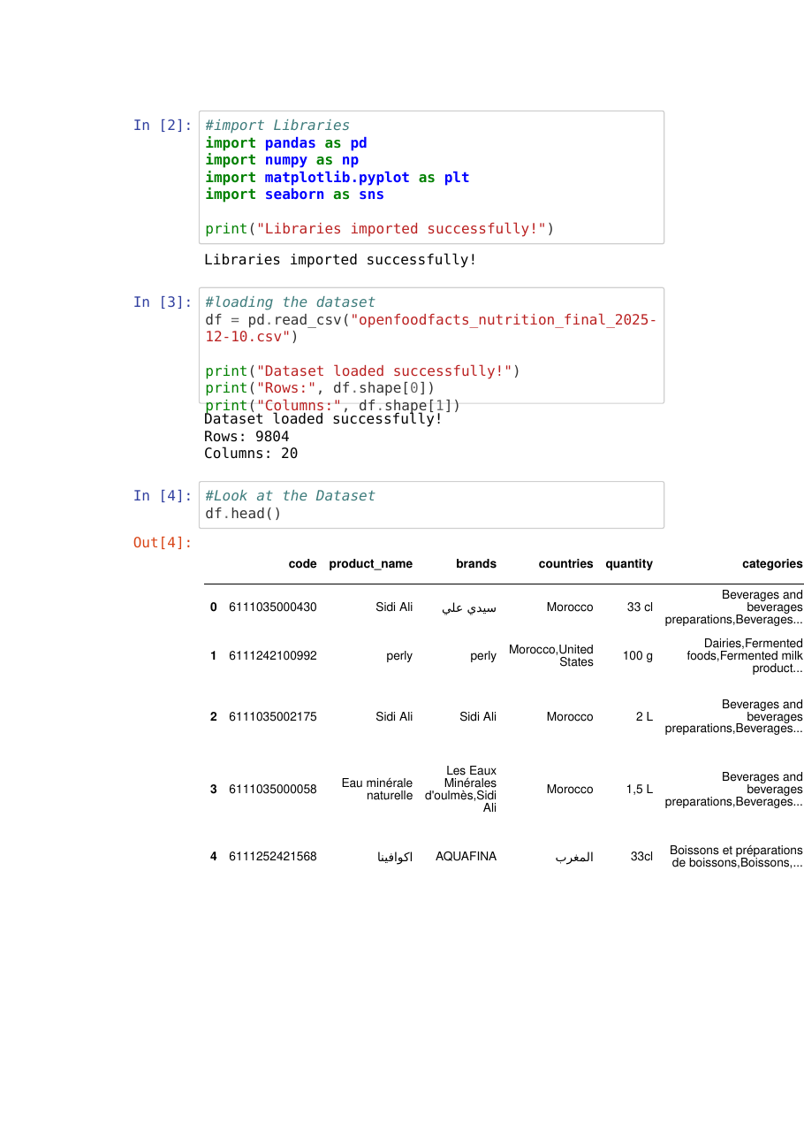
Figure 1. Notebook screenshot showing library import, dataset loading, and raw data preview.

5. Feature Engineering Methodology
Feature engineering was based on the nutrition variables available after preprocessing. The selected transformations were designed to capture overall macronutrient content, relative composition, and estimated energy contribution. Division operations used guards for zero denominators, and ratio features were clipped to sensible numerical bounds.
Feature | Formula | Rationale | Potential ML Usefulness
1. total_macronutrients | fat_100g + carbohydrates_100g + proteins_100g | Combines the three main macronutrient quantities into one aggregate feature. | Provides a compact measure of the recorded macronutrient content and may help models compare overall nutrient composition.
2. sugar_carb_ratio | sugars_100g / carbohydrates_100g (when carbohydrates > 0), clipped to 0–1 | Represents the proportion of recorded carbohydrates accounted for by sugars. | Adds relative composition information that is not visible from sugar or carbohydrate quantity alone.
3. saturated_fat_ratio | saturated-fat_100g / fat_100g (when fat > 0), clipped to 0–1 | Represents the proportion of recorded fat accounted for by saturated fat. | Provides a relative fat-composition feature that may be useful in nutritional classification or analysis.
4. fiber_carb_ratio | fiber_100g / carbohydrates_100g (when carbohydrates > 0), clipped to 0–1 | Represents fiber relative to total recorded carbohydrates. | Captures an additional relationship between fiber and carbohydrate content.
5. protein_energy_pct | (proteins_100g × 4 / energy-kcal_100g) × 100, when energy > 0; clipped to 0–100 | Estimates the percentage of recorded energy associated with protein using the notebook's calculation. | Converts protein quantity into an energy-relative feature that can support comparisons across products.
6. carb_energy_pct | (carbohydrates_100g × 4 / energy-kcal_100g) × 100, when energy > 0; clipped to 0–100 | Estimates the percentage of recorded energy associated with carbohydrates. | Provides an energy-relative representation of carbohydrate contribution.
7. fat_energy_pct | (fat_100g × 9 / energy-kcal_100g) × 100, when energy > 0; clipped to 0–100 | Estimates the percentage of recorded energy associated with fat. | Provides an energy-relative representation of fat contribution.
8. macronutrient_balance | (proteins_100g + carbohydrates_100g) / (fat_100g + 1) | Creates a numerical relationship between protein/carbohydrate content and fat content. | Adds a combined composition indicator that may help models distinguish products with different macronutrient profiles.
Note: These engineered variables are analytical features created from the dataset. They should not be interpreted as clinical or individualized nutrition recommendations.
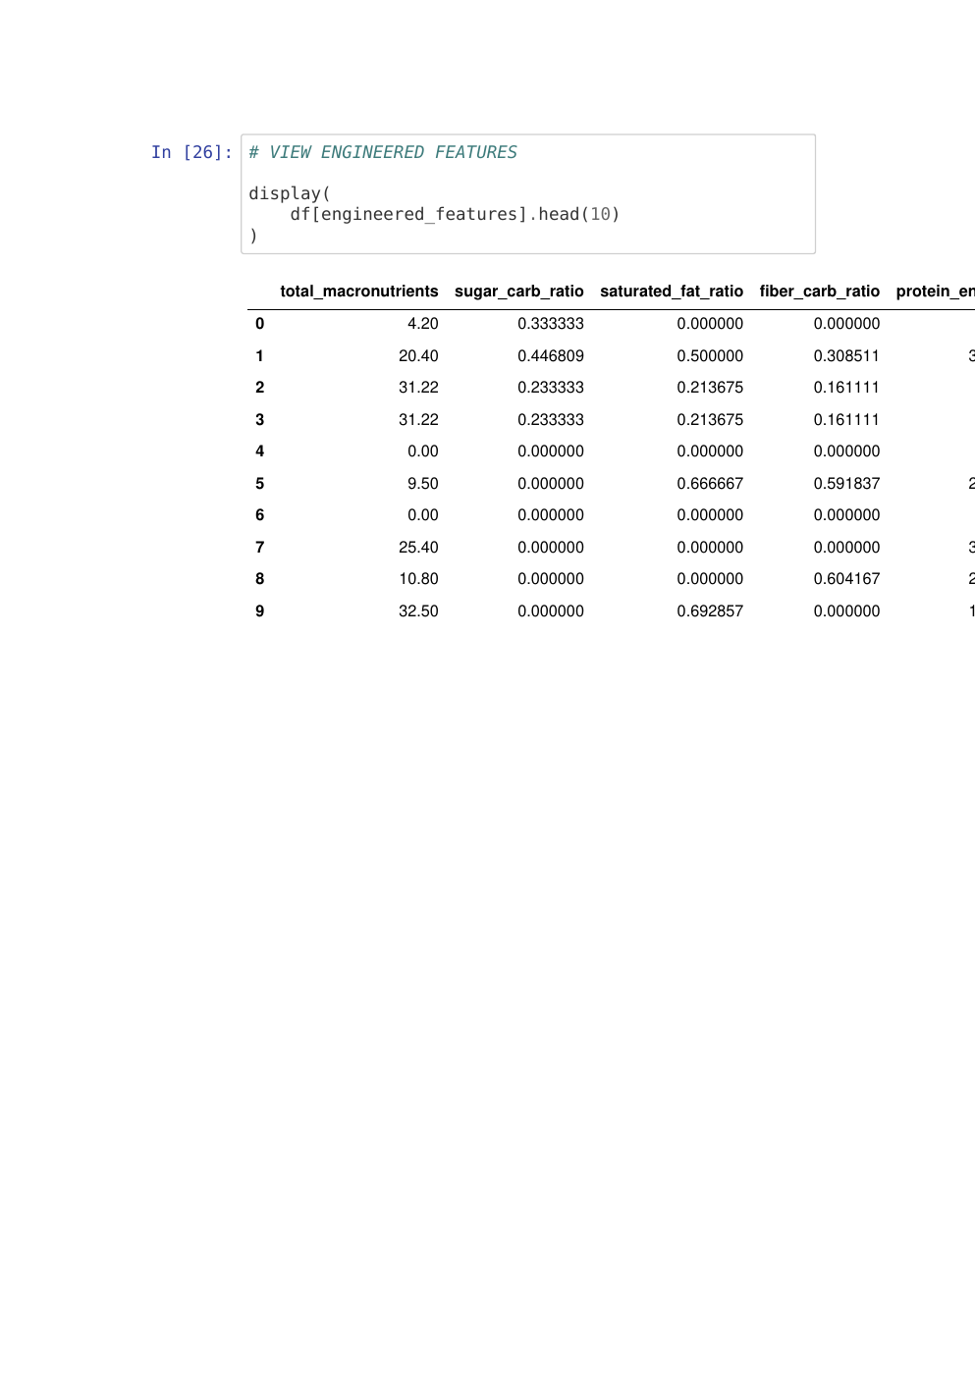
Figure 2. Notebook screenshot showing the engineered-feature output preview.

6. Feature Evaluation
Feature | Mean | Median | Minimum | Maximum
total_macronutrients | 50.064 | 48.880 | 0.000 | 116.428
sugar_carb_ratio | 0.429 | 0.359 | 0.000 | 1.000
saturated_fat_ratio | 0.286 | 0.214 | 0.000 | 1.000
fiber_carb_ratio | 0.228 | 0.112 | 0.000 | 1.000
protein_energy_pct | 12.904 | 8.857 | 0.000 | 100.000
carb_energy_pct | 44.756 | 46.275 | 0.000 | 100.000
fat_energy_pct | 34.052 | 30.638 | 0.000 | 100.000
macronutrient_balance | 8.181 | 3.085 | 0.000 | 101.430
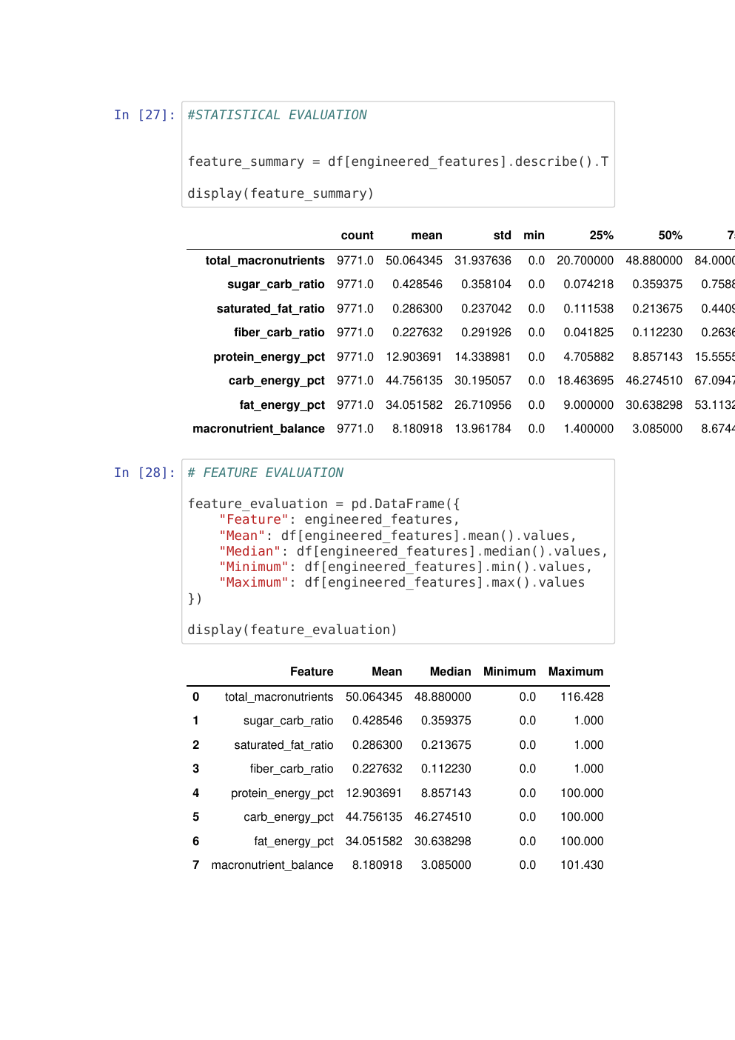
Figure 3. Notebook screenshot showing statistical summary and feature evaluation results.

7. Validation Results
Validation Check | Result | Status
Final dataset rows | 9,771 | Passed
Final dataset columns | 25 | Passed
Missing values in final CSV | 0 | Passed
Duplicate rows in final CSV | 0 | Passed
Infinite values in engineered features | 0 | Passed
The notebook confirms zero missing values across all eight engineered features and zero infinite values. The final exported CSV also contains no missing values and no duplicate rows.
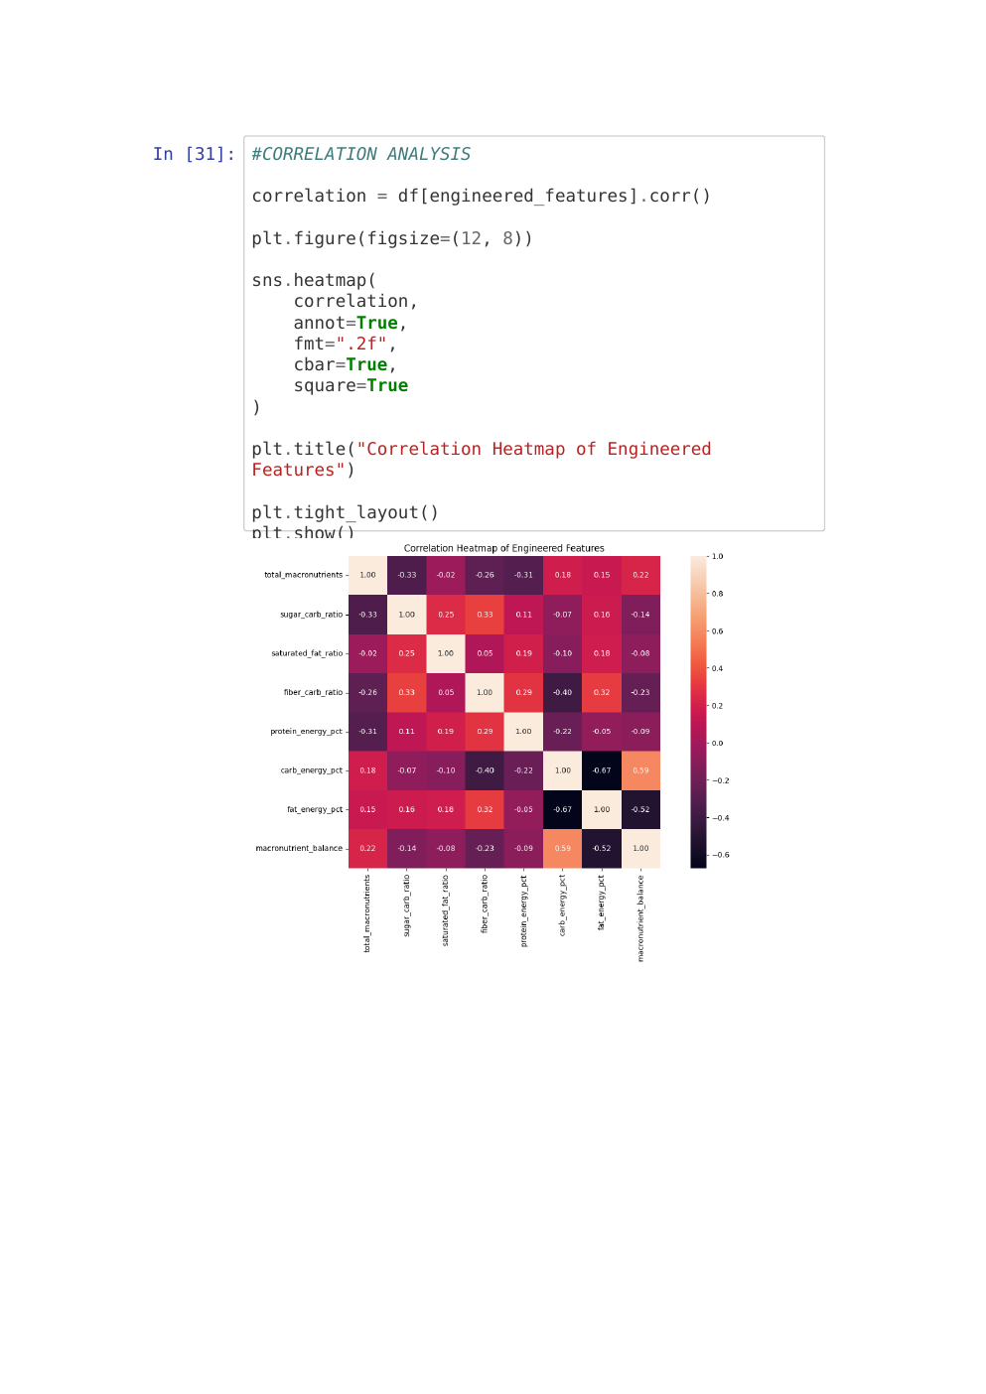
Figure 4. Notebook screenshot showing the correlation analysis of engineered features.
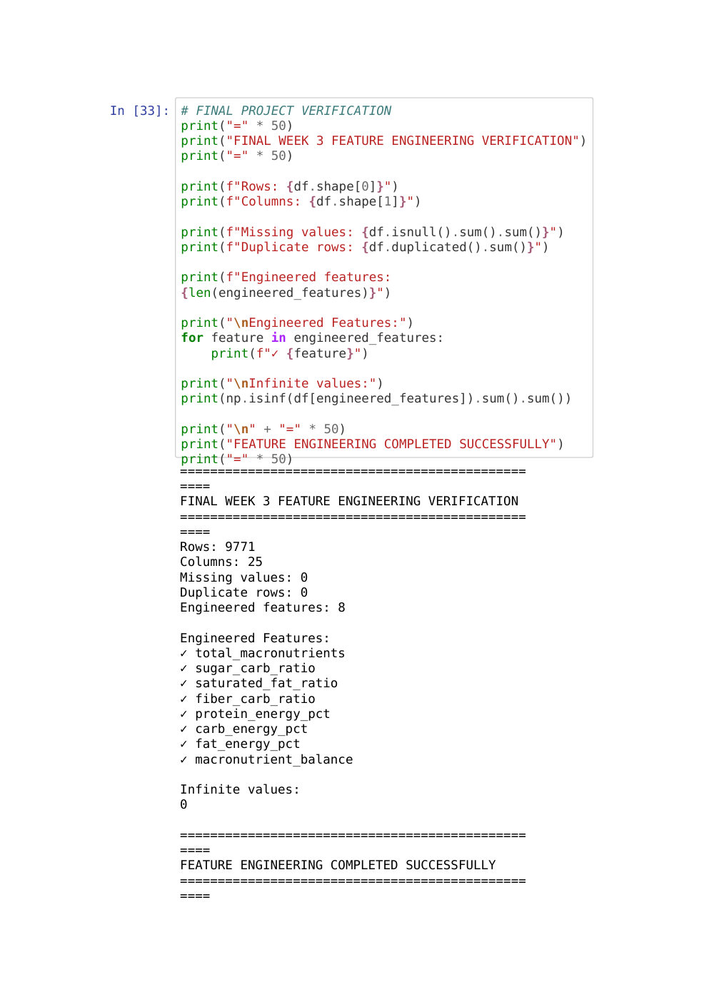
Figure 5. Notebook screenshot showing final verification results.

8. Observations
- Eight derived numerical features were successfully added to the cleaned dataset.
- Ratio features were constrained to 0–1, reducing the effect of implausible ratio values.
- Energy-percentage features were constrained to 0–100 according to the notebook implementation.
- total_macronutrients has a mean of approximately 50.064 and a maximum of 116.428.
- The average sugar-to-carbohydrate ratio is approximately 0.429.
- The average saturated-fat ratio is approximately 0.286.
- The average fiber-to-carbohydrate ratio is approximately 0.228.
- The average estimated protein, carbohydrate and fat energy percentages are approximately 12.904%, 44.756% and 34.052%, respectively.
- macronutrient_balance has a mean of approximately 8.181 and a maximum of 101.430.
- All engineered features contain 9,771 valid observations in the final dataset.

9. Usefulness for Machine Learning
The engineered variables can provide models with relationships that would otherwise need to be learned from several separate raw columns. Aggregate features can reduce the complexity of representing composition, while ratios can expose relative relationships. Energy-percentage features can provide a common interpretive scale for macronutrient contribution.
- Classification: engineered nutrition features could help distinguish product groups when an appropriate target variable is available.
- Clustering: composition and ratio features can help group products with similar nutritional profiles.
- Regression: derived features may provide additional predictors for a continuous target, subject to validation.
- Feature selection: descriptive statistics and correlation analysis can be used later to identify redundant or informative predictors.

10. Challenges and Solutions
Challenge | Observation | Solution
Different scales and magnitudes | Nutrition variables have different ranges. | Created ratios and energy-relative features.
Division by zero | Some products can have zero carbohydrates, fat, or energy. | Used conditional calculations with zero fallback.
Extreme derived ratios | Raw ratios can become unusually large when denominators are very small. | Applied clipping to ratio/percentage features.
Data quality | Missing and duplicate records could affect derived features. | Completed preprocessing and validation before engineering.

11. Final Dataset Export
The completed feature-engineered dataset was exported as:
food_processing_feature_engineered.csv
The exported file contains 9,771 rows and 25 columns. It includes the original analytical variables plus eight engineered features and was validated for missing and duplicate records.

12. Conclusion
The Week 3 Feature Engineering task was completed successfully. Starting from the cleaned food nutrition dataset, eight meaningful derived features were created using aggregate, ratio, and energy-based transformations. The features were evaluated using descriptive statistics and validation checks. The final dataset contains 9,771 records and 25 columns, with zero missing values, zero duplicate rows, and no infinite values in the engineered features. The resulting dataset is suitable as a prepared input for further exploratory analysis, feature selection, and machine-learning experiments.

13. Future Scope
- Test the engineered features in supervised machine-learning models using a clearly defined target.
- Compare model performance with and without the engineered features.
- Perform feature importance analysis using tree-based models or model-agnostic techniques.
- Investigate correlations and multicollinearity among raw and engineered variables.
- Create additional domain-informed features if more reliable product or ingredient information becomes available.
Notebook evidence: The figures above are screenshots generated from the submitted Week 3 Jupyter Notebook and placed in the corresponding report sections.

14. Submission Checklist
✓ Week 3 Jupyter Notebook – Completed
✓ Feature-engineered CSV dataset – Completed
✓ Eight engineered features – Completed
✓ Feature rationale documented – Completed
✓ Feature statistical evaluation – Completed
✓ Missing-value validation – Completed
✓ Infinite-value validation – Completed
✓ Final dataset export – Completed
✓ Week 3 internship report – Completed

Student Declaration
I, Vibhuti Prajapati, confirm that this report presents the Feature Engineering work completed for the Week 3 internship task and is based on the submitted Jupyter Notebook and final feature-engineered dataset.

Student Name: Vibhuti Prajapati
Date: 4 September 2026

