**Homework 5 CS 5331: Data Analytics**

**--** **Vibhuti Gupta & Gantaphon Chalumporn**

**Run LDA topic model algorithm, analyze your dataset, and visualize your results.**

**➢ For the dataset, it can be your project dataset, or Harvey Twitter dataset.**

We ran the LDA on Harvey Twitter dataset.

**➢ Choose a proper topic model numbers. A close up of a map

Description generated with high confidence**

**➢ For the analysis, you may compare the topic movements or popular topics dynamic**

**changes, or anything you feel interesting.**

**➢ For the visualization, you can use word cloud or any other visualization methods.**

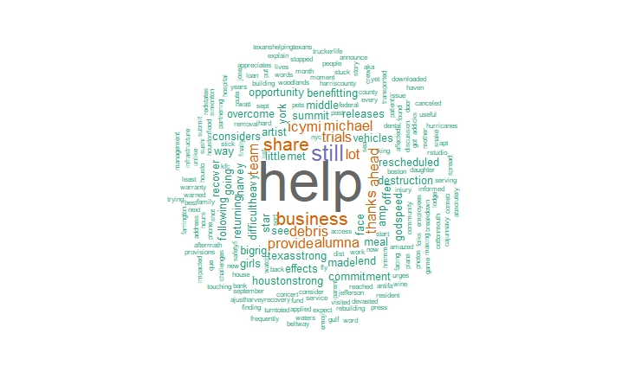

From the result we visualize it with word cloud. As shown in the figure above, “help” is