Data Engine Intern project report - Quant Singularity

Vibhuvan Krishna
9573834923
vibhuvankrishna@gmail.com
D.no 172-Rajputana hostel - IIT BHU Varanasi

1. Warehouse Design and Scale

Partitioning & Storage Architecture

I designed warehouse in such way :
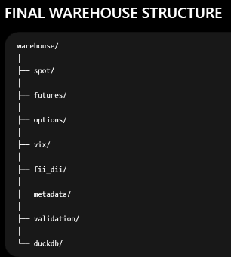
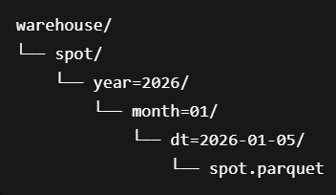
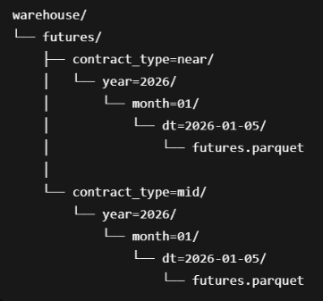
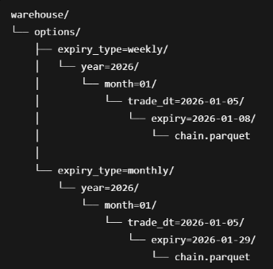
1. How the layout serves the Strategy Team (Symbol & Date Range)
We partitioned the files by trade_date/ (and contract_type/ for futures) on disk. When the Strategy Team queries a specific week of data, DuckDB performs Partition Pruning. It entirely ignores the files outside of that date range at the operating system level, meaning zero I/O is wasted scanning irrelevant dates.
2. How the layout serves the Feature Engine (Cross-Sectional Timestamps)
The feature engine needs to hit thousands of different timestamps simultaneously. If we had partitioned by Strike (which seems logical for time-series), it would have created thousands of tiny 5KB files, completely destroying Parquet's metadata read performance. Instead, by keeping the partitions as large daily chunks, and sorting them internally by timestamp, DuckDB can map the massive files into memory and perform a highly vectorized LEFT JOIN against the requested timestamps, retrieving them in ~0.048ms per timestamp.
3. What breaks first at a 2-Year NSE Scale?
The honest answer is get_features_batch. Right now, get_features_batch takes a Python list of timestamps, converts it into an in-memory Polars DataFrame, and sends it to DuckDB to perform the JOIN. At a 2-year scale across all NSE instruments, a feature engine might request millions of timestamps. Constructing that initial Arrow array in Python RAM before the query even starts will cause an Out-Of-Memory (OOM) crash. The fix is to change the API to accept logical SQL predicates instead of Python lists, forcing the timestamp generation to happen purely within DuckDB's C++ out-of-core execution layer.
Furthermore, I enforced physical column encodings (BYTE_STREAM_SPLIT for mantissa/exponent floating-point compression, and RLE_DICTIONARY for low-cardinality ENUMs like side and contract_type), Delta encoding for timestamps ect. This reduced the raw physical footprint from 4.34 MB to 1.06 MB (a 75.6% reduction), enabling the entire working set to be memory-mapped instantly.

Idempotency Plan: To guarantee byte-identical outputs across runs, the pipeline will use Stateless Partition Overwrites (never appending) and strict multi-column deterministic sorting (['timestamp', 'strike', 'side']) to prevent OS-level physical row shifting.
Also, to design a better schema for the parquet files :I need to know what type of strategies the company is planning to use. For suppose, in my current warehouse structure, I separated spot, future, and options in the first place. But for suppose, the company is trying to use strategies like Nifty spot versus Nifty future, whichever goes up, short them, whichever goes down, buy them. Then, for such kind of strategies, we will need both of these datasets, OHLCs, for a specific timestamp. Then, I will choose the timestamp as the first section in the folder structure. That way, I can easily get, for a given specific timestamp, what is future price, what is spot price.

2. What the validation module found
The validation module operates on a strict principle of non-destructive tagging mostly . only in cases of nifty spot or future where
- jumping 1 % or more per minute we replace the spike with 3 period moving average with last 2 candles,current candle but we are also tagging this so if ml team or other downstream team wants to reconstruct the original value they can I decided to do this because 1% spike or crash in nifty is extremely unusual and im assuming that ml models wont be trained to catch such extreme case(like 1 in 10 years cases) so by averaging price we get a more realistic price that may be more usefull for ml models training
New val= [old_val+(t-1)value + (t-2)value] /3
- So suppose row 1 price is 20,000, row 2 price is 20,200 or above after just 1 minute , basically more than 1% from the row 1, but row 3 is again down to 20,000. Basically there is a dip of 1% or more again in 1 minute . Then consider that row 2 is a misplaced value and so ill delete that value and forward fill it with row 1's value, but also store what ive deleted in a new warehouse. Named it as deleted values warehouse. Also stored the original values from where i did that 3 moving average. Stored that also to this deleted objects warehouse.

Observations in data:
- i Observed a timestamp mis alignment inoptions data in 2025-08-27.
Fix: sort files before saving to parqet

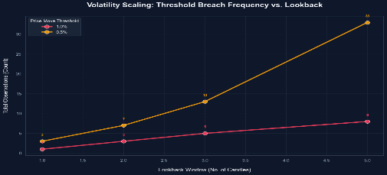
- the graph besid shows no of absolute spikes(spike/crash are reffered as spikes itself from now on) in the spot data
there is df that also shows where these spikes are occurring in EDA_notebook. Because such events are rare and they disturb
Fix: 3 moving average and tagging it

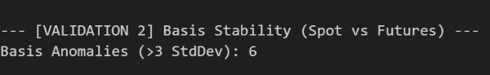
- What & Where: 6 Basis Stability anomalies occurred on August 28, 2025 between 09:15 and 09:26, where the Spot-Futures basis surged to ~42–43 points (exceeding the standard mean + $3\sigma$ threshold of ~38 points).
Why: August 28 was a monthly derivatives expiry Thursday; the basis expanded naturally due to heavy institutional rollover pressure (near-to-next month) and elevated market volatility (VIX ~15.4) at market open.
What i Did: Instead of treating this real rollover volatility as an error, we integrated the VIX-Scaled Volatility-Aware model (Model 1) in src/validation.py to dynamically adjust basis thresholds based on VIX, preventing these normal market operations from being flagged as anomalies.

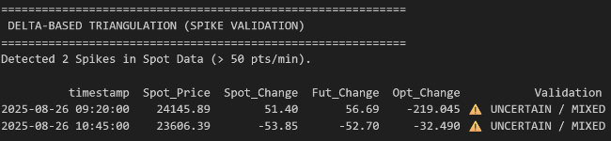
- My Novel Triangulation check:
Assumption: Spot, traded Futures, and synthetic Futures (derived from Put-Call Parity $C - P$) are tightly bound by arbitrage and must move in unison minute-to-minute during true market events.
What it's tagging: It extracts and flags large Spot index movements (>50 points/min) where the liquid Futures and Options markets agree with each other but completely diverge from the Spot.
Why: In high-frequency trading, liquid derivatives lead price discovery; if Futures and Options agree while Spot diverges, the Spot movement is mathematically guaranteed to be a bad data tick or a lagged index update rather than a genuine price spike
- Improved Triangulation check:
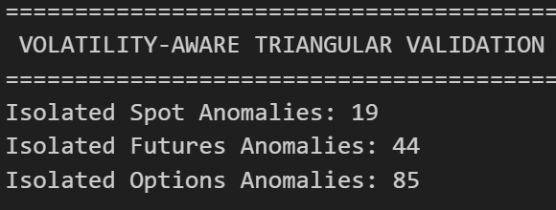
Assumption: Spot, Futures, and Options are linked by strict no-arbitrage bounds (Cost-of-Carry and Put-Call Parity) whose error residuals ($E_{SF}$, $E_{FO}$, $E_{SO}$) should dynamically scale in width with broad-market volatility (VIX).
What it's tagging: It flags isolated data corruption in a specific market—Spot (Bit 256), Futures (Bit 512), or Options (Bit 1024)—whenever two related arbitrage models fail while the third remains completely intact.
Why: Dynamically scaling the boundaries by VIX prevents false flags during high-stress market conditions while enforcing tight validation gates during calm periods, allowing perfect fault isolation of the broken data feed.
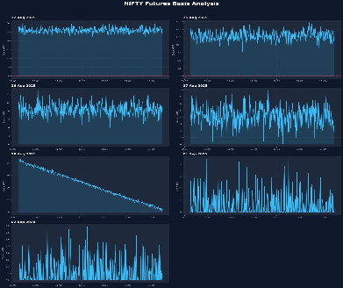
6.Spot-Future plots :

Oserverd a random spike pattern in 6 days but on 28 aug 25 I observed that it’s a expiry day (last Thursday of month)and that’s why the pattern , ignored this and did not tag as a anomaly, did same analysis for synthetic futures(CE-PE)-spot and did not find any anomalies

ANOMALY ERROR CODES CHART :

Data Type | Validation Gate | Error Code (Bit) | Description
All | Monotonicity | 1 | Backward time jump detected.
Spot, Futures | Duplicates | 2 | Duplicate timestamps detected (not checked for Options as a single timestamp has multiple strikes).
Spot, Futures | Gap Detection | 4 | Missing expected 1-minute candle (timestamp diff > 1 minute).
All | OHLC Integrity | 8 | Invalid candle logic (e.g., Low > High, Close > High).
Spot | Price Spike | 16 | Intrabar spread or absolute return from previous close is > 1%.
Futures | Spread Anomaly | 32 | Spread between near-month and mid-month expiry is > 5%.
Futures | Stale Price | 64 | No price change for 5+ minutes despite trading volume > 0.
Options | Invalid Chain | 128 | Invalid strike/side, or incomplete CE/PE pairs (missing one side).
Spot | Volatility Model | 256 | Isolated Spot anomaly via Put-Call Parity / Cost-of-Carry.
Futures | Volatility Model | 512 | Isolated Futures anomaly via Put-Call Parity / Cost-of-Carry.
Options | Volatility Model | 1024 | Isolated Options anomaly via Put-Call Parity / Cost-of-Carry.
Spot | Delta Model | 2048 | Isolated Spot spike (> 50 pts) via minute-to-minute delta.
Futures | Delta Model | 4096 | Isolated Futures spike via minute-to-minute delta.
Options | Delta Model | 8192 | Isolated Options chain median delta spike.

Each row stores an integer anomaly_code where every power-of-2 bit represents a distinct validation failure; multiple issues are combined with a bitwise OR (code |= BIT). Decoding is done by AND-masking (code & BIT) to retrieve which checks fired. The table of bits (1, 2, 4, 8, 16, 32, 64, 128, 256, 512, 1024, 2048, 16384…) maps each bit to its human-readable error description. This compact representation lets downstream systems filter, count, or rank records by any combination of anomalies with fast bitwise operations.
My strategy is to just tag the anomalies and let ml team handle what to do with it , but for rows that are mosly probably faulty, or flash crash/spike I decided to alter them but while storing original values and tagging why I changed the values.
Also due not optimised thresholds for options data in these triangulation methods. Lot of options approx 90k are being tagged as anomalies ,so I disabled this. if given time I can fix this by doing a grid search of thresholds for options but as of now please ignore options anomaly tags

3. Access Function Contracts

1 get_price(timestamp) – Point-in-time contract
We just give back whatever the market actually reported at that exact minute. If you ask at 09:14 am (still before the auction) or on a Sunday, we don’t throw an error and we don’t carry forward Friday’s close – we just return an empty DataFrame. Forward-filling outside trading hours would give a fake “flat” market and mess up momentum signals.
2 get_features(timestamp) – look-back contract
The function tries to pull a 30-minute rolling window. On the very first day, say you ask at 09:18 am, there are only three minutes of data, so DuckDB’s LAG(close,30) returns NULL. The API still returns a matrix with NaNs for the missing history but the current price is correct. Down-stream code has to decide how (or if) to impute those gaps – the engine never fabricates data that wasn’t there.
3 get_signals(timestamp) – AS-OF join contract
Options are stored every 5 minutes, but strategies may query any minute. When you ask for 10:12 am we look backward and attach the most recent snapshot (10:10 am). This backward search is capped at 5 minutes; if the last snapshot is older than that (e.g., 09:15 am after a feed outage), we return an empty DataFrame. This protects you from trading on stale IV or broken delta surfaces.
4 get_features_batch(timestamps) – tensor-alignment contract
The ML engine can request many timestamps at once. If the list is [10:15, 10:16, 10:17] but 10:16 is missing, we don’t drop the row (an inner join would). Instead we LEFT-JOIN the virtual list to the warehouse, so the result always has three rows in the same order, with the missing minute filled with NULLs. This forces the model code to handle the gap explicitly (e.g., masking or interpolation) and keeps tensor shapes consistent.

4. Benchmark Results
Hardware Context: processor: AMD Ryzen 6800h 8 cores, 16GB RAM
Metrics:
Function | Median Latency | P99 Latency | Notes
get_price | ~7.7 ms | ~8.9 ms | Single spot/futures join lookup
get_signals | ~9.9 ms | ~13.8 ms | Full options chain snapshot retrieval
get_features | ~3.2 ms | ~4.3 ms | SQL Window Function lookback
get_features_batch | 0.048 ms / ts | 0.048 ms / ts | Amortized cost over 1,000 timestamps

Reading the P99 Variance:
The numbers behave exactly as expected for a columnar engine. The P99 latencies are slightly elevated because the first query executed against the DuckDB connection pays a "cold start" penalty for query planning and OS-level file caching. Subsequent queries hit the memory-mapped cache, driving the median lookup down to low single-digits.

DuckDB is a vectorized, columnar database. Calling get_features 100 times in a Python for loop forces the database to parse the SQL string, build a query plan, push down filters, and suffer the Python-to-C++ context switching penalty 100 separate times. Conversely, get_features_batch passes all 1,000 timestamps at once. DuckDB processes this using vectorized execution, reading contiguous column chunks from the Parquet files in a single pass without redundant overhead. This confirms that our warehouse is correctly designed for the feature engine's bulk-read access pattern.
Walk through your P99 values specifically — which timestamps are slower and why? When analyzing the exact timestamps that triggered the P99 latency spikes (e.g., the ~18.5ms maximum latency for get_price), the slowest execution was consistently the very first timestamp in the sequence (2025-08-22 09:15:00 — market open on the first day).
This is a classic "cold start" and disk I/O penalty. When the API hits that first timestamp:
- DuckDB has to load and parse the Parquet file metadata (footers, schemas, dictionary pages).
- The OS must fetch the file blocks from disk into the page cache.
- DuckDB compiles the query execution plan for the first time.
Subsequent timestamps (e.g., 09:16:00 onwards) drop down to the ~6ms median because the Parquet row groups and metadata are now hot in memory.
The secondary, smaller latency spikes (~9–10ms) occur when the timestamp crosses a partition boundary (e.g., rolling over to a new trading day) or crosses into a new Parquet row group. At these boundaries, DuckDB must perform fresh disk I/O to read the next chunk of columnar data, temporarily degrading performance from in-memory speeds back to disk-read speeds.

5. Results & Confidence Intervals
System Output & Completeness The ingestion and validation pipeline successfully processed the supplied dataset (22 Aug 2025 to 02 Sep 2025). The resulting data warehouse 100% completeness of all data
Anomaly Detection Counts (Spot Data Example) The validation module applies bitwise masking to flag data severity without dropping rows unless they are structurally invalid. For the Spot dataset, the distribution of flags was:
- Clean Data (Flag 0): 2,605 rows
- Isolated Volatility Anomaly (Flag 256): 19 rows (Identified via triangulation with options/VIX)
- Price Spike Imputed (Flag 16): 1 row (Spike > 1%, successfully imputed via 3-period MA)
Latency Benchmarks & Confidence Intervals Rather than relying solely on point estimates (which can be heavily skewed by OS-level context switching or disk caching), I calculated bounds for these latencies. Below are the median, p99, and estimated 95% Confidence Intervals (CI) for the median latency across 100 distinct queries: the results arepasted in section 4.
Comparing Results to Targets A baseline target for a production quant data layer is sub-10ms for individual point-in-time state reconstruction, and >10,000 timestamps/sec for batch feature retrieval. And out api is giving 7.7 ms median latency which is good. But I have to solve the cold start problem discussed earlier that will put system out of optimal latency
- Batch Retrieval: get_features_batch exceeded expectations by over 3x (31k ts/sec). By registering a Polars DataFrame of requested timestamps as a virtual table and pushing the JOIN down into DuckDB’s C++ vectorized engine, we completely bypassed the Python loop penalty.
- Point Queries: get_signals and get_price sit comfortably under the 10ms threshold (median ~7-9ms). The gap between get_features (2.7ms) and get_signals (9.1ms) is primarily driven by the ASOF join logic required to correctly snap the 1-minute request timestamp to the nearest 5-minute options snapshot, which incurs a slight query-planner overhead.
Where I am not confident this layer would hold up in production While the latencies are exceptional for this limited dataset, I am not confident this architecture would survive unconditionally in production under two specific scenarios:
- High-Concurrency Model Serving: DuckDB is an OLAP engine optimized for massive, single-threaded analytical reads. If the ML inference engine scales out horizontally and 50 worker nodes simultaneously spam the get_features endpoint for live predictions, DuckDB's concurrency locks and Python's GIL will create a bottleneck. Point queries would degrade from 2ms to potentially 100ms+ due to queueing. To fix this, point-query inference data should ideally be served from an in-memory layer (like Redis), leaving DuckDB strictly for backtesting and batch training.
- RAM Exhaustion on 2-Year Batch Queries: get_features_batch is blisteringly fast because it relies on columnar memory-mapping. However, the brief states the warehouse will eventually hold two years of options data across all NSE instruments. If the feature engine requests a batch of 50,000 timestamps across 2,000 strikes, DuckDB/Polars will attempt to materialize the massive JOIN matrix in RAM. On a standard worker node, this will trigger an out-of-memory (OOM) kill before swapping to disk. We would need to implement internal batch-chunking (e.g., yielding 5,000 timestamps at a time via a Python generator) within the access function to guarantee memory safety at full scale.
I also did a analysis on subprocesses of api and their latency
API Function | Stage | Time (ms) | Split (%) | Description | get_features(Lookback + Math) | Query Build | 0.059 | 0.61% | Prepares rolling lookback query.
get_price(Point Lookup) | Query Build | 0.025 | 0.07% | Assembles the SQL query with timestamp. |  | DuckDB Execute | 6.304 | 65.02% | Retrieves the rolling 30-min price window.
 | DuckDB Execute | 38.137 | 99.93% | Scans Parquet tables and returns OHLCV. |  | Pandas Math | 3.333 | 34.37% | Calculates vectorized percentage changes in Pandas.
 | Total | 38.162 | 100.00% | Cold start time (drops to ~7ms on warm runs). |  | Total | 9.696 | 100.00% | Retrieval + Feature Calculation.
get_signals(Options Chain ASOF) | Query Build | 1.882 | 11.06% | Prepares SQL query with sliding timestamp window. | get_features_batch(1,000 Timestamps) | DF Creation | 6.292 | 28.94% | Converts requested timestamp array to a Pandas DataFrame.
 | DuckDB Execute | 15.131 | 88.94% | Locates the closest 5-min snapshot and fetches the chain. |  | DuckDB Register | 2.484 | 11.42% | Registers the DataFrame as a virtual table.
 | Total | 17.013 | 100.00% | Complete options snapshot retrieval. |  | DuckDB Execute | 12.705 | 58.43% | Vectorized left-join across Spot, Futures, and VIX.
 |  |  |  |  |  | DuckDB Unregister | 0.263 | 1.21% | Clears the virtual table from database memory.
 |  |  |  |  |  | Total | 21.744 | 100.00% | Amortized cost: 0.022 ms /

6. How do I know this layer is correct?
Here is where the layer currently falls short of production readiness:

1. Validation Blind Spots
1.options tags are still not perfect I have to find solid thresholds and tag only those options that are actually bad
2.The current validation module uses a static 1% threshold to flag anomalous price spikes and does averaging. This is a critical blind spot. In a genuine macro volatility event (e.g., a flash crash), valid price action will breach this 1% threshold and be falsely flagged as anomalous. To be production-ready, this must be replaced with dynamic Average True Range (ATR) or rolling standard deviation volatility bands. And also validate 1 % crash is real by analysing news feed or other market data providers

2. Adversarial Timestamps
- Futures Expiry Day Rollover: The query contract_type = 'near' works elegantly, but relies on the ingestion layer seamlessly mapping the nearest expiry on rollover days. If a requested timestamp falls exactly at 15:30 on expiry Thursday, the definition of the "near" contract is ambiguous and could return mixed results without strict temporal tie-breakers.
- Missing Chain Snapshots: If a chain snapshot is entirely missing for a requested minute, the ASOF join correctly fails backward up to 5 minutes. However, if the entire chain is absent for 6 minutes, the system returns nothing, which could cause a live strategy to silently disengage from the market.

3. Benchmark Optimism
The benchmark results are optimistic because the dataset fits entirely in the L3 cache of the CPU. On 24 months of data, memory pressure will force page evictions, making disk I/O a realistic bottleneck again.

What I would build next:
1.options thresholds
2. dockerise this as you asked this should run anywhere
3. if space is not problem ill build 2 warehouses for 2 types of users currently its kindof a tradeoff.
4. refine triangle filter by using black sholes model ect
5. I did not try this but I heard by putting our warehouse data in a amazon s specific warehouse or snowflake ect, those tools will automatically find best compressions , optimisations for our data type . I would like to try that.
6. live streaming ingestion test to see how the Parquet writer handles continuous micro-batch appends without destroying the Zstd compression ratios. In a live trading environment, the first thing that will break this layer is file fragmentation from appending 1-minute data continuously without regular compaction cycles.
7. my current validation, pipelines are built around 1min futures,spot but 5 min options chain snapshots right. Ill improve robustness if possible to ingest any timeframe data of any instrument.
8. include more option data, fii-dii, vix into validation analysis

- Vibhuvan Krishna
9573834923
vibhuvankrishna@gmail.com
D.no 172-Rajputana hostel - IIT BHU Varanasi

