PAPERTRADE

Learner-First Perpetual Trading
Design System & UX Specification
v3 — implementation-ready design contract for a virtual-money trading + learning platform
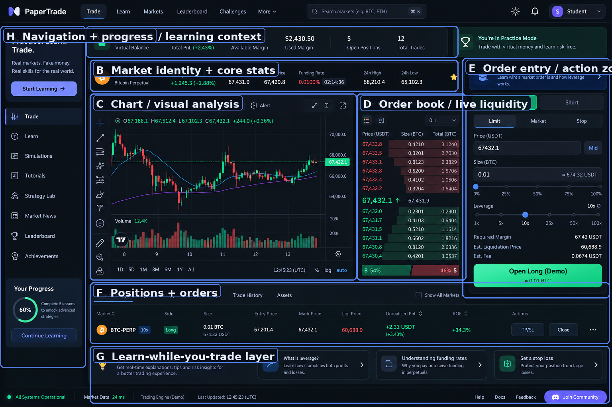
Primary reference screen. Preserve the relationship between market context, analysis, execution, outcomes and learning.
Core product promise. Real market data and realistic trading mechanics, but every order uses virtual money. The interface should make learning, not speculation, the main goal.

0. Product flow — build in this order
1. Public entry → Login / Create account.
2. Authentication → minimal, trustworthy account screens.
3. Onboarding → explain virtual money, select learning level, start first lesson.
4. Trade workspace → market + chart + order book + order entry + positions.
5. Learn in context → surface explanations immediately after relevant interactions.
6. Review outcome → teach PnL, margin, liquidation, funding and risk.
7. Progression → unlock complexity by understanding, not by payment or deposits.

1. Product principles
Principle | Design decision | Engineering consequence
Learner first | Professional terminal, tutor-like guidance. | Progressive disclosure and contextual explanations.
Virtual money is explicit | Practice Mode and virtual balance remain visible. | No deposit/withdrawal language in demo flows.
Color is semantic | Purple = brand/learning; green/red = direction/outcome. | Tokenized semantic colors.
Fast but safe | Realtime market feed; clear order states. | WebSocket + selective subscriptions + submit locking.
Show consequences | Position state explains what the trade caused. | Live PnL, margin, liquidation and chart markers.
Don't overwhelm | Beginner defaults, advanced controls behind disclosure. | Conditional/advanced order settings are progressive.

2. Visual foundation

2.1 Colors
Token | Hex | Primary usage
Background | #0B0D12 | App / page background
Surface | #12151C | Panels / cards
Elevated | #181C24 | Inputs / active surfaces
Border | #252B36 | Dividers / field borders
Text | #F4F7FB | Primary text / key numbers
Muted | #98A2B3 | Secondary copy
Brand | #8B7CFF | Auth, learning, focus, neutral primary CTA
Long / Success | #19D98B | Long, profit, successful action
Short / Danger | #FF5C67 | Short, loss, liquidation, destructive action
Info | #55A7FF | Learning / neutral info
Warning | #F5B942 | Funding, countdown, caution

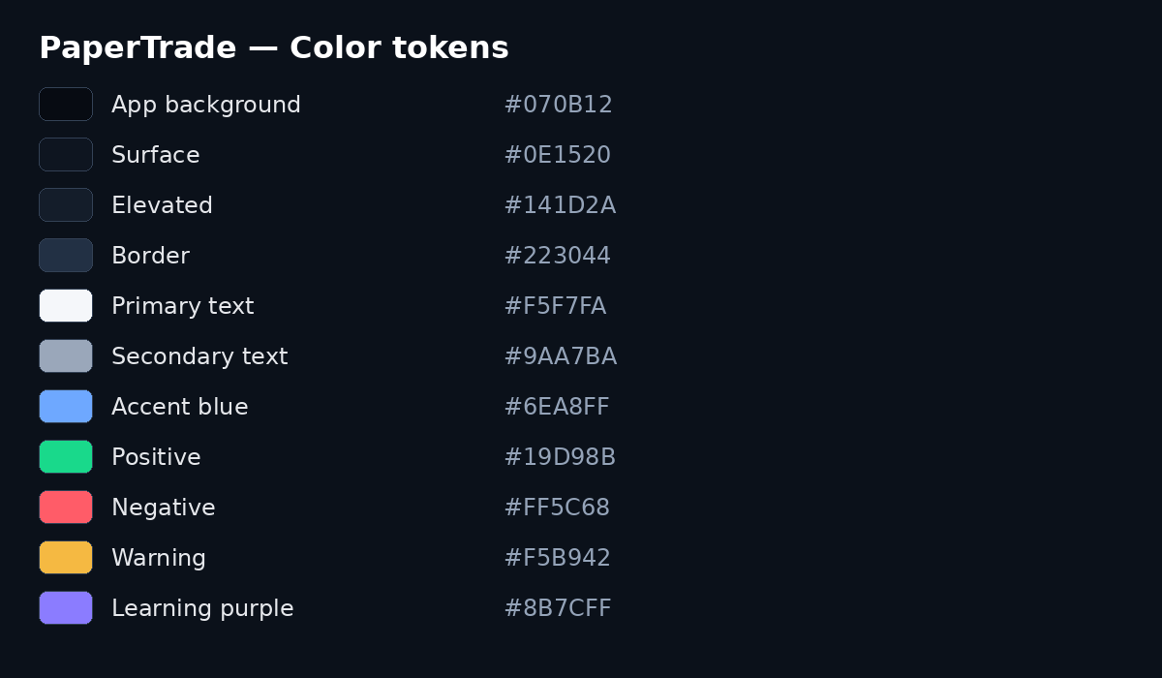
Reference: color token sheet.

2.2 Typography
Role | Spec | Use
Body | Inter / system UI, 14–16px | Learning copy, labels
Page heading | 650–750 weight | Auth and learning titles
Market number | Tabular numbers | Price, size, PnL, ROE, time
Micro label | 11–12px, 600 | LIVE, Mark Price, Funding Rate
Helper | 12–13px muted | Field guidance / explanations

- Use `font-variant-numeric: tabular-nums` for market data.
- Keep prices at stable decimal precision per market.
- Do not make every label uppercase; use sentence case for learners.
- Learning copy gets more line-height than the dense market terminal.

2.3 Density, spacing and surfaces
Token | Value
Base spacing | 4px
Primary rhythm | 8px
Panel padding | 16px
Dense table padding | 10–12px
Large learning/auth padding | 24px
Control height | 40–44px
Radius | 10–12px
Status pill | 999px

3. Component system — shadcn/ui
Use shadcn/ui as the canonical interaction layer. Customize its tokens to PaperTrade. Use Lightweight Charts for the actual candlestick terminal rather than a generic component-library chart.
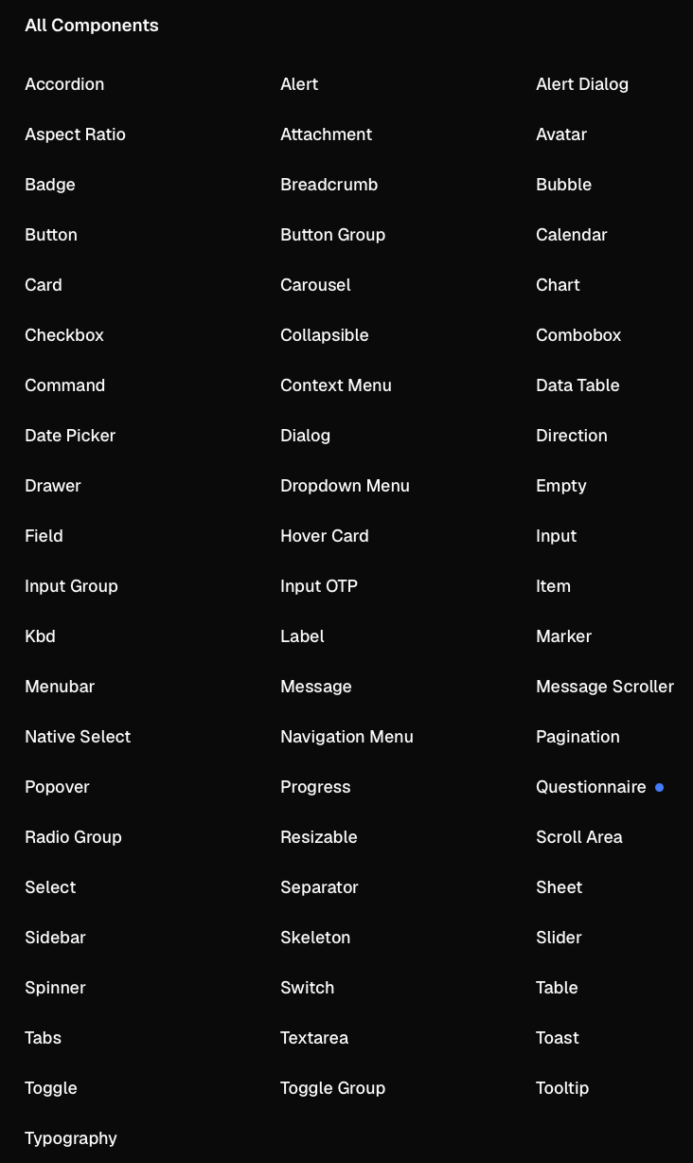
Reference: provided shadcn/ui-style component inventory.
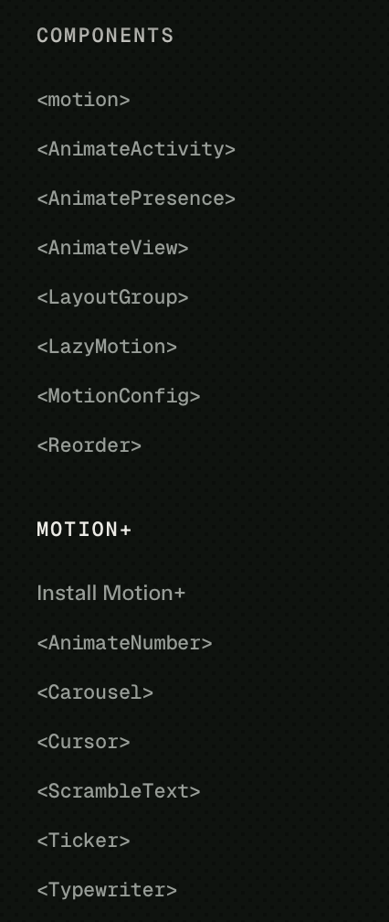
Reference: provided Motion / Framer Motion component inventory.
Component | Where | Behavior
Button | All CTAs | Variants: brand / Long / Short / destructive / secondary / ghost.
Button Group | Long/Short, timeframes | One selected value; keyboard accessible.
Card | Auth, learning, panels | Low-contrast dark surface.
Field / Label / Input | Auth + order form | Label → control → description → error.
Input Group | Price/currency, size/asset, search | Suffix/prefix never steals input width.
Select | Finite settings | Market unit, timeframe options.
Combobox | Market search | Keyboard search + recent markets.
Tabs | Chart/Depth, Book/Trades, Positions/Orders | Compact terminal navigation.
Tooltip | Jargon + icon-only actions | Never the only place critical information exists.
Popover / Hover Card | Metric definitions | Quick explanation without leaving flow.
Dialog / Alert Dialog | High-risk actions | Close all, reset, extreme leverage.
Dropdown Menu | Account/tools | Short command lists.
Command | Global ⌘K | Search markets, lessons, pages and actions.
Checkbox | TP/SL, Reduce Only, Post Only, terms | Explicit text label required.
Radio Group | Onboarding level | Large selectable cards around the radio.
Slider | Leverage, size percent | Current value always visible.
Progress | Learning progress | Never represent PnL.
Badge | Demo, 10x, Long, Short, Live | Short semantic marker.
Alert / Toast | System + order feedback | Inline for important errors; toast for acknowledgement.
Skeleton | Initial loading | Match final geometry to avoid layout shift.
Scroll Area | Orderbook/trades | Only visible rows should render at scale.
Resizable | Desktop panes | Persist layout locally.
Sheet / Drawer | Mobile order panel / learning | Use instead of shrinking desktop panel.
Separator | Panel grouping | Low contrast.
Table | Positions/history | Dense numeric table with sticky header.
Empty | No positions/orders | Explain what the learner can do next.
Avatar | Account menu | Initials/provider image.
Calendar / Date Picker | History/analytics | Keep out of first-trade flow.
Accordion / Collapsible | Advanced order fields + lesson details | Progressive disclosure.
Breadcrumb | Learning lesson path | Useful inside Learn, not the trade terminal.
Kbd | Keyboard shortcuts | ⌘K and safe trading shortcuts.
Native Select | Mobile simple choices | Prefer native behavior when faster/touch friendly.
Toggle / Toggle Group | Chart/layout options | Compact settings.
Pagination | History/leaderboard | Not for live feeds.

3.1 PaperTrade-specific wrappers
- MarketHeader, PriceTicker, FundingBadge, PracticeModeBanner.
- OrderBook, TradeFeed, OrderPanel, LeverageControl, RiskPreview, DemoTradeButton, SignedOutTradeCTA.
- PositionTable, PositionCard, OrderHistoryTable, PnLChip, LiquidationBadge.
- LearningPrompt, ConceptPopover, LessonProgress, FirstTradeCoach, TradeReviewCard.
- ConnectionStatus, MarketDataStaleBanner, ReconnectToast, ErrorSummary.

4. Motion system — Framer Motion
Use Framer Motion for meaningful UI transitions and onboarding. Do not use it as the rendering engine for market ticks, orderbook rows or every PnL update.
Scenario | Motion | Duration | Rule
Auth page enter | opacity + y 8px | 180–220ms | Subtle only
Onboarding step | AnimatePresence + directional slide | 220–300ms | One step at a time
Learning card | opacity + small lift | 120–180ms | No bounce
Sheet / Drawer | slide | 220–280ms | No elastic overshoot
Toast | opacity + y | 160–220ms | Short
Order submit | button content swap | 100–160ms | No full-panel animation
Position appears | single highlight | 250–450ms | One time only
Price updates | CSS/direct/frame-synced | ~1 frame | Not Framer Motion per tick
Orderbook rows | none | — | Do not layout-animate live rows

<motion.div
initial={{ opacity: 0, y: 8 }}
animate={{ opacity: 1, y: 0 }}
transition={{ duration: 0.2, ease: "easeOut" }}
/>
<AnimatePresence mode="wait">
{/* onboarding / sheet / learning transitions */}
</AnimatePresence>
Reduced motion. Respect `prefers-reduced-motion`. In reduced-motion mode remove movement and keep immediate or opacity-only state changes.

5. Authentication
Auth is intentionally simpler than the terminal: same dark foundation, much less density, and clear learning-oriented messaging.
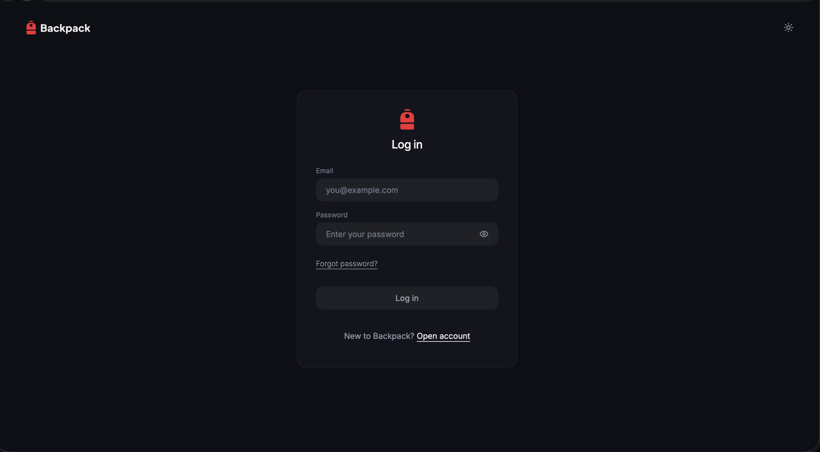  Login reference | 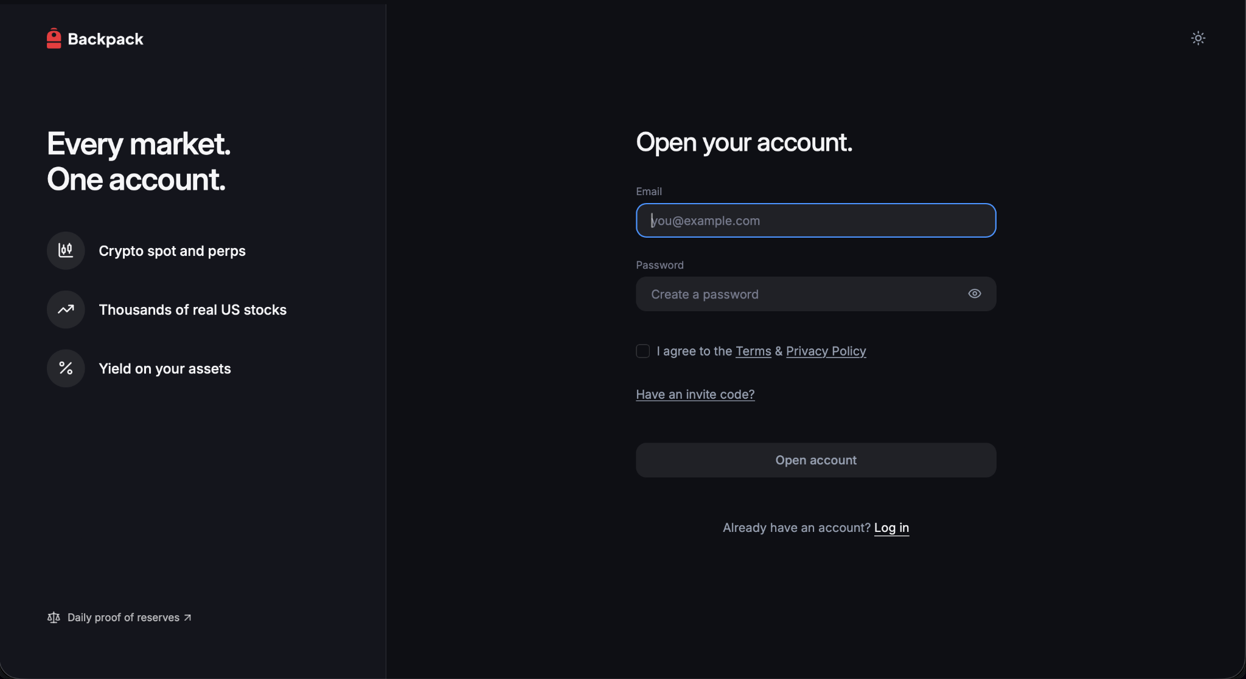  Create account reference

5.1 Login
- Centered card, large negative space, PaperTrade wordmark top-left, theme toggle top-right.
- Fields: Email, Password, Forgot password, Log in, Open account.
- Primary auth CTA = brand purple. Never use Long/Short green/red.
- Loading = Signing in…; duplicate submission blocked.
- Reserve error space so validation does not cause the card to jump.

5.2 Create account
- Desktop split-screen: left value proposition, right form.
- Headline: “Learn trading. Practice safely.”
- Value points: real market data, virtual money, realistic order mechanics, risk-free practice.
- Form: Email, Password, terms/privacy, optional invite code, Create account, Log in.
- Keep copy calm. Avoid bonuses, urgency, guaranteed profits or deposit language.

5.3 Post-auth onboarding
1. Welcome — show virtual balance and explicitly say no real money is involved.
2. Experience level — New / Basic / Experienced.
3. First lesson — Market vs Limit order.
4. Guided first trade — small default size, clear hints.
5. Review — show entry, mark price, margin, PnL and liquidation.
6. Continue — unlock advanced features progressively.

5.4 Mandatory signed-out trading behavior
Non-negotiable. When the user is not logged in, never show `Open Long` or `Open Short` as the primary CTA. The action area must say `Log in to trade`, with an optional secondary `Create free account` link.

User state | Order area | CTA
Signed out | Educational preview; submission disabled. | Log in to trade
Signed out, first visit | Explain account requirement inline. | Create free account
Logged in demo account | Full controls enabled. | Open Long (Demo) / Open Short (Demo)
Submitting | Lock duplicate submit. | Submitting…
Rejected | Restore controls + reason. | Retry / Edit
Filled | Position appears + chart marker. | Manage position

6. App shell & navigation

Reference: top navigation and account controls.
- Top-level: Trade, Learn, Markets, Leaderboard, Challenges, More.
- Global Command menu supports markets, lessons, navigation and actions.
- Practice Mode / virtual account stays visible in authenticated trading screens.
- Left navigation is also the curriculum scaffold.
- Mobile navigation becomes a Sheet/Drawer.

7. Market header

Reference: market header hierarchy.
- Order: symbol → current price → Mark/Index → Funding → 24h metrics → Open Interest.
- Current price gets the largest numeric treatment.
- Funding and countdown use amber when they require attention.
- Clicking a metric opens a Popover with a beginner definition.
- Market search uses Combobox.

8. Chart & analysis
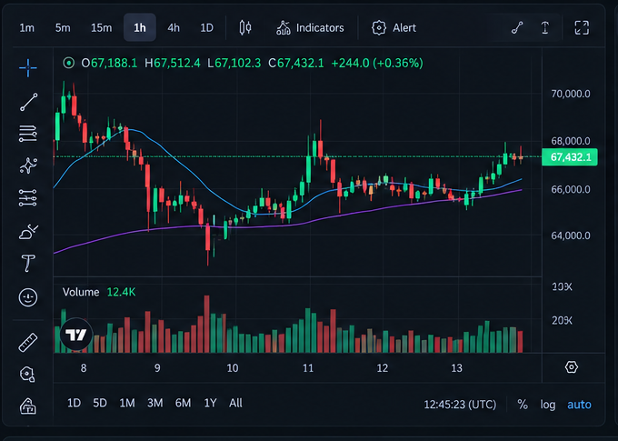
Reference: chart and compact analysis toolbar.
- Use Lightweight Charts for candlesticks; shadcn handles surrounding controls and learning overlays.
- Beginner default: candles + volume, minimal indicators, 5m/15m/1h controls.
- Entry, TP, SL and liquidation are horizontal markers when relevant.
- Concept explanations use Popover / LearningPrompt.
- Do not animate the whole chart on every tick.

9. Order book & trades
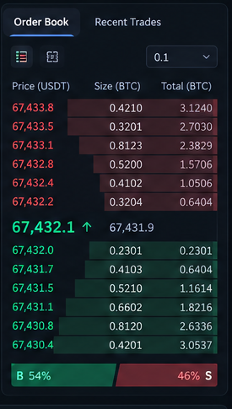
Reference: order book.
- Anchor the center price and make it visually dominant.
- Red = asks; green = bids. Depth bars remain subtle.
- Order Book and Recent Trades use Tabs.
- Use Scroll Area and virtualize large feeds.
- Clicking a price can populate the limit price and should visibly acknowledge the action.

10. Order entry
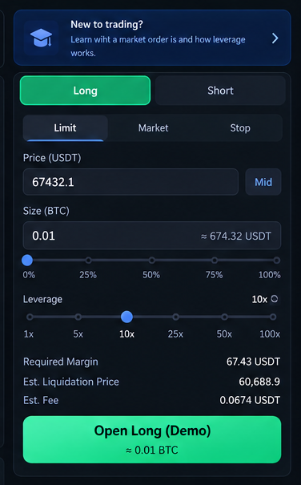
Reference: order-entry panel.
Zone | Required component | Teaching behavior
Direction | Button Group | Long/Short is first decision; green/red semantics.
Type | Tabs / Toggle Group | Limit + Market visible; conditional under disclosure.
Price | Field + Input Group | Explain limit price; Mid/BBO helper.
Size | Field + Slider | Show asset amount + approximate notional.
Leverage | Slider | Show current leverage + risk hint.
Risk | Checkboxes / Collapsible | TP/SL, Reduce Only, Post Only.
Preview | Card | Required Margin, Est. Liquidation, Est. Fee.
Submit | Button | Explicit context-rich label.

10.1 Order button semantics
Button | Color | Use
Create account / Start learning / Log in | Purple | Account + education
Open Long (Demo) | Green | Authenticated demo trade
Open Short (Demo) | Red | Authenticated demo trade
Log in to trade | Purple | Signed-out trade gate
Close / Close all | Red outline / destructive | Position management
Cancel / Details | Secondary | Neutral actions

- Signed-out users never see Open Long / Open Short as the primary trade CTA.
- Normal demo trades do not need confirmation dialogs.
- Extreme leverage, Close All or Reset Simulator may use Alert Dialog.
- After click: `Submitting…`; duplicate submission is impossible.

11. Positions, orders & history
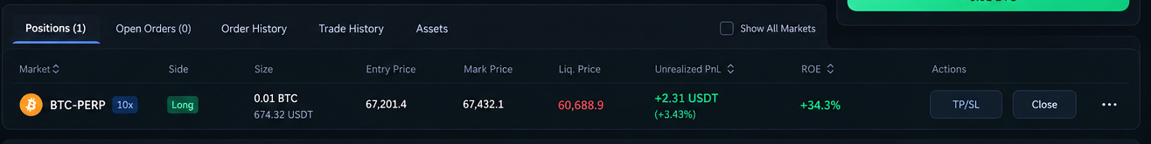
Reference: position outcomes.
- Primary metrics: Size, Entry, Mark, Liquidation, Margin, Unrealized PnL, ROE and Actions.
- PnL updates in realtime without page-wide rerenders.
- Empty state explains the next action.
- Close/TP-SL are direct management actions; Close All uses Alert Dialog.

12. Learning system
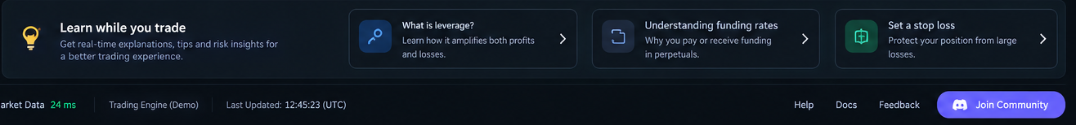
Reference: contextual learning cards.
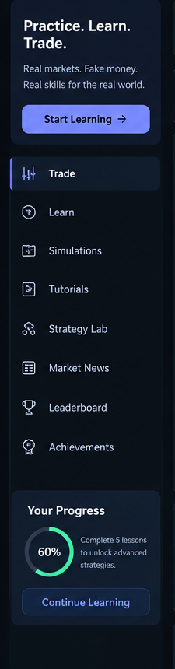
Reference: left-side learning navigation and progress.
Component | Trigger | Example
Progress | Curriculum milestones | Lesson 4 of 7
LearningPrompt | Relevant action | What is leverage?
Popover | Click/focus on jargon | Mark Price definition
Sheet / Drawer | Learn more | How liquidation works
Accordion | Long reference | Funding mechanics
Questionnaire | Onboarding | Experience level
Empty | No positions/orders | Place a demo trade to see the lifecycle

13. Feedback, loading & reliability
State | UI | Rule
Loading | Skeleton | Preserve final geometry.
Live | Green dot + Live | Small, not distracting.
Reconnecting | Amber status + reconnect copy | Do not pretend stale data is live.
Stale market | Visible stale indicator | Stop implying live prices.
Order rejected | Inline reason + Toast | Restore control immediately.
Order filled | Toast + row highlight + chart marker | Highlight once.
Empty | Teaching empty state | Give the next action.

14. Responsive & accessibility
- Desktop: navigation + chart + orderbook + order entry + bottom outcome panel.
- Tablet: chart remains primary; orderbook becomes collapsible.
- Mobile: chart first, order entry in Sheet, positions/cards below.
- Touch targets at least 44×44px.
- Visible focus rings; no hover-only core education.
- Never use green/red alone; pair with Long/Short and positive/negative semantics.
- Respect reduced motion.
- Use accessible names for icon-only chart tools and account controls.

15. Frontend architecture & performance
Vite + React + TypeScript
├── Tailwind + shadcn/ui
├── Zustand → UI + normalized realtime snapshots
├── TanStack Query → REST/server state
├── Native WebSocket → market + account realtime
├── Web Worker → orderbook/high-frequency calculations
├── Lightweight Charts → candlestick chart
├── Decimal.js → precise client calculations
├── Zod → runtime validation
├── React Hook Form → forms
├── Framer Motion → UI transitions only
└── Vitest + Playwright → unit + E2E

15.1 Realtime path
WebSocket
→ message router
→ sequence validation
→ market-data engine
→ Web Worker (when needed)
→ latest snapshot
→ narrow Zustand subscriptions
→ React component
→ frame-synced paint
- Do not poll live prices when WebSocket is available.
- Maintain orderbook incrementally; sequence gaps trigger snapshot resync.
- Process every market event internally but throttle visual painting to browser frames.
- Market updates must not rerender navigation, learning cards or unrelated panels.
- Use incremental chart updates rather than replacing the full dataset.
- Backend/simulator engine is authoritative for fills, balance, margin and liquidation.

16. Security & trust model
- Frontend validation is UX only; backend validation is authoritative.
- Do not store private keys, seed phrases or session secrets in localStorage/sessionStorage.
- Prefer secure HttpOnly cookies for sessions when supported by the backend architecture.
- Use HTTPS + WSS in production.
- Use a strict Content Security Policy and minimize third-party scripts.
- Order requests should support idempotency/deduplication on the backend.
- Rate limiting, authorization and account-state checks belong on the backend.

17. Core learner journeys

17.1 Signed-out user
1. Browse public market/chart if enabled.
2. See educational order panel.
3. CTA reads `Log in to trade` — never Open Long/Open Short.
4. Click opens Login and preserves selected market.
5. After login, the panel upgrades to demo execution without losing context.

17.2 First trade
1. Explain Limit vs Market.
2. Use small default size.
3. Show margin and estimated liquidation before submit.
4. Submit → Submitting… → simulator acknowledgement.
5. Position appears; chart shows entry.
6. Explain PnL and Mark Price.
7. Offer next lesson.

17.3 Loss / liquidation review
1. PnL moves negative without screen-wide flashing.
2. Risk hint appears near margin/leverage.
3. If liquidation occurs, explain why using the exact position numbers.
4. Review entry, exit/liquidation, leverage, margin and PnL.
5. Recommend the next risk-control lesson.

18. Implementation checklist
□ Centralized semantic color tokens.
□ Purple reserved for account/learning primary actions.
□ Green/red reserved for Long/Short, outcome and danger semantics.
□ Login centered; signup split-screen desktop.
□ Signed-out trade CTA is `Log in to trade` / `Create free account`.
□ Authenticated trade CTA is `Open Long (Demo)` / `Open Short (Demo)`.
□ shadcn/ui primitives are the canonical component layer.
□ Framer Motion used only for intentional UI transitions.
□ Orderbook/market feed isolated from normal React rendering.
□ Web Worker available for high-frequency processing.
□ Lightweight Charts used for candlesticks.
□ Decimal.js used for precise decimal calculations.
□ Practice mode and virtual-money status always visible when trading.
□ Learning progress is separate from PnL.
□ Loading, stale, reconnect, rejected and filled states explicitly designed.
□ Playwright covers auth, signed-out gate, first trade, rejection, position update and close.

19. Final design language
Tone: calm, instructional, precise. The product should feel credible enough to teach real trading mechanics while repeatedly reminding the learner that the account is simulated. Prefer “Practice trading”, “Learn how leverage works”, “Virtual balance”, “Estimated liquidation price”, “Open Long (Demo)” and “Log in to trade”. Avoid hype, guaranteed-profit language and deposit-like calls to action.

