PROJECT REPORT
PROFESSIONAL TRAINING
PERFORMANCE MANAGEMENT SYSTEM
A Web-Based Application Developed Using Python and Streamlit
Submitted By
Vivek Yadav
B.Tech – Computer Science & Engineering (Data Science)
Lloyd Institute of Engineering & Technology
Academic Session: 2026–2027

CERTIFICATE
This is to certify that the project titled “Professional Training Performance Management System” is a project report prepared by Vivek Yadav as part of his academic/professional training work. The project demonstrates the application of Python programming and Streamlit to develop an interactive system for organizing training-related information and monitoring performance.
The work presented in this report describes the purpose, design, technology stack, workflow, implementation approach, testing strategy, and future scope of the application.
Date: ____________________
Place: ___________________
Project Guide / Mentor: ______________________________
Department: _________________________________________

DECLARATION
I hereby declare that the project report titled “Professional Training Performance Management System” has been prepared for academic and professional training purposes. The project is intended to demonstrate practical skills in Python, Streamlit, data processing, web application development, and performance-oriented reporting.

ACKNOWLEDGEMENT
I sincerely thank my institute, faculty members, mentors, and everyone who supported me during the development and documentation of this project. I am also thankful to the Python and Streamlit communities and their documentation for providing the technical foundation required to build an interactive application.

TABLE OF CONTENTS
1. Abstract
2. Introduction
3. Problem Statement
4. Objectives
5. Scope of the Project
6. Existing and Proposed System
7. Technology Stack
8. System Requirements
9. System Architecture
10. Functional Modules
11. Project Management Module
12. Data and Performance Management
13. Application Workflow
14. Implementation Approach
15. Testing and Validation
16. Security and Reliability Considerations
17. Advantages and Limitations
18. Future Enhancements
19. Conclusion
20. References
21. Appendix – Application Screenshot

1. ABSTRACT
The Professional Training Performance Management System is a web-based application developed using Python and Streamlit. The purpose of the system is to provide a structured and interactive environment for organizing professional training information and monitoring learner or participant performance.
Training programs commonly generate information about projects, training activities, participants, assessments, attendance, progress, and supporting documents. Managing these records manually can make it difficult to maintain consistency and obtain a consolidated view of progress. This project addresses that problem through a lightweight browser-based interface.
The application uses Python for processing and business logic and Streamlit for the user interface. The system can be extended to manage project/training records, assessment results, performance indicators, and supporting documents. The visible project-management interface provides fields for project name, associated institution/organization, client name, project status, start/end dates, description, and project-document upload.
The project demonstrates practical knowledge of Python application development, Streamlit components, form handling, data processing, user interaction, and performance reporting.

2. INTRODUCTION
Professional training is an important part of academic and organizational skill development. A training program may contain multiple activities and projects, and each activity can have its own timeline, description, status, and supporting documentation. A performance management system helps convert these records into organized information that can be reviewed by learners, trainers, or administrators.
The proposed application focuses on a simple and accessible user experience. Instead of requiring a separate frontend and backend framework for a small-scale application, Streamlit allows the interface to be created directly with Python. This makes the project suitable for rapid development, demonstration, and future expansion.
The system is designed around the principle of collecting structured information first and then using that information to generate useful summaries and performance views.

3. PROBLEM STATEMENT
Manual management of training and project information can result in scattered records, repetitive data entry, difficulty tracking ongoing work, and time-consuming performance calculations. When project details and performance records are stored in different places, it becomes harder to understand overall progress.
The problem addressed by this project is the need for a lightweight application that can organize training/project information and provide a foundation for systematic performance monitoring.

4. OBJECTIVES
- Develop an interactive web application using Python and Streamlit.
- Create a structured interface for entering and managing professional training/project information.
- Maintain important project details such as name, organization, client, status, dates, and description.
- Support project-document upload so relevant evidence can be associated with a project.
- Provide a foundation for recording and analyzing training performance.
- Reduce manual calculations and repetitive record management.
- Present information in a clear and user-friendly format.
- Design the system so that database integration, authentication, analytics, and reporting can be added later.

5. SCOPE OF THE PROJECT
The system is intended for small to medium-sized professional training programs, academic skill-development activities, internships, project-based learning, and similar performance-tracking scenarios.
- Training/project record creation and management.
- Project status tracking, including ongoing and completed activities.
- Start and end date management.
- Project description and associated organization/client information.
- Upload and association of supporting project documents.
- Performance data management as an extensible module.
- Dashboard and summary views as the application is expanded.
- Future report generation and analytics.

6. EXISTING AND PROPOSED SYSTEM
Aspect | Manual / Existing Approach | Proposed Application
Record keeping | Multiple files or spreadsheets | Structured web interface
Project status | Manually checked | Ongoing/completed status field
Dates | Separate manual records | Start and end date fields
Documentation | Stored separately | Project document upload
Calculations | Manual formulas | Python-based processing
Access | File-dependent | Browser-based Streamlit application
Expansion | Difficult to standardize | Modular and extensible

7. TECHNOLOGY STACK
Technology | Role in the Project
Python | Application logic, data processing, validation and calculations
Streamlit | Interactive web interface and dashboard components
Pandas | Tabular data handling, filtering and analysis where required
NumPy | Numerical processing where required
Matplotlib / Plotly | Optional performance charts and visual analytics
CSV / Excel / Database | Possible data storage layer depending on deployment
VS Code / Jupyter | Development, experimentation and testing
The core implementation is Python + Streamlit. Supporting libraries can be included according to the data source and analytics requirements of the deployed version.

8. SYSTEM REQUIREMENTS

8.1 Hardware Requirements
- Processor: Dual-core processor or better.
- RAM: 4 GB minimum; 8 GB recommended for development.
- Storage: At least 500 MB for the project and Python environment.
- Standard laptop/desktop display.
- Internet connection for package installation or cloud deployment.

8.2 Software Requirements
- Windows, Linux, or macOS.
- Python 3.x.
- Streamlit and required Python packages.
- VS Code or another Python-compatible IDE.
- Modern web browser such as Chrome, Edge, or Firefox.

9. SYSTEM ARCHITECTURE
The application follows a simple data-processing architecture. Users interact with Streamlit widgets. Input is validated by Python logic and then stored or processed through the selected data layer. The processed information can be displayed as tables, metrics, status indicators, and charts.
Layer | Responsibility
Presentation Layer | Streamlit forms, inputs, buttons, tables, metrics and charts
Application Layer | Python validation, calculations, filtering and business rules
Data Layer | CSV/Excel/database records, depending on deployment
Document Layer | Supporting project files uploaded through the application
Reporting Layer | Summaries, performance indicators and visual reports

10. FUNCTIONAL MODULES

10.1 Project / Training Record Module
This module captures the main information associated with a professional training project. The interface shown in the application contains fields for Project Name, Project Associated With (such as an institution or organization), Client Name, project status, Start Year/Month, End Year/Month, a brief description, and project-document upload.

10.2 Project Status Module
The interface includes an option to mark a project as ongoing. This provides a simple way to distinguish active work from work with a defined end date.

10.3 Document Management Module
The project interface provides an upload area for supporting project documentation. Such documents can serve as evidence of project work and can be associated with the relevant project record.

10.4 Performance Management Module
The broader system is designed to support performance tracking through structured indicators such as assessment score, completion percentage, attendance/participation, task completion, or other project-specific measures. The exact indicators can be configured according to the training program.

10.5 Dashboard / Reporting Module
A dashboard can summarize total projects, ongoing projects, completed projects, average scores, completion rates, and other indicators. Charts can be added to make trends and performance gaps easier to understand.

11. PROJECT MANAGEMENT MODULE
The project-management form is a key part of the application because project activities are often an important component of professional training. The form allows the user to capture the identity, association, timeline, status, description, and documentation of a project.
Field | Purpose
Project Name | Unique or recognizable name of the project
Project Associated With | Institution, organization or training body related to the project
Client Name | Client or stakeholder associated with the project, when applicable
Project Ongoing | Indicates whether the project is currently active
Start Year / Month | Beginning of project timeline
End Year / Month | End of project timeline when completed
Brief Description | Short explanation of project purpose and work
Project Document | Supporting document/evidence associated with the project
Document Title | Descriptive title for the uploaded document
This structured approach is more suitable for reporting than storing all information in a single free-text field.

12. DATA AND PERFORMANCE MANAGEMENT
Performance management requires consistent data. A typical record may contain a participant identifier, training/project name, activity, score, maximum score, attendance or participation, completion status, and remarks.
Indicator | Example Calculation / Interpretation
Score Percentage | (Obtained Score / Maximum Score) × 100
Completion Rate | (Completed Activities / Total Activities) × 100
Attendance Rate | (Sessions Attended / Total Sessions) × 100
Average Score | Average of recorded assessment scores
Project Status | Ongoing or completed based on project state
Performance Gap | Difference between current performance and target threshold
These calculations are examples of performance indicators that can be implemented in Python. Thresholds should be configured according to the requirements of the training program rather than treated as universal standards.

13. APPLICATION WORKFLOW
1. User opens the Streamlit application.
2. User enters project/training information through the form.
3. Python validates required fields and input values.
4. The record is stored in the selected data source.
5. Supporting documents can be uploaded and associated with the record.
6. Performance-related data can be processed using Python.
7. The application displays summaries, status information, tables, and visualizations.
8. Users can review progress and identify records requiring attention.

14. IMPLEMENTATION APPROACH

14.1 Streamlit Interface
Streamlit provides widgets such as text inputs, selection controls, checkboxes, date controls, text areas, file uploaders, buttons, metrics, and data tables. These components allow the application to be developed with a Python-first approach.

14.2 Input Validation
Required fields should be checked before a record is saved. Date values should be logically consistent, such as ensuring an end date is not earlier than the start date. Uploaded files should also be checked for permitted file types and reasonable file size.

14.3 Data Processing
Python can clean, filter, transform, and calculate values before presenting them to the user. Pandas is suitable when the application uses tabular datasets.

14.4 Visualization
Performance information can be represented using summary metrics and charts. Examples include score distributions, completion trends, attendance percentages, and project-status counts.

14.5 Error Handling
The application should provide clear messages when required fields are missing, values are invalid, a file is unsupported, or an operation cannot be completed.

15. TESTING AND VALIDATION
Test Case | Expected Result
Submit form with required fields empty | Application asks user to provide required information
Enter valid project details | Record is accepted and processed
Mark project as ongoing | Ongoing status is retained and end-date handling follows application rules
Enter inconsistent dates | Application rejects or requests correction
Upload supported project document | File is accepted according to configured limits
Upload unsupported file | Application displays an appropriate validation message
Calculate score percentage | Correct percentage is produced
Open dashboard/report | Processed information is displayed without calculation errors
Testing should be repeated after every major change to the data model, interface, calculations, or file-handling logic.

16. SECURITY AND RELIABILITY CONSIDERATIONS
- Validate all user inputs before processing.
- Restrict uploaded file types and sizes.
- Avoid exposing sensitive information in dashboard outputs.
- Use authentication and authorization if the system is deployed for multiple users.
- Use a secure database rather than plain local files for production-scale deployment.
- Keep regular backups of important records and documents.
- Log application errors without exposing confidential data to end users.

17. ADVANTAGES AND LIMITATIONS

17.1 Advantages
- Simple browser-based interface.
- Python-first development reduces frontend complexity.
- Structured project and training information.
- Supports interactive data analysis and visualization.
- Easy to demonstrate and extend.
- Can evolve from a local prototype into a deployed application.

17.2 Limitations
- A local-file storage approach is not ideal for large multi-user deployments.
- Authentication and role-based access may need to be added.
- Advanced analytics require a sufficiently large and clean dataset.
- Document storage needs additional design for production environments.
- The exact performance indicators depend on the training program's requirements.

18. FUTURE ENHANCEMENTS
- User login and role-based access for trainees, trainers, and administrators.
- Integration with MySQL or another production database.
- Automated PDF/Excel performance reports.
- Email notifications for deadlines and low-performance indicators.
- Advanced dashboards with historical performance trends.
- Machine-learning based performance prediction after sufficient historical data is available.
- Feedback and trainer-review module.
- Cloud deployment for secure remote access.
- Audit logs and version history for project records.
- Mobile-friendly interface and API integration.

19. CONCLUSION
The Professional Training Performance Management System demonstrates how Python and Streamlit can be used to create a practical, interactive web application for organizing professional training and project information. The application provides a structured approach to recording project details, tracking status and timelines, associating supporting documents, and creating a foundation for performance analysis.
The project combines programming, data processing, user-interface development, and reporting concepts in a single application. With database integration, authentication, automated reporting, and advanced analytics, the system can be further developed into a more complete training-management platform.

20. REFERENCES
- Python Documentation – Python programming language documentation.
- Streamlit Documentation – Streamlit framework documentation.
- Pandas Documentation – Data analysis and manipulation library.
- NumPy Documentation – Numerical computing library.
- Matplotlib / Plotly Documentation – Data visualization libraries.

21. APPENDIX – APPLICATION SCREENSHOT
The following screenshot shows the Add Projects interface of the application. It demonstrates the project-information form and document-upload functionality.
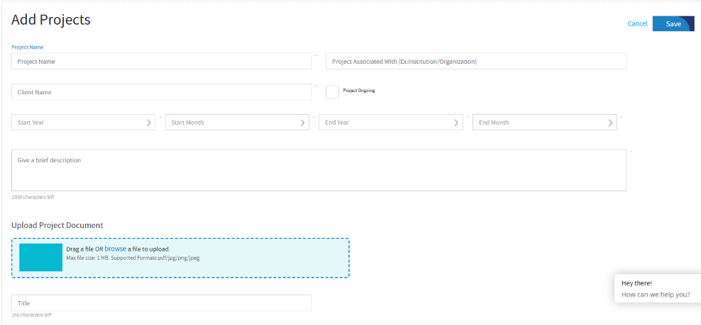
Figure 1: Add Projects interface of the Professional Training Performance Management System

