**Bank Data Warehouse – Dimensional Modeling**

**Project Name:** Bank Data Warehouse – Dimensional Modeling

## 1. Project Overview

The objective of this project is to design and implement a **Dimensional Data Model (Star Schema)** in **MySQL** for the bank’s operational data from multiple CSV files. This will enable efficient **analytics, reporting, and business intelligence** for banking operations including transactions, payments, loans, and credit cards.

## 2. Source Data

| File Name | Key Columns |
| --- | --- |
| transaction.csv | TransactionID, AccountID, Amount, TransactionType, Date |
| payments.csv | PaymentID, Amount, Fee, FromAccountID, ToAccountID, PaymentDate, PaymentType, CustomerSegment, ExchangeRate |
| loans.csv | LoanID, CustomerID, BranchID, EmployeeID, LoanAmount, InterestAmount, OutstandingBalance |
| employee.csv | EmployeeID, FirstName, LastName, BranchID, ManagerID, Position, HireDate |
| cust.csv | CustomerID, FirstName, LastName, DateOfBirth, Email, PhoneNumber, Address, BranchID |
| creditcard.csv | CardID, CardNumber, CardType, CreditLimit, CustomerID, Balance, IssueDate, ExpirationDate, InterestRate, BillCycle, Status |
| branches.csv | BranchID, BranchName, Address, City, State, Zipcode |
| accounts.csv | AccountID, AccountType, Balance, CreditScore, Currency, CustomerID, DateOpened, ManagerID, ODLimit |

## 3. Fact and Dimension Tables

### Dimension Tables

* **dim_customer**: CustomerID (PK), FirstName, LastName, DateOfBirth, Email, PhoneNumber, Address, BranchID (FK)
* **dim_branch**: BranchID (PK), BranchName, Address, City, State, Zipcode
* **dim_employee**: EmployeeID (PK), FirstName, LastName, BranchID (FK), ManagerID, Position, HireDate
* **dim_account**: AccountID (PK), AccountType, Balance, CreditScore, Currency, CustomerID (FK), DateOpened, ManagerID (FK), ODLimit
* **dim_creditcard**: CardID (PK), CardNumber, CardType, CreditLimit, CustomerID (FK), Balance, IssueDate, ExpirationDate, InterestRate, BillCycle, Status

### Fact Tables

* **fact_transactions**: TransactionID (PK), AccountID (FK), CustomerID (FK), BranchID (FK), TransactionAmount, TransactionFee, TransactionType, TransactionDate
* **fact_payments**: PaymentID (PK), FromAccountID (FK), ToAccountID (FK), CustomerSegment, Amount, Fee, ExchangeRate, PaymentType, PaymentDate
* **fact_loans**: LoanID (PK), CustomerID (FK), BranchID (FK), EmployeeID (FK), LoanAmount, InterestAmount, OutstandingBalance
* **fact_creditcards**: CreditCardFactID (PK), CardID (FK), CustomerID (FK), Balance, CreditLimit, InterestRate

## 4. ER Diagram

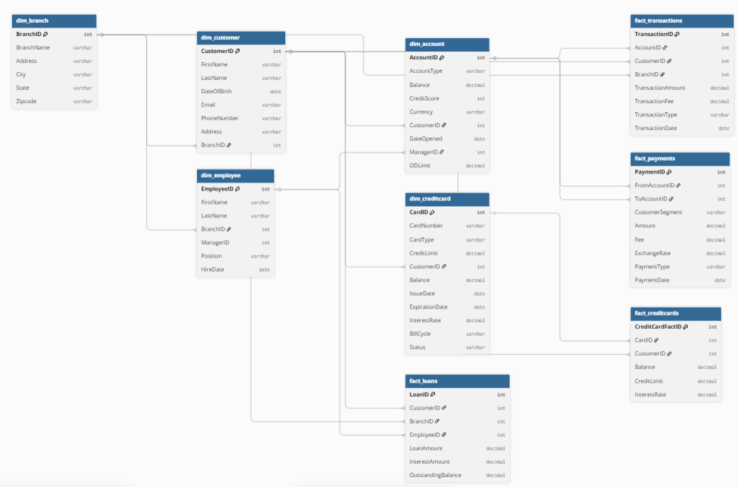

## 5. Notes

1. Foreign key constraints link fact tables to dimensions.
2. Each fact row represents a single transactional event.
3. Dimensions can implement SCD Type 2 using StartDate, EndDate, IsCurrent for historical tracking.
4. This DBML can be visualized using tools like **DBDiagram.io** for ERD representation.