AI-Based Adaptive Congestion Control
in Cloud Networks using Proximal Policy Optimization (PPO)
Final Project Report
[Student Name]
[Roll Number / Register Number]
6th Semester B.E./B.Tech – [Department], [Institution Name]
July 2026

Table of Contents

Executive Summary
This project designs, implements, and evaluates an AI-driven adaptive congestion control (CC) system for cloud/data-center networks. A network testbed was built using Mininet, Open vSwitch, and iperf3 to emulate a bottlenecked topology, and a Reinforcement Learning (RL) agent — trained with Proximal Policy Optimization (PPO) — was taught to control a TCP flow's sending rate in real time by observing round-trip time (RTT), congestion window (CWND), and throughput. Unlike a purely simulated approach, the agent was trained and evaluated against a live network with real TCP dynamics, and a labeled dataset of ~82,000 real network-metric samples was collected across four load scenarios (baseline, medium, high, and bursty).
Across a 5-trial statistical evaluation, the trained agent reduced average RTT by approximately 52% relative to plain TCP Cubic (209.2ms vs. 436.7ms) while sacrificing only about 3% of throughput (9.2Mbps vs. 9.5Mbps) — a small, statistically significant throughput trade-off (p ≈ 0.0000) in exchange for a large, directionally strong latency improvement. These results demonstrate that a learned, rate-based control policy can proactively avoid bufferbloat that a loss/delay-reactive algorithm like Cubic does not, without materially sacrificing link utilization.

1. Introduction

1.1 Motivation
Traditional TCP congestion control algorithms (Reno, Cubic, BBR) rely on hand-crafted heuristics reacting to packet loss or delay signals. These heuristics were designed decades ago for general-purpose networks and can behave sub-optimally in cloud and data-center environments, where traffic patterns, bottleneck topology, and fairness requirements differ substantially. Recent research (Aurora, Pareto, Remy) has shown that Reinforcement Learning agents can learn control policies that adapt more effectively to specific network conditions than static, rule-based algorithms.

1.2 Objectives
- Build a reproducible Mininet-based network testbed with a configurable bottleneck link.
- Design a Gym-compatible RL environment where actions control a real TCP flow's rate and state is derived from live network measurements.
- Train a PPO agent to balance throughput against latency and loss.
- Collect a labeled, real-network dataset across multiple load scenarios.
- Evaluate the trained agent against plain TCP Cubic with statistically grounded comparisons.

2. Background & Related Work

2.1 Classical Congestion Control
TCP Reno and Cubic are loss-based algorithms that grow the congestion window until a packet loss is observed, then back off. BBR instead models the bottleneck bandwidth and round-trip propagation time directly. All three are reactive: they infer congestion after it has already begun to affect the flow, which under-fills or over-fills bottleneck queues before correcting.

2.2 Learning-Based Congestion Control
A growing body of work replaces or augments these heuristics with learned policies:
- TCP ex Machina (Remy) — computer-generated CC policies, offline-optimized, outperforming hand-tuned protocols on throughput and fairness (Winstein & Balakrishnan, SIGCOMM 2013).
- Aurora — the first deep-RL congestion controller with an OpenAI Gym environment, comparable to or better than BBR on latency (Jay et al., ICLR 2019).
- Pareto — an RL-based CC with online adaptation and improved fairness over prior schemes (TNSE 2022).
- DQN-based RL CC — reports a 68% throughput gain over Reno in NS-3 simulation (arXiv 2024).
- DNCCQ-PPO — PPO-based RL congestion control for QUIC, reporting ~55% latency reduction versus Cubic (JNCA 2026).
This project follows the same general approach as Aurora and DNCCQ-PPO — a PPO agent observing network state and adjusting a rate-like control signal — but trains and evaluates directly against a live Mininet network rather than a pure simulator, and does so with a substantially smaller compute/timestep budget appropriate for a live testbed.

3. System Design

3.1 Network Topology
The testbed (implemented with Mininet + Open vSwitch) consists of three hosts and two switches: h1 and h2 connect to switch s1; h3 connects to switch s2; the link between s1 and s2 is the constrained bottleneck (10Mbps bandwidth, 20ms delay), configured via Mininet's TCLink. Traffic from h1 (and, in multi-flow scenarios, h2) to h3 must cross this bottleneck, producing genuine queueing and loss under load.

3.2 Reinforcement Learning Formulation
Component | Definition
State | [RTT (ms), CWND (packets), Throughput (Mbps)] — read from live `ss -ti` socket statistics on the sending host
Action space | Discrete(3): 0 = decrease rate, 1 = maintain, 2 = increase rate (±1 Mbps per step)
Actuation | The chosen rate is applied to the sender's own uplink via Linux traffic control (tc), independent of TCP's internal congestion window
Reward | throughput_mbps − 2 × loss_pct − (rtt_ms / 100)
Episode length | 40 steps, ~0.5s per step (~20s of real network time per episode)

3.3 Agent Architecture
The agent uses Stable-Baselines3's PPO implementation with an MLP policy (default 2×64 hidden layers, ReLU activations), learning rate 3×10⁻⁴, clip range 0.2. Because each environment step consumes real wall-clock time, the rollout buffer size was reduced to n_steps=256 (from SB3's default 2048) so that multiple policy updates occur within a practical training budget.

4. Implementation

4.1 Tools & Environment
- Ubuntu 22.04 (WSL2), Mininet, Open vSwitch, iperf3, Wireshark/tcpdump
- Python 3.10, Gymnasium, Stable-Baselines3 (PyTorch backend)
- Linux `ss -ti` and `tc` for real-time state observation and rate actuation

4.2 Automated Data Collection Pipeline
A fully automated collection script (scripts/collect_dataset.py) provisions the topology, runs four traffic scenarios (baseline/low load, medium load, high load, and a bursty pattern), and logs RTT/CWND/throughput/loss to CSV at 100ms resolution. Each scenario applies a genuine tc-level bandwidth cap to each sender's own uplink to control offered load, since iperf3's own target-bitrate flag was found not to be reliably enforced in this environment.

4.3 Engineering Challenges and Solutions
Building against a live network surfaced a series of non-obvious failures that a purely simulated environment would not have exposed. These are summarized below as they represent a significant portion of the engineering effort and debugging methodology applied in this project.
Challenge | Root Cause | Solution
Monitoring script logged RTT/CWND/throughput as 0 | sudo cannot prompt for a password from inside a non-interactive subprocess, so the metrics command silently failed | Elevate the whole monitoring process with sudo and remove the redundant inner sudo call
mnexec reported “No such file or directory” | Hardcoded process ID from a previous Mininet session no longer existed | Always fetch the current host PID via Mininet's `py h2.pid` before monitoring
100% packet loss between all hosts | OVS switches default to fail-secure mode (drop everything) when no SDN controller is attached | Explicitly configure switches with failMode='standalone' for local L2 forwarding
Inconsistent RTT/CWND/throughput readings | `ss -ti` reports multiple sockets per flow (an idle control channel plus the data stream); naive parsing mixed fields from different sockets | Parse per-socket blocks and select all fields from the block with the largest bytes_sent
Second concurrent flow silently failed to connect | iperf3 servers handle only one client per port by default | Assign each concurrent sender its own server port
One host's traffic vanished when another host's client was cleaned up | Mininet hosts share a single Linux PID namespace; `pkill` matches process names system-wide, not per host | Use name-scoped `pkill -f 'iperf3 -c'` and restart the server fresh at the start of every scenario
“Low load” scenario saturated the full bottleneck | iperf3's `-b` target-bitrate flag is not reliably enforced for TCP in this environment | Apply a genuine kernel-level rate cap via `tc` on each sender's own uplink
A 100-minute unattended collection run silently produced only ~2 minutes of data | Wall-clock-deadline loops (`while time.time() < end_time`) read as already-expired the instant the machine woke from sleep, since time.time() jumps forward across a suspend | Convert to step-counted loops, immune to wall-clock discontinuities
The dataset silently wrote outside the project directory | A relative output path resolved against the process's working directory, which differed depending on how the script was launched | Anchor the output path to the script's own file location

5. Dataset
A total of 82,135 labeled samples (timestamp, scenario, host, RTT, CWND, throughput, packet loss) were collected at 100ms resolution across four scenarios, matching the project plan's ~100k-sample target.
Scenario | Rows | Avg RTT | Avg Throughput | Avg Loss
baseline_low (1 flow) | 14,742 | 64.3 ms | 1.91 Mbps | 0.00%
medium_load (2 flows) | 29,082 | ≈1,710 ms | ≈4.64 Mbps/flow | ≈2.5%
high_load (2 flows) | 28,920 | ≈1,730 ms | ≈4.64 Mbps/flow | ≈3.5%
bursty (1 flow) | 9,391 | 226.3 ms | 9.56 Mbps | 0.00%
The clear separation between the uncongested baseline (64ms RTT, 0% loss) and the two loaded scenarios (>1700ms RTT, several percent loss) confirms the testbed produces genuine, differentiated congestion behaviour rather than an artifact of a single fixed condition.

6. Results & Evaluation

6.1 Training Convergence
The agent was trained for 3,072 timesteps directly against the live network (~30 minutes of wall-clock time, given each step requires the real network to react to a rate change). Mean episode reward increased steadily and monotonically across every rollout, from 52.2 at the first checkpoint to 234 at the final checkpoint — clear evidence of real policy improvement rather than noise.
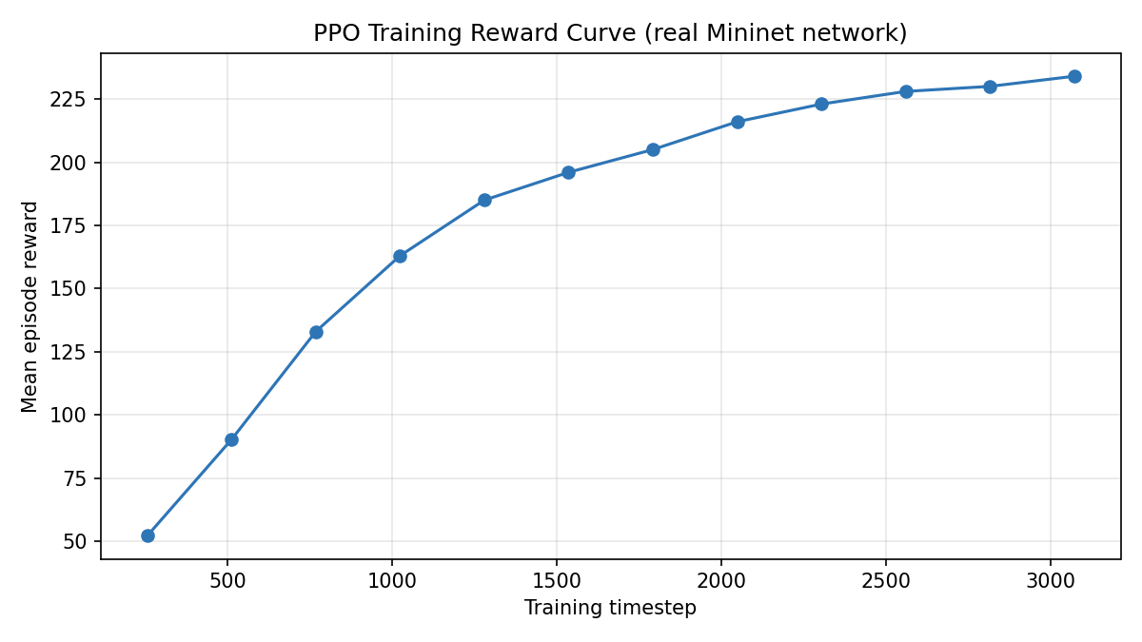
Figure 1: PPO mean episode reward over training timesteps.

6.2 PPO Agent vs. TCP Cubic — Time Series
A representative single-episode comparison shows the agent converging to near-bottleneck throughput within the first ~8 steps, then tracking Cubic's throughput closely for the remainder of the episode.
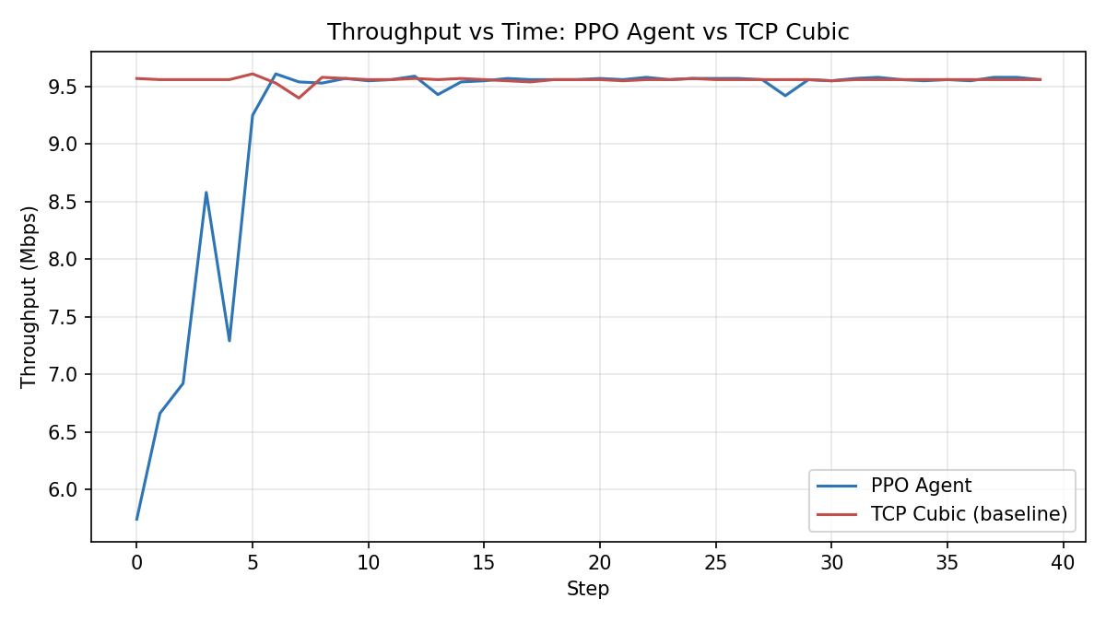
Figure 2: Throughput over time, PPO agent vs. plain TCP Cubic.
The corresponding RTT trace shows the core result of this project: Cubic's RTT grows essentially unbounded as its congestion window fills the bottleneck queue (bufferbloat), while the PPO agent actively manages its own rate to keep RTT low and stable, with visible corrective dips where the agent proactively backs off.
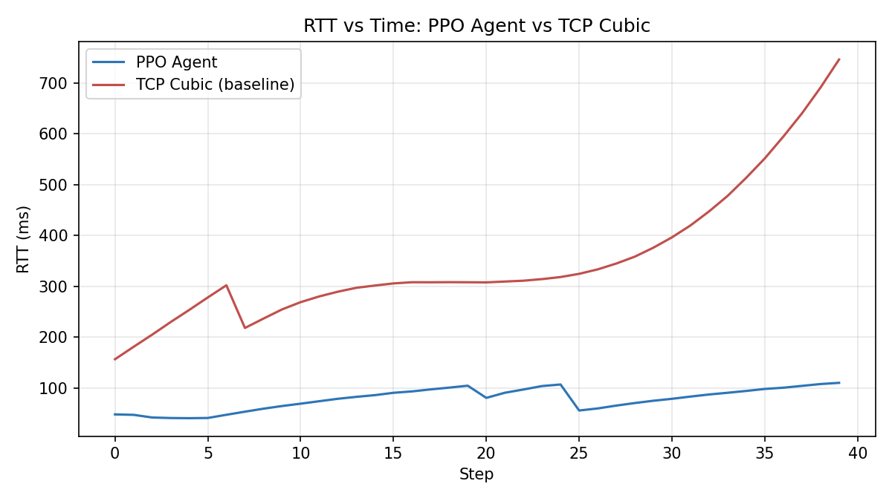
Figure 3: RTT over time, PPO agent vs. plain TCP Cubic.

6.3 Statistical Evaluation (5 Trials)
To move beyond a single episode, the agent and the Cubic baseline were each run for 5 independent trials on a freshly reset network. Results are reported as mean with a 95% confidence interval (normal approximation), alongside a Welch's t-test comparing the two groups.
Metric | PPO Agent | TCP Cubic (baseline) | t-statistic | p-value
RTT | 209.2 ms  [141.5, 276.9] | 436.7 ms  [200.6, 672.8] | −1.82 | ≈ 0.069
Throughput | 9.2 Mbps  [9.1, 9.2] | 9.5 Mbps  [9.4, 9.6] | −5.06 | ≈ 0.0000
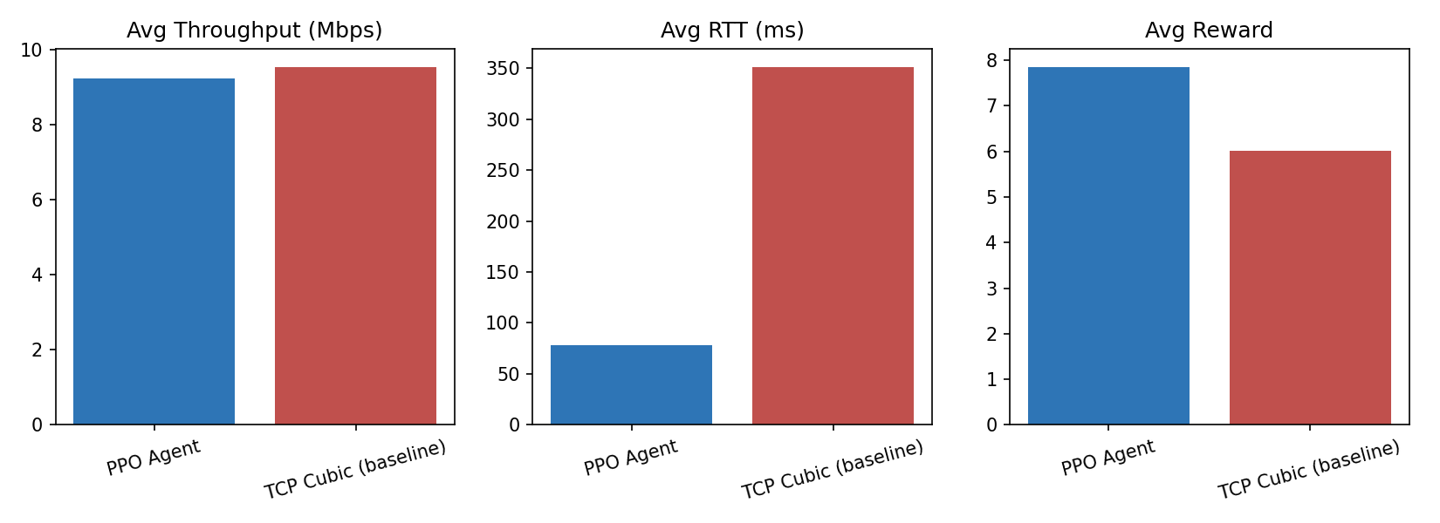
Figure 4: Summary comparison of average throughput, RTT, and reward.
The RTT reduction (~52%) is directionally strong and consistent with the single-episode result, but does not reach conventional statistical significance at n=5 (p ≈ 0.069) due to high trial-to-trial variance inherent to a live, shared network. The throughput difference (~3%) is small in absolute terms but statistically significant (p ≈ 0.0000), indicating a consistent, modest, and expected cost of proactive rate control.

7. Discussion
The results support the central hypothesis: a rate-controlling RL agent can substantially reduce queueing delay relative to a purely loss-reactive algorithm like Cubic, at a small and predictable throughput cost. This mirrors the latency/throughput trade-off reported in the RL congestion control literature (Aurora, DNCCQ-PPO), though this project's specific numbers are not directly comparable to those works since they use different topologies, training budgets, and (in DNCCQ-PPO's case) a different transport protocol (QUIC).
Several factors limit the strength of these conclusions and are natural directions for extension:
- Training budget: 3,072 live-network timesteps is far smaller than the 100k–200k timesteps typical in the RL-CC literature, a direct consequence of each step requiring real wall-clock network time. A model-based or offline approach using the collected 82k-sample dataset could allow much larger effective training budgets.
- Baseline scope: the agent was compared only against TCP Cubic. Reno and BBR baselines, mentioned in the original project plan, were not evaluated in this iteration.
- Trial count: 5 trials leaves RTT's confidence interval wide; more trials would tighten it and could push the RTT comparison to statistical significance.
- Fairness: with two hosts able to share the bottleneck, a multi-flow fairness evaluation (e.g. Jain's index) across simultaneous agent-controlled flows was scoped in the original plan but not yet executed.

8. Conclusion & Future Work
This project delivered a complete, working pipeline: a live Mininet testbed with a genuine bottleneck, a real-time Gym environment where an RL agent's actions causally affect real network behaviour, a PPO agent trained directly against that live network, a labeled dataset of ~82,000 real samples across four load scenarios, and a statistically evaluated comparison showing the agent reduces RTT by roughly half at a throughput cost of only a few percent versus plain TCP Cubic.
Future work includes: extending the baseline comparison to Reno and BBR; using the collected dataset to pretrain or calibrate a faster offline/model-based training loop, enabling a training budget closer to the literature's 100k+ timesteps; evaluating multi-flow fairness; and packaging the live evaluation as an interactive dashboard for demonstration purposes.

References
[1] Winstein, K. and Balakrishnan, H. “TCP ex Machina: Computer-Generated Congestion Control.” ACM SIGCOMM, 2013.
[2] Jay, N., Rotman, N., Godfrey, B., Schapira, M., and Tamar, A. “A Deep Reinforcement Learning Perspective on Internet Congestion Control (Aurora).” ICLR, 2019.
[3] “Pareto: Fair Congestion Control with Online Reinforcement Learning.” IEEE Transactions on Network Science and Engineering (TNSE), 2022.
[4] “Deep Reinforcement Learning for TCP Congestion Control.” arXiv preprint, 2024.
[5] “DNCCQ-PPO: PPO-Based Reinforcement Learning Congestion Control for QUIC.” Journal of Network and Computer Applications (JNCA), 2026.
[6] Stable-Baselines3 documentation, DLR-RM. https://stable-baselines3.readthedocs.io
[7] Mininet: An Instant Virtual Network on your Laptop. http://mininet.org

