NEURAL STYLE TRANSFER
Manojpraphakar T^{#1},Gokulasankar P^{#2},Kishokkumar S^{#3},Kowshika R^{#4},Muhammed Musthafa D^{#5}

^{#1,} Assistant Professor, Department of Computer Science and Engineering, Sri Shakthi Institute of Engineering and
Technology, Coimbatore Tamil Nadu,India.
#2,#3,#4,#5 UG Student, Department of Computer Science and Engineering, Sri Shakthi Institute of Engineering and
Technology, Coimbatore Tamil Nadu,India.

Abstract:

Changing over the semantic substance of an picture into diverse styles could be a troublesome picture preparing assignment. Maybe the foremost critical restricting calculate of past approaches was the need of visual representations that clearly spoken to semantic data and hence isolated picture substance from fashion. Here we utilize picture representations inferred from convolutional neural systems optimized for protest location that expressly uncover high-level picture data. We present a neural craftsmanship fashion calculation that can partitioned and recombine the content and fashion of characteristic pictures. The calculation permits you to form unused pictures of tall perceptual quality, combining the substance of any photo with the appearance of various popular works of art. Our comes about give unused experiences into profound picture representations learned by convolutional neural systems and illustrate their potential for high-level picture blend and control.
KEYWORDS:CONVOLUTIONAL NEURAL NETWORK,CONTENT IMAGE,STYLE IMAGE

I.Introduction

Style transfer from one image to another can be viewed as a texture transfer problem. The goal of texture transfer is to synthesize the texture of the source image while limiting the texture synthesis to preserve the semantic content of the target image. For surface blend, there's a wide run of capable non-parametric calculations that can synthesize photorealistic common surfaces by resampling pixels from a given source surface (7, 30, 8, 20). Most of the previous texture transfer algorithms are based on these non-parametric texture synthesis methods and use various methods to maintain the structure of the target image. For example, Efros and Freeman present a search map that displays the properties of the target image as follows:B.Image intensity to limit the texture synthesis process [8]. Hertzman et al. Use image analogy to transfer textures from an already stylized image to the target image [13]. It focuses on

preserving the approximate scale of the target image [1].Improve this algorithm by also supporting texture transfer with edge orientation information [22]. However, ideally, the style transfer algorithm should be able to extract the semantic content of the target image (e.g. objects and general landscape) and then pass the information to the texture transfer routine to represent the semantic content of the target image in the style of the source image. The fundamental need is therefore to find image representations that independently model changes in the semantic content of the image and its representation style.

It is presented. Such factorized representations have so far been realized only for a controlled subset of natural images, such as: B. Faces under different lighting conditions with letters in different fonts [29] or handwritten numbers and street addresses [17]. The general separation of content and style in natural images remains a very difficult problem. In any case, later progresses in profound convolutional neural systems [18] have delivered capable computer vision frameworks that learn to extricate high-level semantic data from characteristic pictures. Convolutional neural networks trained on well-labeled data for a specific task, such as object recognition, learn how to distill high-level image content into general feature representations that can be generalized across datasets. It has been shown that [6] It can also be transferred to other visual information processing tasks. In this work, we demonstrate how to independently process and manipulate the content and style of natural images using a general feature representation learned by a powerful network. Algorithm for performing image style transfer. Conceptually, it is a texture transfer algorithm that constrains texture synthesis methods through state-of- the-art convolutional neural network feature representation.Since the texture model is also based on a deep image representation, the style transfer method elegantly reduces to an optimization problem within a single neural network.New images are generated by matching feature representations of sample images in the context of texture synthesis (12, 25, 10) and by performing sample search to improve understanding of deep image representations (27, 24) .

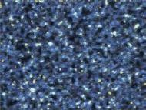
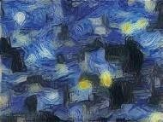
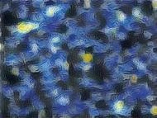
a b

Style Reconstructions

c d e

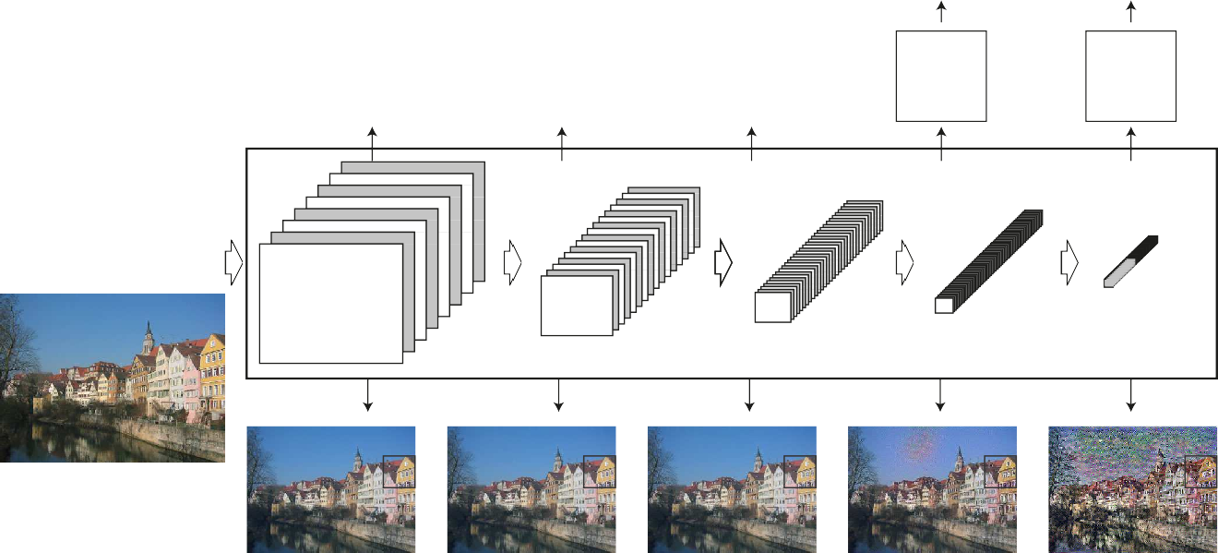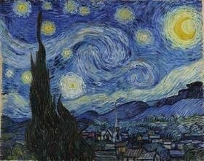




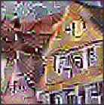

Figure 1. Picture representations in a Convolutional Neural Organize (CNN). A given input picture is spoken to as a set of sifted pictures at each preparing arrange within the CNN. Whereas the number of diverse channels increments along the preparing pecking order, the estimate of the sifted pictures is decreased by a few downsampling component (e.g. max-pooling) leading to a diminish within the add up to number of units per layer of the arrange. Substance Recreations. We are able picture the data at distinctive preparing stages within the CNN by remaking the input picture from as it were knowing the network's reactions in a specific layer. We reproduce the input image from from layers 'conv1 2' (a), 'conv2 2' (b), 'conv3 2' (c), 'conv4 2' (d) and 'conv5 2' (e) of the initial VGG-Network. We discover that recreation from lower layers is nearly idealize (a–c). In higher layers of the arrange, point by point pixel data is misplaced whereas the high-level substance of the picture is protected (d,e). Fashion Reproductions. On best of the initial CNN enactments we utilize a highlight space that captures the surface data of an input picture. The fashion representation computes relationships between the distinctive highlights completely different layers of the CNN. We reproduce the fashion of the input picture from a fashion representation built on distinctive subsets of CNN layers.
This makes pictures that match the fashion of a given picture on an expanding scale whereas discarding information of the worldwide course of action of the scene.

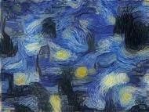
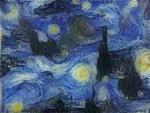
general feature representations that can be generalized across datasets. It has been shown that [6] It can also be transferred to other visual information processing tasks. In this work, we demonstrate how to independently process and manipulate the content and style of natural images using a general feature representation learned by a powerful network. Algorithm for performing image style transfer. Conceptually, it is a texture transfer algorithm that
constrains texture synthesis methods through state-of-the-art convolutional neural network feature representation.Since the texture model is also based on a deep image representation, the style transfer method elegantly reduces to an optimization problem within a single neural network.New images are generated by matching feature representations of sample images in the context of texture synthesis 12, 25, 10] and by performing sample search to improve understanding of deep image representations [27, 24] .In truth, our fashion

exchange calculation combines a parametric surface show based on convolutional neural systems [10] and a strategy for altering its picture representation [24].

Deep image reprsentations
The result comes about displayed underneath were produced on the basis of the VGG arrange [28], which was prepared to perform protest acknowledgment and localisation [26] and is portrayed ex- tensively within the unique work [28]. We utilized the include space given by a standardized adaptation of the 16 convo- lutional and 5 pooling layers of the 19-layer VGG arrange. We normalized the organize by scaling the weights such that the cruel enactment of each convolutional channel over pictures and positions is rise to to one. Such re-scaling can be done for the VGG organize without changing its yield, since it contains as it were correcting straight actuation capacities and no normalization or pooling over feature maps. We don't utilize any of the completely associated layers. The demonstrate is publicly accessible and can be investigated within the caffe-framework [14]. For picture blend we found that supplanting the greatest pooling operation by normal pooling yields somewhat

Content representation
Each layer within the organize characterizes a non- linear channel bank whose complexity increments with the position of the layer within the organize. Consequently a

Style representation
Fashion Representation To get a fashion representation of the input picture, we utilize a highlight space outlined to capture surface data [10]. This feature space can be constructed based on the filter responses in any layer of the network. This is the correlation between different filter responses, where the expectation is taken into account over the spatial extent of the feature map.These feature correlations are given by the Gram matrix Gl ∈ RNl×Nl, where Gl is the dot product between vectorized feature maps i and j in class l: class l.To imagine the picture data encoded at diverse layers of the chain of command, one can perform angle plummet on the white commotion picture to discover another picture that matches. characteristic response of the original image (Figure 1, content reconstruction) [24].
given input picture →x is encoded in each layer of the Convolutional Neural Organize by the channel reactions to that picture. A layer with Nl distinct channels has Nl highlight maps each of estimate Ml, where Ml is the stature times the width of the highlight outline. So the re- sponses in a layer l can be put away in a lattice Fl ∈ RNl×Ml where Fl is the enactment of the ith channel at position j in from which the slope with regard to the picture →x can be computed using standard blunder back-propagation (Fig 2, right). Hence we will alter the at first arbitrary picture→x until it produces the same reaction in a certain layer of the Convolutional Neural Organize as the first picture->x.

When Convolutional Neural Systems are prepared on object acknowledgment, they create a representation of the picture that creates question data progressively express along the preparing chain of command [10]. In this manner, along the process- ing progression of the arrange, the input picture is changed into representations that are progressively sensitive to the ac- tual substance of the picture, but gotten to be generally invariant to its exact appearance. In this way, higher layers within the organize capture the high-level substance in terms of objects and their course of action within the input picture but don't compel the ex- act pixel values of the reproduction exceptionally much (Fig 1, con- tent recreations d, e). In differentiate, recreations from the lower layers basically duplicate the precise pixel values of the initial picture (Fig 1, substance recreations a–c). We subsequently allude to the highlight reactions in higher layers of the arrange as the substance representation.

Let p→ and →x denote the original and generated images, as well as Pl and Fl..By introducing feature correlations of several classes, we obtain a multi-scale static representation of the input image, capturing its texture information but not the overall layout. Again, we can imagine the information collected by feature spaces of this type built on different. When Convolutional Neural Systems are prepared on object acknowledgment, they create a representation of the picture that creates question data progressively express along the preparing chain of command [10]. In this manner, along the process- ing progression of the arrange, the input picture is changed into representations that are progressively sensitive to the ac- tual substance of the picture, but gotten to be generally invariant to its exact appearance.

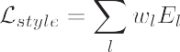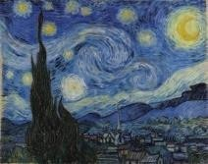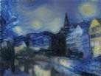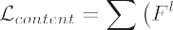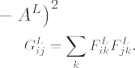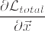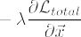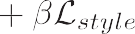
..
..
5
1 .
5
1 .
1
conv1_ ²
# feature
conv1_ ²
conv4_ 3 2
conv4_ 3 2

Figure 2. Fashion exchange calculation. To begin with substance and fashion highlights are extricated and put away. The fashion picture →a is passed through the arrange and its fashion representation Al on all layers included are computed and put away (cleared out). The substance picture p→ is passed through the arrange and the substance representation Pl in one layer is put away (right). At that point a irregular white commotion picture →x is passed through the organize and its fashion highlights Gl and substance highlights Fl are computed. On each layer included within the fashion representation, the element- wise cruel squared contrast between Gl and Al is computed to allow the fashion misfortune L style (cleared out). Moreover the cruel squared contrast between Fl and Pl is computed to allow the content loss L content (right). The full misfortune L total is at that point a direct combination between the substance and the fashion misfortune. Its subordinate with regard to the pixel values can be computed utilizing mistake back-propagation (center). This angle is utilized to iteratively upgrade the picture →x until it at the same time matches the fashion highlights of the fashion picture →a and the substance highlights of the

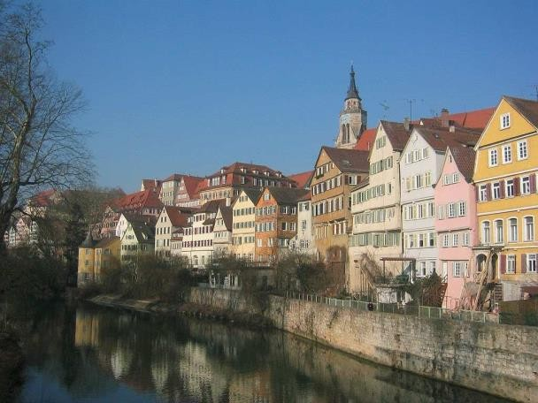
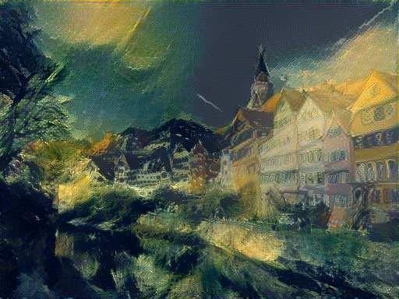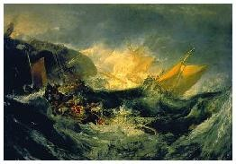A

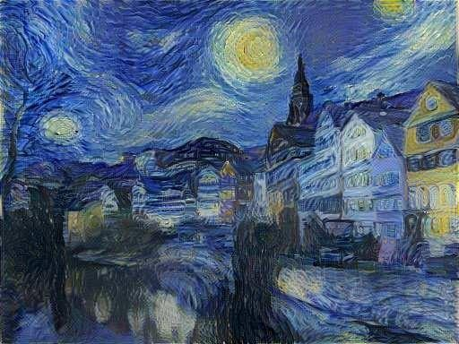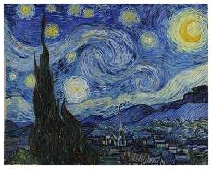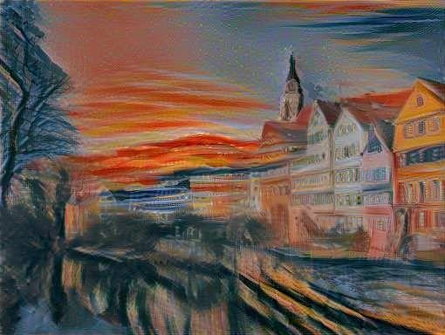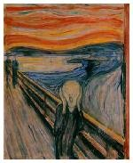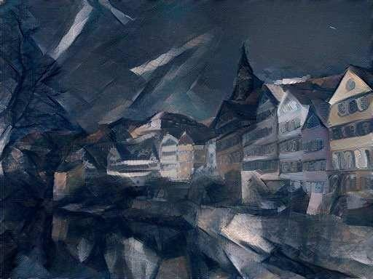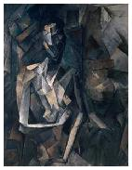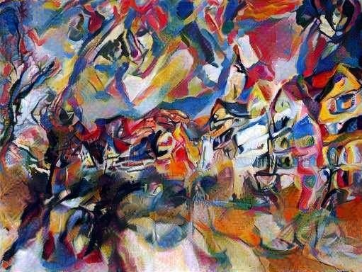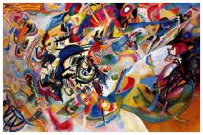

Figure 3. Pictures that combine the substance of a photo with the fashion of a few well-known works of art. The pictures were
made by finding an picture that at the same time matches the substance representation of the photo and the fashion representation of the craftsmanship. The initial photo portraying the Neckarfront in Tu¨bingen, Germany, is appeared in A (Photo: Andreas Praefcke). The portray that given the fashion for the respective generated picture is appeared within the foot cleared out corner of each board. B The Wreck 1805

Results
The key finding of this paper is that the representations of substance and fashion within the Convolutional Neural Network are well separable. That's , we are able control both representa- tions freely to deliver modern, perceptually meaning- ful pictures. To illustrate this finding, we produce im- ages that blend the substance and fashion representation from two distinctive source pictures. In specific, we coordinate the con- tent representation of a photo portraying the riverfront of the Neckar stream in Tu¨bingen, Germany and the fashion representations of a few well-known works of art taken from diverse periods of craftsmanship (Fig 3). The pictures appeared in Fig 3 were incorporated by coordinating the substance representation on layer 'conv4 2' and the fashion representation on layers 'conv1 1', 'conv2 1', 'conv3 1'. The proportion α/β was either 1 × 10−3 (Fig 3 B), 8 × 10−4 (Fig 3 C), 5 ×
10−3 (Fig 3 D), or 5 × 10−4 (Fig 3 E, F).

3.1 .Trade-off between substance and Style

Picture substance and fashion cannot be totally unraveled. When integrating an picture that combines the substance of one picture with the fashion of another, there as a rule does not exist an picture that superbly matches both limitations at the same time. In any case, since the misfortune func- tion we limit amid picture union may be a direct com- bination between the loss functions for substance and fashion separately, we will easily direct the accentuation on ei- ther reproducing the substance or the fashion (Fig 4). A solid emphasis on substance, one can clearly distinguish the photo- chart, but the fashion of the portray isn't as well-matched (α/β = 1 × 10−1, Fig 4, foot right). For a particular combine of substance and fashion pictures one can alter the trade-off be- tween substance and fashion to form outwardly engaging pictures.

Impact of diverse layers of CNN Layer
Another critical figure within the picture blend handle is the choice of layers to coordinate the substance and fashion repre- sentation on. As laid out above, the style representation could be a multi-scale representation that incorporates different layers of the neural arrange. The number and position of these lay- ers decides the neighborhood scale on which the fashion is coordinated, driving to diverse visual encounters (Fig 1, fashion recon- structions). We find that coordinating the fashion representations up to higher layers within the organize jam neighborhood pictures structures an progressively huge scale, driving to a smoother and more nonstop visual involvement. In this way, the outwardly most appealing pictures are more often than not made by coordinating the fashion representation up to tall layers within the organize, which is why for all pictures appeared we coordinate the fashion highlights in layers 'conv1 1', 'conv2 1', 'conv3 1', 'conv4 1' and 'conv5 1' of the To dissect the impact of utilizing diverse layers to coordinate the substance highlights, we show a fashion exchange result ob- tained by stylising a photo with the same craftsmanship and parameter arrangement (α/β = 1 × 10−3), but in one coordinating the substance highlights on layer 'conv2 2' and within the other on layer 'conv4 2' (Fig When coordinating the con- tent on a
lower layer of the organize, the calculation matches much of the detailed pixel data in the photo and the produced picture shows up as in the event that the surface of the craftsmanship- work is only mixed over the photo (Fig 5, mid- In differentiate, when coordinating the content highlights on a better layer of the organize, point by point pixel information of the photo isn't as unequivocally limitation and the surface of the artwork and the substance of the photo are prop- erly consolidated. That's , the fine structure of the image, for case the edges and colour outline, is changed such that it concurs with the fashion of the work of art whereas showing the substance of the photo (Fig 5, foot).

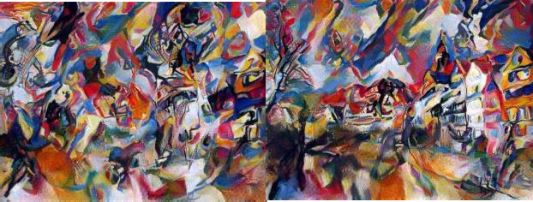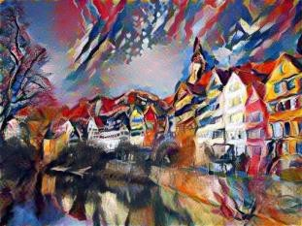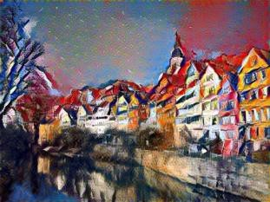

Figure 4. Relative weighting of coordinating substance and fashion of the individual source pictures. The proportion α/β between coordinating the substance and coordinating the fashion increments from best cleared out to foot right. A tall accentuation on the fashion viably produces a tex- turised adaptation of the fashion picture (beat cleared out). A tall accentuation on the substance produces an picture with as it were small stylisation (foot right). In hone one can easily insert between the two extremes. Accentuation on substance, one can clearly recognize the photo- chart, but the fashion of the portray isn't as well- matched (α/β = 1 × 10−1, Fig 4, foot right). For a particular match of substance and fashion pictures one can alter the trade-off be- tween content and fashion to form outwardly engaging pictures.

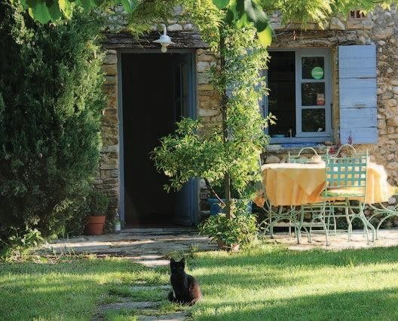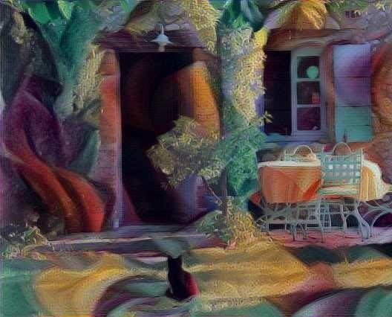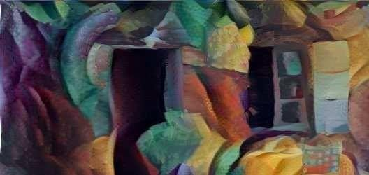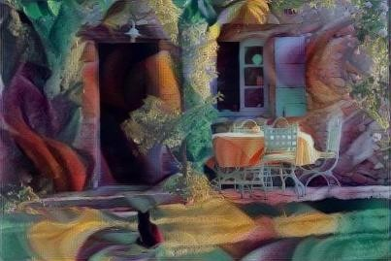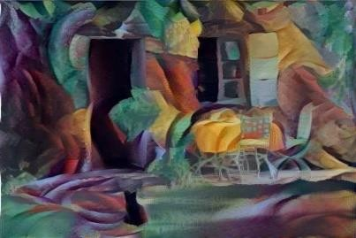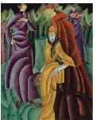Figure 5. The impact of coordinating the substance representation completely different layers of the organize. Coordinating the substance on layer 'conv2 2' preserves much of the fine structure of the initial pho- tograph and the incorporated picture looks as in case the surface of the portray is basically mixed over the photo (center). When coordinating the substance on layer 'conv4 2' the surface of the paint- ing and the substance of the photograph merge together such that the substance of the photo is shown within the fashion of the portray(foot). Both pictures were created with the same choice of dad- rameters (α/β = 1 × 10−3). The portray that served as the fashion picture is appeared within the foot cleared out corner and is named Jesuiten III by Lyonel Feininger, 1915.
Conv2_2
Conv4_2

Photorealistic fashion exchange
In this way distant the center of this paper was on imaginative fashion transfer. In common in spite of the fact that, the calculation can exchange the fashion between subjective pictures. As an illustration we exchange the fashion of a photo of Modern York by night onto an picture of London in daytime (Fig 6). In spite of the fact that photorealism isn't completely protected, the orchestrated picture takes after much of the colours and lightning of the fashion picture and to a few degree shows an picture of London by night.

Stsyle Image


Content Image


Figure 6. Photorealistic style transfer. The style was transferred from a photo of New York at night to a photo of London during the day. Image synthesis was started from the content image and the ratio α/β was 1 × 10−2

Discussion
Here we illustrate how to utilize highlight representations from high-performing Convolutional Neural Systems to exchange picture fashion between self-assertive pictures. Whereas we are ready to appear comes about of tall perceptual quality, there are still a few specialized impediments to the calculation.

Likely the foremost constraining figure is the determination of the orchestrated pictures. Both, the dimensionality of the op- timisation issue as well as the number of units within the Convolutional Neural Organize develop straightly with the num- ber of pixels. Subsequently the speed of the amalgamation professional- cedure depends intensely on picture determination. The pictures displayed in this paper were integrated in a determination of approximately 512 × 512 pixels and the union strategy seem take up to an hour on a Nvidia K40 GPU (depending on the
correct picture estimate and the halting criteria for the slope plummet). Whereas this execution right now disallows online and intuitively applications of our fashion exchange calculation, it is likely that future enhancements in profound learning will moreover increment the execution of this strategy.

Another issue is that orchestrated pictures are sometimes subject to a few low-level clamor. While typically less of an is- sue within the creative fashion exchange, the issue gets to be more clear when both, substance and fashion pictures, are pho- tographs and the photorealism of the integrated picture is affected. However, the commotion is exceptionally characteristic and ap- pears to take after the channels of units within the network. In this way it might be conceivable to develop effective de-noising.

Artistic stylisation of pictures is customarily examined in computer design beneath the name of non-photorealistic ren- dering. Separated from the work on surface exchange, common approaches are conceptually very distinctive to our work in that they grant particular calculations to render a source im- age in one particular fashion. For a later audit of the field we allude the reader to [21].

The division of image content from fashion isn't nec- essarily a well characterized issue. This can be generally since it isn't clear what precisely

characterizes the fashion of an picture. It could be the brush strokes in a portray, the colour map, certain prevailing shapes and shapes, but moreover the composi- tion of a scene and the choice of the subject of the picture – and likely it is a blend of all of them and numerous more. In this manner, it is by and large not clear in case picture substance and fashion can be totally isolated at all – and if so, how. For ex- sufficient it isn't conceivable to render an image in the
fashion of van Gogh's “Starry Night” without having picture structures that take after the stars. In our work we consider fashion trans- fer to be effective on the off chance that the created picture 'looks like' the style image but appears the objects and view of the con- tent picture. We are completely mindful in spite of the fact that that this assessment model is not one or the other numerically exact nor all around.

REFERENCES

- N. Ashikhmin. Quick surface exchange. IEEE Computer Chart- ics and Applications, 23(4):38–43, July 2003.

- M. Berning, K. M. Boergens, and M. Helmstaedter. SegEM:Effective Picture Examination for High-Resolution Connec- tomics. Neuron, 87(6): 1193–1206, Sept. 2015.

- C. F. Cadieu, H. Hong, D. L. K. Yamins, N. Pinto,
D. Ardila, E. A. Solomon, N. J. Majaj, and J. J. DiCarlo. Profound Neu- ral Systems Equal the Representation of Primate IT Cor-tex for Center Visual Protest Acknowledgment. PLoS Comput Biol, 10(12):e1003963, Dec. 2014.

- L.-C. Chen, G. Papandreou, I. Kokkinos, K. Murphy, and A. L. Yuille. Semantic Picture Division with Profound Convolutional Nets and Completely Associated CRFs. arXiv:1412.7062 [cs], Dec. 2014. arXiv: 1412.7062. 2

- M. Cimpoi, S. Maji, and A. Vedaldi. Profound channel banks for surface acknowledgment and division. In Procedures of the IEEE Conference on Computer Vision and Design Recogni- tion, pages 3828–3836, 2015.

- J. Donahue, Y. Jia, O. Vinyals, J. Hoffman, N. Zhang,
E. Tzeng, and T. Darrell. DeCAF: A Profound Convolu- tional Enactment Highlight for Nonexclusive Visual Acknowledgment. arXiv: 1310.1531 [cs], Oct. 2013. arXiv:
1310.1531.

- A. Efros and T. K. Leung. Surface union by non-
parametric testing. In Computer Vision, 1999. The Master- ceedings of the Seventh IEEE Universal Conference on, volume 2, pages 1033–1038. IEEE, 1999.

- A. A. Efros and W. T. Freeman. Picture sewing for tex- ture amalgamation and exchange. In Procedures of the 28th an- nual conference on Computer illustrations and intelligently tech- niques, pages 341– 346. ACM, 2001.

- D. Eigen and R. Fergus. Foreseeing Profundity, Surface Normals and Semantic Names With a Common Multi-Scale Convolu- tional Engineering. pages 2650–2658, 2015.

- L. A. Gatys, A. S. Ecker, and M. Bethge. Surface Synthe- sis Utilizing Convolutional Neural Systems. In Progresses in Neural Data Preparing Frameworks 28, 2015. 3, 4

- U. Gu¨c¸lu¨ and M. A. J. v. Gerven. Profound Neural Systems Uncover a Slope within the Complexity of Neural Represen- tations over the Ventral Stream. The Diary of Neuro- science, 35(27):10005–10014, July 2015.

- D. J. Heeger and J. R. Bergen. Pyramid-based Surface Butt-centric- ysis/Synthesis. In Procedures of the 22Nd Yearly Con- ference on Computer Design and Intelligently Procedures, SIGGRAPH '95, pages 229–238, Modern York, NY, USA, 1995. ACM. 3

- A. Hertzmann, C. E. Jacobs, N. Oliver, B. Curless, and D. H. Salesin. Picture analogies. In Procedures of the 28th an- nual conference on Computer illustrations and intelligently tech- niques, pages 327–340. ACM, 2001.

- Y. Jia, E. Shelhamer, J. Donahue, S. Karayev, J. Long, R. Gir- shick, S. Guadarrama, and T. Darrell. Caffe:Convolutional engineering for quick include implanting. In Procedures of the ACM Worldwide Conference on Interactive media, pages 675–678.
ACM, 2014. 3

- S. Karayev, M. Trentacoste, H. Han, A. Agarwala, T. Darrell,A. Hertzmann, and H. Winnemoeller. Recognizing picture fashion. arXiv preprint arXiv: 1311.3715, 2013. 2

- S.-M. Khaligh-Razavi and N. Kriegeskorte. Profound Super- vised, but Not Unsupervised, Models May Clarify IT Cor- tical Representation. PLoS Comput Biol, 10(11):e1003915, Nov. 2014.

- D. P. Kingma, S. Mohamed, D. Jimenez Rezende, and
M. Welling. Semi-supervised Learning with Profound Genera- tive Models. In Z. Ghahramani, M. Welling,
C. Cortes, N. D. Lawrence, and K. Q. Weinberger, editors, Progresses in Neu- ral Data Preparing Frameworks 27, pages 3581–3589. Curran Partners, Inc., 2014.

- A. Krizhevsky, I. Sutskever, and G. E. Hinton. Imagenet classification with profound convolutional neural systems. In Progresses in neural data handling frameworks, pages 1097–1105, 2012.

- M. Ku¨mmerer, L. Theis, and M. Bethge. Profound Look I: Boost- ing Saliency Forecast with Include Maps Prepared on Ima- geNet. In ICLR Workshop, 2015.
- V. Kwatra, A. Scho¨dl, I. Essa, G. Turk, and A. Bobick. Graphcut surfaces: picture and video blend utilizing chart cuts. In ACM Exchanges on Illustrations (ToG), volume 22, pages 277–286. ACM, 2003.

- J. E. Kyprianidis, J. Collomosse, T. Wang, and T. Isenberg. State of the ”Art”: A Scientific categorization of Aesthetic Stylization Tech- niques for Pictures and Video. Visualization and Computer Design, IEEE Exchanges on, 19(5):
866–885, 2013. 8

- H. Lee, S. Seo, S. Ryoo, and K. Yoon. Directional Surface Exchange. In Procedures of the 8th Universal Symposium on Non-Photorealistic Activity and Rendering, NPAR '10, pages 43–48, Modern York, NY, USA, 2010. ACM.

- J. Long, E. Shelhamer, and T. Darrell. Completely Convolutional Systems for Semantic Division. pages 3431–3440, 2015. 2

- A. Mahendran and A. Vedaldi. Understanding Profound Picture Representations by Rearranging Them. arXiv:1412.0035 [cs],Nov. 2014.
arXiv:1412 0035. 3, 6

- J. Portilla and E. P. Simoncelli. A Parametric Surface Show Based on Joint Measurements of Complex Wavelet Coefficients. Universal Diary of Computer Vision, 40(1):
49–70, Oct. 2000. 3.

