Mariah Guzman
Professor Bund
CIS-3100
December 10,2025
Subset 3
Critical success factors from subset 1
The goal of the SmartMerch app was for the customer to navigate to a festival booth with their preferred merchandise and to order and pick up later. The results should include shorter waiting times, an improved shopping experience, and easier product finding, resulting in increased customer satisfaction and sales. SmartMerch has done exactly that. Created by Google Firebase, the prototype offers a sleek design and exceeds expectations, here is the preview link: https://9000-firebase-studio-1765348495069.cluster-vaj47lhsg5btorp45gb3vuznb2.cloudworkstations.dev.
Features to address the critical success factors saw improvement through its development. The flow of purchase for the user is as follows:
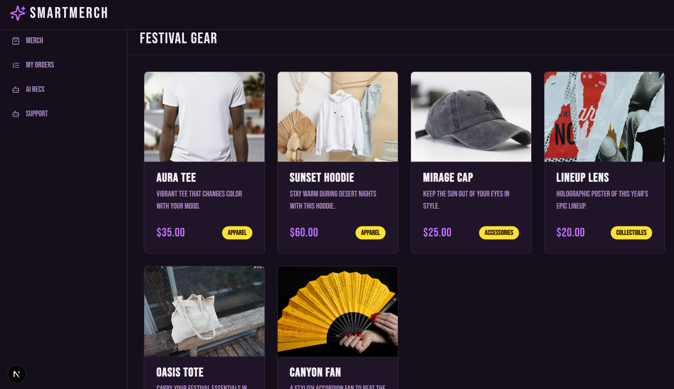

When browsing merch, it shows real-time availability, including booths. Additionally, when clicking on one of the booth locations, the screen will take you to the map location where it’s located.
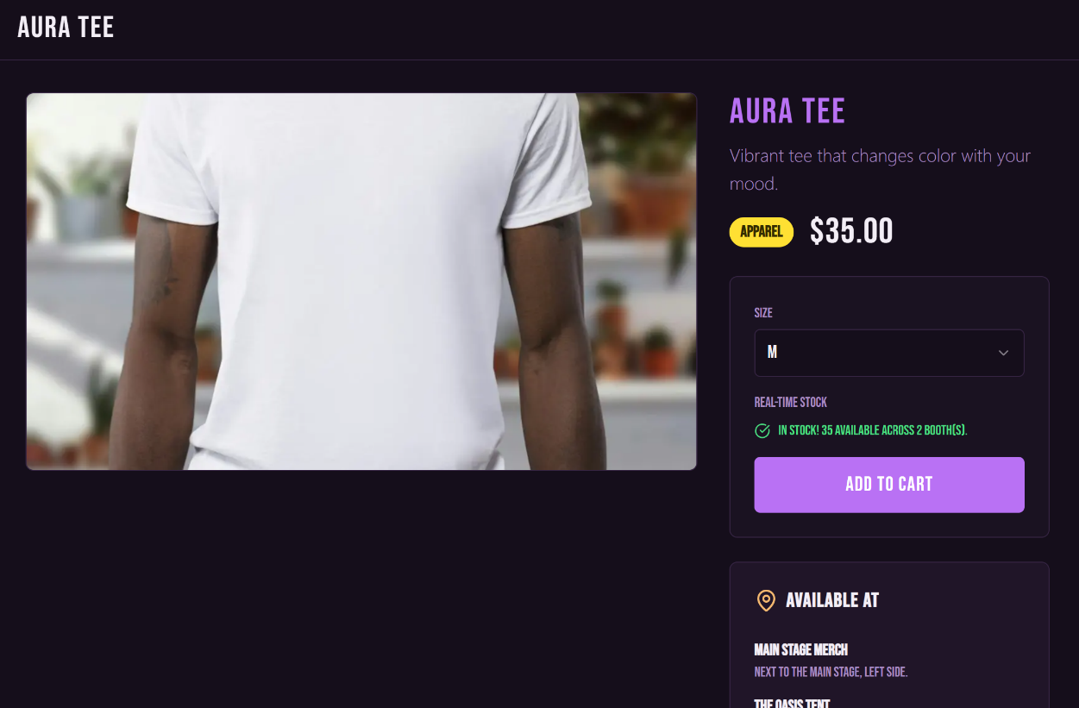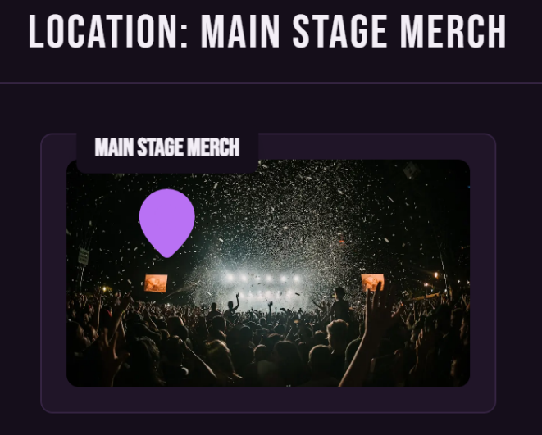
Similar to online shopping, when clicking your cart you should be able to see everything in there along with the total. 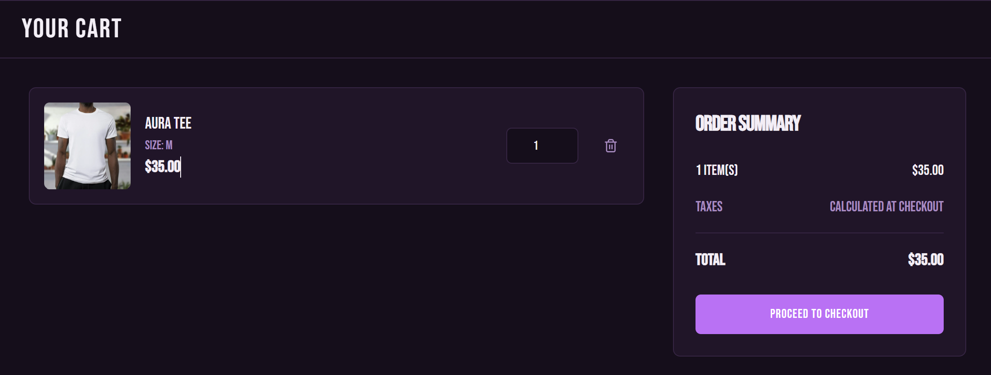
When proceeding to cart, it will allow the user to place their payment information and their items will be reserved in the system to avoid oversell. The next step after should give the QR code and pick-up information, however, I was not able to do this on Firebase unless adding payment information.
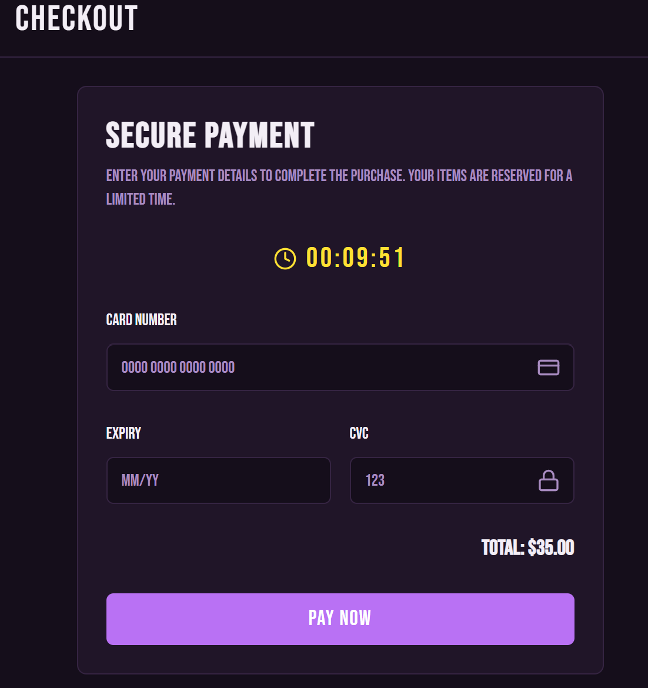

Located on the left tab the user may click “My Orders” to see all orders placed all at once and where they may or have been picked up.
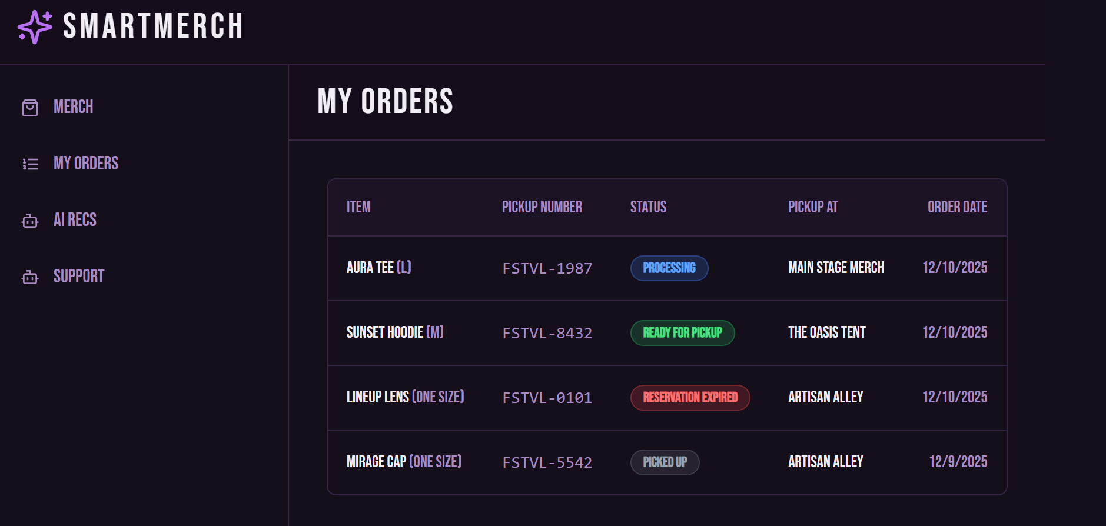
Other exciting features are more customer-focused such as Chat Support where the user can ask AI for recommendations, find merch, or ask questions.
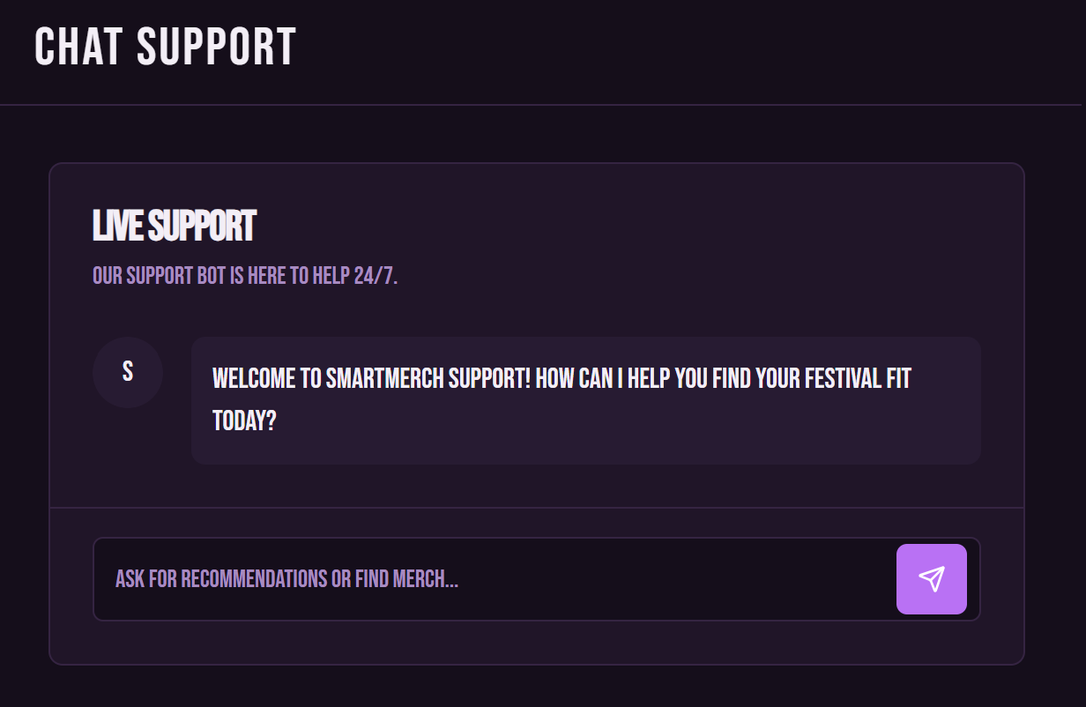

Lastly, AI recommendations will show recommendations based on collected data. Here the user may type in their age group and select their size and AI will build personal recommendations.
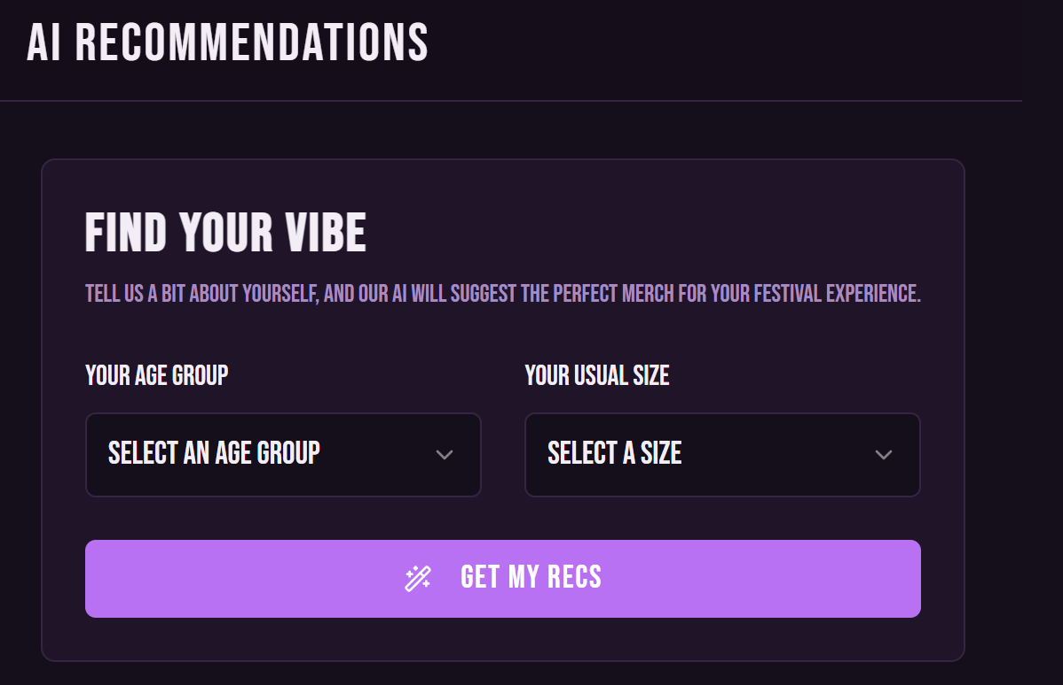

Future Improvements
While this remains an outline, I have identified several key areas for future development. A critical success factor involves expanding the predictive model to more accurately evaluate the required stock for an event before it begins. Though the app currently succeeds at reducing customer wait times, developing this model further will directly help eliminate overstock and waste. Additionally, by encouraging customers to pre-order weeks in advance, the company can secure guaranteed sales and gather valuable data to predict sales for future events. Another major improvement would be enhancing the AI recommendations. The app could collect personal data, such as age and size, during user sign-up to automatically generate high-accuracy recommendation lists, thus boosting sales. Going even further, analyzing user actions, such as saved artists in their setlist or previously purchased shows, would provide more intentional psychographic data for personalized item recommendations. Regarding the location map feature, I plan to evolve it from a static image to a dynamic, interactive map that clearly displays photos of the exact booth location and surrounding areas for easier navigation. Lastly, ensuring the application can securely store payment information is essential for customer efficiency, removing the need for users to manually type details and allowing them to fully enjoy the live experience.

