**PHASE 2 PROJECT :**

**Naan Mudhalvan - IOT**

**Project statement: Public Transport And Optimization**

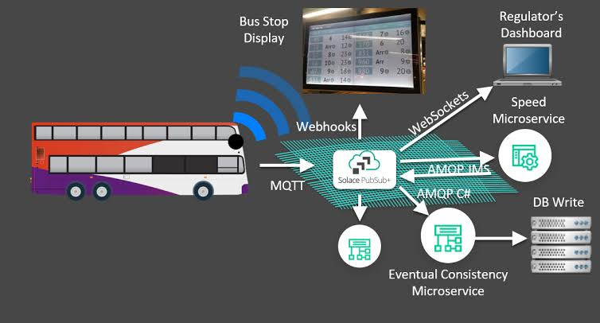

**Introduction to Public Transport Optimization in IoT:**

The world’s urban landscapes are increasingly defined by bustling cities, where public transportation systems serve as the lifeblood of efficient mobility. However, these systems often face challenges such as congestion, delays, and resource inefficiencies. In the age of the Internet of Things (IoT), a transformative solution emerges – Public Transport Optimization through IoT technology.

IoT offers a paradigm shift in the way we design, manage, and experience public transportation. By embedding sensors, data analytics, and real-time connectivity into buses, trains, stations, and traffic infrastructure, cities can create smart, responsive jitransit ecosystems. These systems offer commuters personalized travel information, reduce waiting times, improve safety, and enhance sustainability.

Public Transport Optimization in IoT fosters data-driven decision-making, enabling transit authorities to predict demand, optimize routes, and minimize environmental impact. It empowers passengers with real-time updates and contactless payment options, making commuting more convenient and enjoyable.

This introduction sets the stage for exploring the profound impact of IoT on public transport, highlighting how it transforms urban mobility, enhances commuter experiences, and promotes sustainable and efficient transit solutions.

**Content For Project Phase 2:**

Consider incorporating machine learning algorithms to improve arrival time prediction accuracy based on historical data and traffic conditions.

**Objective Innovative Idea for Public Transport Optimization in IoT: “Dynamic Demand-Responsive Transit”**

Objective:

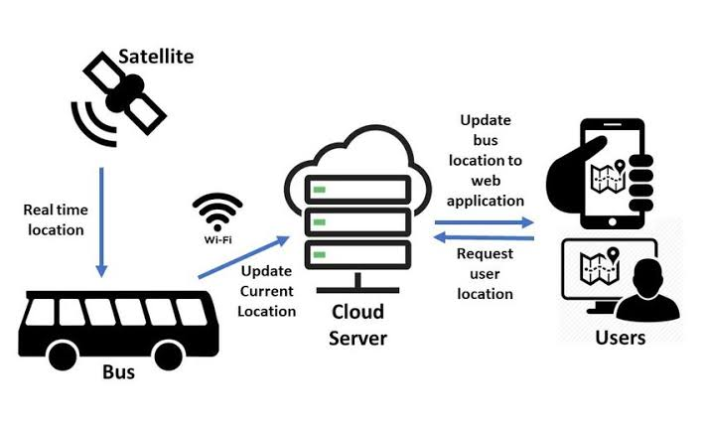The objective of “Dynamic Demand-Responsive Transit” is to revolutionize public transportation by creating a system that adapts in real-time to passenger demand and traffic conditions. This innovative approach harnesses the power of IoT technology to optimize routes and schedules, making public transport more efficient, convenient, and environmentally friendly.

Key Features:

1. IoT-Enabled Passenger Sensors: Equipping vehicles with IoT sensors enables them to detect passenger demand as it unfolds, ensuring that routes and schedules can be dynamically adjusted.
2. Mobile App Integration: A passenger mobile app connects users with the IoT system, allowing them to request pick-up/drop-off points, track vehicle locations, and receive real-time updates.
3. Adaptive Routing:Advanced algorithms continuously calculate optimal routes, factoring in passenger demand, traffic conditions, and road closures. This ensures that vehicles take the most efficient paths.
4. Smart Bus Stops:Bus stops are equipped with IoT displays that provide real-time information on vehicle arrivals, occupancy levels, and estimated wait times.
5. Environmental Impact Tracking: The system collects data on vehicle emissions and fuel consumption, allowing for the calculation and reduction of the public transport system’s carbon footprint.

**IoT Sensor Design Idea: “Smart Passenger Load Sensors”**

Objective:Develop pressure sensors strategically placed within public transport vehicles to collect real-time data on passenger occupancy and distribution.

Design Details:

1. Seat Sensors: Embed pressure sensors in seats to detect occupancy.

2. Floor Sensors: Install floor sensors to identify standing passengers and high-traffic zones.

3. IoT Connectivity: Connect sensors to transmit real-time data to a central control center and passenger mobile apps.

4. Analytics: Analyze sensor data to determine passenger load, seat availability, and distribute insights to passengers.

Benefits:

Efficient resource allocation, enhanced passenger experience with accurate seating information, reduced congestion, data-driven decision-making for transit authorities, and improved sustainability through lower emissions.

Smart Passenger Load Sensors optimize public transport, benefiting transit authorities and passengers by improving efficiency, comfort, and sustainability.

**Innovative Real-Time Transit Idea: “Green Commute Assistant”**

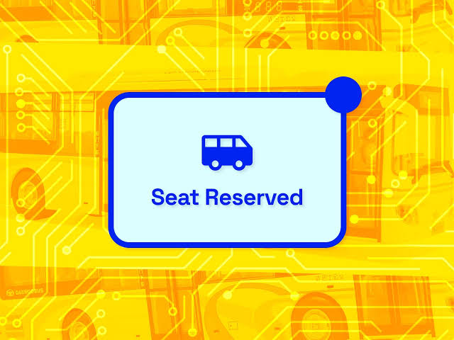

Objective: Create a “Green Commute Assistant” using IoT technology to promote eco-friendly commuting and reduce traffic congestion.

Features: It offers real-time traffic updates, monitors vehicle emissions, facilitates dynamic carpooling, suggests eco-friendly routes, tracks carbon footprints, and provides contactless payment options. Passengers can contribute feedback, fostering continuous improvements.

Benefits: This solution encourages sustainable commuting, reduces congestion, improves air quality, and enhances passenger convenience. By leveraging real-time data and IoT connectivity, the “Green Commute Assistant” empowers commuters to make environmentally responsible choices while optimizing their daily transit experience.

**Innovative Integration Approach: “Unified Mobility Hub”**

Objective: Create a “Unified Mobility Hub” through IoT integration, linking diverse public transit modes, third-party services, and real-time data.

Features: Collect data from various transit sources, offer a passenger mobile app for route planning and payments, enable intermodal journey planning, monitor environmental impact, and provide multi-modal connectivity.

Benefits: Passengers enjoy a streamlined transit experience, reducing congestion, and accessing eco-friendly transit options. Transit authorities gain data-driven insights for service improvements. The “Unified Mobility Hub” revolutionizes urban transportation, making it more efficient, convenient, and sustainable.

**Machine Learning Arrival Time Prediction in Public Transport:**

Incorporating machine learning algorithms to improve arrival time prediction for public transport optimization based on historical data and traffic conditions is a complex task. I’ll provide you with a high-level structure and some code snippets to get you started. This example uses Python and scikit-learn for machine learning and assumes you have historical data available.

First, you’ll need to gather and preprocess your data, which may include features like time of day, day of the week, historical travel times, weather conditions, and more. Here’s a simplified example:

Import pandas as pd

# Load historical data

Data = pd.read_csv(‘historical_data.csv’)

# Preprocess the data, convert timestamps, and engineer features

Data[‘timestamp’] = pd.to_datetime(data[‘timestamp’])

Data[‘hour’] = data[‘timestamp’].dt.hour

Data[‘day_of_week’] = data[‘timestamp’].dt.dayofweek

# Create a target variable (e.g., arrival delay in minutes)

Data[‘arrival_delay’] = data[‘actual_arrival_time’] – data[‘scheduled_arrival_time’]

# Prepare features and target variable

X = data[[‘hour’, ‘day_of_week’, ‘previous_travel_time’, ‘weather_conditions’]]

Y = data[‘arrival_delay’]

Next, you can split your data into training and testing sets:

fom sklearn.model_selection import train_test_split

X_train, X_test, y_train, y_test = train_test_split(X, y, test_size=0.2, random_state=42)

Now, you can choose and train a machine learning model. Let’s use a simple linear regression model as an example:

Y_pred = model.predict(X_test)

# Evaluate the model (you can use different metrics based on your needs)

From sklearn.metrics import mean_absolute_error, mean_squared_error

Mae = mean_absolute_error(y_test, y_pred)

Mse = mean_squared_error(y_test, y_pred)

Once your model is trained, you can use it to make predictions on new data. You can also evaluate its performance:

Y_pred = model.predict(X_test)

# Evaluate the model (you can use different metrics based on your needs)

From sklearn.metrics import mean_absolute_error, mean_squared_error

Mae = mean_absolute_error(y_test, y_pred)

Mse = mean_squared_error(y_test, y_pred)

To continuously update your model and improve prediction accuracy, you should periodically retrain it with new data.

Finally, you can integrate this predictive model into your public transport system to provide real-time arrival time predictions based on historical data and current conditions. This may involve setting up APIs, web services, or other methods to serve predictions to users.

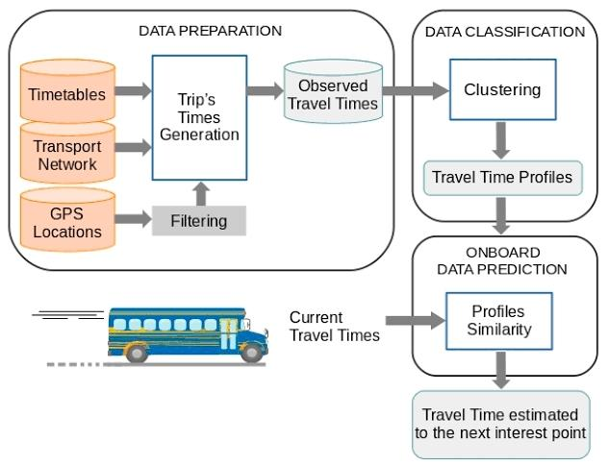

Please note that this is a simplified example, and a production-level public transport optimization system would require more sophisticated models, data preprocessing, and integration with real-time data sources for traffic conditions. Additionally, ensure you have the necessary permissions and data privacy considerations when working with historical and real-time transport data.

